A combined SH- and P-wave seismic reflection survey to support seismic microzonation in the 2012 Emilia epicentral area (Italy)

Petronio¹ L. *, Baradello¹ L., Affatato¹ A., Barbagallo¹ A., Cristofano¹ G., Sorgo¹ D., Poggi¹ V., Minarelli² L., Boehm¹ G., Martelli³ L., Lai^{4,5} C. G.

¹ National Institute of Oceanography and Applied Geophysics – OGS, Italy
² National Institute of Geophysics and Volcanology, INGV, L’Aquila, Italy
³ Geological, Seismic and Soil Survey, Emilia-Romagna Region, Bologna, Italy
⁴ Department of Civil and Architectural Engineering, University of Pavia, Italy
⁵ European Centre for Training and Research in Earthquake Engineering, EUCENTRE, Pavia, Italy

*Corresponding author

Lorenzo Petronio, Researcher, National Institute of Oceanography and Applied Geophysics, OGS, Borgo Grotta Gigante – 34010 Sgonico (TS), Italy, lpetronio@inogs.it

ABSTRACT
In some geological environments, such as thick sedimentary basins, the deeper layers may also significantly contribute to amplification effects particularly al low frequencies. The recognized influence of the deeper geology on the seismic ground motion behavior at the surface implies the need to adopt geophysical techniques to provide a realistic model over a large range of depths. This paper deals with the acquisition and processing of a combined shear- and compressional-wave seismic reflection data acquired in the frame of the microzonation study of the Cavezzo municipality in Northern Italy. This site is located in the 2012 Emilia earthquake epicentral area part of the Po Plain which corresponds to a deep sediment-filled basin. The main goal of the research was the subsoil investigation to obtain an accurate geological model with reliable seismic velocities for local-scale seismic waveform studies, as needed for hazard assessment and calculation of earthquake scenarios. Specifically, we were able to: (1) demonstrate the applicability of reflection seismic prospection in soft-sediments infill basin for site characterization in earthquake engineering; (2) evaluate S- and P-wave signal resolution and penetration capabilities; (3) improve the velocity model of the Cavezzo area by S- and P-wave interval velocities measurements in Plio-Quaternary formations.

1 - Introduction
It has long been observed that a conspicuous of ground shaking variability produced by an earthquake is strongly correlated with local geological conditions, and this issue is referred to as the seismic site effects. The assessment of site effects represents one of the most critical issues in the microzonation studies to evaluate seismic hazard and for earthquake design of new engineering projects.
Alluvial plains have always represented a very attractive environment for human settlements due to the favourable conditions and, nowadays, 55% of the world population lives in urban areas located in such geological context. High population density, presence of industrial activities and infrastructures, makes cities located above soft-sediment filled basin particularly exposed to seismic hazard because ground motion amplification can be large in terms of the amplitude and signal duration. Aggravations of seismic effects on buildings that are situated in the basin area have been evidenced through modelling studies and experimental data. Some remarkable examples include the Kanto basin (Koketsu and Kikuchi, 2000; Dhakal and Yamanaka, 2013), the Los Angeles basin (Olsen, 2000; Komatitsch et al., 2004), the Osaka basin (Kagawa et al., 2004), the Rhine Graben (Scherbaum et al. 2003; Hinzen et al. 2004; Ewald et al., 2006; Parolai et al., 2006), the Grenoble basin (Cornou et al., 2003, Stupazzini et al., 2009; Chaljub et al., 2010), the Rhone valley (Roten et al. 2006), the northern part of the Brabant massif covered by loose sediments (Nguyen et al. 2004; Wathelet et al. 2004), the Po Plain (Vuan et al., 2011; Paolucci et al., 2015) and the Norcia basin (Rodriguez-Plata et al., 2021). All these studies showed that not only the surface geology but also the deeper layers might significantly contribute to amplification effects over a broad frequency range between 0.1 and 10 Hz (Havenith et al., 2007).
To accomplish an accurate seismic microzonation, the determination of reliable S-wave velocity models is of paramount importance. In the seismic microzonation studies, the available budget is, usually, limited, so direct investigations are generally constraineed to the first few upper meters of the soil profile by trenching or excavation. Only in few cases, higher depth boreholes are drilled in deep sediment basins to reach the bedrock that can be located at hundreds of metres below the surface. Seismic prospecting represents low-cost and non-invasive tools able to provide S-wave velocity information over a broad range of depths. In seismic microzonation studies, both active and passive seismic methods are the most suitable approaches because they allow direct estimation of those geophysical properties that are useful for the evaluation of the site response (Poggi et al., 2017).
Passive seismic methods use surface waves to define the properties of soil deposits like the fundamental frequency of resonance and the shear-wave velocity profiles from the inversions of surface-waves dispersion curves. The single-station horizontal-to-vertical spectra-ratio (HVSR or H/V) method, widely known as the "Nakamura's" technique, had originated in Japanese publication (Nakamura and Saito, 1983) and spread all over the world after the publication of the study of Nakamura (1989). Because the HVSR method is relatively simple and low-cost measurement, it has gained widespread popularity and has been used for different purposes also as a geophysical exploration tool (Delgado et al., 2000a,b; Ibs-Von Seht and Wohlenberg, 1999; Parolai et al., 2002, Tarabusi and Caputo, 2017).
Continuing with passive measurements, since the pioneering studies of Aki (1957), Capon (1969) and Lacoss et al. (1969), and the first works of Horike (1985) and Okada (1986), the use of seismic arrays to acquire ambient vibrations and micro-tremors has been recognized as one of the attractive and convenient exploration methods to obtain S-wave velocity profile, especially in urban areas, where the high level of the anthropic noise can limit the use of other geophysical prospection techniques.
Like for the passive seismic data, also in the active surface wave techniques as SASW and MASW (Nazarian et al., 1983; Park et al.; 1999; Foti et al., 2014) (), the information provided by the dispersive behaviour of surface waves can be inverted to retrieve one-dimensional shear-wave velocity models. Passive seismic survey by using velocimeters/seismometers are better suited for deep target prospections while artificial seismic sources and geophones, typically used for active surface wave acquisitions, are able to perform shallow investigations, mainly adopted to estimate the Vs30.
An exhaustive description about the good practice of surface wave analysis is reported in Foti et al. (2018).
Because of the penetration and the high-resolution capabilities, the seismic reflection method allows obtaining a very detailed subsoil image in support to successful management of the urban area (Krawczyk et al., 2013; Martí and Carbonell, 2016). Several studies have been published concerning the use of active seismic methods in an urban context with the aim to locate and characterize geological structures (Beilecke et al., 2016; Rizzo et al., 2020), aquifer and geothermal reservoirs (Liberty, 1998; Bissmann et al., 2013, Della Vedova et al., 2015), to evaluate geohazard (Krawczyk et al., 2012, Zini et al., 2015; Wadas et al., 2017; Polom et al., 2018), to assist underground infrastructure planning (Marti et al., 2008; Malehmir et al., 2015) and to support seismic microzonation (Pugin et al., 2007, Petronio et al., 2018, Tallini et al., 2019). The S-wave reflection technique is preferentially used for earthquake engineering purposes since it provides a direct estimation of S-wave velocities and subsoil geometry that are key parameters for site response analysis The use of vibrating seismic source and land streamer receiver array offers an efficient and adaptable data acquisition system well suited for seismic reflection survey in the urban context (Pugin et al., 2013).
The study area is located in the Po Plain a very thick sedimentary basin in Northern Italy affected by moderate to strong seismicity (Boschi et al., 2000; Guidoboni et al., 2007; Rovida et al., 2011). In this region, ground-motion empirical models underestimate seismic shaking in the basin (Bragato et al., 2011; Massa et al., 2012).This observation indicates the relevant influence of the sedimentary cover on the seismic wavefield (Massa et al., 2012) and highlights the fundamental role of the basin structure in amplifying the ground motion. In such geological contexts, realistic models are needed to perform deterministic modelling able to accurately estimate the ground motion characteristics (Vuan et al., 2011; Molinari et al. 2015; Paolucci et al. 2015; Klin, 2019). Since the 1950’s, this area was interested in an extensive exploration by means of seismic reflection surveys and drillings for hydrocarbon research (Bertello et al., 2010). These prospecting activities allowed to improve the knowledge of the Po Plain basin mainly concerning the geometry of the geological formation and the relative P-wave velocities. As a consequence of the well-recognized importance of S-wave velocity contrasts for site response assessment, Mascandola et al. (2019) proposed the mapping of the seismic bedrock in the Po Plain obtained by passive seismic surveys.
In this study, we present the results obtained from a combined SH- and P-wave seismic reflection survey conducted in the area of Cavezzo municipality in the framework of a seismic microzonation study (Petronio et al. 2018, Lai et al. 2020). The main goals of this work are: 1) to assess the applicability of the seismic reflection method for studies of site response in a deep sedimentary basin, 2) to image the sedimentary sequence and identify the possible main seismic impedance contrasts and 3) to measure S- and P-wave velocities for a reliable local geological model.
The paper is organized as follows. After a brief description of the geological context, the methods part illustrates the seismic reflection survey data acquisition and processing. Then, shear and compressional data were interpreted and compared in term of resolution and penetration depth. Finally, the models for S- and P-wave velocities are presented and discussed.

2 - Geological AND TECTONIC setting
The study area is located at Cavezzo (Emilia-Romagna, Northern Italy) in the Po Plain, corresponding to the deep foreland basin of the Northern Apennines (Figure 1). The basin hosts a thick succession of Plio-Quaternary sediments, deposited, since the middle Pleistocene, into alluvial plain environments by the Po River and its tributaries (Bresciani and Perotti, 2014). The subsurface geology is marked by blind thrust and ramp anticline structures of the Northern Apennines (Pieri and Groppi 1981; Boccaletti and Martelli, 2004; Toscani et al. 2009). The tectonic structures, developed through late Neogene and Quaternary times in the foredeep basin area, are responsible for the intense seismic activity of 2012, characterized by two main events (Mw = 6.1 and 5.9; e.g. Pondrelli et al., 2012), and by a prolonged sequence of aftershock (e.g. Saraò and Peruzza, 2012; Scognamiglio et al., 2012). The tectonic deformation superimposed to the regional subsidence induced maximum subsidence rates in the synclinal areas and minimum values in correspondence of the top of the buried anticlines (Ghielmi et al. 2013; Vannoli et al. 2015; Stefani et al., 2018). The different subsidence rates determined significative lateral variations of depositional facies, thickness, and petrophysical properties (Figure 2). The effect of the Quaternary glacio-eustatic ﬂuctuations, combined with fault-fold deformation pulses, generated a series of discordance boundaries, which were used as marker levels to subdivide the sedimentary successions into allostratigraphic units at the regional scale (Regione Emilia-Romagna and ENI/AGIP, 1998). An unconformity associated with a structural reorganization episode of the Apennine external folds divides two main allostratigraphic units: the Lower Emiliano-Romagnolo Synthem (AEI) and the Upper Emiliano-Romagnolo Synthem (AES). These units are further subdivided into subsynthems, with an average thickness of about 30-40 m, identified by boundaries produced by climate and glacio-eustacy ﬂuctuations (Figure 2). The transgressive surfaces induced by the deglaciation sea rises have been chosen as subsynthem boundaries corresponding to the deactivation of the synglacial coarse-grained sedimentation into middle alluvial-plain environments. The ongoing transgressive-regressive depositional cycle is ascribed to the Ravenna Subsynthem (AES8), and its base corresponds to the beginning of the Holocene. The lower boundary of the underlying Villa Verucchio Subsynthem (AES7) is dated to about 120 kyr, and the base of the Bazzano Subsynthem (AES6) to about 240 kyr (Regione Emilia-Romagna and ENI/AGIP, 1998). Two further depositional cycles are ascribed to AESi, the formally undivided lower portion of the AES. The AEI possibly records two transgressive-regressive pulses that are globally documenting a shallowing evolution of the depositional environment. The thickness of these stratigraphic units increases from the anticline crest area at the south of Mirandola town, toward the syncline area (Figure 2). An angular unconformity associated with a significant deformation phase of the Mirandola structure marks a boundary between AEI and the underlying Marine Quaternary (QM), a thick sequence of shallowing upward marine deposits recording a transition from deep-sea turbiditic sediments to nearshore delta deposits. This unit can reach a thickness of several hundred metres and pinches out laterally on the Mirandola anticline culmination. The underlying Pliocene deposit consists of thick turbiditic sands (Ghielmi et al. 2013). The older units visible in the profile of Figure 2 consist of deep-sea claystone and marls, dated to the Miocene, partially referred to the Colombacci Formation (e.g. Tarabusi and Caputo, 2017; Martelli et al., 2017).

3 - METHODS
In the framework of a level 3 microzonation study (Albarello et al., 2015; Moscatelli et al., 2020), the Institute of Oceanography and Applied Geophysics - OGS performed a shear-wave seismic reflection survey in the territory of the Municipality of Cavezzo with the aim to evaluate the applicability of this method in deep sedimentary basin as a tool to improve the characterization of the sedimentary sequence in seismic hazard perspective. In addition, along the same seismic line, P-wave data were acquired to compare resolution and penetration of S- and P-wave data in such geological context.

3.1 - Data acquisition
Some authors (i.e., Polom, 2012; Krawczyk et al., 2013; Pugin et al., 2013) observed that the signal-to-noise of S-wave seismic reflection data has a beneficial effect when acquisitions are performed on paved or compacted surfaces because the velocity inversion inhibits the surface wave generation, particularly Love waves Based on this consideration and the local logistic situation, we located the seismic line along a secondary paved road. During the acquisition, the road was closed both for safety reasons and to reduce unwanted seismic noise. The seismic line was NW-SE oriented, parallel to the buried front of the Apennine chain (e.g. strike direction), to collect data in a potential horizontal subsoil layering beneficial for reliable conventional velocity analysis. We first acquired the line in S-wave mode by using a cross-line polarized source with cross-line horizontal geophones (Haines and Ellefsen, 2010; Hunter et al., 2002) and afterwards, it was re-acquired by P-wave seismic source and vertical geophones. Preliminary to the production phase, we performed tests to select the sweep signal and the acquisition parameters for both surveys. Table 1 shows the acquisition parameters for SH- and P-wave survey, respectively. We deployed a line with 240 channels line, 2 m spacing, in fixed spread configuration. This acquisition geometry allowed the multi-offset collection of reflected and turning-ray/refracted events that can be usefully analyzed to obtain reliable velocity information both by conventional velocity analysis and tomography. The survey was conducted with a vibroseis (Ivi MiniVib T-2500) as a seismic source in SH- (Figure 3a) and P-wave (Figure 3b) configuration, respectively. A 12 s linear up-sweep was set to 10 – 120 Hz for SH-wave mode and 10 – 240 Hz for P-wave acquisition. The seismic source move-up was 4 m and at each source-point was performed from a minimum 2 to 4 sweeps, depending on the data quality. Data were acquired by DMT- Summit II seismographs and were recorded both on a Windows notebook running a DMT proprietary software to manage the acquisition and on a Linux PC dedicated to the data quality control performed by Seismic Un*x (CWP/SU) package. (Stockwell, 1999).. The raw data were stored uncorrelated to enable pre-correlation processing if required. Data signal-to-noise ratio was high for both datasets as revealed on typical shot gathers shown in Figure 4. We conducted the topographic survey for source and receiver locations using real-time differential GNSS positioning techniques with centimetric precision. The acquisition of a 478 m-long seismic line in SH- and P-wave configuration, including field layout, pre-survey tests and topographic measurements takes 4 days of fieldwork for a team of 6 people.

3.2 - Data processing
Field data were processed using Seismic Un*x (Stockwell, 1999) and Echos-Paradigm software packages. The shot-by-shot quality control performed during the acquisition phase with the repetition of seismic energizations in the presence of noisy records strongly reduces the data editing effort and improves the overall dataset quality. Because the minimal elevation differences along the seismic line and the absence of lateral variations, we did not apply statics corrections simplifying the processing of this type of geophysical data. In this case, the zero-datum reference corresponds to the ground level (22 m above mean sea level). Since the SH-wave data show severals sharp reflections and a limited presence of source-generated coherent noise (i.e., Love and guided waves), we adopted a standard processing sequence for high-resolution seismic data (e.g., Krawczy et al., 2012, Polom et al., 2013, Petronio et al., 2016). Several iterations of interactive velocity analysis of the reflection hyperbolas in the CMP gathers were manually performed by the Echos-Paradigm software tool based on semblance as coherency measurements.
P-wave data contain clear reflections but, differently from SH-wave data, the near-offset traces are contaminated by surface wave noise (Figure 4), specifically Rayleigh waves. Nevertheless, a basic processing sequence (e.g., Steeples and Miller, 1990) allowed to obtain a clear stack section. Table 2 reports the data processing flows utilized for two datasets. As expected from a-priori geological information (Martelli and Romani, 2013) and considering the strike orientation of the seismic line, both SH- and P-wave stack data show a near-horizontal and parallel sedimentary sequence (Figure 5). For this reason, we did not apply dip-moveout (DMO) or prestack-migration algorithms. The seismic sections were converted into depth by a smoothed velocity function to enable a stratigraphical correlation and perform a geological interpretation.

- - Results and discussion

4.1 - Seismic velocity - depth profile
In the seismic reflection survey, the well-known common midpoint (CMP) technique uses a multiplicity of multi-offset source-receiver pairs to improve the signal-to-noise ratio during stacking (Mayne, 1962). Seismic traces with different offsets are sorted in CMP gathers and, based on the assumption that reflection traveltimes follow hyperbolic trajectories, the normal-moveot (NMO) correction removes the offset effect on traveltimes (Yilmaz, 2001). The NMO correction needs to estimate the stacking velocity that allows the best flattens the reflection event on the CMP gather and thus yields the highest stacked amplitude. A proper estimation of seismic velocities is not only fundamental to get the best quality stack section and correct depth positioning, but it can also be a key input for interval velocities computation in absence of direct measurements. The velocity analysis is obtained by picks that correspond to the best coherency of the signal along a hyperbolic trajectory over the entire spread length of the CMP gather. Neidell and Taner (1971) described various types of coherency measures that can be used as attributes in computing velocity functions. For short offsets, the NMO velocity for a horizontally and homogeneous layered earth model can be considered equivalent to the rms velocity (Taner and Koehler, 1969; Al-Chalabi, 1973). Under these assumptions, the formula proposed by Dix (1955) can be utilized to obtain reliable interval velocities functions able to perform the time to depth conversion of seismic data, to support their interpretation and to define realistic geological models.
We performed several velocity analyses on single and super-gathers along the SH-wave line, and, finally, we focused the analysis on CMP gathers located in the central part of the line where a high multi-fold coverage was higher (about 120). We carried out manually the picking in a CMP super-gather composed by 3 adjacent CMP, corresponding to a bin size of 3 m lower than first Fresnel zone (Yilmaz, 2001) computed for a 40 Hz dominant reflection at 1.4 s two-way-time (twt).
Clear hyperbolic signals corresponding to sharp and well identifiable maxima in the semblance panel allowed a reliable picking. Figures 6a and 6b show the CMP super gather and its velocity spectrum with the picked velocities coincident with the semblance peaks, corresponding to the most probable velocity function. The velocity analysis represents an incontrovertible crucial point in multifold seismic reflection data processing because it is a subjective step that strongly depends both on the data quality and on the seismic analyst experience. The estimation of uncertainties is required to verify the reliability of the interval velocity profile computed from stacking velocities. To provide an approximate and reasonable range of uncertainty in velocity determination, we picked two functions with under- and over-estimated velocities with respect to the reference one able to produce, however, decent stacks. We extracted the interval velocities for the different velocity profiles by Dix formula and compute the interface depths (Figure 6c). The same approach was adopted also for P-wave velocity analysis.
In high-resolution S-wave seismic reflection survey with targets not deeper than 80 m, Pugin et al. (2013) observed that the precision of the velocity obtained by semblance analysis is on the order of ±5 m/s in presence of soft sediments while in faster shear-wave media uncertainties is ±15 m/s. We obtained similar values in the shallower part and increasing uncertainities at greater depths (> 200 m 550 m/s ± 50 m/s) due to less moveout on deep reflectors.

In addition to the conventional velocity analysis for NMO corrections we independently performed a seismic traveltime tomography by using reflected signals to obtain velocity models both for S- and P-wave data. We used the technique described by Vesnaver et al. (1999) and Rossi et al. (2007), with minimum time ray tracing modified from Böhm et al. (1999) and the iterative inversion Simultaneous Iterative Reconstruction Technique (SIRT) method (van der Sluis and van der Vorst, 1987; Stewart, 1991). We reconstructed the depth of the horizons exploiting the method of minimum dispersion of the reflection points (Carrion et al., 1993) with an iterative procedure base on the layer stripping approach. In the SH-wave data, we identified 5 main reflectors and picked the reflections on SH-wave data in the common-shot domain. We performed the traveltime inversion also for P-wave data where 6 reflectors were selected and picked. To estimate the reliability of the inversion we computed two parameters: the rms time residual (TRrms) defined as:

TRrms = (1)

where np is the number of picked arrivals (total rays), i is the ray number, and rapresent the observed travel time (picking) and computed travel time of i-ray, respectively; and the average dispersion of reflection points (ADRP):
ADRP = (2)

where np is the number of picked arrivals (total rays), i is the ray number, corresponds to the depth value of the point after depth correction (dt = time residual, V = average velocity above the point), and is the depth of the actual horizon at the same horizontal coordinates associated to the reflection point. Table 3 reports the TRrms and the ADRP values computed for both SH- and P-wave velocity models. Figure 7 shows the SH- and P-wave velocity models obtained by reflection tomography and the comparison with velocity profiles obtained by velocity analysis performed for NMO corrections. Both approaches adopted to achieve the velocity profiles from seismic reflection data are in good agreement.

4.2 - SH- versus P-wave: resolution and penetration
From the theoretical point of view, shear waves offer a better resolution than P-waves since shear waves travel slower than compressional waves. Shorter wavelengths travel for more cycles than larger wavelengths, which results in a finer vertical resolution and a much rapid attenuation with consequently limited penetration. Besides the theoretical considerations, the applicability of seismic reflection by both type of waves is strongly dependent on the near-surface conditions and the geology of the site under investigation. In this pilot study, we carried out independent SH- and P-wave reflection profiling to evaluate the suitability of the method in supporting microzonation studies. Both vibroseis datasets contain evident reflections with different penetration and resolution capability. SH-wave data show reflections at near-offsets between 0.120 – 1.8 s twt corresponding to an investigation window ranging from few meters to about 400 m below the ground surface (Figures 4a and 4b).
P-wave reflected events are observable in the optimum window (Hunter et al., 1984) - below first arrivals and above the Rayleigh waves – from about 0.100 to 0.800 s twt, corresponding to depths of 70 and 1100 m, respectively (Figures 4c and 4d). In this case, the reduced offsets available for P-wave data inhibits the detection of deeper reflections.
For the SH-wave data set, assuming a dominant frequency around 36 Hz and an average velocity in the range of 200 – 520 m/s we computed vertical resolutions of 1.4 and 3.5 m, respectively, using the one-fourth wavelength criterion (Widess, 1973).
The P-wave velocity ranges between 1450 and 2500 m/s with a dominant frequency around 40 Hz determining vertical resolutions of 9.1 m in the shallower part and 15.6 m in the deeper one. As S-wave velocities are 3 – 8 times lower in comparison with P-wave velocities with similar frequency spectra, shear-wave data provide a higher resolution capability.

4.3 – Seismic data interpretation and geomodel building

The most relevant reflections on both SH- and P-wave data were detected and correlated with the sedimentary sequence described by Martelli and Romani (2013) and in other studies (Regione Emilia-Romagna and ENI/AGIP, 1998, Minarelli et al., 2016, Tarabusi and Caputo, 2017).
Figure 8 shows the data interpretation performed on the SH- and P-wave seismic data depth converted. The shorter wavelength of SH-wave data offers a greater resolution and improved imaging of shallow depths compared to the P-wave section. The SH-wave data allow penetrating until the top of QM and a more in-depth interface located at about 340 m below the ground surface. The P-wave stack section reveals the sedimentary succession until the Lower Pliocene strata located at depths greater than 1000 m.
The interpretation of the shallower portion was performed based on the CARG regional mapping (Molinari and Pizziolo, 2009) and by data collected in the frame of the Cavezzo municipality seismic microzonation study (Lai et al., 2020). The succession globally records a shallowing evolution, from deep-water turbiditic environments to alluvial plains systems, through a time interval spanning over Pliocene and the whole of the Quaternary times. The Ravenna Subsynthem AES8 frames the ﬁrst 15 m of subsurface and consists of Secchia river deposits and marsh muds. Fine-grained sediments dominate the underlying Villa Verrucchio Subsynthem AES7 (15 - 52 m), associated with some ﬂuvial sand intercalations, deposited by Apennine rivers. The Bazzano Subsynthem AES6 (52 - 85 m) encompasses ﬂuvial sands, probably deposited by the Po river.
The underlying AESi synthem (85 -160 m) represents to the lower portion of the Upper Emiliano-Romagnolo Synthem (AES). This synthem is marked by a reflection, better detectable in the P-wave data, located at a depth of about 125 m, probably corresponding to a boundary between two transgressive-regressive cycles. At this depth, a significative velocity increase both for S- and P-wave data is present (Fig. 7).
Moving downwards, the AEI synthem (160 – 230 m) consists of sand and clay deposited in marine, transitional and continental environments. This unit shows a lowering of the P-wave velocity probably associated with the presence of biogenic methane gas as observed at the Mirabello borehole site (Minarelli et al., 2016).
The underlying Marine Quaternary (QM) consists of marine sediments that recorded a regression phase from deep-sea to nearshore delta deposits. In this sector of the Po plain, QM has a thickness of about 600 m. The S-wave penetration allows looking into the upper part of this unit (QM1), while P-wave data reach the interface between the base of the QM (QM2) and the Pliocene turbiditic sands located at a depth of about 830 m.
Table 4 summarizes thickness and seismic velocities (S- and P-wave) of the investigated stratigraphic sequence in support to deterministic ground motion modelling.
S-wave velocities are in agreement with values measured by two downhole seismic investigations (Medolla North and Mirandola South) performed nearby the crest of the Mirandola anticline (Martelli and Romani, 2013) and intercepting the same middle-upper Quaternary formations encountered at Cavezzo. Comparable low S-wave velocities are also measured by a borehole investigation conducted in the syncline site of Mirabello (Minarelli et al., 2016), where Plio-quaternary sediments are reasonably consistent to the sedimentary sequence encountered in the study area (Table 4).
The analysis of the P-wave first arrivals performed on the shot-gathers indicates the presence of the water table (i.e., P-wave velocity > 1540 m/s) at about 4.5 m below the ground surface as confirmed by water level measurements conducted in nearby boreholes.

From seismic hazard viewpoint, all the investigated stratigraphic intervals have velocities lower than 800 m/s, which officially defines the “engineering bedrock” according to the European Building Code (EN 1998-5 2004) and the Italian Building Code (NTC 2018).
Seismic data allow obtaining both Vs and Vp for AES6, AESi, AEI and the upper part of QM (QM1). Figure 9 shows the cross-plot of the interval Vs-Vp and the computed linear regression. To extend the S-wave velocity model to deeper levels, we obtain the Vs from Vp with the linear regression relation Vs = 0.499 Vp – 390.01. Based on this empirical relationship, possible shear-wave velocities near or greater than 800 m/s could be associated with the lower portion of QM (QM2) sediments at a depth of about 475 m.

4.4 – Site amplification

We computed the site amplification by using the velocity models obtained by the seismic reflection survey. Fig. 10 shows …… (Come suggerivi si potrebbero calcolare gli spettri con 4 modelli > Vnmo min, Vnmo ok, Vnmo max, Vtomo) Valerio potresti aggiungere qualche frase di spiegazione sul codice utilizzato (+ bibliografia) e commenti sui risultati.

The main acoustic impedance contrasts may play an essential role in the earthquake site response, and the identification of these boundaries is a critical issue in seismic microzonation investigations.
The widely adopted HVSR method allows to estimate the fundamental period of a site and also to constrain the geologic models for numerical computations of ground motions.
In the presence of unconsolidated deposits overlay a rigid basement, the single-station microtremor data can be used as a low-cost exploration tool to infer sediments thickness if a-priori independent geological information (i.e., shear-wave velocity) are available. In deep basins, the seismic bedrock can be covered by several hundred to thousand meters thick sedimentary sequence. In this geological setting, the adoption of the HVSR technique is challenging because several peaks are usually present, and their association to possible geological interfaces is usually not a trivial issue. Shear-wave reflection data can also offer an opportunity to obtain indications about the fundamental site period [VP1] (Cranswick et al., 1990; Williams et al., 2000; Hunter et al., 2002; Benjumea et al., 2003; Hunter et al., 2010). The time stack section represents the reflectivity sequence, and the signal amplitudes are related to the impedance contrasts between confining layers. In this case, we performed a true-amplitude data processing of SH-wave data to preserve the relative amplitudes (Figure 11a). We computed the Hilbert transform to obtain the complex seismic trace, and, similarly to sub-bottom profiling data processing (Henkart, 2006), we extracted the instantaneous amplitude/envelope (Figure 11b). The envelope curve can be translated in the frequency domain by the formula:

f = 1 / T = 1/ (2 twt) (3)

where T, twt and f are, respectively: the period, two-way time in the stack section and the frequency.

Figure 12a shows the envelope versus frequency after the application of a high-cut filter in time-domain data to better identify the local maxima. These peaks, corresponding to the main seismic impedance contrasts, can represent a benchmark for a possible correlation of the HVSR data in term of stratigraphic interpretation (Figure 12b, 12c and 12d).

Conclusions

For the reliability of any seismic response analysis, a key issue is the definition of an accurate subsoil model, in particular, the S-wave velocity profile and the identification of the seismic bedrock are of foremost importance. In the deep sedimentary basins, the stiff bedrock can be located at depths greater than the penetration or resolution capabilities of the most common geophysical prospecting methods adopted in microzonation studies. In these geological settings, the definition of reliable geophysical models is not a trivial issue. The seismic reflection data can estimate the total thickness of unconsolidated overburden and the velocity profile from shear wave reflections. Nevertheless, the S-wave reflection seismic method is not commonly adopted in such type of studies which are preliminary to the assessment of site effects. Before this survey, no data obtained by active seismic prospecting were available within or near the Cavezzo area. This study investigated the sedimentary Plio-Quaternary sequence, from few meters below ground surface to a depth greater than 400 m, by SH-wave seismic reflection. We also acquired P-wave data to extend the exploration range and to compare resolution and penetration capabilities for both types of waves in such geological setting. In this seismic survey, the joint use of SH- and P-wave was mutually beneficial: the higher resolution of S-wave data combined with greater penetration of P-wave data permits the investigation of the subsoil geometry few meters below the surface until the depth of about 1 km.
The high-quality data allow obtaining a clear stack section with near-horizontal and parallel stratifications. We computed S- and P-wave interval velocities by conventional velocity analysis for NMO correction and by traveltime reflection tomographic inversion. The velocity functions derived by the two different approaches are in good agreement, so the resulting velocity model is reasonably well constrained and robust. The S-wave velocity profile indicates low values (< 800 m/s) until to the lower portion of the QM formation at a depth of 475 m. These interval velocities are similar to the data obtained by the seismic borehole measurements performed in this Po Plain sector and intercepting the same sedimentary sequence (Minarelli et al., 2016). In the depth interval investigated both by S- and P-wave, we obtained an empirical relationship between interval velocities that extend the Vs model below the MiniVib source's penetration capabilities in the shear-wave configuration.
The seismic impedance contrasts between confining layers origin reverberation and entrapment of the seismic waves. As the seismic reflection method produces the reflectivity corresponding to the impedance contrasts sequence, these data represent valuable information for assessment of the fundamental period of the site. Furthermore, they can be used as a benchmark to guide the interpretation and the inversion of the passive seismic data (i.e., HVSR, seismic array) that are routinely acquired in support of seismic microzonation studies.

ACKNOWLEDGMENTS
This research has been carried out within the framework of the European LIQUEFACT project. The LIQUEFACT project has received funding from the European Union’s Horizon 2020 Research and Innovation Programme under Grant Agreement No. 700748. This support is gratefully acknowledged by the authors. In this framework, the authors would like to acknowledge the Major of the Cavezzo Municipality and the technical staff in particular Agnese Malagoli for the support. A special thank to Marco Stefani for the help in editing the geology section of the manuscript.

REFERENCES

Aki, K., 1957. Space and time spectra of stationary waves with special reference to microtremors, Bull. Earthquake Res. Inst. Univ. Tokyo, 35, 415–456.

Albarello, D., Socco. V. L., Picozzi, M., Foti, S., 2015. Seismic Hazard and land management policies in Italy: the role of seismic investigations. First Break 33: 87–93.

Al-Chalabi, M., 1973. Series approximation in velocity and traveltime computation: Geophysical Prospecting, 21, 783-795.

Beilecke, T., Krawczyk, C., Ziesch, J., Tanner, D. C., 2016. Near-surface fault detection using high-resolution shear wave reflection seismics at the CO2CRC Otway Project site, Australia. Journal of Geophysical Research, 121, 9, 6510-6532. https://doi.org/10.1002/2015JB012668

Benjumea, B., Hunter, J.A., Aylsworth, J.M., and Pullan, S.E., 2003. Application of high resolution seismic techniques in the evaluation of earthquake site response: Tectonophysics, 368, 193–209.

Bertello, F., Fantoni, R., Franciosi, R., Gatti, V., Ghielmi, M., Pugliese, A., 2010. From thrust-and-fold belt to foreland: Hydrocarbon occurrences in Italy, in Petroleum Geology: From Mature Basin to New Frontiers, Petrol. Geol. Conf., Ser. 2010, vol. 7, edited by B. A. Vining and S. C. Pickering, pp. 113–126, Geol. Soc., London, U. K.

Bissmann, S., Orlowsky, D.J., Loske B., 2013. How to Explore Deep Geothermal Reservoirs in Populated Areas. Conference Proceedings, Near Surface Geoscience 2013 - 19th EAGE European Meeting of Environmental and Engineering Geophysics, Sep 2013, cp-354-00034. https://doi.org/10.3997/2214-4609.20131354

Boccaletti, M., Martelli, L., 2004. Carta sismo-tettonica della Regione Emilia-Romagna scala 1:250.000 e note illustrative. Selca, Firenze. https://ambiente.regione.emilia-romagna.it/it/geologia/pubblicazioni/cartografia-geo-tematica/carta-sismotettonica-della-regione-emilia-romagna

Böhm, G., Rossi, G., Vesnaver, A., 1997. Adaptive regridding in 3-D reflection tomography, Annali di Geofisica, XL,1, 69-83.

Boschi, E., 2000. A «new generation» earthquake catalogue. Annali di Geofisica, 43(4), 609-620.

Bragato, P.L., Sugan, M., Augliera, P., Massa, M., Vuan, A., Saraò, A., 2011. Moho reflection effects in the Po plain (northern Italy) observed from instrumental and intensity data. Bull Seismol Soc Am 101(5): 2142–2152.

Bresciani, I., Perotti, C. R., 2014. An active deformation structure in the Po Plain (N Italy): The Romanengo anticline. Tectonics, 33, 2059–2076. https://doi.org/10.1002/2013TC003422

Capon, J., 1969. High-resolution frequency-wavenumber spectrum analysis, Proc. IEEE, 57, 1408-1418.

Carrion, P., Boehm, G., Marchetti, A., Pettenati, F., Vesnaver, A., 1993. Reconstruction of lateral gradients from reflection tomography. J. of Seism. Expl., 2: 55-67.

Chaljub, E., Moczo, P., Tsuno, S., Bard, P.-Y., Kristek, J., Kaser, M., Stupazzini, M., & Kristekova, M., 2010. Quan-titative comparison of four numerical predictions of 3Dground motion in the Grenoble valley, France, Bull. Seis-mol. Soc. Am.,100(4), 1427–1455.
Cornou, C., Bard, P.-Y., Dietrich, M., 2003. Contribution of dense array analysis to the identification and quantification of basin-edge-induced waves. I. Methodology, Bull. Seism. Soc. Am. 93, no. 6.

Cranswick E., King, K., Carver, D., Worley, D., Williams, R. A., 1990. Site response across downtown Santa Cruz, California Geophysical Research Letters 17, 1,793–1,796.

Delgado, J., Lopez Casado, C., Estevez, A. C., Giner, J., Cuenca A., Molina, S., 2000a. Mapping soft soils in the Segura river valley (SE Spain): a case study of microtremors as an exploration tool, J. Appl. Geophys. 45, 19–32.

Delgado, J., Lopez Casado, C., Giner, J., Estevez, A. C., Cuenca, A., Molina, S., 2000 b. Microtremors as a geophysical exploration tool: applications and limitations, Pure Appl. Geophys. 157, 1445–1462.

Della Vedova, B., Petronio, L., Poletto, F., Palmieri, F., Marcon, A., Corubolo, P., 2015. The geothermal district heating system on the Grado Island (north‐eastern Adriatic Sea). World Geothermal Congress 2015, 19– 25.

Dhakal, Y., Yamanaka, H., 2013. An evaluation of 3-D velocity modelsof the Kanto basin for long-period ground motion simulations, J. Seism.,17,1073–1102.
Dix, CH., 1955. Seismic Velocities from Surface Measurements. Geophysics 20, no. 1: 68 – 86.
Ewald, M., Heiner, I., Hinzen, K. G., Scherbaum, F., 2006. Basin-related effects on ground motion for earthquake scenarios in the Lower Rhine Embayment. Geophys. J. Int., 166, 197 – 212.
Foti, S., Lai, C.G., Rix, G.J., Strobbia, C. (2014). Surface Wave Methods for Near-Surface Site Characterization. Pubblicato da CRC Press, Taylor & Francis Group, pp. 467. August 2014. ISBN: 978-0-415-67876-6.

Foti, S., Hollender, F., Garofalo, F., Albarello, D., Asten, M., Bard, P.Y., Comina, C., Cornou, C., Cox, B., Di Giulio, G., Forbriger, T., Hayashi, K., Lunedei, E., Martin, A., Mercerat, D., Ohrnberger, M., Poggi, V., Renalier, F., Sicilia, D., Socco, V., 2018. Guidelines for the good practice of surface wave analysis: a product of the InterPACIFIC project. Bull. Earthq. Eng. 16, 2367–2420. https://doi.org/10.1007/s10518-017-0206-7.

Ghielmi, M., Minervini, M., Nini, C., Rogledi, S., Rossi, M., 2013. Late Miocene–Middle Pleistocene sequences in the Po Plain - Northern Adriatic Sea (Italy): The stratigraphic record of modification phases affecting a complex foreland basin, Marine and Petroleum Geology, Special Issue: The Geology of the Periadriatic Basin and of the Adriatic Sea, 42, 50-81; doi:10.1016/j.marpetgeo.2012.11.007.

Guidoboni, E., Ferrari, G., Mariotti, D., Comastri, A., Tarabusi, G., Valensise, G., 2007. CFTI4Med, Catalogue of Strong Earthquakes in Italy (461 B.C.-1997) and Mediterranean Area (760 B.C.-1500). INGV-SGA, http://storing.ingv.it/cfti4med/

Haines, S.S., Ellefsen, K.J., 2010. Shear-wave seismic reflection studies of unconsolidated sediments in the near surface. Geophysics 75(2), B59–B66.

Havenith, H.B., Fäh, D., Polom, U., Roullé, A., 2007. S-wave velocity measurements applied to the seismic microzonation of Basel, Upper Rhine Graben. Geophysical Journal International, Volume 170, 1, 346–358; https://doi.org/10.1111/j.1365-246X.2007.03422.x

Henkart, P., 2006. Chirp sub-bottom profiler processing—a review. Sea Technol 47(10): 35 – 38.
Hinzen, K. G., Weber, B., Scherbaum, F., 2004. On the resolution of H/V measurements to determine sediment thickness, a case study across a normal fault in the lower Rhine embayment, Germany. J. Earth. Eng., 8, 909–926.

Horike, M., 1985. Inversion of phase velocity of long-period microtremors to the S-wave-velocity structure down to the basement in urbanized areas. Journal of Physics of the Earth 33, 59–96.

Hunter, J.A. , Pullan, S.E., Burns, R.A. , Gagne, R.M., Good, R.C. 1984. Shallow seismic reflection mapping of the overburden-bedrock interface with the engineering seismograph - some simple techniques. Geophysics 49, 1381-1385.

Hunter, J.A., Benjumea, B., Harris, J.B., Miller, R.D., Pullan, S.E., Burns, R.A., Good, R.L., 2002. Surface and downhole shear wave seismic methods for thick soil site investigations. Soil Dynamics and Earthquake Engineering (9–12), 931–941.

Hunter, J.A., Crow, H.L., Brooks, G., Motazedian, D., et al. 2010. Seismic site classification and site period mapping in the Ottawa area using geophysical methods. Geological Survey of Canada. Open File 6273.

Ibs-von Seht, M., Wohlenberg, J., 1999. Microtremors measurements used to map thickness of soft soil sediments, Bulltin of the Seismological Society of America, v.89, p. 250–259.

Kagawa, T, Zhao, B., Miyakoshi, K., Irikura K., 2004. Modeling of 3D basin structures for seismic wave simulations based onavailable information on the target area: case study of the Osaka basin. Bull Seismol Soc Am 94:1353–1368.

Klin, P., 2019. ER3D: Structural and geophysical 3D model of central Emilia-Romagna, public project on the Open Science Framework, https://doi.org/10.17605/OSF.IO/G7PKR, 2019.

Koketsu, K., Kikuchi, M., 2000. Propagation of seismic ground motion in the Kanto basin, Japan. Science 288, 1237-1239.

Komatitsch, D., Liu, Q., Tromp, J., Suss, P., Stidham, C., John, H., Shaw, J. H., 2004. Simulations of Ground Motion in the Los Angeles Basin Based upon the Spectral-Element Method. Bulletin of the Seismological Society of America, 94, 187–206.

Krawczyk, C. M., Polom, U., Trabs, S., and Dahm, T., 2012. Sinkholes in the city of Hamburg-New urban shear-wave reflection seismic system enables high-resolution imaging of subrosion structures, J. Appl. Geophys., 78, 133–143. https://doi.org/10.1016/j.jappgeo.2011.02.003, 2012.

Krawczyk, C., Polom, U., Beilecke, T., 2013. Shear-wave reflection seismics as a valuable tool for near-surface urban applications. Lead. Edge 32, 256–263. http://dx.doi.org/10.1190/tle32030256.1

Lacoss, R.T., Kelly, E. J., Toksöz, M.N., 1969. Estimation of seismic noisestructure using arrays. Geophysics, 34, 21–38. doi: https://doi.org/10.1190/1.1440052.1

Lai, C.G., Poggi, V., Famà, A., Zuccolo, E., Bozzoni, F., Meisina, C., Boni, R., Martelli, L., Massa, M., Mascandola, C., Petronio, L., Affatato, A., Baradello, L., Castaldini, D., Cosentini, R. M., 2020. An inter-disciplinary and multi-scale approach to assess the spatial variability of ground motion for seismic microzonation: the case study of Cavezzo municipality in northern Italy. Engineering Geology, in press. https://doi.org/10.1016/j.enggeo.2020.105722

Liberty, L. M., 1998. Seismic reflection imaging of a geothermal aquifer in an urban setting. Geophysics, 63 (4): 1285–1294. doi: https://doi.org/10.1190/1.1444430

Malehmir, A., Zhang, F., Dehghannejad, M., Lundberg, E., Döse, C., Friberg, O., Brodic, V, Place, Svensson, J. M., Möller, H., 2015. Planning of urban underground infrastructure using a broadband seismic landstreamer — Tomography results and uncertainty quantifications from a case study in southwestern Sweden. Geophysics, 80: B177-B192. https://doi.org/10.1190/geo2015-0052.1

Martelli, L., and M. Romani (2013). Microzonazione sismica e analisi della condizione limite per l’emergenza delle aree epicentrali dei terremoti della pianura emiliana di maggio-giugno 2012 (Ordinanza del commissario delegato n. 70/2012), Relazione Illustrativa (in Italian); http://ambiente.regione.emiliaromagna.it/geologia/archivio_pdf/sismica/MSord70_relazione.pdf/at_download/file/MSord70_relazione.pdf.

Martelli, L., Bonini, M., Calabrese, L., Corti, G., Ercolessi, G., Molinari, F. C., Piccardi, L., Pondrelli S., Sani, F., Severi, P., 2017. Carta sismotettonica della Regione Emilia-Romagna e aree limitrofe, scala 1:250.000 (edizione 2016). Con note illustrative. Regione Emilia-Romagna, SGSS; CNR, IGG sez. FI; Università degli Studi di Firenze, DST; INGV sez. BO. D.R.E.AM. Italia (in Italian). https://ambiente.regione.emilia-romagna.it/it/geologia/pubblicazioni/cartografia-geo-tematica/carta-sismotettonica-della-regione-emilia-romagna-e-aree-limitrofe-edizione-2016

Martí, D. , Carbonell, R., Flecha, I., Palomeras, I. , Font-Capó, J., Vázquez-Suñé, E., Pérez-Estaún, A., 2008. High-resolution seismic characterization in an urban area: Subway tunnel construction in Barcelona, Spain. Geophysics, 73: B41-B50. doi: https://doi.org/10.1190/1.2832626

Martí D., Carbonell R., 2016. Shallow Seismic Characterization in Urban Areas: Challenges and Solutions. In: Beer M., Kougioumtzoglou I., Patelli E., Au IK. (eds) Encyclopedia of Earthquake Engineering. Springer, Berlin, Heidelberg.

Mascandola, C., Massa, M., Barani, S., Albarello, D., Lovati, S., Martelli, L., Poggi, V. 2019. Mapping the Seismic Bedrock of the Po Plain (Italy) through Ambient‐Vibration Monitoring. Bulletin of the Seismological Society of America 109 (1): 164–177. https://doi.org/10.1785/0120180193

Massa, M., Augugliera, P., Franceschina, G., Lovati, S., Zupo, M., 2012. The July 17, 2011, ML 4.7, Po Plain (northern Italy) earthquake: Strong-motion observations from the RAIS network, Ann. Geophys., 55(2), 309–321, doi:10.4401/ag-5389.
Mayne, W., 1962. Common reflection point horizontal stacking techniques, Geophysics. 27, 927-938.

Minarelli, L., Amoroso, S., Tarabusi, G., Stefani, M., Pulelli, G., 2016. Down-hole geophysical characterization of middle-upper Quaternary sequences in the Apennine Foredeep, Mirabello, Italy. Ann. Geophys. 59 (5), S0543. https://doi.org/10.4401/ag-7114.

Molinari, F.C., Pizziolo, M., 2009. Note Illustrative della Carta Geologica d’Italia alla scala 1/50000, Foglio 202 San Giovanni in Persiceto. ISPRA, Servizio Geologico d’Italia, 104 p. (in Italian).

Molinari, I., Argnani, A., Morelli, A., Basini, P., 2015. Development and testing of a 3D seismic velocity model of the po plain sedimentary basin, Italy. Bulletin of the Seismological Society of America, 105(2A), 753–764.

Moscatelli, M., Albarello, D., Scarascia Mugnozza, G., Dolce, M., 2020. The Italian approach to seismic microzonation. Bull Earthquake Eng. https://doi.org/10.1007/s10518-020-00856-6.

Nakamura, Y., and A. Saito (1983). Estimations of seismic response char-
acteristics and maximum acceleration of surface ground using strong
motion records, Proc. of the 17th JSCE Earthquake Engineering
Symposium 1983, 20 –22 July 1983, 25–28 (in Japanese).

Nakamura, Y., 1989. A Method for Dynamic Characteristics Estimation of Subsurface using Microtremor on the Ground Surface, Quarterly Report of RTRI, 30:1, 25-33.

Nazarian, S., K.H. Stokoe II, K.H., Hudson, W.R., 1983. Use of spectral analysis of surface waves method for determination of moduli and thicknesses of pavement systems, Transport. Res. Record, 38-45.
Neidell, N. S., Taner, M. T., 1971. Semblance and other coherency measures for multichannel data: Geophysics, Soc. of Expl. Geophys., 36, 482-497.

Nguyen, F., Van Rompaey, G., Teerlynck, H., Van Camp, M., Jongmans, D., Camelbeeck, T., 2004. Use of microtremor measurement for assessingsite effects in Northern Belgium – interpretation of the observed intensityduring the MS=5.0 June 11 1938 earthquake. J. Seismol.,,8, 41–56

Nogoshi, M., Igarashi, T., 1971. On the amplitude characteristics of microtremors. J. Seism. Soc. Japan. 24, 24-40 (in Japanese with English abstract).

Okada, H., 1986. A research on long period microtremor array observations and their time and spatial characteristcs as probabilistic process, report of a Grant-in-Aid for Cooperative Research (A) No. 59340026 supported by the Scientific Research Fund in 1985 (in Japanese).

Olsen, K. B., 2000. Site amplification in the Los Angeles basin from 3D modeling of ground motion,Bull. Seism. Soc. Am.90, S77–S94.

Paolucci, E., Albarello, D., D’Amico, S., Lunedei, E., Martelli, L., Mucciarelli, M., Pileggi, D., 2015. A large scale ambient vibration survey in the area damaged by May–June 2012 seismic sequence in Emilia Romagna, Italy. Bulletin of Earthquake Engineering, 13(11), 3187-3206.

Park, C.B., Miller, R.D., Xia, J., 1999. Multichannel analysis of surface waves, Geophysics, 64(3): 800-803.

Parolai, S., Bormann, P., Milkereit, C., 2002. New Relationships between V_{s}, Thickness of Sediments, and Resonance Frequency Calculated by the H/V Ratio of Seismic Noise for the Cologne Area (Germany). Bulletin of the Seismological Society of America; 92 (6): 2521–2527. doi: https://doi.org/10.1785/0120010248

Parolai, S., Richwalski, S.M., Milkereit, C., Fäh, D., 2006. S-wave velocity profiles for earthquake engineering purposes for the Cologne Area (Germany), Bull. Earth. Eng., 4, 65–94.

Petronio, L., Boaga, J., Cassiani, G., 2016. Characterization of the Vajont landslide (NorthEastern Italy) by means of reflection and surface wave seismic. https://doi.org/10.1016/j.jappgeo.2016.03.012

Petronio, L., Affatato, A., Baradello, L., Barbagallo, A., Cristofano, G., Sorgo, D., Lai, C.G., Poggi, V., 2018. Shear wave seismic reflection survey in the 2012 Emilia epicentral area. 38th GNGTS, Bologna, Italy.

Pieri, M., Groppi, G., 1981. Subsurface geological structure of the Po Plain, Italy, Consiglio Nazionale delle Ricerche, Progetto finalizzato Geodinamica, sottoprogetto Modello Strutturale, pubbl. n. 414, Rome, 13 p. (in Italian).

Poggi, V., Burjánek, J., Michel, C., and Fäh, D., 2017. Seismic site-response characterization of high-velocity sites using advanced geophysical techniques: application to the NAGRA-Net. Geophys. J. Int. Volume 210, Issue 2, 645-659.

Polom, U. , 2012. Shear Wave Reflection Seismic by Combining Vibratory Sources and Land Streamer Receiver Setups. 74 th Conference &Exhibition. Workshop: Shear Wave Reflection Seismic – Feasibilities and Challenges for Near Surface Characterisation, Copenhagen, Denmark.

Polom, U., Bagge, M., Wadas, S., Winsemann, J., Brandes, C., Binot, F., Krawczyk, C., 2013. Surveying near-surface depocentres by means of shear wave seismics. First Break, 31(8), 67–79.

Polom, U., Alrshdan, H., Al-Halbouni, D., Holohan, E. P., Dahm, T., Sawarieh, A., Atallah, M. Y., Krawczyk, C. M., 2018. Shear wave reflection seismic yields subsurface dissolution and subrosion patterns: application to the Ghor Al-Haditha sinkhole site, Dead Sea, Jordan, Solid Earth, 9, 1079–1098. https://doi.org/10.5194/se-9-1079-2018

Pondrelli, S., Salimbeni, S., Perfetti, P., Danecek, P. (2012). Quick regional centroid moment tensor solutions for the Emilia 2012 (northern Italy) seismic sequence. Ann. Geophys., 55: 4.

Pugin, A.J.-M., Hunter, J.A., Motazedian, D., Khaheshi-Banab, K., 2007. “An Application of Shear Wave Reflection Landstreamer Technology to Soil Response Evaluation of Earthquake Shaking in an Urban Area, Ottawa, Ontario“, in the Symposium on the Application of Geophysics to Environmental and Engineering Problems (SAGEEP) Conference Bulletin.

Pugin, A.J.-M., Brewer, K., Cartwright, T., Pullan, S., Didier, P., Crow, H., Hunter, J.A., 2013. Near surface S-wave seismic reﬂection proﬁling—New approaches and insights, First Break, 31(2), 49–60, doi:10.3997/1365-2397.2013005.

Regione Emilia-Romagna, ENI-AGIP, 1998. Riserve idriche sotterranee della Regione Emilia- Romagna. Selca, Firenze (in Italian).

Rizzo, E., Capozzoli, L., De Martino, G., Piscitelli, S., Bellanova, J., Caputo, R., Lapenna, V., Petronio, L., Baradello, L., Affatato, A., Morelli, G., Fischanger, F., 2020. Deep geophysical investigation in urban area: ferrara city example. EGU General Assembly EGU2020-9294. https://doi.org/10.5194/egusphere-egu2020-9294

Rodriguez-Plata, R., Ozcebe, A.G., Smerzini, C., Lai, C.G. (2021). Aggravation factors for 2D site effects in sedimentary basins: the case of Norcia, central Italy. Soil Dynamics and Earthquake Engineering. Vol. 149, 106854.
Rossi, G., Gei, D., Böhm, G., Madrussani, G. & Carcione, J. 2007. Attenuation tomography: an application to gas-hydrate and free-gas detection. Geophysical Prospecting, 55, 655-669.

Rovida, A., Camassi, R., Gasperini, P., Stucchi, M., 2011. CPTI11, la versione 2011 del Catalogo Parametrico dei Terremoti Italiani. Milano, Bologna, http://emidius.mi.ingv.it/CPTI

Roten, D., Cornou, C., Fäh, D., Giardini, D., 2006. 2D resonances in Alpine valleys identified from ambient vibrationwavefields, Geophys. J. Int., 165, 889–905.

Saraò, A., Peruzza, L., 2012. Fault-plane solutions from moment-tensor inversion and preliminary Coulomb stress analysis for the Emilia Plain. Ann. Geophys., 55, 647-654, doi:10.4401/ag-6134.

Scherbaum F., K. Hinzen K., Ohrnberger M., 2003. Determination of shallow shear wave velocity profiles in the Cologne, Germany area using ambient vibrations. Geophys. J. Int., 152, 597-612.

Scognamiglio, L., Margheriti, L., Mele, F. M., Tinti, E., Bono, A., De Gori, P., Lauciani, V., Lucente, F. P., Mandiello, A. G., Marcocci, C., Mazza, S., Pintore, S., Quintiliani, M., 2012. The 2012 Pianura Padana Emiliana seismic sequence: Locations, moment tensors and magnitudes, Ann. Geophys., 55, 549– 559.

Steeples, D.W., Miller, R.D., 1990. Seismic reflection methods applied to engineering, environmental, and groundwater problems. In: Ward S.H. (ed), Geotechnical and Environmental Geophysics, Soc. Expl. Geophys., Tulsa, Okla., 1, pp. 1-30.

Stefani, S., Minarelli, L., Fontana, A., Hajdas, I., 2018. Regional deformation of late
Quaternary fluvial sediments in the Apennines foreland basin (Emilia, Italy). Int. J.
Earth Sci. 107 (7), 2433–2447. https://doi.org/10.1007/s00531-018-1606-x.

Stewart, R. R., 1991. Exploration Seismic Tomography: Fundamentals, ed. Domenico, S.N., Society of Exploration Geophysicists, Tulsa.

Stockwell, J. W., 1999. The CWP/SU: Seismic Un∗x Code available at http://www.cwp.mines.edu/cwpcodes, Computers & Geosciences, Volume 25, Issue 4, 415-419, ISSN 0098-3004,
https://doi.org/10.1016/S0098-3004(98)00145-9.

Stupazzini, M., Paolucci, R., Igel, H., 2009. Near-fault earthquake ground-motion simulation in the Grenoble Valley by a high-performance spectral element code. Bulletin of the Seismological Society of America, 99(1): 286-301.

Tallini, M., Spadi, M., Cosentino, D., Nocentini, M., Macerola, L., Cavuoto, G., Di Fiore, V., 2019. Seismic Hazard of L'Aquila downtown (central Italy): new insights for 3D geological model based on high-resolution seismic reflection profile and borehole stratigraphy, Solid Earth Discuss., https://doi.org/10.5194/se-2019-25

Taner, M. T., Koehler, F., 1969. Velocity spectra — digital computer derivation applications of velocity functions: Geophysics, 34, no. 06, 859–881.

Tarabusi, G; Caputo, R., 2017. The use of HVSR measurements for investigating buried tectonic structures: the Mirandola anticline, Northern Italy, as a case study. International Journal of Earth Sciences, 106, 341-353, https://doi.org/10.1007/s00531-016-1322-3

Toscani, G., Burrato, P., Di Bucci, D., Seno, S., Valensise, G., 2009. Plio-Quaternary tectonic evolution of the Northern Apennines thrust fronts (Bologna-Ferrara section, Italy): seismotectonic implications. Ital. J. Geosci. (Boll.Soc.Geol.It.), Vol. 128, No. 2, 605-613. https://doi.org/10.3301/IJG.2009.128.2.605

Van der Sluis, A., Van der Vorst, H. A., 1987. Numerical solution of large, sparse linear algebraic systems arising from tomographic problems, in Seismic Tomography, pp. 49-83, ed. Nolet, G. D., Reidel, Dordrecht.
Vannoli, P., Burrato, P., Valensise, G., 2015. The seismotectonics of the Po Plain (Northern Italy): tectonic diversity in a blind faulting domain, Pure and Applied Geophysics, 172, 1105-1142; doi:10.1007/s00024-014-0873-0.

Vesnaver, A., Böhm, G., Madrussani, G., Petersen, S., Rossi, G., 1999. Tomographic imaging by reflected and refracted arrivals at the North Sea. Geophysics, 64, 1852-1862.

Vuan, A., Klin, P., Laurenzano, G., Priolo E., 2011. Far-source long period displacement response spectra in the Venetian and Po plains (Italy) from 3D wavefield simulations, Bull. Seismol. Soc. Am. 101, no. 3, 1055–1072.

Wadas, S. H., Tanner, D. C., Polom, U., Krawczyk, C. M., 2017. Structural analysis of S-wave seismics around an urban sinkhole: evidence of enhanced dissolution in a strikeslip fault zone, Nat. Hazards Earth Syst. Sci., 17, 2335–2350. https://doi.org/10.5194/nhess-17-2335-2017.

Wathelet, M., Jongmans, D., Ohrnberger, M., 2004. Surface wave inversion using a direct search algorithm and its application to ambient vibration measurements, Near Surf. Geophys., 2, 211–221.

Widess, M.B., 1973. How thin is a thin bed, Geophysics, 38, 1176-1180.

Williams, R. A. , Stephenson, W. J. , Frankel, A. D. , Cranswick, E. , Meremonte, M. E. , Odum, J. K., 2000. Correlation of 1- to 10-Hz earthquake resonances with surface measurements of S-wave reflections and refractions in the upper 50 m, Bulletin of the Seismological Society of America 90, 1323–1331.

Zini, L., Calligaris, C., Forte, E., Petronio, L., Zavagno, E., Boccali, C., Cucchi, F., 2015. A
multidisciplinary approach in sinkhole analysis: the Quinis village case study (NE Italy).
Eng. Geol. 197, 132–144. https://doi.org/10.1016/j.enggeo.2015.07.004.

Yilmaz, Öz, 2001. Seismic Data Analysis. Society of Exploration Geophysics 2065 pages.

TABLES

Table 1 Acquisition parameters for SH- and P-wave data

 | SH-wave | P-wave
Source | IVI MiniVib T-2500 (SH-wave mode), upsweep 10 – 120 Hz, 12 s, 1800 - 2000 Lb | IVI MiniVib T-2500 (P-wave mode), upsweep 10 – 240 Hz, 12 s, 1800 - 2000 Lb
Sensors | 14 Hz – horizontal geophone | 40 Hz – vertical geophone
Line length (m) | 475 | 475
Channel interval (m) | 2 | 2
Active channels | 240 (fixed spread) | 240 (fixed spread)
Pilot signal | Ground force | Ground force
Seismic source interval (m) | 4 | 4
N. energizations/point | 2 – 4 | 2 – 4

Table 2 Processing sequences applied to the SH- and P-wave seismic reflection data

 | SH-wave | P-wave
Data editing and geometry | Set to zero noisy traces | Set to zero noisy traces
Vertical stack | 2 shots | 2 shots
Gain: Spherical divergence compensation and Decay curve inversion | Velocity used 250 m/s | Velocity useed 1400 m/s
Band-pass filter | 20-80 Ormsby | 40-140 Ormsby
CDP sort and Velocity analysis on CDP gathers | Semblance (150 – 650 m/s range) and CVS methods | Semblance (1400 – 3000 m/s range) and CVS methods
NMO correction | with manual stretching mute | with manual stretching mute
FX-deconvolution | on CDP with NMO | on CDP with NMO
Stack | Mean method | Mean method
Time to depth conversion | Smoothed stack velocity table | Smoothed stack velocity table

Table 3 Reliability of the reflection tomography inversion: rms time residuals (TRrms) and the average dispersion of reflection points computed for 5 horizonts (HSn, n=1, 2, 3, 4, 5) and 6 horizonts (HPn, n=1, 2, 3, 4, 5, 6) for SH- and P-wave reflections, respectively.

SH-wave reflection arrivals |  | P-wave reflection arrivals
TRrms | ADRP | TRrms | ADRP
HS1 3.3 ms 0.85%  HS2 2.8 ms 0.48%  HS3 5.3 ms 0.58%  HS4 9.1 ms 0.66%  HS5 13.1 ms 0.72% | HS1 0.52 m ~1.3%  HS2 0.69 m ~1.0%  HS3 1.48 m ~1.13%  HS4 2.43 m ~1.0%  HS5 4.42 m ~1.3% | HP1 2.1 ms 1.40%  HP2 1.0 ms 0.48%  HP3 0.9 ms 0.35%  HP4 1.2 ms 0.38%  HP5 1.6 ms 0.31%  HP6 1.9 ms 0.26% | HP1 0.52 m ~1.3%  HP2 0.69 m ~1.0%  HP3 1.48 m ~1.13%  HP4 2.43 m ~1.0%  HP5 4.42 m ~1.3%  HP6 3.10 m ~0.47%

Table 4 Ve and Vp measured within stratigraphic units at Cavezzo by seismic reflection data and the derived Poisson ratios. Last two columns report the Vs measured in borehole at syncline site of Mirabello and in the anticline sedimentary sequence of Mirandola, respectively.

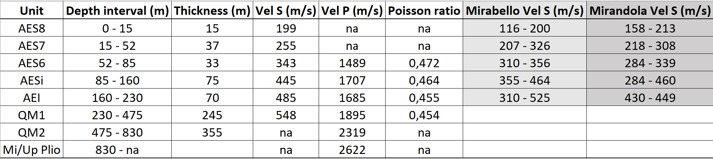

FIGURES
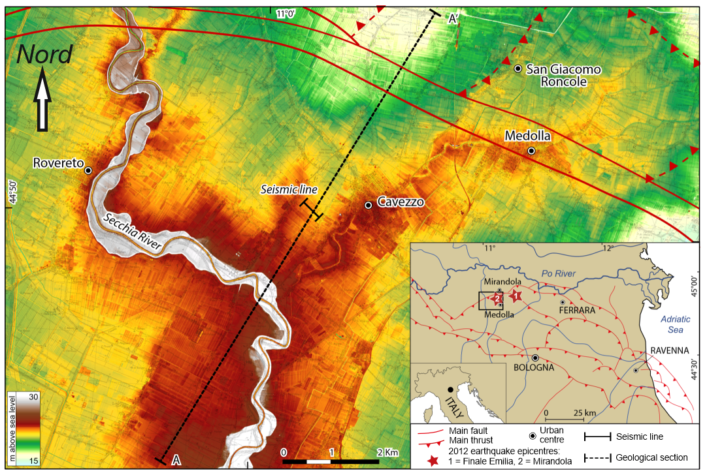
Figure 1. Geographical location of the study area.

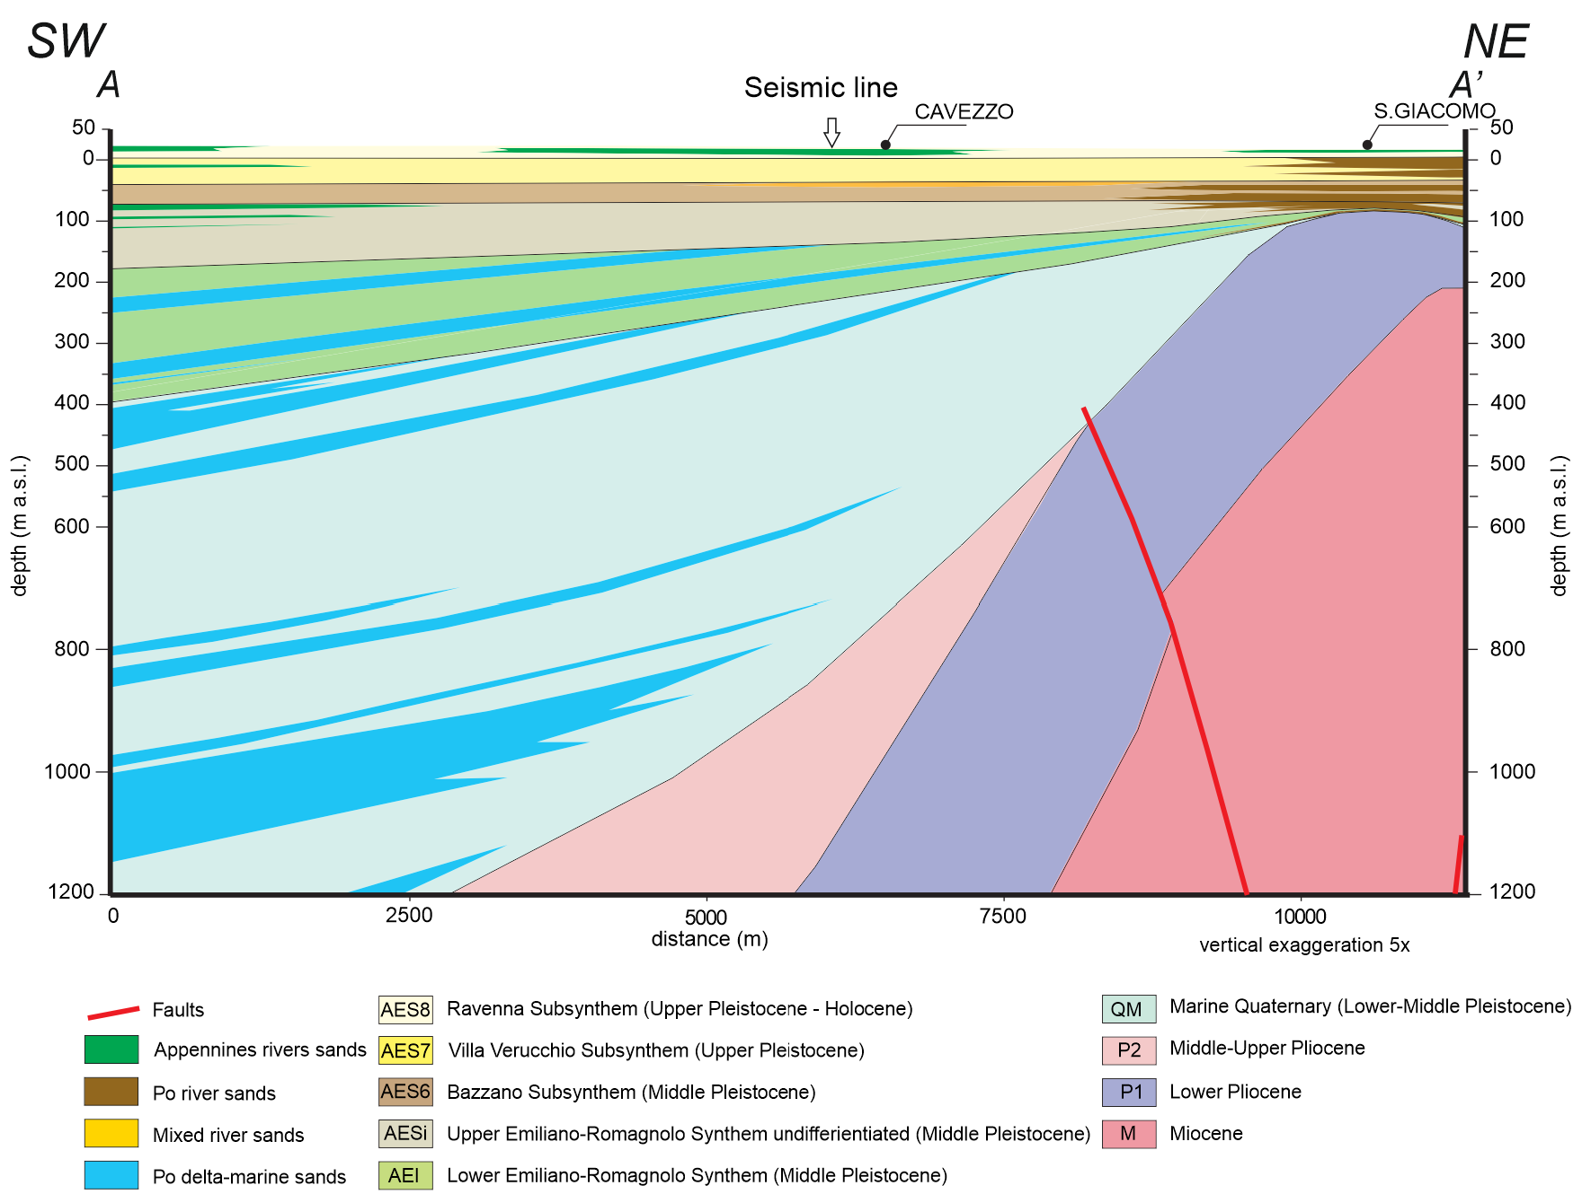
Figure 2. Geological section AA’ (modified from Martelli and Romani, 2013). See Fig.1 for the location.

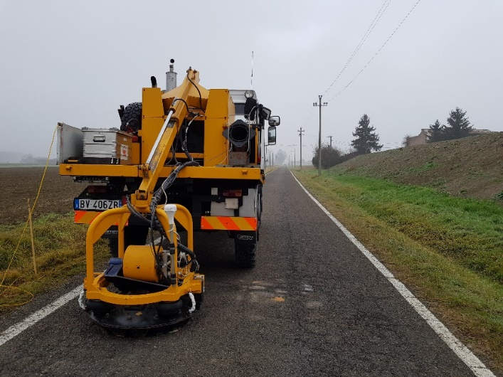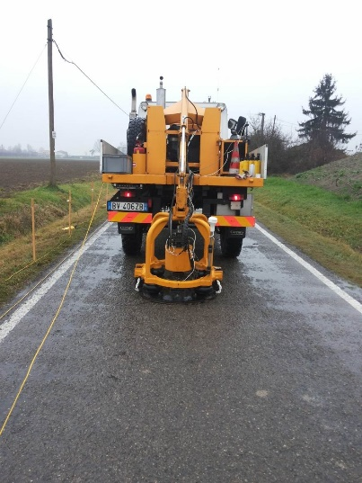
Figure 3. Minivib seismic source in SH- (a) and P-wave (b) mode during acquisition.

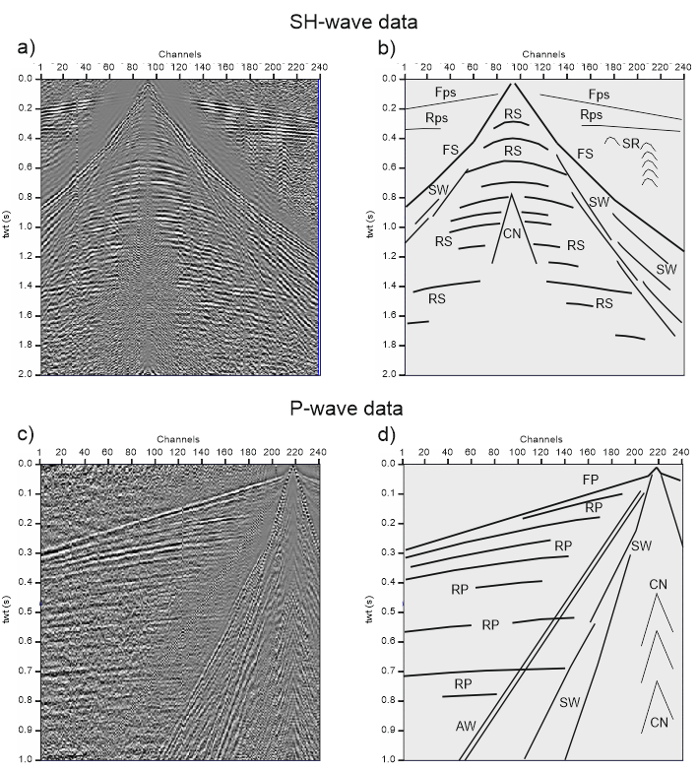
Figure 4. Two examples of SH- (a) and P-wave (c) data (bandpass filter and AGC) with wavefield interpretation (b) and (d). Fps = P- spurious first arrival, Rps = P- spurious reflection, RS = S-wave reflection, FS = S-wave first arrival, SW = surface wave, CN = correlation noise, FP = P-wave first arrival, RP = P-wave reflection, AW = air-wave

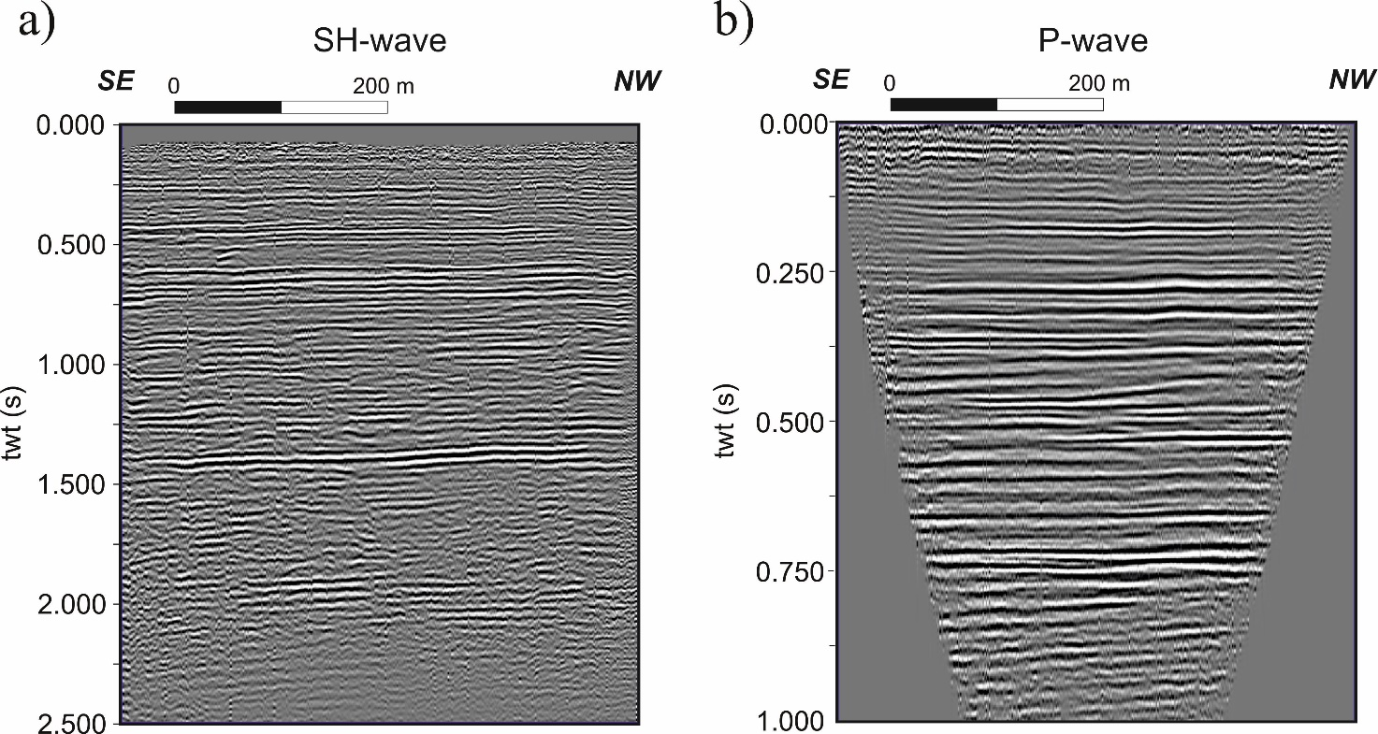
Figure 5. SH- and P-wave seismic sections.

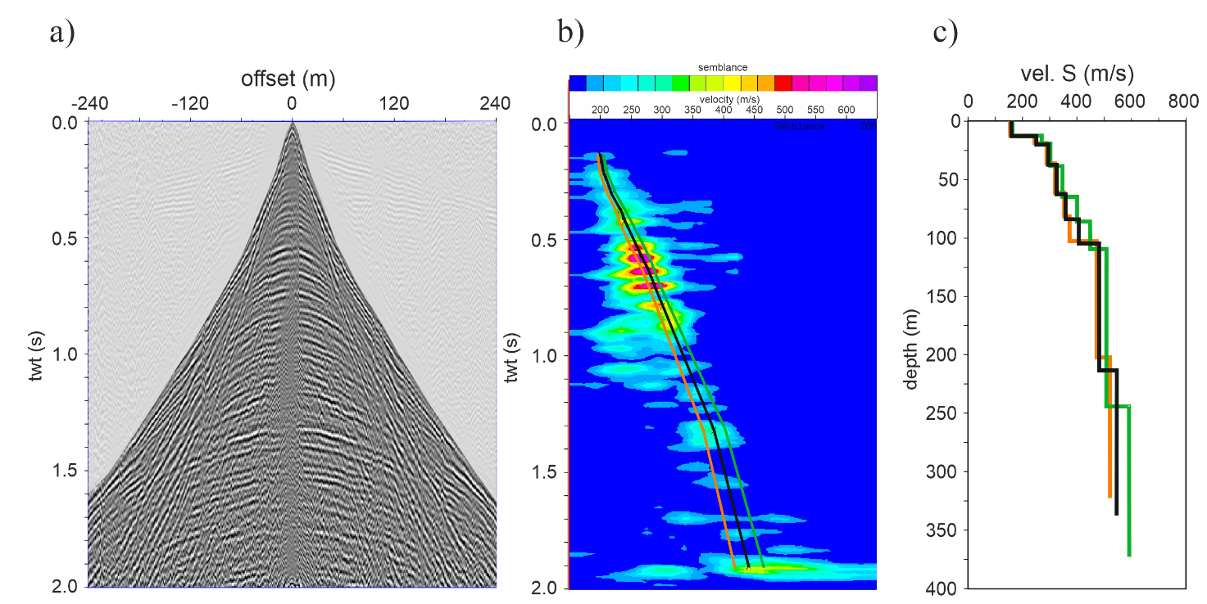

Figure 6. SH-wave data: velocity analysis. a) CMP super gather; b) semblance spectrum with the most-probable (black), under- (red) and over-estimated (green) velocity picking; c) interval velocities provided by the three velocity analysis.
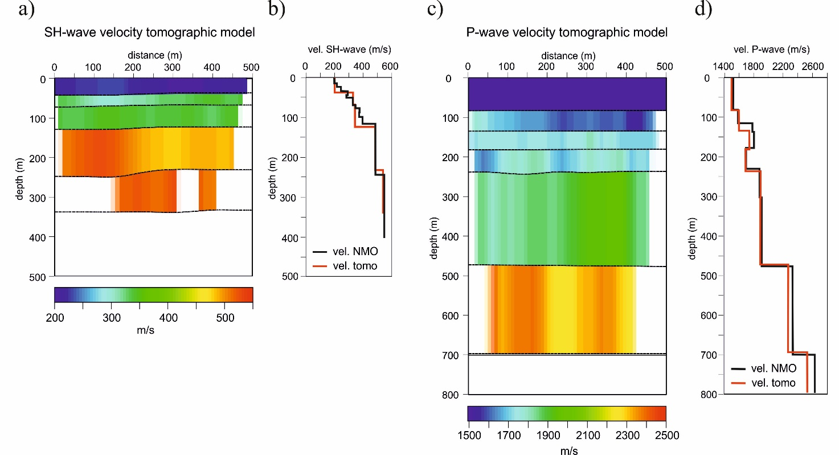
Figure 7. S- and P-wave velocity models. a) 2D S-wave velocity model from reflection tomography. b) S-wave velocity models comparison: NMO velocity analysis (black) and tomography inversion (red). c) 2D P-wave velocity model from reflection tomography. d) P-wave velocity models comparison: NMO velocity analysis (black) and tomography inversion (red).

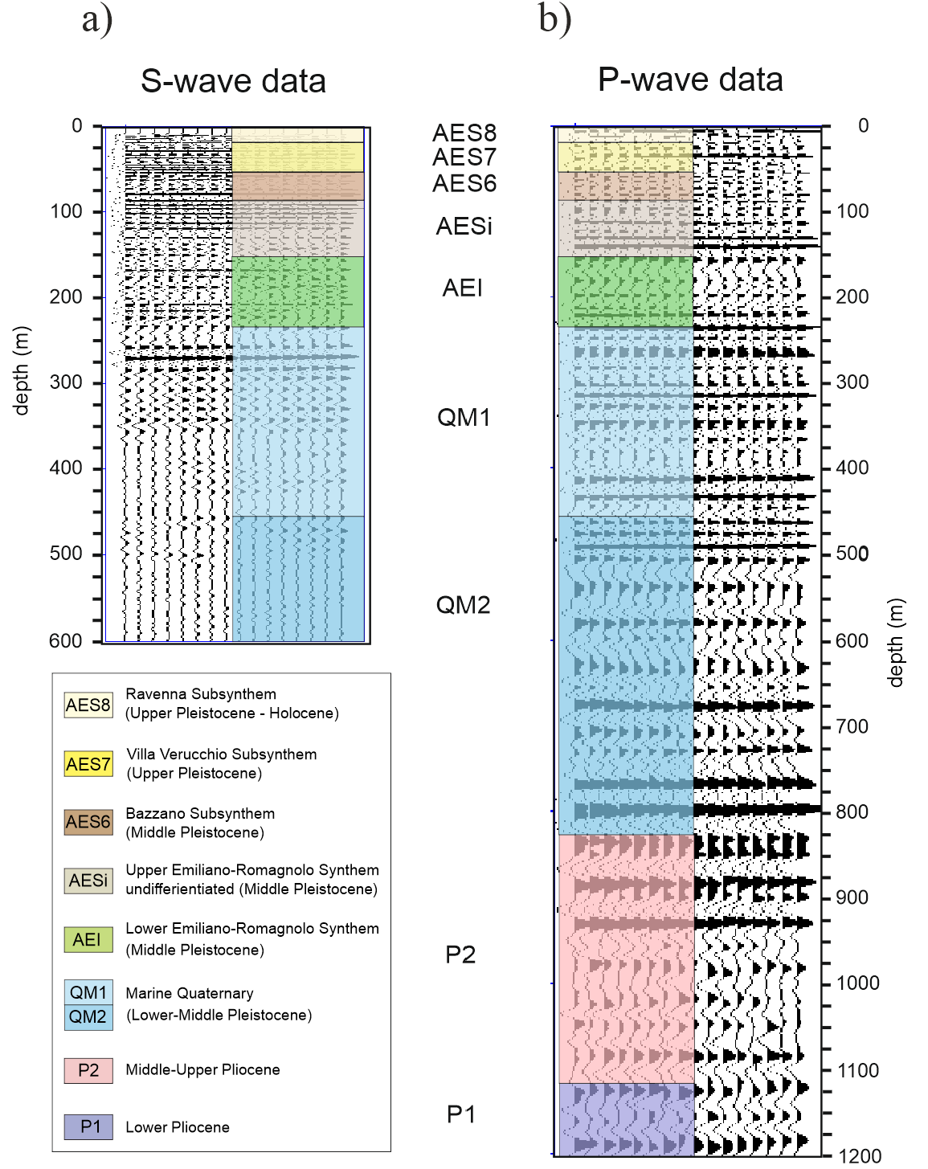

Figure 8. S- and P-wave data interpretation.

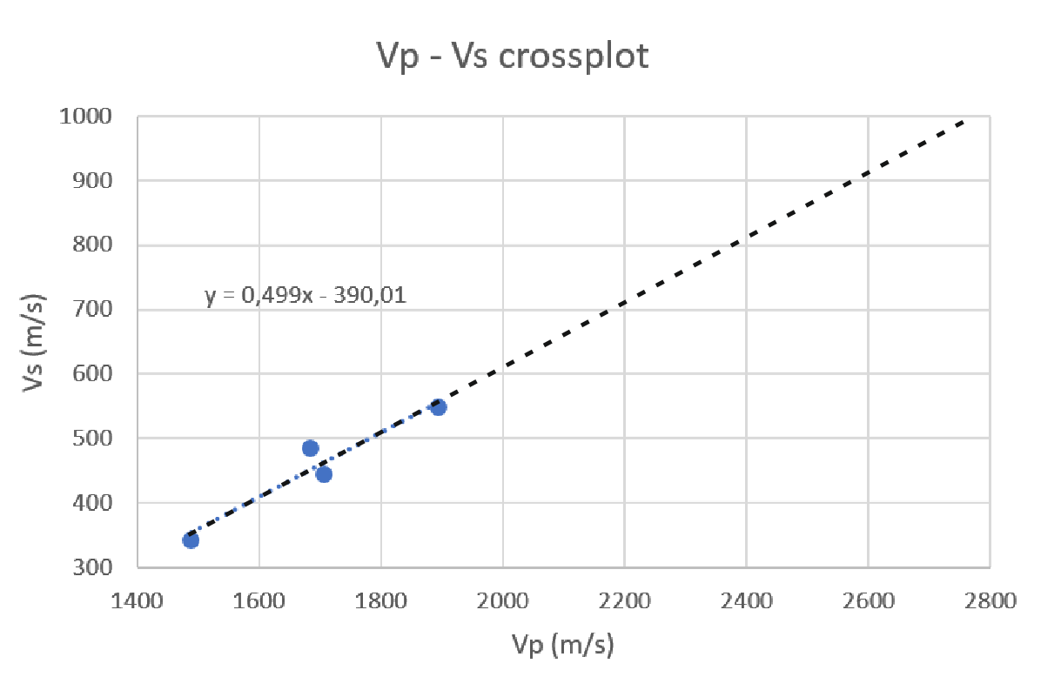

Figure 9. Vp - Vs crossplot.

Figure 10. Site amplification computed with different velocity models.

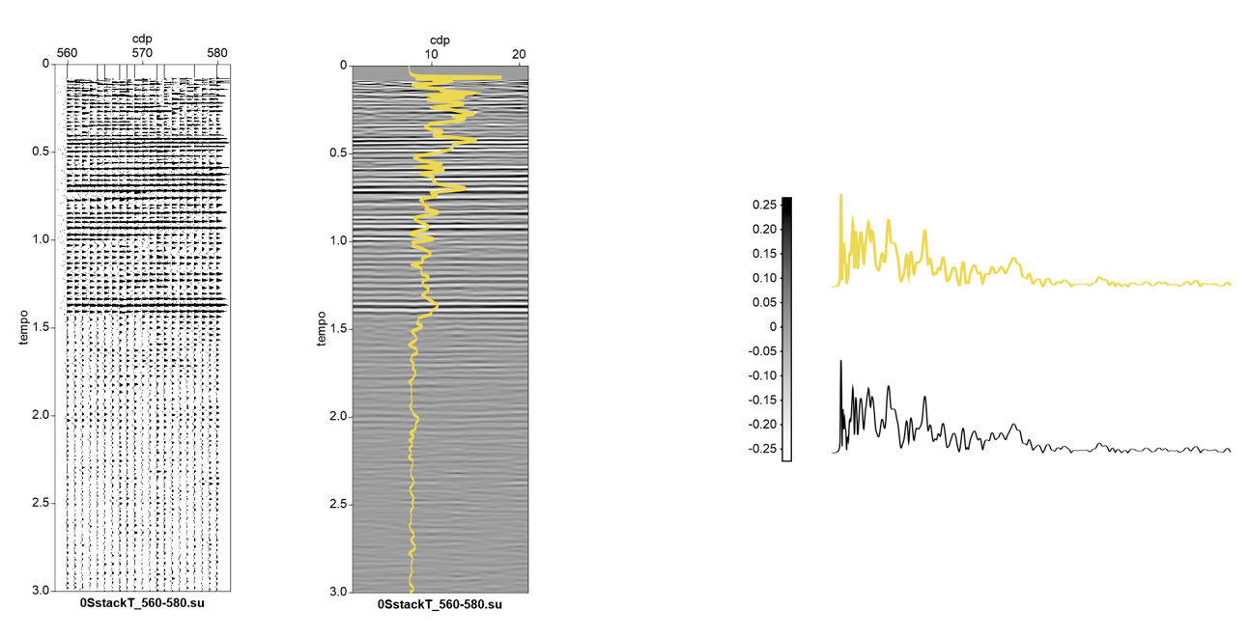
Figure 11. SH-wave data stack in wiggle mode (a) and variable area mode with the superposition of the envelope (b).

Figure 12. The envelope permits to detect the local maxima (a). The peaks are depth converted by S-wave seismic velocity function obtained by the reflection data processing (b) and compared with seismic-stratigraphy column (c), SH- (d) and P-wave (e) functions, respectively.
