TECTONOPHYSICS
Supporting Information for
Structure of the crust-uppermost mantle beneath the Ethiopian volcanic province using ambient seismic noise and teleseismic P wave coda autocorrelation

Sisay Alemayehu (1,2), Abdelkrim Aoudia (2), Atalay Ayele (1), Surya Pachhai (2,3), Hari Ram Thapa (2), C. J. Ebinger (4), Radia Kherchouche (2,5), Mariangela Guidarelli (6), and Seongryong Kim (7)

- Institute of Geophysics, Space Science and Astronomy, Addis Ababa University, Addis Ababa, Ethiopia.
- The Abdus Salam International Center for Theoretical Physics (ICTP), Trieste, Italy
- Department of Geology and Geophysics, University of Utah, Salt Lake City, UT, USA
- Department of Earth and Environmental Sciences, Tulane University, New Orleans, LA, USA
- Centre de Recherche en Astronomie, Astrophysique et Géophysique, BP. 63, Bouzaréah, 16340, Algiers, Algeria. (https://www.craag.dz)
- National Institute of Oceanography and Applied Geophysics (OGS), Trieste, Italy
- Department of Earth and Environmental Sciences, Korea University, Republic of Korea

Contents of this file

Figures S1 – S22
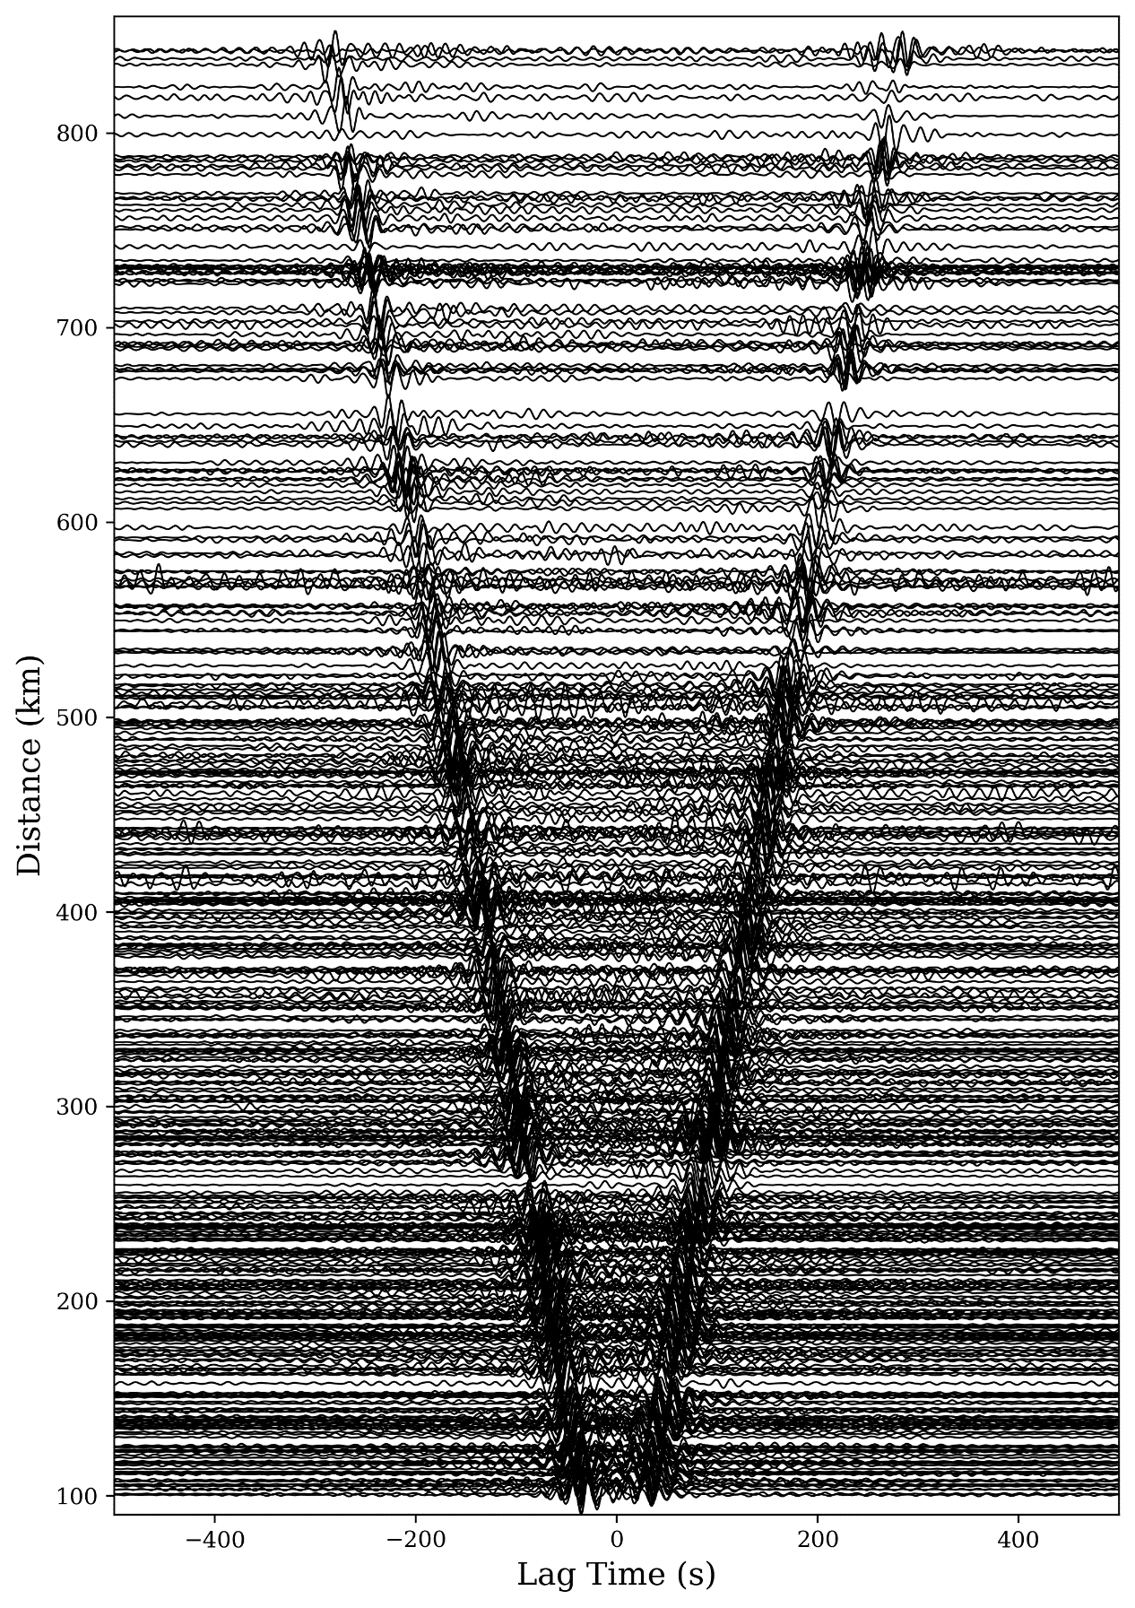
Figure S1. The cross-correlograms bandpass filtered between 10-50 s for all the interstation distances.

Figure S2. Sensitivity kernels for Rayleigh-wave (left) group and (right) phase velocity for different periods.

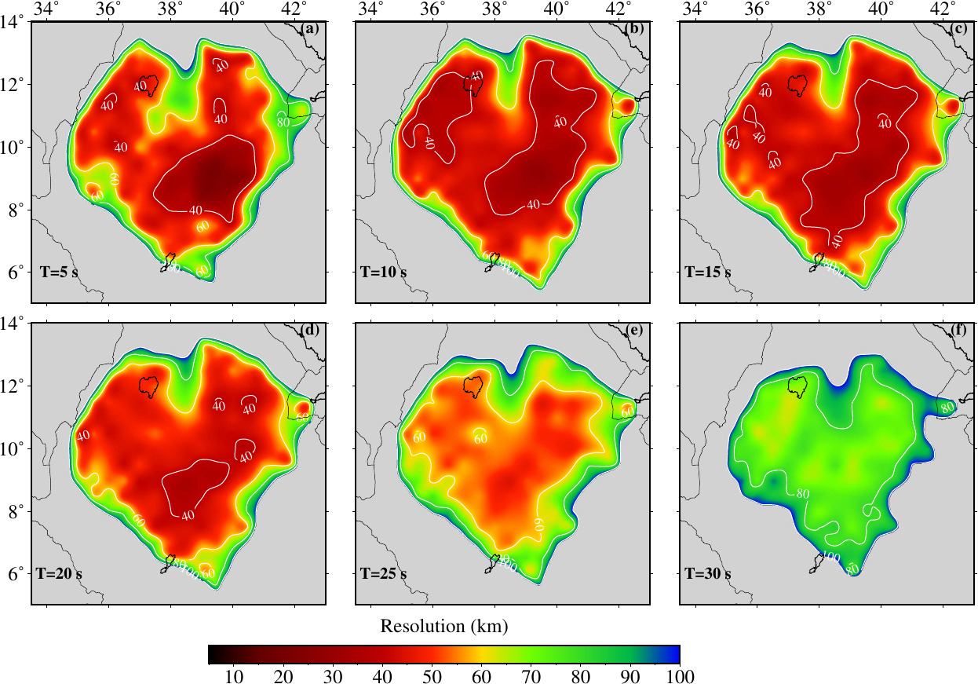

Figure S3. Spatial resolution estimates for group velocity at (a) 5, (b) 10, (c) 15, (d) 20, (e) 25, and (f) 30 seconds.
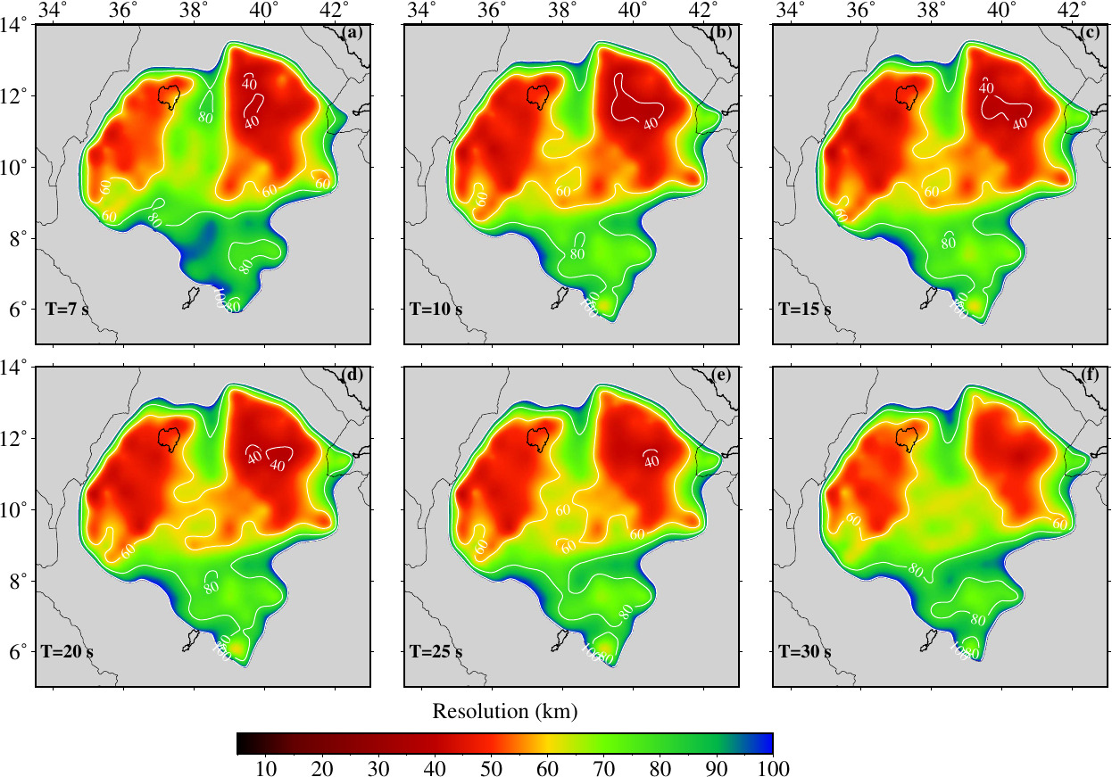
Figure S4. Spatial resolution estimates for phase velocity at (a) 7, (b) 10, (c) 15, (d) 20, (e) 25, and (f) 30 seconds.

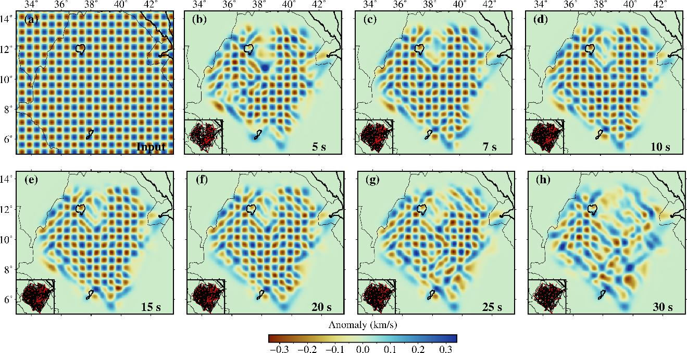

Figure S5: (a) Initial checkerboard of grid size of 0.25º × 0.25º (i.e., 0.50º × 0.50º anomaly size). (b-h) Recovered checkerboard test after inversion based on the ray-coverage at each period for group velocity. Periods are mentioned in the bottom right corner of each plot and ray-coverage at each period are presented at bottom left corner.

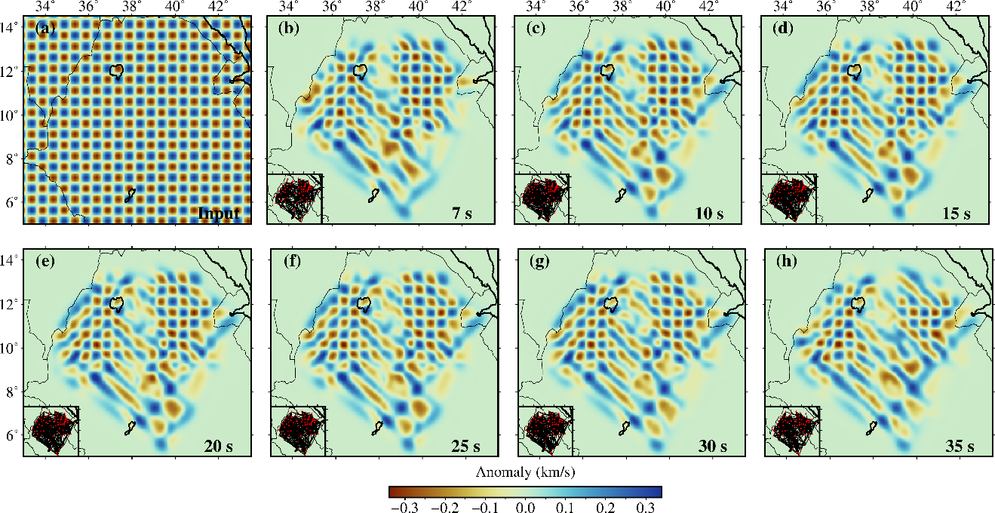

Figure S6: (a) Initial checkerboard of grid size of 0.25º × 0.25º (i.e., 0.50º × 0.50º anomaly size). (b-h) Recovered checkerboard test after inversion based on the ray-coverage at each period for phase velocity. Periods are mentioned in the bottom right corner of each plot and ray-coverage at each period are presented at bottom left corner.

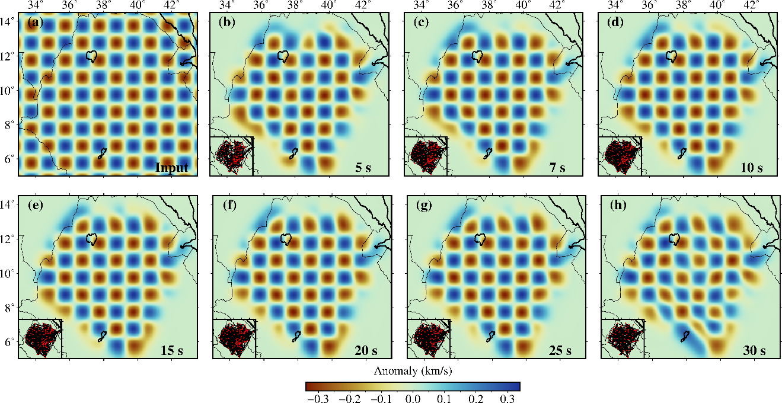
Figure S7: (a) Initial checkerboard of grid size of 0.50º × 0.50º (i.e., 1.0º × 1.0º anomaly size). (b-h) Recovered checkerboard test after inversion based on the ray-coverage at each period for group velocity. Periods are mentioned in the bottom right corner of each plot and ray-coverage at each period are presented at bottom left corner.

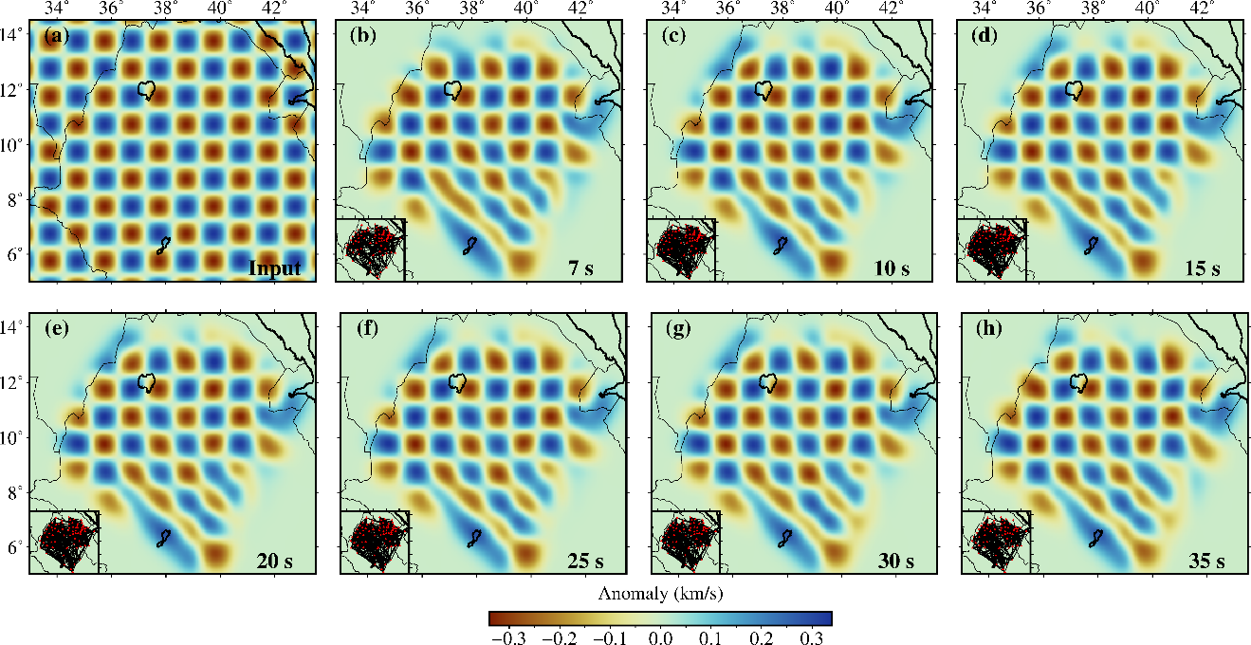

Figure S8: (a) Initial checkerboard of grid size of 0.50º × 0.50º (i.e., 1.0º × 1.0º anomaly size). (b-h) Recovered checkerboard test after inversion based on the ray-coverage at each period for phase velocity. Periods are mentioned in the bottom right corner of each plot and ray-coverage at each period are presented at bottom left corner.
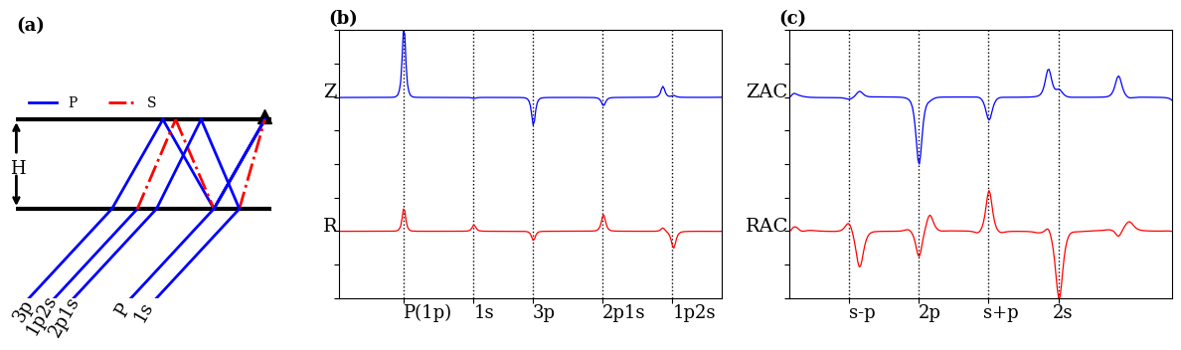
Figure S9. (a) Schematic diagram of various conversions and reverberations of P wave entering a 5 km thick (H) layer over half-space. The Vp (4.0 km/s) and Vs (2.0 km/s) are P-wave and S-wave velocities within that layer. The numbers before s and p represent the number of s and p rays, respectively, within the layer before it reaches the receiver. (b) Vertical (black line) and radial (red line) components of the impulsive response due to the structure within the layer shown in (a). (c) One-sided autocorrelation of vertical (black line) and radial (red line) components of the responses shown in (b) after removing the direct P.
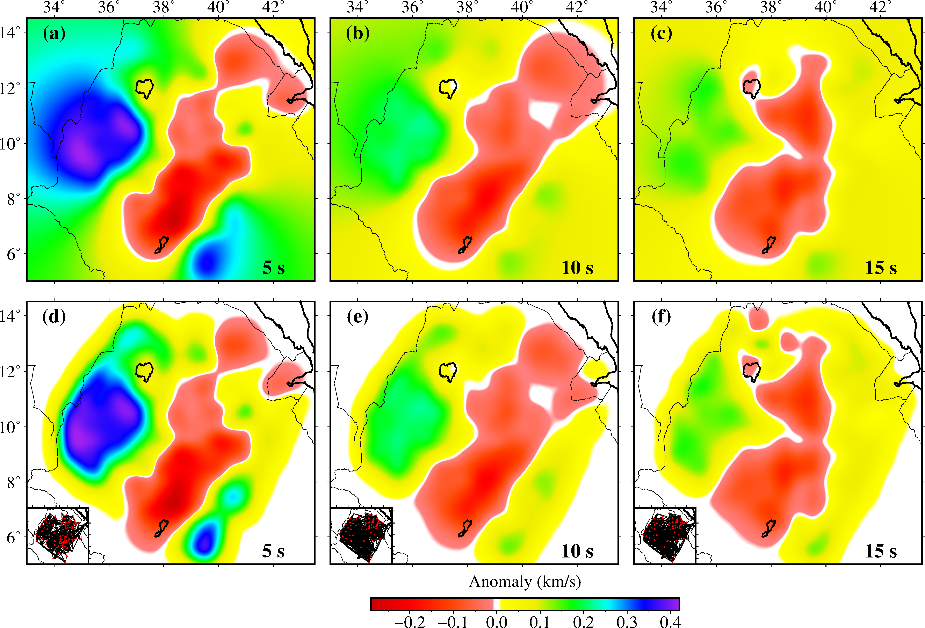
Figure S10: (a-c) Input model with high and low group velocity anomaly at period 5, 10, and 15 s across our study area. (d-f) Output model by inverting the travel time along each ray path at each period. The ray-coverage at each period is shown in bottom left of each plot.

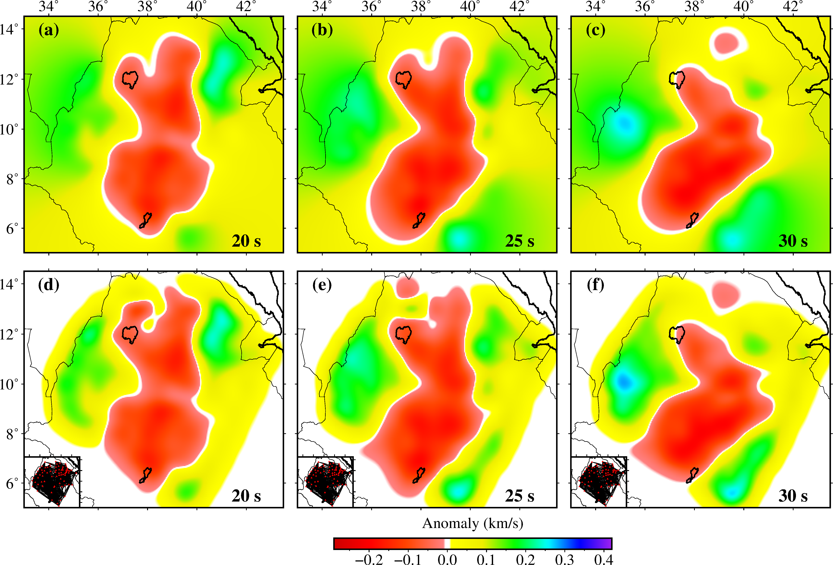

Figure S11: (a-c) Input model with high and low group velocity anomaly at period 20, 25, and 30 s across our study area. (d-f) Output model by inverting the travel time along each ray path at each period. The ray-coverage at each period is shown in bottom left of each plot.

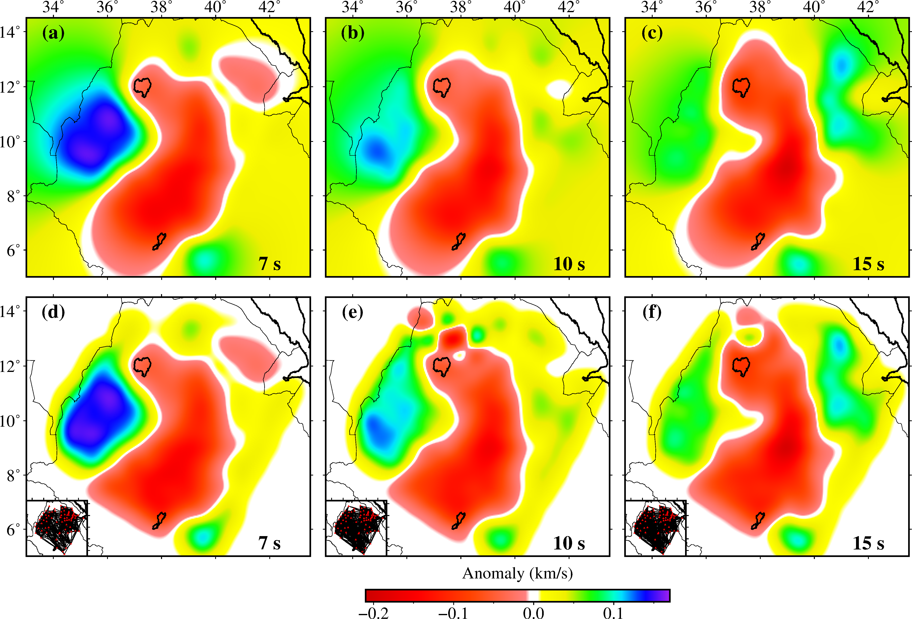
Figure S12: (a-c) Input model with high and low phase velocity anomaly at period 7, 10, and 15 s across our study area. (d-f) Output model by inverting the travel time along each ray path at each period. The ray-coverage at each period is shown in bottom left of each plot.
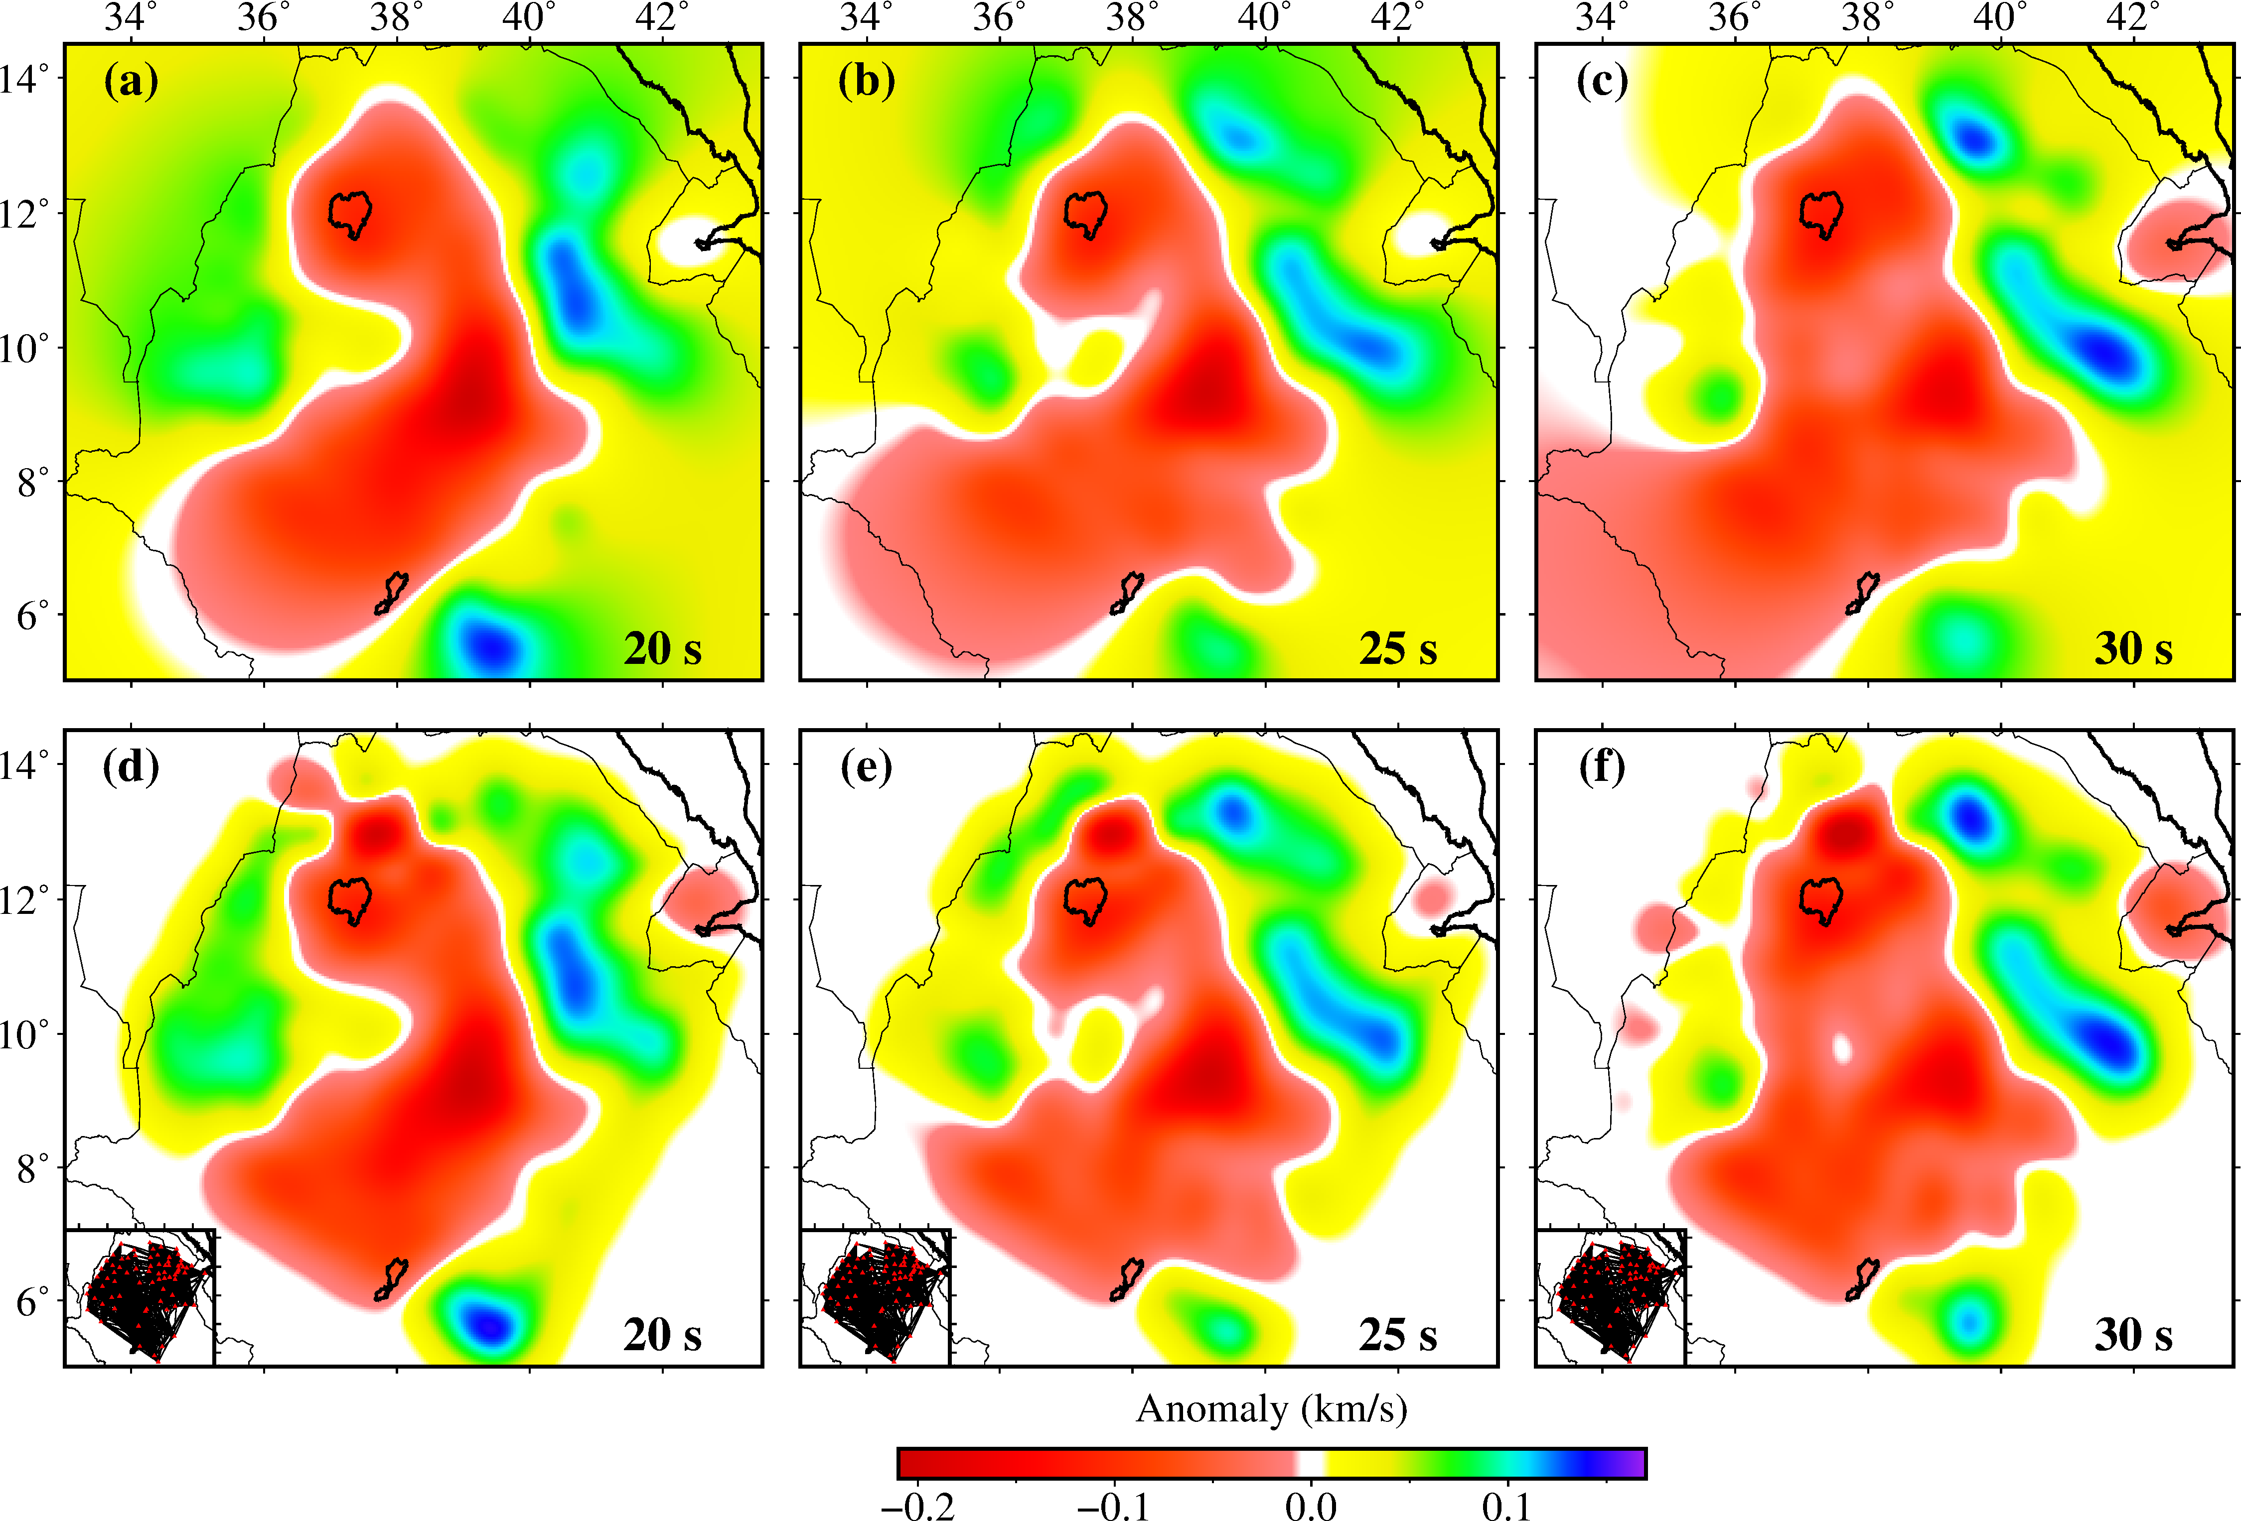

Figure S13: (a-c) Input model with high and low phase velocity anomaly at period 20, 25, and 30 s across our study area. (d-f) Output model by inverting the travel time along each ray path at each period. The ray-coverage at each period is shown in bottom left of each plot.

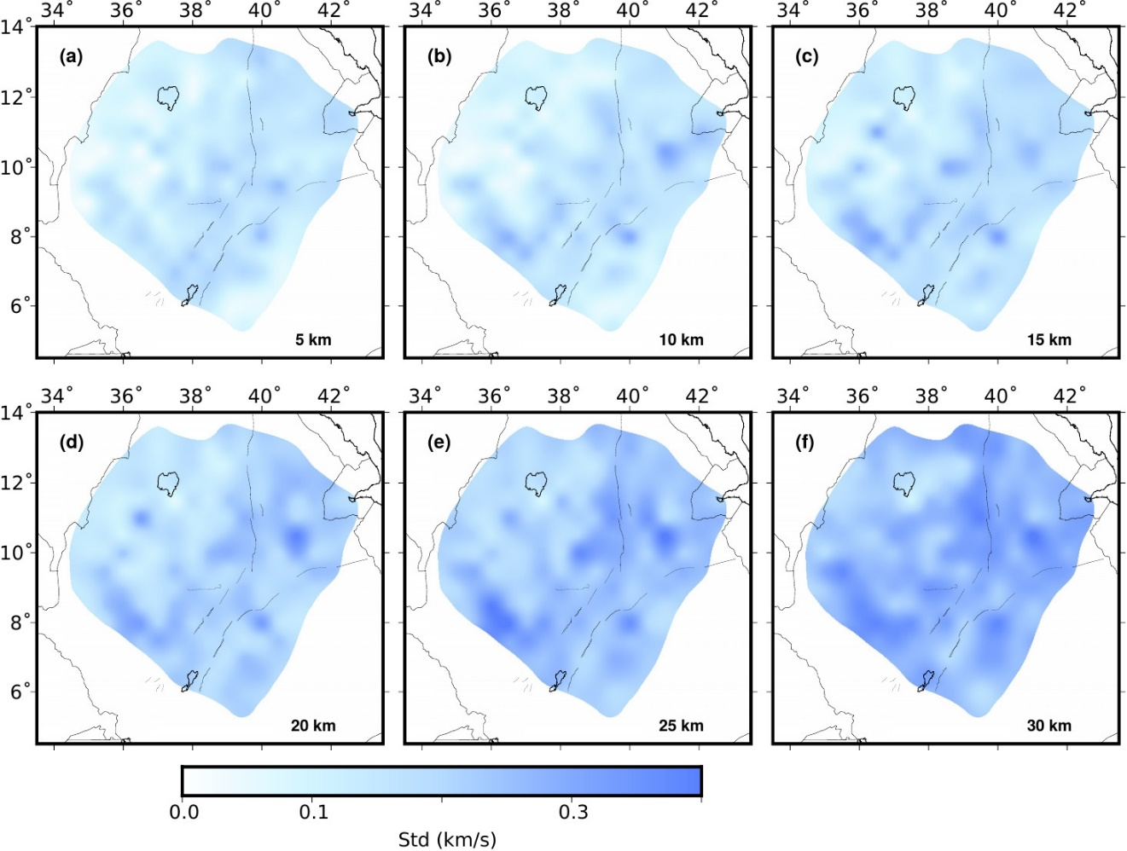

Figure S14. Horizontal slices of standard deviations (km/s) of the 3-D shear velocity model at (a) 5, (b) 10, (c) 15, (d) 20, (e) 25, and (f) 30 km depths.

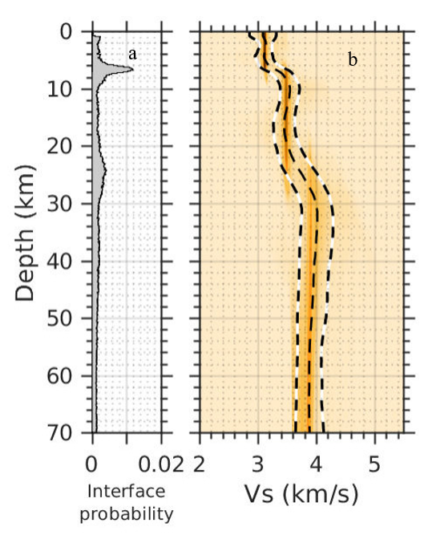
Figure S15. Posterior probability density of (a) discontinuities and (b) shear velocity as a function of depth, obtained from the trans-dimensional Bayesian inversion for grids 36°E, 11.5°N Ethiopian plateau from Fig. 1. The dashed white and black lines represent the velocity standard deviations from the average of ensemble model represented by black dashed line.

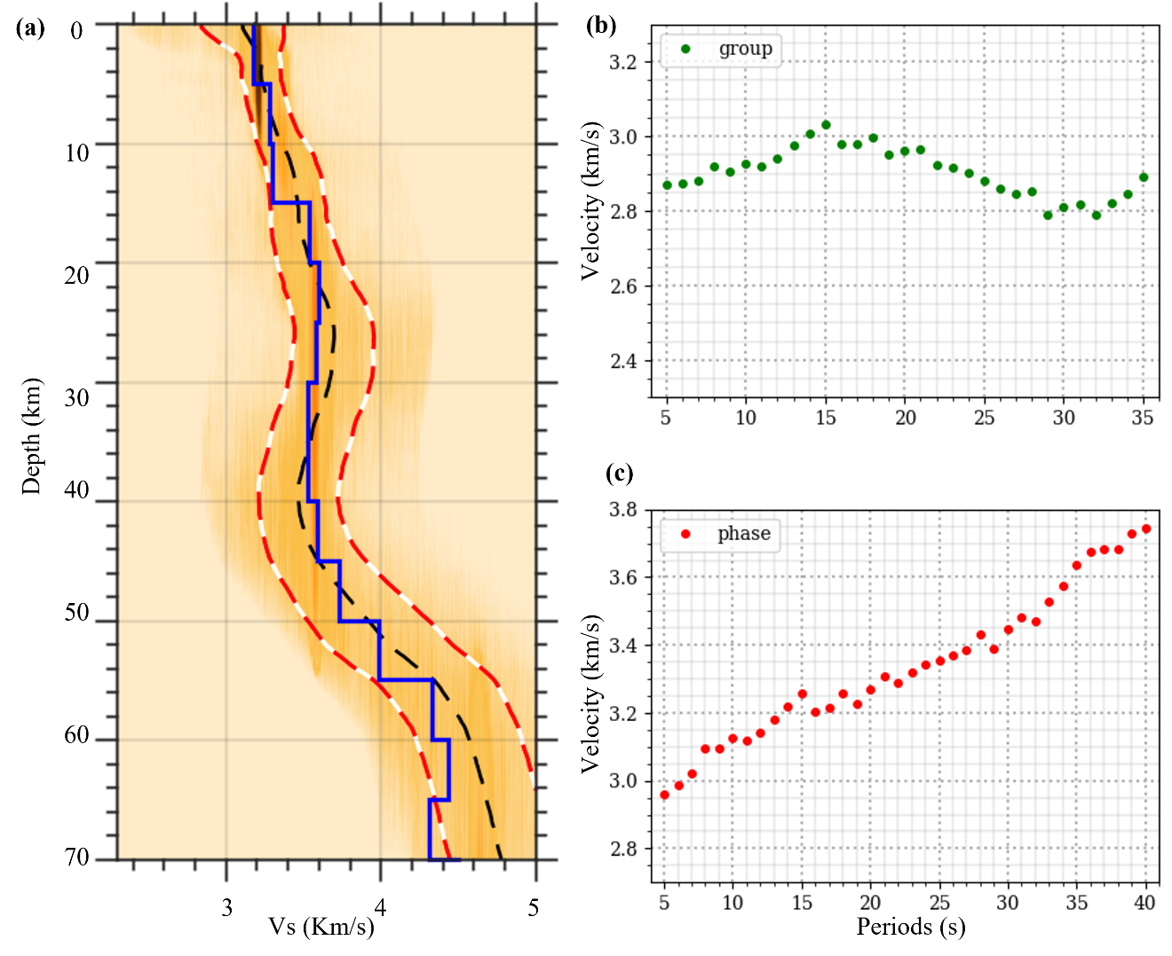

Figure S16: a) Posterior Probability Density (PPD) for the S-wave velocity as a function of depth. The black dashed line represents the velocity model obtained from the joint inversion of phase and group dispersion data and blue solid line represents true model. (b-c) Synthetic group and phase dispersion data corresponding to the velocity model, represented by the blue solid line in (a). The green and red solid circles are the group dispersion data and the phase dispersion data after adding 2 % of correlated noise to the synthetic dispersion data.
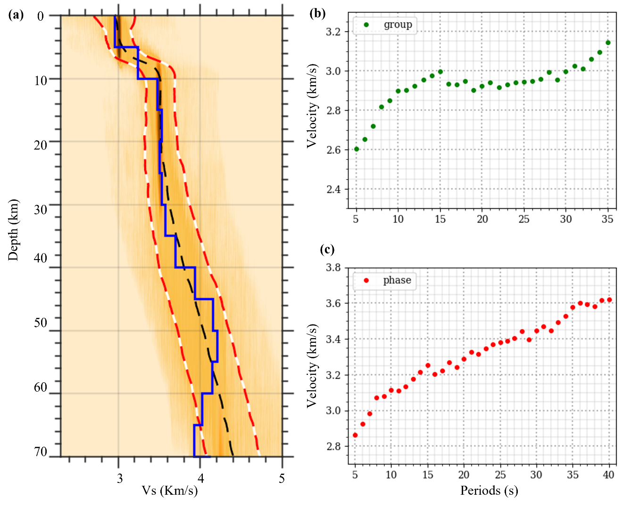
Figure S17: Same as Figure S9 with another true model (blue solid line in (a)).
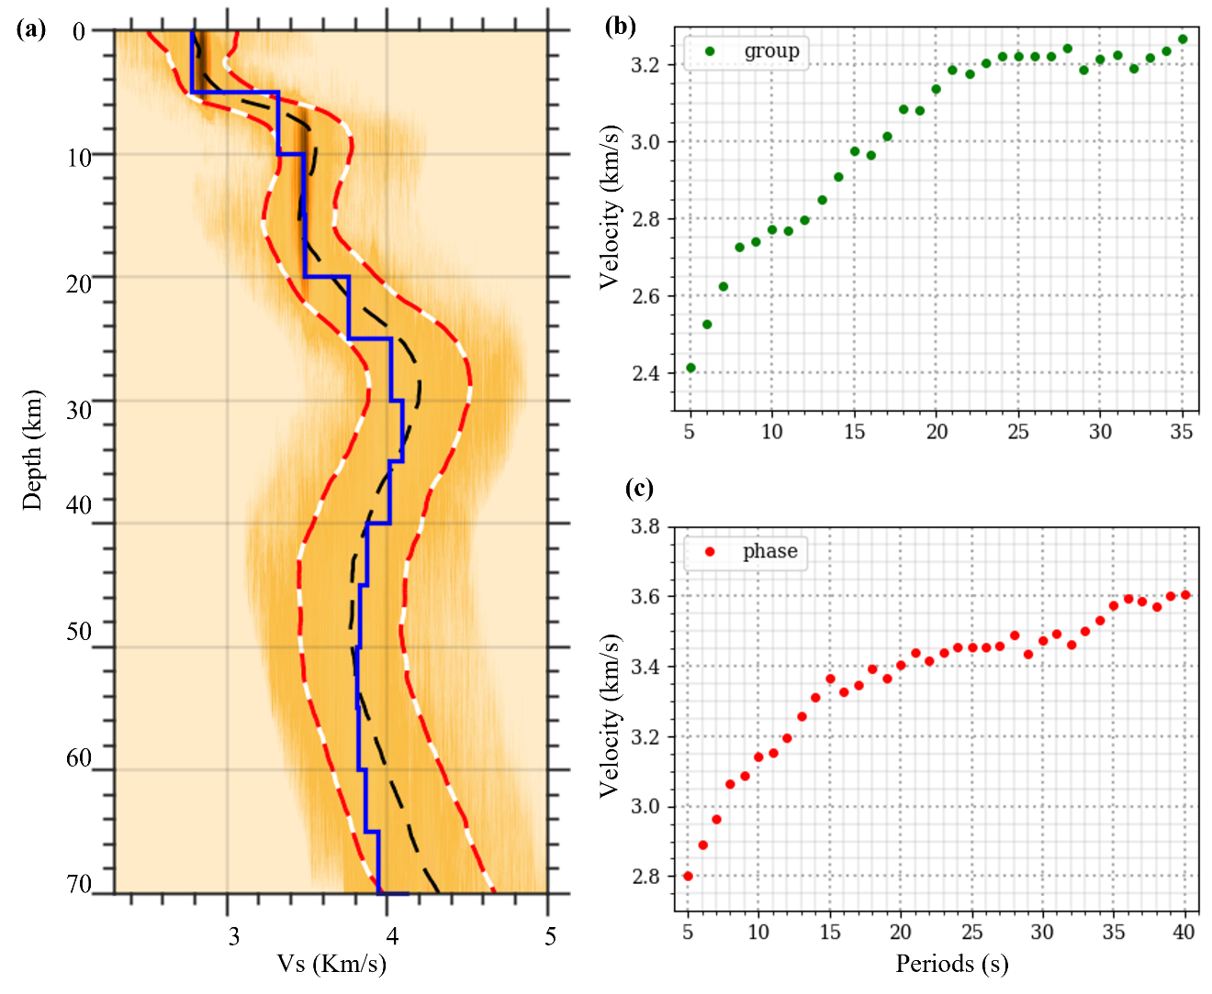
Figure S18: Same as Figure S9 with another true model (blue solid line in (a)).

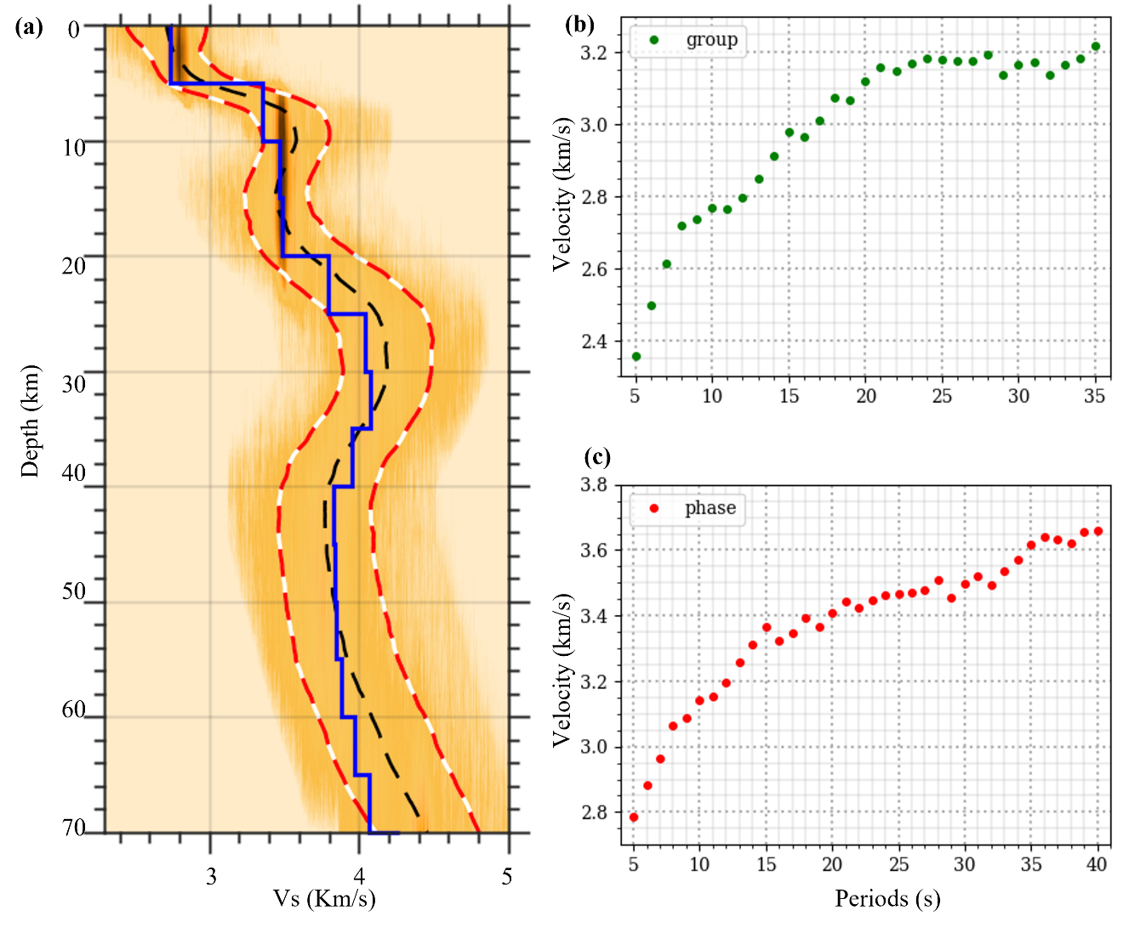
Figure S19: Same as Figure S9 with another true model (blue solid line in (a)).

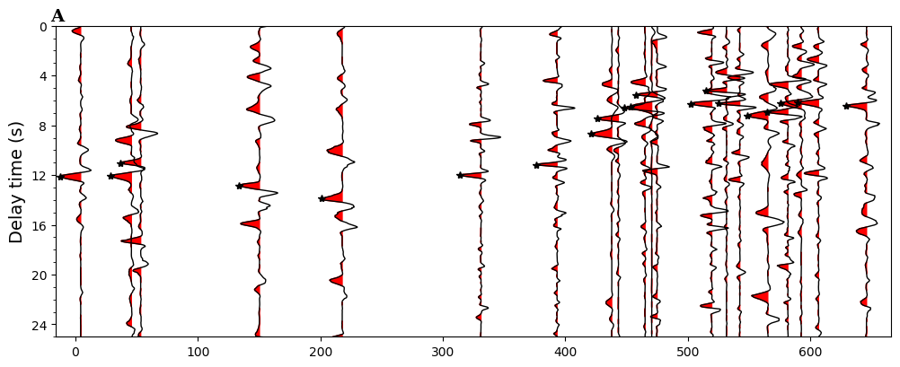
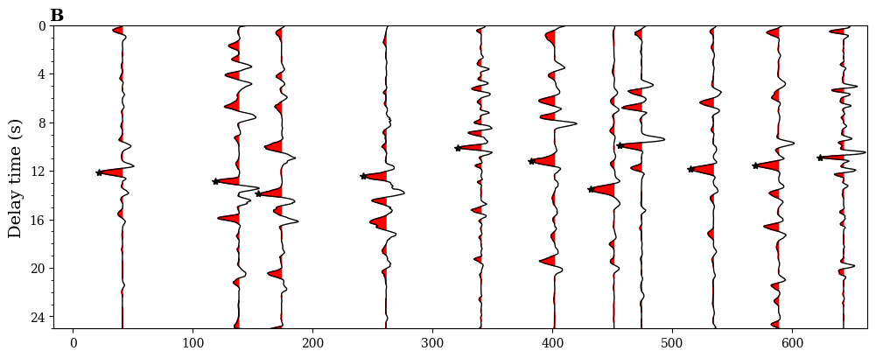
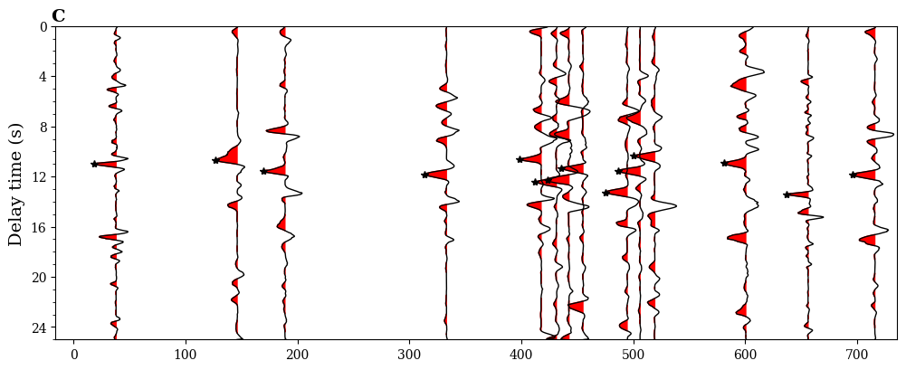
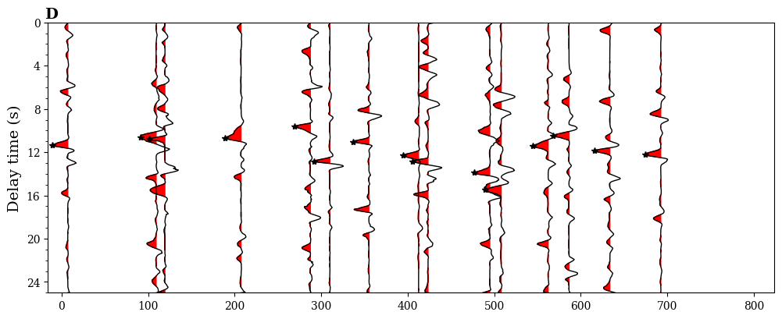
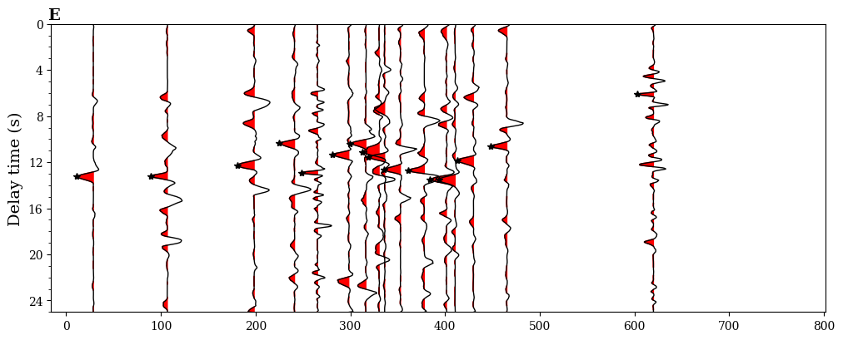
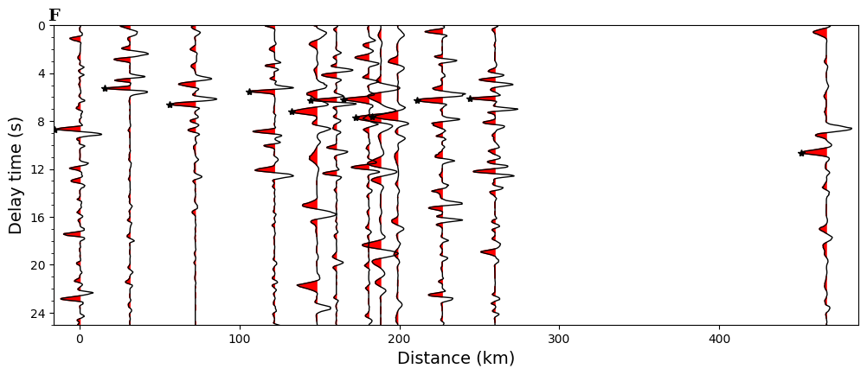Figure S20. Vertical stacked autocorrelation for different stations along profile A - F (Fig. 6) respectively. Black star shows the prominent phases in autocorrelogram which indicate the time picks of P reflections corresponding to Moho beneath each station.
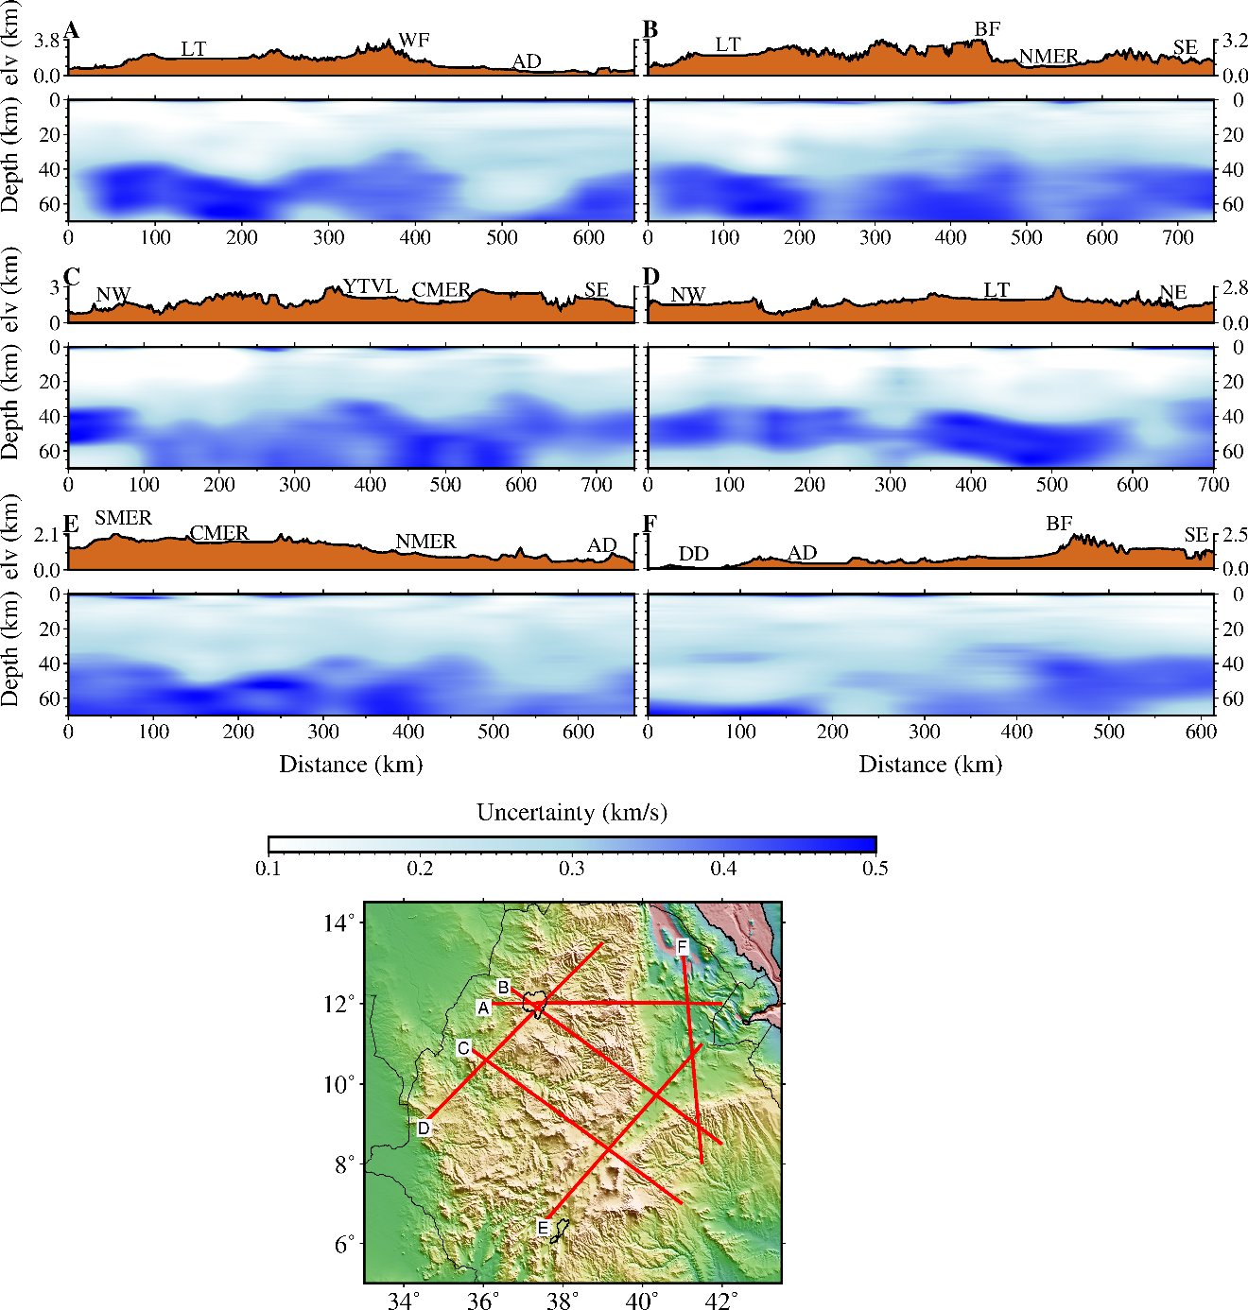

Figure S21. Vertical sections for the standard deviations of the 3-D S-wave velocity model, obtained from joint inversion of group and phase velocity dispersion data, along profiles shown in Fig. 6. WF: West Flank, LT: Lake Tana, AD: Afar Depression, DD: Danakil Depression, BF: Boarder Fault, NMER, SMER and CMER: Northern Southern and Central Main Ethiopian Rift, NW, SE and SW: Northwestern, South Eastern and Western Ethiopian plateau respectively. YTVL: Yerer-Tullu Wellel volcano tectonic lineament.

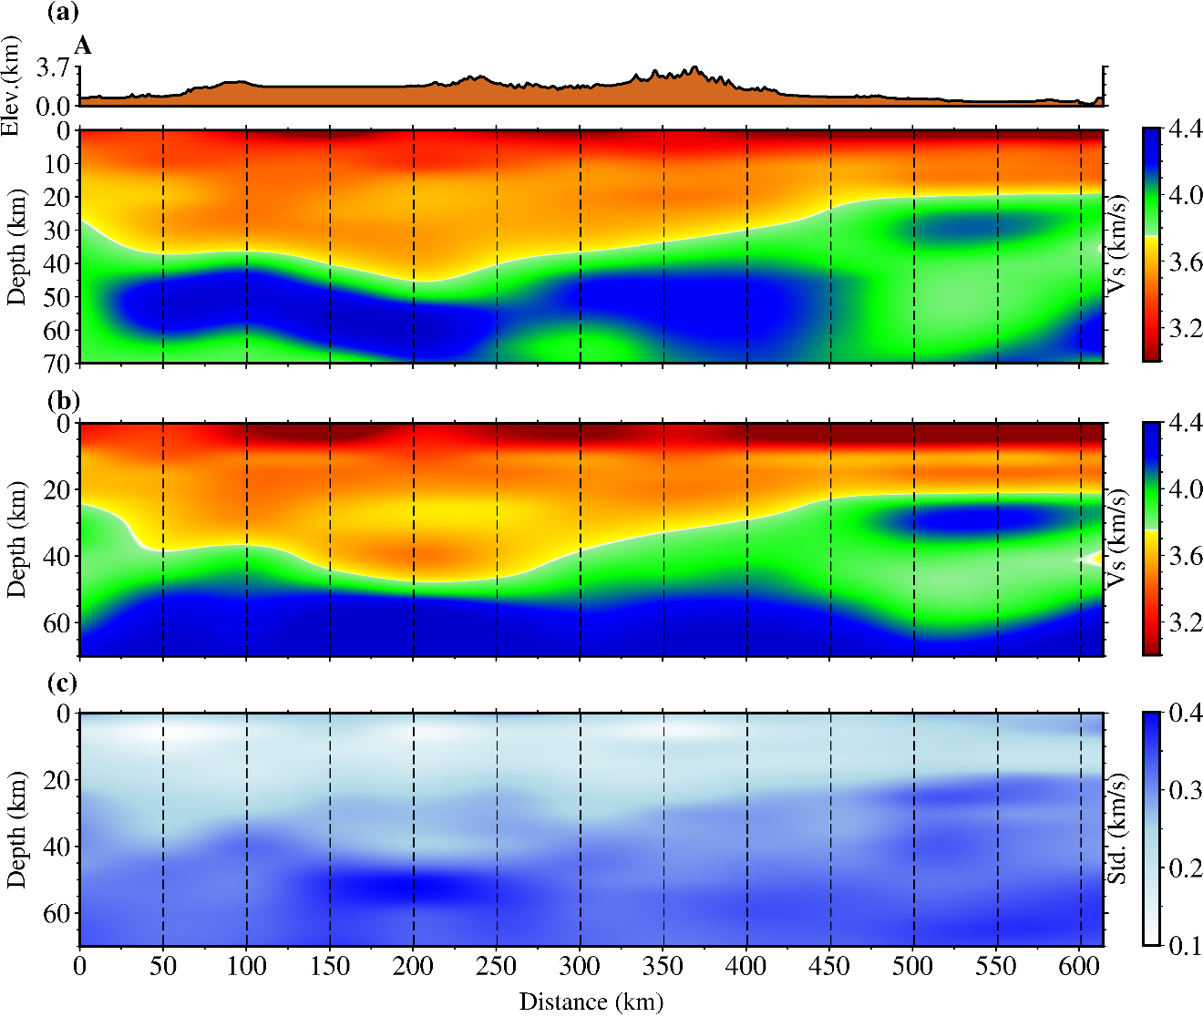
Figure S22. (a) The velocity model (profile A from our inversion), used to generate the synthetic group and phase velocity dispersion curves. (b) The velocity model retrieved applying the transdimensional Bayesian inversion of the (noise added) dispersion curves prepared in (a). (c) The uncertainty estimated from the ensemble of models. The vertical dashed lines represent the specific location where we extracted the velocity model where synthetic phase and group dispersion curves were computed based.

