Climate change impact on flood hazard over Italy

- Matilde García-Valdecasas Ojeda1,2,3, Fabio Di Sante1,2, Erika Coppola1,Adriano Fantini1, Rita Nogherotto1,2,
- Francesca Raffaele1, and Filippo Giorgi1

- 1 Earth System Physics Section, International Centre for Theoretical Physics (ICTP), Trieste, Italy
- 2 Istituto Nazionale di Oceanografia e di Geofisica Sperimentale (OGS), Sgonico, Italy
- 3Departamento de Física Aplicada, Universidad de Granada, Granada, Spain

ABSTRACT

- This study assesses future projections of flood hazards across the Italian rivers’ basins. For this purpose,

- sub-daily river discharge for the entire Italian territory was simulated with the CETEMPS hydrological

- model (CHyM) using as climate forcing both observational datasets and regional climate simulations

- completed with the ICTP Regional Climate Model (RegCM4). First, simulated precipitation and river

- discharge were evaluated against observational products, showing for both models a goodperformance

- in simulating Italian precipitation and discharge characteristics. Then, projections of these variables

- were explored for two time slices, near (2020-2049) and far (2070-2099) future, under the RCP8.5

- emission scenario, with RegCM4 driven by output from a global climate model projection. The RegCM4

- outputs were also bias-adjusted by means of the N-dimension multivariate bias correction (MBCn)

- method. We found that, although the bias-correction has an impact on the mean precipitation bias, the

- improvement is less clear on extreme precipitation although it is noticeable for average yearly peak flow

- and the hourly peak flow at return periods of 10, 50, and 100 years. Nevertheless, projected changes in

- extreme hydrological variables do not show significant differences when bias correction is applied.

- Under the RCP8.5 scenario, an increase of yearly peak flow is evident in most of the Italian peninsula,

- with values from 30% to more than 100% for the mid and far time slices respectively, especially over

- the Po River and along the eastern coasts of Italy. Similar conclusions are found for the hourly peak

- flows of 10, 50, and 100 years of return periods. These indicators thus suggest a general increase of

- flood hazard expected over the region.

- Keywords: CHyM model, RegCM4 model, climate change, floods, extreme river discharge.

1. Introduction

- Flood is one of the most devastating natural disasters, leading to severe impacts on

- society and ecosystems. According to the Centre for Research on the Epidemiology of Disasters

- (CRED), only in 2020, over 33 billion people worldwide were affected by floods, and 6171

- people died. In Europe, in particular, floods have caused economic losses of around €271 billion

- from 2000 to 2019 (CRED, 2021). Flood hazard estimation is, therefore, an essential tool for

- developing reliable strategies to protect the population from flood-related damages.

- In recent decades, many studies have focused on the assessment of the impacts of climate

- change on precipitation. From these studies, one can conclude that there is a relatively robust

- agreement that extreme precipitation is mostly projected to increase, both in frequency and

- intensity, under global warming conditions (e.g., Christensen and Christensen, 2007; Coppola

- et al., 2020; Nikulin et al., 2011; Pendergrass and Hartmann, 2014). Nevertheless, how changes

- in atmospheric variables will affect river discharge is still under investigation, particularly when

- focusing on extreme events at regional scales (Andersen and Marshall Shepherd, 2013).

- Flooding is expected to be strongly affected by changes in climatic patterns, as an increase in

- extreme precipitation is likely to lead to enhanced flood-generating processes (Whitfield, 2012).

- However, the link between extreme precipitation and the occurrence of flood events is not

- necessarily linear, in that flood occurrence also depends on complex relationships between

- snow accumulation and melting, underground water flow, and local channel characteristics. For

- this reason, the assessment of the interplay between the spatiotemporal patterns of the changes

- in precipitation and discharge is a research topic of great interest.

- Assessments of the future flood hazard over large basins are commonly performed by

- coupling global climate models (GCMs) with land-surface schemes and hydrological models

- (e.g., Alkama et al., 2013; Arnell and Gosling, 2016; Dankers et al., 2014; Prudhomme et al.,

- 2003; Sperna Weiland et al., 2012). The low resolution of GCMs, however, prevents similar

- assessments for small regional scale river basins for which an increased resolution is required

- (Huang et al., 2019), especially for capturing extreme events such as floods. In this regard,

- regional climate models (RCMs) have become increasingly popular because they can describe

- regional climates by considering sub GCM-grid scale forcings (e.g., local topography,

- coastlines, or land cover distribution) and dynamical processes occurring at high spatial

- resolution of roughly 10-50 km (Giorgi, 2019).

- The increase in temporal resolution is also especially important for correctly representing

- the occurrence of flood peaks in small catchments (Zhu et al., 2018). This is because small

- catchments are more sensitive to the occurrence of short-duration storms as they have a limited

- capacity to displace large volumes of water falling in a relativelyshort period. Authors such as

- Yang et al. (2016) studied the impact of the temporal resolution of climate data as input to

- hydrological models and found that hydrological simulations driven by sub-daily climate

- variables can capture much better the peak flow values compared to models driven by daily

- climate input. Several studies that were using regional climate model to drive hydrological

- models for the European continent (e.g., Alfieri et al., 2018, 2015; Dankers and Feyen, 2009;

- Di Sante et al., 2021; Feyen et al., 2012; Prudhomme et al., 2003) generally find increasing

- flood hazards mostly in central Europe basins, especially in terms of higher frequency more

- than of higher magnitude (Alfieri et al., 2015). An opposite flood response to climate change

- signal is observed over Europe if the flood magnitude is considered. Over the Northeast region

- the snow melting is the main driver of major floods and the decrease of snow accumulation

- during the snow season leads to a decrease of floods magnitude. This is observed, in particular,

- for the large river catchments. On the opposite, over the Central European region, the small

- river catchments would be more affected by an increase of magnitude that would be probably

- linked to an increase of extreme convective precipitation events over the area (Di Sante et al.,

93 2021; Vautard et al., 2019).

  - Since climate models are often affected by systematic model biases, bias correction is

  - considered as a crucial step in using model output for impact studies (e.g., Casanueva et al.,

  - 2016; Christensen et al., 2008; Piani et al., 2010). However, this method is not free of

  - controversy, in particular when dealing with extreme values correction. In this regard, authors

  - such as Ehret et al. (2012) pointed out that bias correction must be performed with caution since

  - it introduces new sources of uncertainty that occasionally can become large. Climate change

  - impact assessments, therefore, should be performed considering both raw and bias-corrected

  - climate model data.

  - A large number of bias correction approaches have been proposed in recent years (e.g.,

  - Boé et al., 2007; Cannon, 2018; Cannon et al., 2015; Gómez-Navarro et al., 2018; Kim et al.,

  - 2021; Piani et al., 2010). Several authors investigated the ability of these procedures to correct

  - different climate variables using a wide range of evaluation methods (Argüeso et al., 2013;

  - Fang et al., 2015; Gudmundsson et al., 2012; Gutjahr and Heinemann, 2013; Lafon et al., 2013;

  - Maraun, 2016; Themeßl et al., 2012, 2011). However, most studies focus on analyzing climate

  - data at the daily scale, and therefore how the correction modifies sub-daily simulated values

  - and the resulting effect on sub-daily discharge remains not well understood.

  - Despite the fact that the Italian region is frequently affected by severe inundation events,

  - scientific studies concerning flood hazard estimation over this region are few. Moreover, most

  - of these studies focus on limited areas or small basins (Di Salvo et al., 2017; Marchesini et

  - al., 2016; Morelli et al., 2014; Sole et al., 2008), specific past events (Amadio et al., 2013;

  - Marchi et al., 2010; Masoero et al., 2013; Norbiato et al., 2007; Santo et al., 2012), or target

  - flood risk rather than hazard (Albano et al., 2017; Dottori et al., 2016; Salvati et al., 2010).

  - Therefore, in this study we aim to assess the current state and future evolution of flood

  - hazards throughout the entire Italian territory. Towards this goal, river discharge for the Italian

  - territory was simulated using the CETEMPS hydrological model (CHyM) (Coppola et al.,

  - 2007) by feeding it with climate data from both high-resolution observational datasets and

  - two RCM simulations. Specifically, we use output from the ICTP Regional Climate Model

  - (RegCM4, Giorgi et al., 2012) at 12 km spatial resolution to resolve the spatial and temporal

  - climate detail within the river catchments analyzed (Gosling et al., 2011; Whitfield, 2012).

  - Furthermore, we investigate the impact of using bias-corrected climate outputs at a sub-daily

  - temporal scale for both present and future conditions under an increased greenhouse gas

  - concentration scenario.

  - The work is structured as follows: In Section 2, we describe the data and methods used;

  - Section 3 presents the results obtained; and Section 4 discusses and highlights the main

  - findings of this work.

2. Data and Methods

  - 2.1 Observations

  - Precipitation is the main atmospheric component that controls the hydrological response

  - in catchments, playing a critical role in hydrological simulations (Chiew et al., 2009; Ly et al.,

  - 2013; Obled et al., 1994). However, it is also one of the most challenging variables to

  - characterize due to its high spatiotemporal variability. Hence, using different precipitation

  - products is highly recommended when evaluating climate models, particularly at the regional

  - scale (Prein and Gobiet, 2017).

  - Table 1 lists the observational precipitation gridded products we have used to evaluate

  - RegCM4. The Alpine precipitation dataset (EURO4M-APGD) (Isotta et al., 2014) and the

  - Northern-Central Italy daily precipitation dataset (ARCIS) (Pavan et al., 2019) are high-

  - resolution, high quality, station-based gridded products developed from dense observational

  - networks over the Alps and north-central Italian regions, respectively. E-OBS (Haylock et al.,

  - 2008) is a set of European-wide observational products that have been widely applied for model

  - evaluation purposes. In this study, the ensemble version 20e is used (Cornes et al., 2018). We

  - also consider the HIRLAM-MESAN Reanalysis (HMR) (Landelius et al., 2016), a European

  - regional reanalysis based on downscaling and data assimilation techniques. Finally, the recently

  - developed high-resolution GRidded Italian Precipitation Hourly Observations (GRIPHO)

  - dataset (Fantini, 2019; Fantini et al., 2022) is used to feed CHyM and to bias-correct the

  - simulated precipitation values.

  - To evaluate the hydrological model, observational datasets of river discharge from two

  - sources were collected (Table 2). MV1, MV2, and MV3 are hourly discharge datasets provided

  - by the University of L’Aquila, covering the Po River, upper Po River, and the entire Italian

  - territory for different periods. In addition, we use the long-term daily discharge data from the

  - European Water Archive (EWA, 2014).

  - Finally, the ERA5 reanalysis product from the European Centre for Medium-Range

  - Weather Forecasts (ECMWF) reanalysis (Hersbach et al., 2020) is used as reference dataset to

  - correct the RegCM4 temperature data. This selection was based on data availability, as this

  - reanalysis product provides hourly outputs with a grid resolution of 31 km and is a product

  - with an accurate representation of temperature (Tarek et al., 2020).

2.2 Climate simulations

  - The RegCM4 model version 4.6.1 was used to complete two regional climate

  - simulations covering the entire European region according to the EURO-CORDEX domain

  - specifications (Jacob et al., 2014), with a spatial resolution of 12 km on a Lambert Conformal

  - Conic projection.

  - Both simulations were carried out with the same configuration and differ only in the

  - initial and lateral boundary conditions (LBCs). In the first, the ECMWF ERA-Interim

  - reanalysis product (Dee et al.,2011) provides the LBCs (hereafter referred to as RegCM-ERA)

  - for the period 1979 to 2016. The second simulation, completed as part of the Producing

  - RegIoNal ClImate Projections Leading to European Services Project (PRINCIPLES,

  - https://www.gerics.de/science/projects/detail/071974/index.php.en), is driven by the Met

  - Office Hadley Centre HadGEM2-ES CMIP5 global climate model (HadGEM2-ES) (Collins et

  - al., 2011) (hereafter referred to as RegCM-HAD) for the period 1971–2099. For the latter, the

  - period from 2006 to 2099 was completed under the Representative Concentration Pathway 8.5

172 (RCP8.5) (Moss et al., 2008; Riahi et al., 2007).

2.3 Bias correction

- Here we use the N-dimension multivariate bias correction (MBCn) algorithm developed

- by Cannon (2018) to correct sub-daily precipitation and temperature outputs from both RegCM-

- ERA (hereafter referred to as RegCM-ERA_3h) and RegCM-HAD (hereafter referred to as

- RegCM-HAD_3h). This method combines correction of climate simulation outputs via

- Quantile Delta Mapping (QDM) (Cannon et al., 2015) with the adjustment of dependency

- structures using an N-dimensional probability density function transform algorithm (Pitié et al.,

- 2007, 2005). MBCn thus preserves the projected changes in the simulated quantiles by using

- QDM, which has proven to represent better extreme values in the future (Cannon et al., 2015)

- and yields more physically consistent outputs as it considers inter-variable dependencies

- (François et al., 2020). The algorithm utilizes a multi-step process in which the original data

- are multiplied by random orthogonal matrices before being corrected. Then, the resulting

- datasets are rotated back, thus obtaining the final bias-corrected data. This multi-step process

- is applied iteratively until the multivariate distributions of bias-corrected data and the observed

- distributions converge.

- Three hourly precipitation and temperature outputs from RegCM4 were extracted and

- bias corrected according to the observational distributions from GRIPHO (for precipitation)

- and ERA5 (for temperature) using the MBC R-package (Cannon, 2020). MBCn was calibrated

- using observations from 2001 to 2016, which corresponds to the entire GRIPHO period.

- Because the observations have an hourly frequency, they were transformed from 1-hour to 3-

- hour data. Thereby, 3-hourly precipitation corresponds to the average of the three hours

- centered on a given time step (i.e., 00, 03, 06, 09, 12, 15, 18, and 21), whereas the temperature

- is the instantaneous value at the same times. An MBCn with 30 iterations was applied for each

- month separately using three-month windows centered on each calendar month. For

- precipitation, the dry-days threshold was set to 0.05 according to Cannon (2018).

2.4 Hydrological model

- The CHyM model version 6.07 was used to simulate hourly streamflow over the entire

- Italian territory. CHyM is a spatially distributed, grid-based hydrological model initially

- developed by the Center of Excellence in Telesensing of the Environment and Model Prediction

- System (CETEMPS) of the University of L’Aquila. It was specially designed for flood events

- prediction (Tomassetti et al., 2005; Verdecchia et al., 2008), but has been also applied in hydro-

- climatological studies over different regions of Italy, Europe, and South Asia (Coppola et al.,

- 2014; Di Sante et al., 2021, 2019; Fantini, 2019; Sangelantoni et al., 2019). Moreover, its

- routing scheme was employed as the hydrological component in the Regional Earth System

- Model (RESM) RegCM-ES (Di Sante et al., 2019).

- CHyM simulates hydrological processes (i.e., surface runoff, evapotranspiration,

- percolation, infiltration, melting, and return flow discharge) and, using a Digital Elevation

- Model (DEM), recreates an eight-flow direction river network employing a Cellular Automata

- (CA) theory-based algorithm (Coppola et al., 2007, 2006). The surface routing is performed

- according to the kinematic shallow water approximation from Lighthill and Whitman (1955).

- We used the HydroSHEDS Hydrologically-conditioned DEM with roughly 90 m of spatial

- resolution (https://www.hydrosheds.org) (Lehner et al., 2008), as it was specifically designed

- for hydrological usage. CHyM is based on a Fortran90 code and runs in a parallel computer

- architecture using the MPI standard. More details of this hydrological model can be found in

- Coppola et al. (2007).

- The Italian territory was divided into nine sub-regions (Fig. 1a) based on the operational

- domains used by CETEMPS for flood forecasting. These sub-regions, defined using stress

- indices, have demonstrated to be effective in establishing a reliable and feasible river network

- for the entire Italian territory (Tomassetti et al., 2005; Verdecchia et al., 2008). The nine

- domains are the Po basin, Liguria, North-Eastern Italy, Central-Northern Italy, Central Italy,

- Central-Southern Italy, Calabria, Sicily, and Sardinia.

- The simulations were completed using a specific configuration for each domain, with

- spatial resolution ranging from roughly 300 m (for the Liguria, Calabria, Sicily, and Sardinia

- domains) to 900 m (for the Po basin) depending on the catchment size, orography, and

- administrative boundaries, with time steps from 50 s to 400 s. The hydrological model

- parameters were established according to Coppola et al. (2014), who calibrated the CHyM

- model in the upper Po basin for climatological application purposes. In terms of river dynamics,

- the Po river basin, which has the longest flow discharge time series among the Italian rivers,

- can be considered representative of many European rivers; thus, the same parameters were used

- to set up all domains (Sangelantoni et al., 2019).

- Different climate sources were used to run the CHyM model, as shown in Table 3. To

- evaluate the hydrological model performance, one simulation fed with observational climate

- data was completed (CHyM-OBS) at hourly time aggregation. The observational data used

- were the GRIPHO precipitation dataset and the observational near-surface temperature from

- thermometer networks (CIMA, 2014). To fill the gaps in GRIPHO due to missing data, daily

- weather forecasts carried out with the Mesoscale Model 5 (MM5) (Grell et al., 1994) were used

- following the same procedure for real-time weather forecasting applied at CETEMPS for nearly

- two decades (Colaiuda et al., 2020).

- Then, for each domain, two additional simulations were completed, in which the CHyM

- model was fed with 3-hourly climate outputs from RegCM-ERA (hereafter referred to as

- CHyM-ERA) and RegCM-HAD (CHyM-HAD) (see section 2.2 for further details).

- Additionally, bias-corrected climate outputs were also used to simulate the river discharge

- (CHyM-ERA_3h and CHyM-HAD_3h for simulations forced by RegCM-ERA_3h and

- RegCM-HAD_3h, respectively).

- Different time slices were used depending on data availability; For the recent past, the

- CHyM-OBS simulations spanned the years 2000 to 2016, the CHyM-ERA simulations the

- period 1979 to 2016. For the CHyM-HAD simulations, three periods were considered; the

- reference period from 1975 to 2005 and two future time slices, spanning the years 2019 to 2049

- (near future), and 2069 to 2099 (far future). For all hydrological simulations, the first year was

- considered as spin-up time, and therefore it was rejected from the statistical analyses.

2.5 Evaluation of the climate and hydrological simulations

- Firstly, the precipitation outputs of the RegCM4 simulations and the river discharge

- from the CHyM simulations are evaluated. The RegCM results are compared to the different

- observational products in terms of (1) annual cycle, (2) mean seasonal precipitation, and (3)

- extreme R99pTOT precipitation. The latter is computed using only precipitation in wet days

- (pr > 1 mm/day) and represents, for each grid point, the percentage of precipitation above the

- 99th percentile. The comparison is carried out either by aggregating grid-point values over four

- different homogeneous climate regions (Fig. 1b), or by directly comparing grid-point values.

- For these analyses, the period of each observational dataset varies depending on data

- availability (Table 1), but they all cover at least a 30-year period, except for GRIPHO, whose

- precipitation time series span from 2001 to 2016.

- The CHyM performance is assessed by comparing daily discharge from CHyM-OBS

- to station datasets using the Kling-Gupta Efficiency (KGE) skill score metric (Gupta et al.,

- 2009; Kling et al., 2012) (Table 4). A similar evaluation was performed with CHyM-ERA to

- assess the coupled RegCM-CHyM performance.

- The skill score

- metrics used were the index of agreement (Willmott, 1981) and the Kling-Gupta Efficiency

- (KGE) (Gupta et al., 2009; Kling et al., 2012) (Table 4). The index of agreement is a

- dimensionless metric that reflects differences in the mean and variance between the simulated

- (Qsim) and observed (Qobs) discharges. The KGE assesses the model’s performance by taking

- into consideration errors in the dynamic (r), the discharge volume (or bias) (β), and the
- variability (�). In this metric, dynamic errors are considered by means of the Pearson’s r
- coefficient; discharge volume errors, as the bias between simulated (Q̅ sim) and observed mean
- (Q̅obs); and variability errors as the ratio between the standard deviation in simulations (Ssim) and
- observations (Sobs). Furthermore, each component of the KGE is investigated separately,

- allowing model errors to be directly attributed to either the dynamic, volume, or variability

- components. In this regard, a bias component, β, greater than 1 indicates an overestimation of

- the mean in relation to observations, while a β value lower than 1 represents a negative bias.
- Similarly, a value of �lower (higher) than 1 indicates that the simulated daily variability is
- underestimated (overestimated) (Towner et al., 2019).

285 In order to assess the potential benefit of using bias correction to simulate the daily river

discharge, we use the following metric (Towner et al., 2019):

Iss= (|SSc|) - (|SSr|) (1)
- where SSc represents the different skill score metrics (i.e., index of agreement, KGE, r, �, or
- �) computed from the CHyM simulations fed with bias-corrected values and SSr those from
- raw data. When Iss is positive, MBCn is considered to provide a better skill than raw data.

- To assess the role of bias correction in terms of extreme values, we compared the

- CHyM-OBS simulations with those forced by the RegCM4 using both raw and bias-corrected

- outputs. The maximum discharge (or yearly peak flow) for each year and river point was

- extracted to compute metrics such as the average yearly peak flow (Q̅ymax), the hourly peak flow

- for different return periods (QRPs), and the annual empirical frequency of events above QRPs. To

- that end, the yearly peak flows were fitted to a Gumbel distribution using a simple maximum

- likelihood method (Alfieri et al., 2015; Di Sante et al., 2021; Fantini, 2019; Maione et al., 2003),

- and the analytical QRPs were estimated. Then, a peak over threshold (POT) method was applied

- to the hourly time series of the modeled river flow to determine the annual empirical frequency

- of extreme discharge. A declustering approach was adopted to ensure the independence of the

- events, with a time interval between two consecutive flood events determined by the basin area

- (Hu et al., 2020): dt > 5 + 2.59 log (a) (2) where dt represents the time interval and a is the

- catchment area in square kilometers.

2.6 Projections in precipitation and river discharge

- Changes in precipitation and discharge were explored by comparing historical

- simulations (1976-2005) with those from the two future time slices, the near (2020-2049) and

- the far (2070-2099) future, in relative terms. Analogously to the evaluation, the results with and

- without bias correction were also compared. For the POT analysis, QRPs from historical

- distributions were used as thresholds also for the future.

3. Results

- 3.1 Validation of the RegCM simulations

- Fig. 2 compares the annual cycle of precipitation for observations and RegCM4

- simulations over the four macroregions. In general, the raw RegCM4 outputs (RegCM-ERA,

- RegCM-HAD) accurately capture the shape of the annual precipitation cycle in the four

- macroregions. although with some discrepancies compared to observations. In particular

- RegCM-HAD overestimates precipitation in summer over the Central, Islands, and Southern

- regions. As expected, when the bias correction is applied to the RegCM4 outputs, these model

- biases are considerably improved (see results from RegCM-ERA_BC and RegCM-HAD_BC).

- For seasonal mean precipitation (Fig. 3), RegCM-ERA and RegCMHAD accurately reproduce

- the autumn and winter precipitation peaks observed in GRIPHO and HMR over the

- southwestern coasts of Italy. These simulations successfully capture the precipitation peaks

- over the Alps found in all observation datasets in the spring, summer, and autumn, but they

- tend to produce isolated hot spots, particularly in the summer. Both raw simulations, moreover,

- produce similar Italian precipitation climatologies, suggesting that, independently of the

- driving data, RegCM4 is able to correctly reproduce the main precipitation climatological

- features over Italy. However, the raw simulations also show underestimated precipitation

- values during winter over the Gulf of Genoa, Liguria, and the Po Plain when compared to

- HMR, E-OBS, and GRIPHO, with values up to 5 and 8 mm/day for simulated and observed

- precipitation, respectively. In contrast, summer precipitation is overestimated over most of

- Sardinia, particularly when compared to HMR and E-OBS. Bias-corrected precipitation shows

- significantly better spatial agreement with observations (Fig. 3). Moreover, the results clearly

- demonstrate the influence of the dataset used as reference, for example, the bias-corrected

- precipitation outputs and GRIPHO exhibit higher precipitation values compared to the other

- observational datasets in the winter over Calabria.

- Fig. 4 reports the extreme R99pTOT for both observations and simulations. Overall, extreme

- precipitation from the raw simulations compares well with observations although the model

- slightly overestimates high values, especially when driven by ERA-Interim. This is particularly

- true in high-altitude regions, such as the Alps, pre-alpine areas of northeastern Italy, and the

- central part of the Apennines. It should be kept in mind that observational gridded products

- tend to underestimate precipitation amounts over mountainous areas (Prein and Gobiet, 2017),

- a shortcoming that might be even more evident when metrics such as the R99pTOT are

- examined. In contrast, RegCM4 underestimates extreme precipitation in the Puglia region of

- southeastern Italy and over most of Sicily and the eastern part of Sardinia when compared to

- GRIPHO. The results also show that, while MBCn is able to correct mean precipitation, it is

- less successful in correcting extreme values. For example, the bias correction successfully

- improves R99pToT values in northeastern Italy and eastern Sardinia but produces more

- extreme precipitation amounts than observed, particularly over flat areas such as the Po plain.

- This behavior appears to be more evident in regions where GRIPHO presents more missing

- values (Sicily Island and Puglia region), suggesting that the adequacy of the correction depends

- on the length and quality of the observation time series.

3.2 Validation of the CHyM simulations

- For the hydrological model evaluation, we compared simulated discharge from CHyM-

- OBS and CHyM-ERA with station-based observed discharge using different skill score metrics.

- This analysis is limited by the availability of observational datasets (in both number of stations

- and time series length) over most domains containing few or no discharge observations.

- Therefore, the validation is reported only for those domains in which there are stations, i.e., the

- Po river and central Italy river basins.

- Fig. 5 shows the index of agreement over the Po (panels a and b) and central Italy river

- basins (panels d and e) considering hydrological simulations driven by both the observational

- data and the model raw simulation. The benefit of using bias-corrected precipitation (Iss) outputs

- to feed the CHyM model are shown in panels c and f. The simulation CHyM-OBS has an overall

- good skill in simulating the daily flows in both domains (values up to 0.87 and 0.90 for the Po

- and central Italy river basins, respectively). The latter is supported by the results from KGE

- (Fig. S1) and Pearson’s r (Fig. S2), with values up to 0.75 and 0.82, respectively. However, this

- behavior is not spatially homogeneous across all basins. For example, for the Po basin (Fig. 5a),

- while most of the evaluated points reach an index of agreement above 0.6, some headwater

- stations in the west and north of the basin fall below 0.4. The stations with the minimum values

- for this metric coincide with those with the lowest KGE (Fig. S1a) and Pearson’s r (Fig. S2a).

- Moreover, the results indicate that the best skills are for those stations with the longest time

- series.

- The results for the central Italy river basins (Fig. 5d), are even more heterogeneous. For the

- Tevere river basin (located in the north-central part of the domain), which is the primary basin

- in the region, the daily simulated discharge presents a good agreement with the observed (KGE

- values around 0.7). However, in other small watersheds, mainly in the eastern and southern

- regions of the domain, values below − 1 are found, suggesting that CHyM, even when using

- observed precipitation, has some deficiencies in capturing daily river discharge there.

- Even though CHyM-ERA shows less skill than CHyM-OBS, the results are still

- acceptable in both domains (values up to 0.72 for the Po and up to 0.64 for central Italy basins).

- The lower performance compared to CHyM-OBS is expected due to the error propagation from

- the regional climate model to the hydrological model. It should be noted that, even when driven

- by the reanalysis, the timing and intensity of high precipitation, critical for a proper

- representation of discharge, might differ significantly from reality in the RCMs. This is evident

- in the Po main river channel, which, due to its size, is less sensitive to precipitation timing and

- reproduces well the daily river flows when compared to other smaller river basins in the central

- Italian domain.

- Concerning the potential benefit of using the bias correction for simulating daily

- discharge, small differences can be found between the index of agreement values for CHyM-

- ERA_3h and CHyM-ERA in the Po basin (Fig. 5c). Almost all stations have similar values in

- a range of ±0.05 units, with just a few headwater stations in the west achieving a small

- improvement in their values (around 0.3) after bias correction. In this basin, the averaged

- (standard deviation) index of agreement for all stations is 0.45 (0.14) and 0.47 (0.13) for CHyM-

- ERA and CHyM-ERA_3h respectively, suggesting on average a very minor improvement when

- bias-corrected inputs are used. The benefit is even more unclear in the central Italy river basins

- (Fig. 5f), where some of the stations show a skill reduction after bias correction. Similarly, the

- Pearson’s r index shows variation among the stations within ±0.02 (Fig. S2f).

- The results from the KGE analysis (Fig. S1) are comparable to those of the previous

- metrics; however, this metric provides additional information regarding the impact of using

- bias correction on the simulated daily discharge. For the Po river basin, stations with poor skill

- (KGE < −0.41) (Knoben et al., 2019) also present a substantial overestimation of the mean (Fig.

- S3a-b) and variability (Fig. S4a-b). For these stations, the use of MBCn, in general, increases

- the KGE (Fig. S1c). The hydrological simulation with bias-corrected climate inputs also

- appears to reproduce daily flows more accurately in headwater stations on the south bank of the

- Po River (Fig. S2c). In this case, the MBCn generates more accurate streamflow values,

- especially in terms of the mean (Fig. S3c) and variability (Fig. S4c). In the central Italy basins,

- part of the worsening in CHyM-ERA_3h occurs for stations where CHyM-OBS already

- presented a poor skill (Fig. S2d). In these stations, CHyM fed with GRIPHO data leads to

- overestimations in the mean that are greater than in CHyM-ERA (Fig. S3d-e). As the correction

- was made using GRIPHO, it provides less skill in capturing the mean. In contrast, in those

- stations where CHyM underestimates the mean discharge volume (more in CHyM-ERA than

- in CHyM-OBS), the bias correction leads to simulated discharge with a slight improvement

- concerning the bias term. On the other hand, the bias correction appears to increase daily flow

- variability. Thus, those points whose variability is underestimated (Fig. S4e) in CHyM-ERA

- improve their skill after bias correction (Fig. S4f). In contrast, stations with overestimated

- variability in CHyM-ERA show a degradation of results.

- The average yearly peak flow for CHyM-OBS, along with the percent bias for

- hydrological simulations fed with RegCM4 when compared to CHyM-OBS are displayed in

- Fig. 6. In this figure, only the major rivers in each of the nine domains are plotted to prevent

- overlaps. Similarly, the average seasonal mean flow is reported in Fig. S5. The hydrological

- simulations fed with raw RegCM4 outputs (i.e., CHyM-ERA and CHyM-HAD) producemean

- (Fig. 5S) and extreme (Fig. 6) values with biases ranging from -50% to 30% when compared

- to CHyM-OBS. Nonetheless, there is a clear tendency to underestimate Q̅ymax in general, and
- especially for CHyM-HAD. An overestimation is seen in the northern side of the Po basin

- (around 30%) and some watersheds over the Central-Southern Italy and Calabria domains.

- When climate outputs are bias-corrected, the differences with CHyM-OBS are generally

- reduced for both peak flow and mean discharge (Figs. 6 and S5), with bias values between -

- 20% and 20%. Nonetheless, for part of the central Italy and central northern Italy watersheds

- (e.g., the Reno and Arno rivers), the MBCn produces higher peak flows than raw data, turning

- underestimations in CHyM-ERA and CHyM-HAD into overestimations in CHyM-ERA_3h

- and CHyM-HAD_3h. This behavior is probably related to the worsening of the bias correction

- method when dealing with extreme precipitation, as discussed in section 3.1.

- Fig. 7 shows the hourly peak flows with return periods of 10, 50, and 100 years (Q10,

- Q50, and Q100) for CHyM-OBS, along with the percent bias for RegCM4-forced hydrological

- simulations. These indicate the amount of discharge expected in an event that has the

- probability of occurring on average every 10, 50, and 100 years, respectively. Hourly peak

- flows for the different RPs show biases with similar spatial patterns, and similar to those

- observed for the average yearly peak flow. However, both underestimations and

- overestimations appear to be slightly greater in magnitude than in Q̅ymax especially for
- simulations having as input the bias-corrected values, and more marked for CHyM-ERA_3hat

- higher return periods. Additionally, the annual average frequency of events with peak flows

- greater than Q10, Q50, and Q100 were also investigated (Fig. S6). Compared to CHyM-OBS,

- RegCM4-driven CHyM simulations, with and without bias correction, slightly overestimate the

- annual frequency of events greater than Q10, Q50, and Q100, especially for higher return periods.

3.3 Projected changes in precipitations

- Fig 8 shows the R99pTOT for the RegCM-HAD simulation in the historical period (1976-

- 2005), along with the relative changes for the near (2020-2049) and far (2070-2099) future.

- Compared to the annual mean precipitation changes in the range of -40% and 40% for the near

- future (Fig. S6, annual), relative changes in R99pTOT show both increases (up to 80%) and

- decreases (up to 30%) when compared to the historical period. The Puglia region appears to be

- the most affected by an increase in extreme precipitation, whereas reductions are found

- especially in northeast Italy and Sardinia. For the far future, increases in extremeprecipitation,

- however, are expected to be widespread across Italy. The highest R99pTOT increases are found

- in the Po Valley and along the eastern coast, where changes higher than 160% are reached

- compared to the historical period. In terms of mean changes, western Italy exhibits a slight

- negative signal in annual precipitation caused by the precipitation reduction, mainly during the

- summer and spring (Fig. S7).

- In general, raw and bias-corrected precipitation outputs present similar changes for both

- the near and far future periods, in terms of both mean and extreme values. However, the use of

- raw precipitation slightly amplifies the dry change signal, whereas the bias-corrected positive

- precipitation changes are higher compared to those using the raw data (Fig. S7). The probability

- density functions (PDFs) of daily precipitation (Fig. S8) also show a shift in precipitation

- distributions toward higher values in all regions. As for previous analyses, trends in raw and

- bias-corrected precipitation are similar. However, the presence of extreme values is more

- noticeable in the bias-corrected outputs, where higher precipitation peaks occur not only in the

- future but also in the historical period.

3.4 Changes in discharge

- The mean discharge, in general, shows an increased mean flow for the near future (Fig.

- S8). For this simulation, a positive signal is clearly found during the winter, when mean flows

- increase by more than 30 %, mainly in the northern side of the Po basin and the Puglia

- region.

- For the autumn

- mean flow, a slight increase is projected mainly over the west of the Po basin and in watersheds

- of the Calabria, Sicily, Sardinia, and Southern Italian domains. In contrast, there is a clear

- negative change signal in the summer (especially in Central Italy and Sardinia) and autumn (for

- North-Eastern Italy, Sardinia, Po, and Central Italy), when reductions reach 20%. The results

- from simulations fed with raw and bias-corrected climate outputs show very similar results for

- the near future period in mean values, except for summer when CHyM-HAD_3h exhibits a

- stronger dry signal.

- At an annual scale, changes in mean flow are moderate, with values ranging from about

- -10% to 10% (Fig S9). However, the yearly average peak flows show greater changes compared

- to the changes in mean discharge (Fig. 9). For the near future, the Sardinia basins present the

- largest dry signal (changes below -20%), and the Puglia region show the maximum wet one,

- with increases above 80%. Also, in this case the differences in projections with and without

- bias correction are negligible, with CHyM-HAD showing a slightly stronger dry signal than

- CHyM-HAD_3h.

- For the far future, the dominant mean flow signal is an increase throughout most of Italy

- (Fig. S9), with exceptions in summer for parts of the Po, North-Eastern Italy, Central-Northern

- Italy, Calabria, and Sicily domains, where a mean flow reduction (up to 20%) is found

- compared to the historical period. It is worth noticing that for this period, the direction of

- changes exhibits greater discrepancies between mean precipitation and discharge. This is

- clearly evident in the autumn when precipitation changes are characterized by slight negative

- signals over most of Italy (Fig. S7), and mean flows indicate a generalized slight increase (Fig.

- S9). After bias correction, the results remain similar, though the positive signal is slightly

- increased. The latter is particularly true during the summer when CHyM-HAD_3h projects an

- increase above 80%, covering a larger area than CHyM-HAD in Central Italy. The change

- signal is stronger in terms of the yearly peak flow when nearly all of Italy experiences an

- increase in Q̅ymax, with values exceeding 80% (Fig. 9). The eastern coasts of Central Italy and
- the Puglia region, which are characterized by a predominance of small catchments, show

- increases of more than 120% during this period.

- Changes in the 10-, 50-, and 100-year return periods of peak flows for CHyM-HAD and

- CHyM-HAD_3h are reported in Figs. 10 and 11, respectively. Overall, CHyM-HAD and

- CHyM-HAD_3h again project changes with similar spatial patterns. However, after bias

- correction, the results indicate slightly higher increases, while the use of raw precipitation yields

- slightly higher decreases. In any case, both simulations show moderate changes for the near

- future, which are similar in spatial patterns to those simulated forQymax. Thesignal of change

- is

- stronger for hourly peak flows. This is especially visible in the Puglia region, where an increase

- of up to 120% is reached for Q10, Q50, and Q100 compared to the historical period, whereas Q̅ymax
- indicates an increase of around 80%. For the near future, moreover, the patterns of change for

- 10-, 50-, and 100-year return periods of peak flows are almost identical in the raw and bias-

- corrected runs. The increase in hourly peak flow is seen everywhere in the far future except for

- part of Calabria, where a few basins show a decreasing signal (values up to 20%). Changes in

- the average yearly frequency of events occurring above the historical Q10, Q50, and Q100

- thresholds have been explored in Fig. 12. As for previous analyses, there are few differences

- between CHyM-HAD and CHyM-HAD_3h, both of which show an increase for a large part of

- Italy in the frequency of extreme discharges by the end of the century. The differences between

- return-period frequencies are more visible in this case and they show how less frequent events

- exhibit greater magnitude of the change signal. Both increases and decreases of frequency are

- found in the near future, when peak flows with a return period greater than Q10 are expected to

- double in frequency in regions over the Po, Central-Southern Italy, and Sicily domains. In

- contrast, large parts of Sardinia, North-Eastern Italy, Calabria, and Central Italy present

- decreases in frequency reaching values of up to 60%. The patterns of change are similar but

- larger in magnitude for events with a return period greater than Q50 and Q100. The main segment
- of the Po River shows increases in the number of events above Q50 and Q100 of more than

- 1200% over the main segment of the Po River in the near future. In the far future, the increase

- is seen everywhere, with changes on average around 200 % for Q10 over most of Italy. The

- frequency increases even more for the 50- and 100-year thresholds, when twelvefold increases

- of frequency appear across many watersheds, especially in the Po basin and in the northeast

- and south of Italy.

4. Discussion and Conclusions

- Our study focuses on flood hazard assessment over Italy, a region frequently affected by

- inundations. Hydrological simulations were completed with the CETEMPS hydrological model

- for both the recent past and future conditions. Sub-daily climate forcings from both observations

- and simulations with the regional climate model RegCM4 were used to properly capture

- extreme discharge patterns over this region, which is characterized by the presence of small

- catchments. Note that only a few studies have dealt with climate change projections for sub-

- daily extreme discharge, owing to a lack of reliable long-term observational data to validate

- both climate and hydrological simulations. Here we used the recently developed high-

resolution station-based observed hourly precipitation dataset GRIPHO. The RegCM

- precipitation was first evaluated by comparison with different observed precipitation products.

- The spatiotemporal patterns of both mean and extreme precipitation over Italy were generally

- reproduced, demonstrating that the RegCM4 output is suitable for use as input of the

- hydrological model.

The ability of CHyM to reproduce daily flow over Italy using different climate inputs was then investigated. In general, CHyM fed with observed data (CHyM-OBS) showed a good skill in reproducing daily discharge when compared to station data. However, the model performance was not uniform, showing a better skill over the Po basin than in the smaller Central Italy basins, where discharge observations are affected by the presence of substantial numbers of missing values and inhomogeneities. Also, the quality of the results is influenced by human activities on hydrological systems, which are known to modify natural flow rivers (Magilligan and Nislow, 2005). In this regard, Italian rivers have undergone significant modifications in the last century (Moccia et al., 2020), which is expected to have an impact on model evaluations

Also, CHyM was able to capture the main patterns of mean and extreme discharge using the RCM climate forcing, though it tended to underestimate the discharge when compared to CHyM-OBS. In contrast, we found overestimations of the annual average frequency of extreme discharge events, particularly for higher return periods. It is still debatable whether the application of bias correction is adequate and needed when looking at changes in streamflow, especially when extreme values are concerned. Our findings indicate that the Ndimension multivariate bias correction using 3-hourly data was capable of satisfactorily correcting biases in seasonal mean precipitation, also improving the representation of the overall shapes of the annual cycle. However, the method was not able to reduce the errors in extreme precipitation. These findings agree with other studies on the performance of bias correction methods (Gudmundsson et al., 2012; Gutjahr and Heinemann, 2013; Huang et al., 2014). Our results, moreover, suggest that the bias correction is highly dependent on the observations used to correct the data and the period selected for calibration (Lafon et al., 2013). We used a 16-year calibration period, limited by the length of GRIPHO, and indeed, this limited length of available data presents a great challenge. For example, Huang et al. (2014) pointed out that the characterization of future flood hazards by using bias-corrected climate outputs requires a long calibration period to avoid problems in generating transfer functions. Furthermore, observed and simulated precipitation can differ in timing and intensity of extreme events for different reasons. On the one hand, precipitation measurements are not error-free (Angulo-Martínez et al., 2018), especially on the sub-daily scale. On the other hand, convection is parameterized in our climate simulations, which could lead to errors in capturing extreme sub-daily precipitation (Hohenegger et al., 2008; Klein et al., 2013). The latter may cause an effect on the transfer functions developed for correcting data, thereby causing a misrepresentation of precipitation peaks (Faghigh et al., 2022). Since bias correction is a post-processing technique created for correcting simulation statistics such as mean, variability, or high quantiles, it cannot correct single events responsible for floods. Therefore, if the RCM has problems capturing physical processes that lead to flooding conditions, it is unlikely that bias correction can provide an actual improvement of this problem (Huang et al., 2014). In this sense, the use of climate outputs from convection-permitting simulations could be beneficial, as they can better represent fine-scale details of precipitation patterns in both frequency and intensity at the sub-daily scale (Pichelli et al., 2021), which could have a substantial impact on the evaluation of future flood risks. We also investigated the effect of bias-corrected climate outputs on river discharge and found that the bias correction leads to a better overall agreement with CHyM-OBS in capturing the seasonal mean flows and the average yearly peak flows. However, in some regions, the use of corrected forcings resulted in higher discharge values than in CHyMOBS, suggesting that the method does not always suitably correct subdaily discharge. Moreover, the comparison with observed discharge data using the KGE skill score metric highlighted that the bias correction is unlikely to provide better daily flow compared to the simulation fed Fig 12. Relative changes in the average yearly frequency of events with hourly peak flow greater than Q10, Q50, and Q100 for the two future time slices, both CHyM simulations, and fed with raw and bias-corrected RegCM4 outputs. M. García-Valdecasas Ojeda et al. Journal of Hydrology 615 (2022) 128628 16 with raw data. Our findings partially agree with other studies assessing the effect of bias correction methods on seasonal precipitation and discharge simulations (Crochemore et al., 2016; Tiwari et al., 2021), which found a benefit in using bias correction for precipitation, but not for streamflow. Projections with and without bias correction showed similar patterns of change in both mean precipitation and discharge. For extremes, although the sign of the change signal is similar in the two approaches, its magnitude is amplified in some parts of Italy, especially at the end of the century. In any case, both bias-corrected and raw simulations exhibited a prevailing positive change signal over Italy, with increases in the annual mean river flow of about 30 % by the end of the century under the RCP8.5 scenario. Our results show that the increase in mean flow is more evident during the winter, when changes of up to 120 % may be amplified by enhanced snowmelt in areas such as the Po basin (Coppola et al., 2014). Moreover, the results from raw and biascorrected climate inputs indicated a ubiquitous increase in extreme precipitation (Coppola et al., 2021) and discharge, with a consequent increase in flood hazard. These findings are consistent with those from Huang et al. (2014), who found that approximately 75 % of the change signal for daily peak flows of the 50-year return period was the same using raw and bias-corrected climate data in hydrological simulations over catchments in Germany. Extreme discharge changes were shown to agree with other studies conducted over the European region. For example, Alfieri et al. (2015), using an ensemble of EURO-CORDEX simulations to feed the LISFLOOD hydrological model, concluded that extreme discharge is likely to increase over the Po basin, with Q100 increasing by more than 40 % by the end of the century. Similarly, Rojas et al. (2012), who used 12 simulations conducted within the ENSEMBLES project, found an increase in flood hazards in Northern Italy. More recently, Di Sante et al. (2021) analyzed river flood projections in Europe using runoff from three ensembles of climate simulations to feed the CHyM model, and found significant increases in Q100 over Italy, mainly over the Po basin and the Puglia region. In that study, the authors pointed out that the increases in extreme discharge will most likely be caused by significant increases in extreme precipitation, which is consistent with our results. Although this study is based on a single model and scenario simulation, it still shows how i) hydrological model simulations driven by RCM outputs, both in perfect LBC and scenario simulations, are able to reproduce the climatology of discharge over the Italian river network when compared to available observations; ii) bias correction is not necessary neither recommended when long-term mean change signals are investigated, and its added value is generally not obvious, especially in terms of extremes. Repeating the study from a multi-model ensemble perspective would give more robustness to these conclusions.

CRediT authorship contribution statement
Matilde García-Valdecasas Ojeda: Conceptualization, Methodology, Investigation, Software, Validation, Formal analysis, Visualization, Writing – original draft, Writing – review & editing. Fabio Di Sante: Conceptualization, Investigation, Methodology, Software, Writing – review & editing. Erika Coppola: Conceptualization, Investigation, Writing – original draft, Writing – review & editing, Supervision, Project administration, Resources, Funding acquisition. Adriano Fantini: Conceptualization, Methodology, Investigation, Software, Validation, Formal analysis, Data curation. Rita Nogherotto: Conceptualization, Investigation, Writing – review & editing, Visualization. Francesca Raffaele: Conceptualization, Investigation, Writing – original draft, Visualization. Filippo Giorgi: Writing – review & editing, Supervision, Funding acquisition.

Declaration of Competing Interest
The authors declare that they have no known competing financial
interests or personal relationships that could have appeared to influence the work reported in this paper. Data availability
Data will be made available on request. Acknowledgments First author was supported by OGS and CINECA under HPC-TRES program award number 2020-02, and at present is supported by FEDER/Junta de Andalucía-Consejería de Transformacion Econ ´ omica, ´ Industria, Conocimiento y Universidades (project P20_00035). We thank the CETEMPS and Dr. Marco Verdecchia for data support. We thank the anonymous reviewers for their valuable comments that helped to improve this work.
Appendix A. Supplementary data
Supplementary data to this article can be found online at https://doi. org/10.1016/j.jhydrol.2022.128628.
622 References

623 Albano, R., Mancusi, L., Abbate, A., 2017. Improving flood risk analysis for effectively supporting the 624 implementation of flood risk management plans: The case study of “Serio” Valley. Environ. Sci. 625 Policy 75, 158–172. https://doi.org/10.1016/j.envsci.2017.05.017
626 Alfieri, L., Burek, P., Feyen, L., Forzieri, G., 2015. Global warming increases the frequency of river 627 floods in Europe. Hydrol. Earth Syst. Sci. 19, 2247–2260. https://doi.org/10.5194/hess-19-2247- 628 2015
629 Alfieri, L., Dottori, F., Betts, R., Salamon, P., Feyen, L., 2018. Multi-Model Projections of River Flood
630 Risk in Europe under Global Warming. Climate 6, 6. https://doi.org/10.3390/cli6010006
631 Alkama, R., Marchand, L., Ribes, A., Decharme, B., 2013. Detection of global runoff changes: results 632 from observations and CMIP5 experiments. Hydrol. Earth Syst. Sci. 17, 2967–2979. 633 https://doi.org/10.5194/hess-17-2967-2013
634 Amadio, M., Mysiak, J., Pecora, S., Agnetti, A., 2013. Looking Forward from the Past: Assessing the 635 Potential Flood Hazard and Damage in Polesine Region by Revisiting the 1950 Flood Event. SSRN 636 Electron. J., 99.2013. https://doi.org/10.2139/ssrn.2362900
637 Andersen, T.K., Marshall Shepherd, J., 2013. Floods in a Changing Climate. Geogr. Compass 7, 95–
638 115. https://doi.org/10.1111/gec3.12025
639 Angulo-Martínez, M., Beguería, S., Latorre, B., Fernández-Raga, M., 2018. Comparison of precipitation 640 measurements by OTT Parsivel 2 and Ties LPM optical disdrometers. Hydrol. Earth Syst. Sci. 22, 641 2811–2837. https://doi.org/10.5194/hess-22-2811-2018
642 Argüeso, D., Evans, J.P., Fita, L., 2013. Precipitation bias correction of very high resolution regional 643 climate models. Hydrol. Earth Syst. Sci. 17, 4379–4388. https://doi.org/10.5194/hess-17-4379-2013 644 Arnell, N.W., Gosling, S.N., 2016. The impacts of climate change on river flood risk at the global scale. 645 Clim. Change 134, 387–401. https://doi.org/10.1007/s10584-014-1084-5
646 Boé, J., Terray, L., Habets, F., Martin, E., 2007. Statistical and dynamical downscaling of the Seine 647 basin climate for hydro-meteorological studies. Int. J. Climatol. 27, 1643–1655. 648 https://doi.org/10.1002/joc.1602
649 Cannon, A.J., 2020. MBC R Package: Multivariate Bias Correction of Climate Model Outputs. R 650 package version 0-10.5. Available at https://cran.r-project.org/web/packages/MBC/ index.htmlh 651 Cannon, A.J., 2018. Multivariate quantile mapping bias correction: an N-dimensional probability 652 density function transform for climate model simulations of multiple variables. Clim. Dyn. 50, 31– 653 49. https://doi.org/10.1007/s00382-017-3580-6

654 Cannon, A.J., Sobie, S.R., Murdock, T.Q., 2015. Bias Correction of GCM Precipitation by Quantile 655 Mapping: How Well Do Methods Preserve Changes in Quantiles and Extremes? J. Clim. 28, 6938– 656 6959. https://doi.org/10.1175/JCLI-D-14-00754.1
657 Casanueva, A., Kotlarski, S., Herrera, S., Fernández, J., Gutiérrez, J.M., Boberg, F., Colette, A., 658 Christensen, O.B., Goergen, K., Jacob, D., Keuler, K., Nikulin, G., Teichmann, C., Vautard, R., 659 2016. Daily precipitation statistics in a EURO-CORDEX RCM ensemble: added value of raw and 660 bias-corrected high-resolution simulations. Clim. Dyn. 47, 719–737.
661 https://doi.org/10.1007/s00382-015-2865-x
662 Chiew, F.H.S., Teng, J., Vaze, J., Kirono, D.G.C., 2009. Influence of global climate model selection on 663 runoff impact assessment. J. Hydrol. 379, 172–180. https://doi.org/10.1016/j.jhydrol.2009.10.004 664 Christensen, J.H., Boberg, F., Christensen, O.B., Lucas-Picher, P., 2008. On the need for bias correction 665 of regional climate change projections of temperature and precipitation. Geophys. Res. Lett. 35, 666 L20709. https://doi.org/10.1029/2008GL035694
667 Christensen, J.H., Christensen, O.B., 2007. A summary of the PRUDENCE model projections of
668 changes in European climate by the end of this century. Clim. Change 81, 7–30.
669 https://doi.org/10.1007/s10584-006-9210-7
670 CIMA, 2014. The Dewetra Platform: A Multi-perspective Architecture for Risk Management during 671 Emergencies, in: Hanachi, C., Bénaben, F., Charoy, F. (Eds.), Information Systems for Crisis 672 Response and Management in Mediterranean Countries. ISCRAM-Med 2014. Lecture Notes in 673 Business Information Processing, Springer, Cham, 196, 165–177. https://doi.org/10.1007/978-3-
674 319-11818-5_15
675 Colaiuda, V., Lombardi, A., Verdecchia, M., Mazzarella, V., Ricchi, A., Ferretti, R., Tomassetti, B., 676 2020. Flood Prediction: Operational Hydrological Forecast with the Cetemps Hydrological Model 677 (CHyM). Int J Environ Sci Nat Res., 24, 556137. https://doi.org/10.19080/IJESNR.2020.24.556137 678 Collins, W.J., Bellouin, N., Doutriaux-Boucher, M., Gedney, N., Halloran, P., Hinton, T., Hughes, J., 679 Jones, C.D., Joshi, M., Liddicoat, S., Martin, G., O’Connor, F., Rae, J., Senior, C., Sitch, S., 680 Totterdell, I., Wiltshire, A., Woodward, S., 2011. Development and evaluation of an Earth-System 681 model – HadGEM2. Geosci. Model Dev. 4, 1051–1075. https://doi.org/10.5194/gmd-4-1051-2011 682 Coppola, E., Nogherotto, R., Ciarlo’, J.M., Giorgi, F., Meijgaard, E., Kadygrov, N., Iles, C., Corre, L., 683 Sandstad, M., Somot, S., Nabat, P., Vautard, R., Levavasseur, G., Schwingshackl, C., Sillmann, J., 684 Kjellström, E., Nikulin, G., Aalbers, E., Lenderink, G., Christensen, O.B., Boberg, F., Sørland, S.L., 685 Demory, M., Bülow, K., Teichmann, C., Warrach‐ Sagi, K., Wulfmeyer, V., 2021. Assessment of

686 the European Climate Projections as Simulated by the Large EURO‐ CORDEX Regional and 687 Global Climate Model Ensemble. J. Geophys. Res. Atmos. 126, e2019JD032356. 688 https://doi.org/10.1029/2019JD032356
689 Coppola, E., Tomasetti, B., Mariotti, L., Verdecchia, M., Visconti, G., 2007. Cellular automata 690 algorithms for drainage network extraction and rainfall data assimilation. Hydrol. Sci. J. 52, 579– 691 592. https://doi.org/10.1623/hysj.52.3.579
692 Coppola, E., Tomassetti, B., Verdecchia, M., Marzano, F.S., Visconti, G., 2006. Small-catchment flood 693 forecasting and drainage network extraction using computational intelligence, in: The 2006 IEEE 694 International Joint Conference on Neural Network Proceedings. IEEE, pp. 851–858. 695 https://doi.org/10.1109/IJCNN.2006.246773
696 Coppola, E., Verdecchia, M., Giorgi, F., Colaiuda, V., Tomassetti, B., Lombardi, A., 2014. Changing 697 hydrological conditions in the Po basin under global warming. Sci. Total Environ. 493, 1183–1196. 698 https://doi.org/10.1016/j.scitotenv.2014.03.003
699 Cornes, R.C., van der Schrier, G., van den Besselaar, E.J.M., Jones, P.D., 2018. An Ensemble Version 700 of the E-OBS Temperature and Precipitation Data Sets. J. Geophys. Res. Atmos. 123, 9391–9409. 701 https://doi.org/10.1029/2017JD028200
702 CRED, 2021. 2020 The Non-COVID year in Disasters: Global Trends and Perspectives 1–8, Available
703 at: http://hdl.handle.net/2078.1/245181
704 Crochemore, L., Ramos, M.-H., Pappenberger, F., 2016. Bias correcting precipitation forecasts to 705 improve the skill of seasonal streamflow forecasts. Hydrol. Earth Syst. Sci. 20, 3601–3618. 706 https://doi.org/10.5194/hess-20-3601-2016
707 Dankers, R., Arnell, N.W., Clark, D.B., Falloon, P.D., Fekete, B.M., Gosling, S.N., Heinke, J., Kim, H., 708 Masaki, Y., Satoh, Y., Stacke, T., Wada, Y., Wisser, D., 2014. First look at changes in flood hazard 709 in the Inter-Sectoral Impact Model Intercomparison Project ensemble. Proc. Natl. Acad. Sci. 111, 710 3257–3261. https://doi.org/10.1073/pnas.1302078110
711 Dankers, R., Feyen, L., 2009. Flood hazard in Europe in an ensemble of regional climate scenarios. J.
712 Geophys. Res. 114, D16108. https://doi.org/10.1029/2008JD011523
713 Dee, D.P., Uppala, S.M., Simmons, A.J., Berrisford, P., Poli, P., Kobayashi, S., Andrae, U., Balmaseda, 714 M.A., Balsamo, G., Bauer, P., Bechtold, P., Beljaars, A.C.M., van de Berg, L., Bidlot, J., Bormann, 715 N., Delsol, C., Dragani, R., Fuentes, M., Geer, A.J., Haimberger, L., Healy, S.B., Hersbach, H., 716 Hólm, E. V, Isaksen, L., Kållberg, P., Köhler, M., Matricardi, M., McNally, A.P., Monge-Sanz, 717 B.M., Morcrette, J.-J., Park, B.-K., Peubey, C., de Rosnay, P., Tavolato, C., Thépaut, J.-N., Vitart,

718 F., 2011. The ERA-Interim reanalysis: configuration and performance of the data assimilation
719 system. Q. J. R. Meteorol. Soc. 137, 553–597. https://doi.org/10.1002/qj.828
720 Di Salvo, C., Ciotoli, G., Pennica, F., Cavinato, G.P., 2017. Pluvial flood hazard in the city of Rome
721 (Italy). J. Maps 13, 545–553. https://doi.org/10.1080/17445647.2017.1333968
722 Di Sante, F., Coppola, E., Farneti, R., Giorgi, F., 2019. Indian Summer Monsoon as simulated by the 723 regional earth system model RegCM-ES: the role of local air–sea interaction. Clim. Dyn. 53, 759– 724 778. https://doi.org/10.1007/s00382-019-04612-8
725 Di Sante, F., Coppola, E., Giorgi, F., 2021. Projections of river floods in Europe using EURO‐ 726 CORDEX, CMIP5 and CMIP6 simulations. Int. J. Climatol. 41, 3203–3221. 727 https://doi.org/10.1002/joc.7014
728 Dottori, F., Figueiredo, R., Martina, M.L. V., Molinari, D., Scorzini, A.R., 2016. INSYDE: a synthetic, 729 probabilistic flood damage model based on explicit cost analysis. Nat. Hazards Earth Syst. Sci. 16, 730 2577–2591. https://doi.org/10.5194/nhess-16-2577-2016
731 Ehret, U., Zehe, E., Wulfmeyer, V., Warrach-Sagi, K., Liebert, J., 2012. HESS Opinions “Should we 732 apply bias correction to global and regional climate model data?” Hydrol. Earth Syst. Sci. 16, 3391– 733 3404. https://doi.org/10.5194/hess-16-3391-2012
734 EWA, 2014. European Water Archive (EWA) of EURO-FRIEND-Water. Available at:
735 https://www.bafg.de/GRDC/EN/04_spcldtbss/42_EWA/ewa_node.html
736 Faghigh, M., Brissete, F., Sabeti, P., 2022. Impact of correcting sub-daily climate model biases for 737 hydrological studies. Hydrol. Earth Syst. Sci., 26, 1545-1563. https://doi.org/10.5194/hess-26-1545- 738 2022
739 Fang, G.H., Yang, J., Chen, Y.N., Zammit, C., 2015. Comparing bias correction methods in downscaling 740 meteorological variables for a hydrologic impact study in an arid area in China. Hydrol. Earth Syst. 741 Sci. 19, 2547–2559. https://doi.org/10.5194/hess-19-2547-2015
742 Fantini, A., 2019. Climate change impact on flood hazard over Italy. Ph.D. thesis, University of Trieste. 743 Fantini, A., Coppola, E., Verdecchia, M., Giuliani, G., 2022. GRIPHO: a gridded high-resolution hourly 744 precipitation dataset over Italy. In preparation.
745 Feyen, L., Dankers, R., Bódis, K., Salamon, P., Barredo, J.I., 2012. Fluvial flood risk in Europe in 746 present and future climates. Clim. Change 112, 47–62. https://doi.org/10.1007/s10584-011-0339-7 747 Giorgi, F., 2019. Thirty Years of Regional Climate Modeling: Where Are We and Where Are We Going 748 next? J. Geophys. Res. Atmos. 124, 2018JD030094. https://doi.org/10.1029/2018JD030094

749 Giorgi, F., Coppola, E., Solmon, F., Mariotti, L., Sylla, M., Bi, X., Elguindi, N., Diro, G., Nair, V., 750 Giuliani, G., Turuncoglu, U., Cozzini, S., Güttler, I., O’Brien, T., Tawfik, A., Shalaby, A., Zakey, 751 A., Steiner, A., Stordal, F., Sloan, L., Brankovic, C., 2012. RegCM4: model description and 752 preliminary tests over multiple CORDEX domains. Clim. Res. 52, 7–29. 753 https://doi.org/10.3354/cr01018
754 Gómez-Navarro, J.J., Raible, C.C., Bozhinova, D., Martius, O., García Valero, J.A., Montávez, J.P., 755 2018. A new region-aware bias-correction method for simulated precipitation in areas of complex 756 orography. Geosci. Model Dev. 11, 2231–2247. https:/doi.org/10.5194/gmd-11-2231-2018
757 Gosling, S.N., Taylor, R.G., Arnell, N.W., Todd, M.C., 2011. A comparative analysis of projected 758 impacts of climate change on river runoff from global and catchment-scale hydrological models. 759 Hydrol. Earth Syst. Sci. 15, 279–294. https://doi.org/10.5194/hess-15-279-2011
760 Grell, G.A., Dudhia, J., Stauffer, D., 1994. A description of the fifth-generation Penn State/NCAR
761 Mesoscale Model (MM5) (No. NCAR/TN-398+STR).
762 https://doi.org/10.5065/D60Z716B
763 Gudmundsson, L., Bremnes, J.B., Haugen, J.E., Engen Skaugen, T., 2012. Technical Note: Downscaling 764 RCM precipitation to the station scale using quantile mapping – a comparison of methods. Hydrol. 765 Earth Syst. Sci. Discuss. 9, 6185–6201. https://doi.org/10.5194/hessd-9-6185-2012
766 Gupta, H. V., Kling, H., Yilmaz, K.K., Martinez, G.F., 2009. Decomposition of the mean squared error 767 and NSE performance criteria: Implications for improving hydrological modelling. J. Hydrol. 377, 768 80–91. https://doi.org/10.1016/j.jhydrol.2009.08.003
769 Gutjahr, O., Heinemann, G., 2013. Comparing precipitation bias correction methods for high-resolution 770 regional climate simulations using COSMO-CLM. Theor. Appl. Climatol. 114, 511–529. 771 https://doi.org/10.1007/s00704-013-0834-z
772 Haylock, M.R., Hofstra, N., Klein Tank, A.M.G., Klok, E.J., Jones, P.D., New, M., 2008. A European 773 daily high-resolution gridded data set of surface temperature and precipitation for 1950–2006. J. 774 Geophys. Res. 113, D20119. https://doi.org/10.1029/2008JD010201
775 Hersbach, H., Bell, B., Berrisford, P., Hirahara, S., Horányi, A., Muñoz‐ Sabater, J., Nicolas, J., 776 Peubey, C., Radu, R., Schepers, D., Simmons, A., Soci, C., Abdalla, S., Abellan, X., Balsamo, G., 777 Bechtold, P., Biavati, G., Bidlot, J., Bonavita, M., Chiara, G., Dahlgren, P., Dee, D., Diamantakis, 778 M., Dragani, R., Flemming, J., Forbes, R., Fuentes, M., Geer, A., Haimberger, L., Healy, S., Hogan, 779 R.J., Hólm, E., Janisková, M., Keeley, S., Laloyaux, P., Lopez, P., Lupu, C., Radnoti, G., Rosnay,

780 P., Rozum, I., Vamborg, F., Villaume, S., Thépaut, J., 2020. The ERA5 global reanalysis. Q. J. R.
781 Meteorol Soc. 146, 1999–2049. https://doi.org/10.1002/qj.3803
782 Hohenegger, C., Brockhaus, P., Schär, C., 2008. Towards climate simulations at cloud-resolving scales.
783 Meteorol. Zeitschrift 17, 383–394. https://doi.org/10.1127/0941-2948/2008/0303
784 Huang, S., Krysanova, V., Hattermann, F.F., 2014. Does bias correction increase reliability of flood 785 projections under climate change? A case study of large rivers in Germany. Int. J. Climatol. 34, 786 3780–3800. https://doi.org/10.1002/joc.3945
787 Huang, Y., Bárdossy, A., Zhang, K., 2019. Sensitivity of hydrological models to temporal and spatial 788 resolutions of rainfall data. Hydrol. Earth Syst. Sci. 23, 2647–2663. https://doi.org/10.5194/hess-23- 789 2647-2019
790 Isotta, F.A., Frei, C., Weilguni, V., Perčec Tadić, M., Lassègues, P., Rudolf, B., Pavan, V., Cacciamani, 791 C., Antolini, G., Ratto, S.M., Munari, M., Micheletti, S., Bonati, V., Lussana, C., Ronchi, C., 792 Panettieri, E., Marigo, G., Vertačnik, G., 2014. The climate of daily precipitation in the Alps: 793 development and analysis of a high-resolution grid dataset from pan-Alpine rain-gauge data. Int. J. 794 Climatol. 34, 1657–1675. https://doi.org/10.1002/joc.3794
795 Jacob, D., Petersen, J., Eggert, B., Alias, A., Christensen, O.B., Bouwer, L.M., Braun, A., Colette, A., 796 Déqué, M., Georgievski, G., Georgopoulou, E., Gobiet, A., Menut, L., Nikulin, G., Haensler, A., 797 Hempelmann, N., Jones, C., Keuler, K., Kovats, S., Kröner, N., Kotlarski, S., Kriegsmann, A., 798 Martin, E., van Meijgaard, E., Moseley, C., Pfeifer, S., Preuschmann, S., Radermacher, C., Radtke, 799 K., Rechid, D., Rounsevell, M., Samuelsson, P., Somot, S., Soussana, J.-F., Teichmann, C., 800 Valentini, R., Vautard, R., Weber, B., Yiou, P., 2014. EURO-CORDEX: new high-resolution 801 climate change projections for European impact research. Reg. Environ. Chang. 14, 563–578. 802 https://doi.org/10.1007/s10113-013-0499-2
803 Kim, S., Joo, K., Kim, H., Shin, J.-Y., Heo, J.-H., 2021. Regional quantile delta mapping method using 804 regional frequency analysis for regional climate model precipitation. J. Hydrol. 596, 125685. 805 https://doi.org/10.1016/j.jhydrol.2020.125685
806 Klein, S.A., Zhang, Y., Zelinka, M.D., Pincus, R., Boyle, J., Gleckler, P.J., 2013. Are climate model 807 simulations of clouds improving? An evaluation using the ISCCP simulator. J. Geophys. Res. Atmos. 808 118, 1329–1342. https://doi.org/10.1002/jgrd.50141
809 Kling, H., Fuchs, M., Paulin, M., 2012. Runoff conditions in the upper Danube basin under an ensemble
810 of climate change scenarios. J. Hydrol. 424–425, 264–277.
811 https://doi.org/10.1016/j.jhydrol.2012.01.011

812 Knoben, W.J.M., Freer, J.E., Woods, R.A., 2019. Technical note: Inherent benchmark or not? 813 Comparing Nash–Sutcliffe and Kling–Gupta efficiency scores. Hydrol. Earth Syst. Sci. 23, 4323– 814 4331. https://doi.org/10.5194/hess-23-4323-2019
815 Lafon, T., Dadson, S., Buys, G., Prudhomme, C., 2013. Bias correction of daily precipitation simulated 816 by a regional climate model: a comparison of methods. Int. J. Climatol. 33, 1367–1381. 817 https://doi.org/10.1002/joc.3518
818 Landelius, T., Dahlgren, P., Gollvik, S., Jansson, A., Olsson, E., 2016. A high‐ resolution regional 819 reanalysis for Europe. Part 2: 2D analysis of surface temperature, precipitation and wind. Q. J. R. 820 Meteorol. Soc. 142, 2132–2142. https://doi.org/10.1002/qj.2813
821 Lehner, B., Verdin, K., Jarvis, A., 2008. New Global Hydrography Derived From Spaceborne Elevation
822 Data. Eos, Trans. Am. Geophys. Union 89, 93–94. https://doi.org/10.1029/2008EO100001
823 Lighthill, M.J., Whitham, G.B., 1955. On kinematic waves I. Flood movement in long rivers. Proc. R.
824 Soc. London. Ser. A. Math. Phys. Sci. 229, 281–316. https://doi.org/10.1098/rspa.1955.0088
825 Ly, S., Charles, C., Degré, A., 2013. Different methods for spatial interpolation of rainfall data for 826 operational hydrology and hydrological modeling at watershed scale. A review. Biotechnol. Agron. 827 Soc. Environ. 17, 392–406
828 Magilligan, F.J., Nislow, K.H., 2005. Changes in hydrologic regime by dams. Geomorphology 71, 61–
829 78. https://doi.org/10.1016/j.geomorph.2004.08.017
830 Maione, U., Mignosa, P., Tomirotti, M., 2003. Regional estimation of synthetic design hydrographs. Int.
831 J. River Basin Manag. 1, 151–163. https://doi.org/10.1080/15715124.2003.9635202
832 Marchesini, I., Rossi, M., Salvati, P., Donnini, M., Sterlacchini, S., Guzzetti, F., 2016. Delineating flood 833 prone areas using a statistical approach. Delin. flood prone areas using a Stat. approach 4, PeerJ 834 Preprints 4:e1937v2. https://doi.org/Mas10.7287/peerj.preprints.1937
835 Marchi, L., Borga, M., Preciso, E., Gaume, E., 2010. Characterisation of selected extreme flash floods 836 in Europe and implications for flood risk management. J. Hydrol. 394, 118–133. 837 https://doi.org/10.1016/j.jhydrol.2010.07.017
838 Masoero, A., Claps, P., Asselman, N.E.M., Mosselman, E., Di Baldassarre, G., 2013. Reconstruction 839 and analysis of the Po River inundation of 1951. Hydrol. Process. 27, 1341–1348. 840 https://doi.org/10.1002/hyp.9558
841 Moccia, D., Salvadori, L., Ferrari, S., Carucci, A., Pusceddu, A., 2020. Implementation of the EU 842 ecological flow policy in Italy with a focus on Sardinia. Adv. Oceanogr. Limnol. 11, 22-34. 843 https://doi.org/10.4081/aiol.2020.8781

844 Morelli, S., Battistini, A., Catani, F., 2014. Rapid assessment of flood susceptibility in urbanized rivers 845 using digital terrain data: Application to the Arno river case study (Firenze, northern Italy). Appl. 846 Geogr. 54, 35–53. https://doi.org/10.1016/j.apgeog.2014.06.032
847 Moss, R., Babiker, M., Brinkman, S., Calvo, E., Carter, T., Edmonds, J., Elgizouli, I., Emori, S., Erda, 848 L., Hibbard, K., Jones, R., Kainuma, M., Kelleher, J., Lamarque, J.F., Manning, M., Matthews, B., 849 Meehl, J., Meyer, L., Mitchell, J., Nakicenovic, N., O’Neill, B., Pichs, R., Riahi, K., Rose, S., Runci, 850 P., Stouffer, R., Vuuren, D. van, Weyant, J., Wilbanks, T., Ypersele, J.P. van, Zurek, M., 2008. 851 Towards New Scenarios for Analysis of Emissions, Climate Change, Impacts and Response 852 Strategies, Intergovernmental Panel on Climate Change, Geneva, 132 pp.
853 Nikulin, G., Kjellstro¨M, E., Hansson, U., Strandberg, G., Ullerstig, A., 2011. Evaluation and future 854 projections of temperature, precipitation and wind extremes over Europe in an ensemble of regional 855 climate simulations. Tellus A Dyn. Meteorol. Oceanogr. 63, 41–55. https://doi.org/10.1111/j.1600- 856 0870.2010.00466.x
857 Norbiato, D., Borga, M., Sangati, M., Zanon, F., 2007. Regional frequency analysis of extreme 858 precipitation in the eastern Italian Alps and the August 29, 2003 flash flood. J. Hydrol. 345, 149– 859 166. https://doi.org/10.1016/j.jhydrol.2007.07.009
860 Obled, C., Wendling, J., Beven, K., 1994. The sensitivity of hydrological models to spatial rainfall 861 patterns: an evaluation using observed data. J. Hydrol. 159, 305–333. https://doi.org/10.1016/0022- 862 1694(94)90263-1
863 Pavan, V., Antolini, G., Barbiero, R., Berni, N., Brunier, F., Cacciamani, C., Cagnati, A., Cazzuli, O., 864 Cicogna, A., De Luigi, C., Di Carlo, E., Francioni, M., Maraldo, L., Marigo, G., Micheletti, S., 865 Onorato, L., Panettieri, E., Pellegrini, U., Pelosini, R., Piccinini, D., Ratto, S., Ronchi, C., Rusca, 866 L., Sofia, S., Stelluti, M., Tomozeiu, R., Torrigiani Malaspina, T., 2019. High resolution climate 867 precipitation analysis for north-central Italy, 1961–2015. Clim. Dyn. 52, 3435–3453.
868 https://doi.org/10.1007/s00382-018-4337-6
869 Pendergrass, A.G., Hartmann, D.L., 2014. Changes in the Distribution of Rain Frequency and Intensity 870 in Response to Global Warming. J. Clim. 27, 8372–8383. https://doi.org/10.1175/JCLI-D-14- 871 00183.1
872 Piani, C., Haerter, J.O., Coppola, E., 2010. Statistical bias correction for daily precipitation in regional 873 climate models over Europe. Theor. Appl. Climatol. 99, 187–192. https://doi.org/10.1007/s00704- 874 009-0134-9

875 Pitié, F., Kokaram, A.C., Dahyot, R., 2007. Automated colour grading using colour distribution transfer. 876 Comput. Vis. Image Underst. 107, 123–137. Pitié, F., Kokaram, A.C., Dahyot, R., 2005. N- 877 dimensional probability density function transfer and its application to color transfer, in: Tenth IEEE 878 International Conference on Computer Vision (ICCV’05) Volume 1. IEEE, pp. 1434-1439 Vol. 2. 879 Prein, A.F., Gobiet, A., 2017. Impacts of uncertainties in European gridded precipitation observations 880 on regional climate analysis. Int. J. Climatol. 37, 305–327. https://doi.org/10.1002/joc.4706
881 Prudhomme, C., Jakob, D., Svensson, C., 2003. Uncertainty and climate change impact on the flood 882 regime of small UK catchments. J. Hydrol. 277, 1–23. https://doi.org/10.1016/S0022- 883 1694(03)00065-9
884 Riahi, K., Grübler, A., Nakicenovic, N., 2007. Scenarios of long-term socio-economic and 885 environmental development under climate stabilization. Technol. Forecast. Soc. Change 74, 887– 886 935. https://doi.org/10.1016/j.techfore.2006.05.026
887 Rojas, R., Feyen, L., Bianchi, A., Dosio, A., 2012. Assessment of future flood hazard in Europe using a 888 large ensemble of bias-corrected regional climate simulations. J. Geophys. Res. Atmos. 117, 109. 889 https://doi.org/10.1029/2012JD017461
890 Salvati, P., Bianchi, C., Rossi, M., Guzzetti, F., 2010. Societal landslide and flood risk in Italy. Nat.
891 Hazards Earth Syst. Sci. 10, 465–483. https://doi.org/10.5194/nhess-10-465-2010
892 Sangelantoni, L., Tomassetti, B., Colaiuda, V., Lombardi, A., Verdecchia, M., Ferretti, R., Redaelli, G., 893 2019. On the Use of Original and Bias-Corrected Climate Simulations in Regional-Scale 894 Hydrological Scenarios in the Mediterranean Basin. Atmosphere 10, 799. 895 https://doi.org/10.3390/atmos10120799
896 Santo, A., Di Crescenzo, G., Del Prete, S., Di Iorio, L., 2012. The Ischia island flash flood of November 897 2009 (Italy): Phenomenon analysis and flood hazard. Phys. Chem. Earth, Parts A/B/C 49, 3–17. 898 https://doi.org/10.1016/j.pce.2011.12.004
899 Sole, A., Giosa, L., Nolè, L., Medina, V., Bateman, A., 2008. Flood risk modelling with LiDAR 900 technology, in: Flood Recovery, Innovation and Response I, WIT Transactions on Ecology and the 901 Environment. WIT Press, Southampton, UK, pp. 27–36. https://doi.org/10.2495/FRIAR080031 902 Sperna Weiland, F.C., van Beek, L.P.H., Kwadijk, J.C.J., Bierkens, M.F.P., 2012. Global patterns of 903 change in discharge regimes for 2100. Hydrol. Earth Syst. Sci. 16, 1047–1062.
904 https://doi.org/10.5194/hess-16-1047-2012

905 Svensson, C., Kundzewicz, W.Z., Maurer, T., 2005. Trend detection in river flow series: 2. Flood and 906 low-flow index series / Détection de tendance dans des séries de débit fluvial: 2. Séries d’indices de 907 crue et d’étiage. Hydrol. Sci. J. 50, 824. https://doi.org/10.1623/hysj.2005.50.5.811
908 Themeßl, M.J., Gobiet, A., Heinrich, G., 2012. Empirical-statistical downscaling and error correction 909 of regional climate models and its impact on the climate change signal. Clim. Change 112, 449–468. 910 . https://doi.org/10.1007/s10584-011-0224-4
911 Themeßl, M.J., Gobiet, A., Leuprecht, A., 2011. Empirical-statistical downscaling and error correction 912 of daily precipitation from regional climate models. Int. J. Climatol. 31, 1530–1544. 913 https://doi.org/10.1002/joc.2168
914 Tiwari, A.D., Mukhopadhyay, P., Mishra, V., 2021. Influence of bias correction of meteorological and 915 streamflow forecast on hydrological prediction in India. J. Hydrometeorol., preprint. 916 https://doi.org/10.1175/JHM-D-20-0235.1
917 Tomassetti, B., Coppola, E., Verdecchia, M., Visconti, G., 2005. Coupling a distributed grid based 918 hydrological model and MM5 meteorological model for flooding alert mapping. Adv. Geosci. 2, 59– 919 63. https://doi.org/10.5194/adgeo-2-59-2005
920 Towner, J., Cloke, H.L., Zsoter, E., Flamig, Z., Hoch, J.M., Bazo, J., Coughlan de Perez, E., Stephens, 921 E.M., 2019. Assessing the performance of global hydrological models for capturing peak river flows 922 in the Amazon basin. Hydrol. Earth Syst. Sci. 23, 3057–3080. https://doi.org/10.5194/hess-23-3057- 923 2019
924 Verdecchia, M., Coppola, E., Faccani, C., Ferretti, R., Memmo, A., Montopoli, M., Rivolta, G., 925 Paolucci, T., Picciotti, E., Santacasa, A., Tomassetti, B., Visconti, G., Marzano, F.S., 2008. Flood 926 forecast in complex orography coupling distributed hydro-meteorological models and in-situ and 927 remote sensing data. Meteorol. Atmos. Phys. 101, 267–285. https://doi.org/10.1007/s00703-007- 928 0278-z
929 Vautard, R., Kadygrov, N., Iles, C., Boberg, F., Buonomo, E., Bülow, K., Coppola, E., Corre, L., 930 Meijgaard, E., Nogherotto, R., Sandstad, M., Schwingshackl, C., Somot, S., Aalbers, E., 931 Christensen, O.B., Ciarlò, J.M., Demory, M-E., Giorgi, F., Jacob, D., Jones, R.G., Keuler, K., 932 Kjellström, E., Lenderink, G., Levavasseur, G., Nikulin, G., Sillmann, J., Solidoro, C., Sørland, S.L., 933 Steger, C., Teichmann, C., WarrachSagi, K., Wulfmeyer, V., 2020. Evaluation of the large 934 EUROCORDEX regional climate model ensemble. J. Geophys. Res. Atmos, 126, e2019JD032344. 935 https://doi.org/10.1029/2019JD032344

936 Whitfield, P.H., 2012. Floods in future climates: a review. J. Flood Risk Manag. 5, 336–365.
937 https://doi.org/10.1111/j.1753-318X.2012.01150.x
938 Willmott, C.J., 1981. ON THE VALIDATION OF MODELS. Phys. Geogr. 2, 184–194.
939 https://doi.org/10.1080/02723646.1981.10642213
940 Yang, X., Liu, Q., He, Y., Luo, X., Zhang, X., 2016. Comparison of daily and sub-daily SWAT models 941 for daily streamflow simulation in the Upper Huai River Basin of China. Stoch. Environ. Res. Risk 942 Assess. 30, 959–972. https://doi.org/10.1007/s00477-015-1099-0
943 Zhu, Z., Wright, D.B., Yu, G., 2018. The Impact of Rainfall Space‐ Time Structure in Flood Frequency
944 Analysis. Water Resour. Res. 54, 8983–8998. https://doi.org/10.1029/2018WR023550

Figure 1 Click here to access/download;Figure;Figure1.jpeg

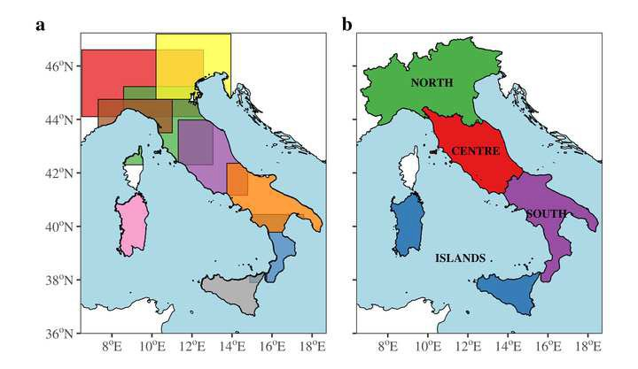

Figure 2 Click here to access/download;Figure;Figure2.jpeg

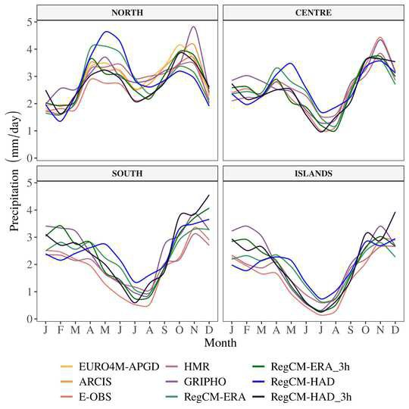

Figure 3 Click here to access/download;Figure;Figure3.jpeg

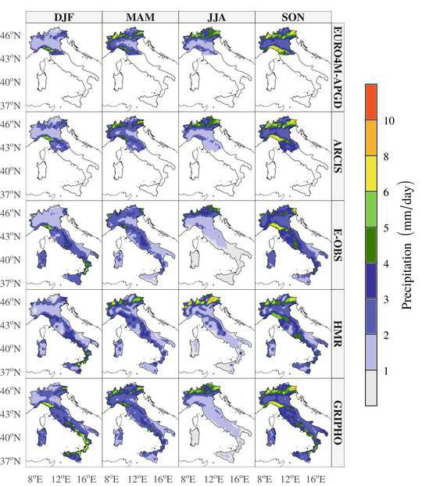

Figure 3 continuation Click here to access/download;Figure;Figure3b.jpeg

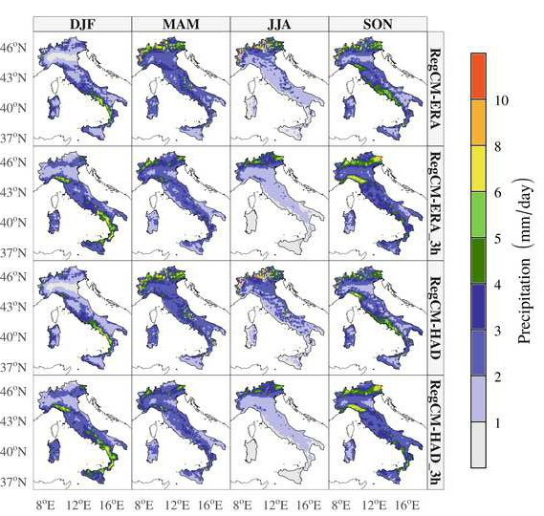

Figure 4 Click here to access/download;Figure;Figure4.jpeg

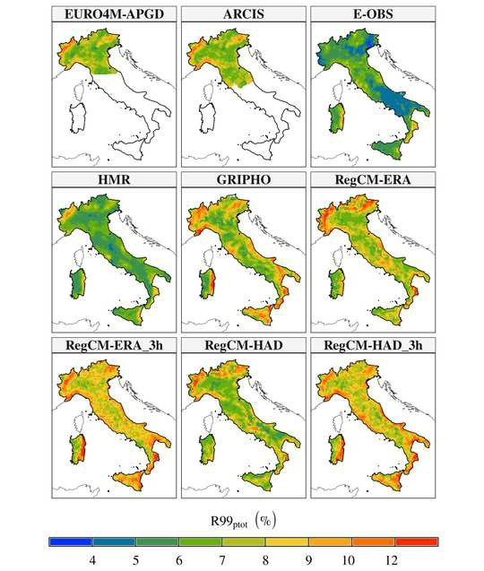

Figure 5 Click here to access/download;Figure;Figure5.jpeg

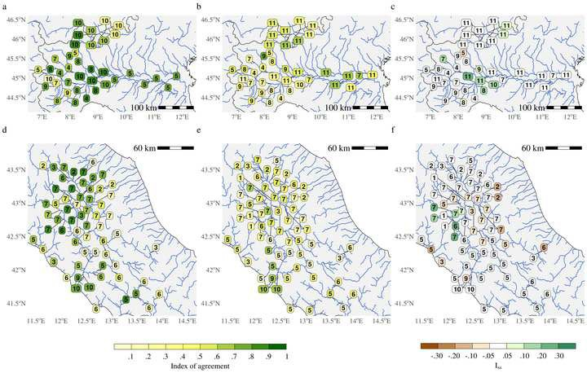

Figure 6 Click here to access/download;Figure;Figure6.jpeg

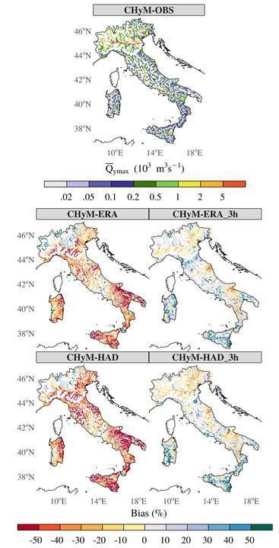

Figure 7 Click here to access/download;Figure;Figure7.jpeg

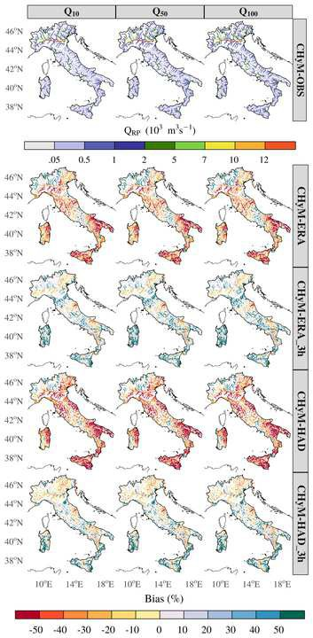

Figure 8 Click here to access/download;Figure;Figure8.jpeg

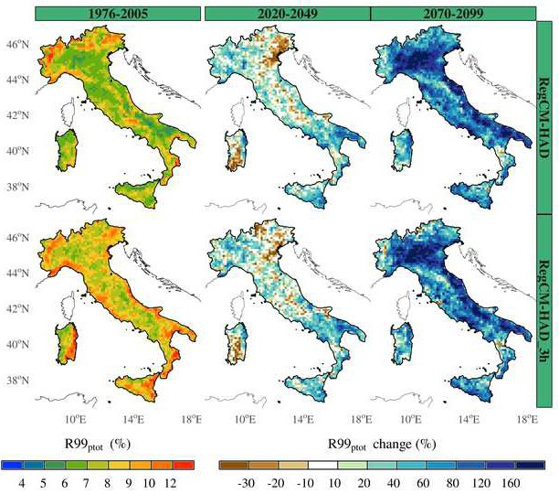

Figure 9 Click here to access/download;Figure;Figure9.jpeg

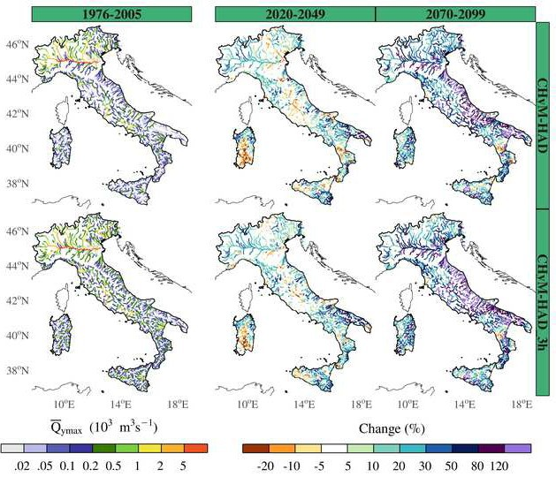

Figure 10 Click here to access/download;Figure;Figure10.jpeg

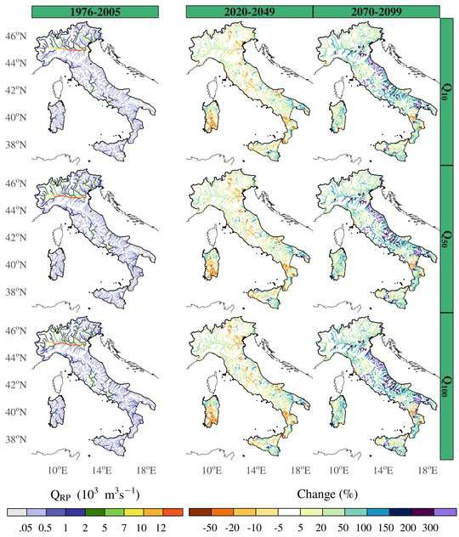

Figure 11 Click here to access/download;Figure;Figure11.jpeg

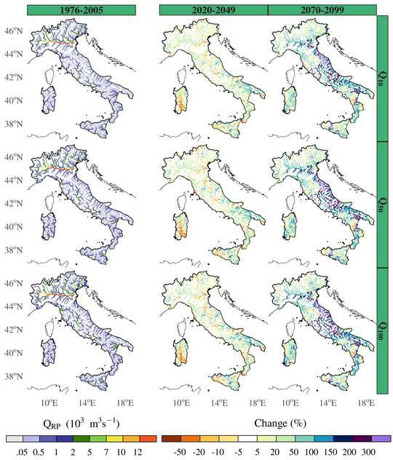

Figure 12 Click here to access/download;Figure;Figure12.jpeg

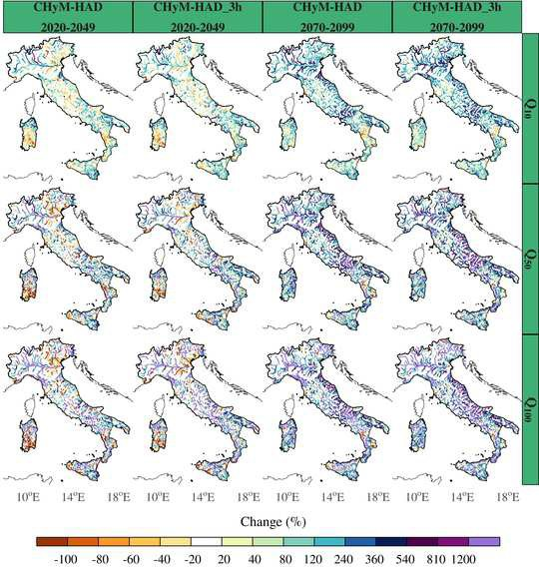

Table Click here to access/download;Table;Tables.docx

- Table 1List of observed precipitation gridded datasets used in this study.

Dataset name | Total (analyzed) period | Spatial resolution | Temporal resolution | Data source
EURO4M-APGD | 1971-2008 (1979-2008) | 5 km | Daily | Station data
ARCIS | 1961-2015 (1986-2015) | ~5 km | Daily | Station data
E-OBS v20e | 1950-2019 (1987-2016) | 0.1˚ | Daily | Station data
HMR | 1979-2013 (1984-2013) | 5.5 km | Daily | Reanalysis
GRIPHO | 2001-2016 (2001-2016) | 12 km | Hourly | Station data

- Table 2 List of observed discharge datasets used in this study.

Dataset name | Period | Region | Temporal resolution | Data source
MV1 | 1995-2005 | Po River | Hourly | Station data
MV2 | 2000-2010 | upper Po River | Hourly | Station data
MV3 | 2000-2016 | Italy | Hourly | Station data
EWA | 1863-2013 | Europe | Daily | Station data

- Table 3Acronyms for the climate and hydrological simulations.

Climate forcings | Climate outputs | Hydrological outputs
Observations  ERA-Interim + RegCM4 | RegCM-ERA | CHyM-OBS  CHyM-ERA
HADGEM2-ES + RegCM4 | RegCM-HAD | CHyM-HAD
ERA-Interim + RegCM4 + MBCn | RegCM-ERA_3h | CHyM-ERA_3h
HADGEM2-ES + RegCM4 + MBCn | RegCM-HAD_3h | CHyM-HAD_3h

- Table 4 Skill score metrics used in the evaluation of the CHyMmodel.

Skill Score Equation Range Perfect fit

Index of agreement

n i=1
n
∑

(Qsim
̅

- - Q

obs

2
(i))
2

[0, 1] 1

∑i=1(|Qsim(i) - Qobs | + |Qobs (i) -Qobs |)
Kling-Gupta Efficiency (KGE) 1 - √(r - 1)2 + (β - 1)2 + (α - 1)2 (-∞, 1] 1
∑n (Q (i) -Q̅ ) (Q (i) - Q̅ )
i=1 sim sim obs obs

Correlation term of the KGE (r)
√∑n (Q
  - - Q
)2 ∑n (Q
2
- - Q )
[-1, 1] 1

Bias term of the KGE (𝛽𝛽)
i=1
sim
sim
Q̅sim Q̅obs Ssim
i=1
obs
obs
[0, ∞) 1

Variability term of the KGE (𝛼𝛼) [0, ∞) 1
S
obs
5

Figure captions

Figure captions

  - Fig. 1. (a) The nine domains (Po Basin in red, Liguria in brown, North-Eastern Italy in

  - yellow, Central-Northern Italy in green, Central Italy in purple, Central-Southern Italy in

  - orange, Calabria in blue, Sicily in gray, and Sardinia in pink) in which the CHyM model

  - was run, and (b) the four macroregions used in the RegCM evaluation.

  - Fig. 2. Mean annual cycle of precipitation from observations (EURO4M-APGD, ARCIS,

  - E-OBS, HMR, and GRIPHO) and RegCM simulations in the four macroregions. RegCM-

  - ERA and RegCM-HAD indicate the results from the raw climate simulations driven by

  - ERA-Interim and HadGEM2-ES, respectively. The corresponding bias-corrected outputs

  - are displayed as RegCM-ERA_3h and RegCM-HAD_3h, respectively.

  - Fig. 3. Seasonal mean precipitation for the observational datasets and RegCM

  - simulations. The columns report the winter (DJF), spring (MAM), summer (JJA), and

  - autumn (SON) mean values.

  - Fig. 4. R99pTOT (%) for the different observational datasets and RegCM simulations.

  - Fig. 5. Index of agreement for CHyM-OBS and CHyM-ERA when compared to

  - observational stations over (a and b, respectively) the Po river basin and (d and e,

  - respectively) central Italy basins, and the benefit gained in simulations fed with bias-

  - corrected simulations in comparison to raw ones (c and f). In the panels, numbers indicate

  - the length of the period in common (years) between observations and simulations, and

  - color the value of the metric.
  - Fig. 6. Average yearly peak flow (Q̅ymax) for CHyM-OBS, along with the percent bias for
  - CHyM simulations driven conducted by raw (CHyM-ERA and CHyM-HAD) and bias-

  - corrected climate outputs (CHyM-ERA_3h and CHyM-HAD_3h) when compared to

  - CHyM-OBS.

  - Fig. 7. As Fig. 6, but for the hourly peak flows with return periods of 10, 50, and 100

26 years (Q10, Q50, and Q100).

- Fig. 8. R99pTOT (%) for the historical period (1976-2005), along with the relative

- changes (%) for the near (2020-2049) and far (2070-2099) future for both raw and bias-

- corrected values.

- Fig. 9. Average yearly peak flow for the historical period, along with the relative projected

- changes (%) for the near and far future in simulations driven with raw and bias-corrected

- climate data.

- Fig. 10. Hourly peak flows for 10, 50, and 100 years of return periods for the historical

- period, along with the relative projected changes (%) for the near and far future in CHyM

- simulations fed with raw RegCM outputs.

- Fig. 11. As Fig. 10, but for the CHyM simulations fed with bias-corrected RegCM

- outputs.

- Fig 12. Relative changes in the average yearly frequency of events with hourly peak flow

- greater than Q10, Q50, and Q100 for the two future time slices, both CHyM simulations,
- and fed with raw and bias-corrected RegCM outputs.

