Eddies and Currents in the Bay of Bengal during Summer Monsoons

A. Pirro¹, H. J. S. Fernando^{1,4}, H. W. Wijesekera², T. G. Jensen², L. R. Centurioni³,
S.U.P. Jinadasa^{5,6}

¹University of Notre Dame, Department of Civil Engineering, Environmental and Earth Sciences, Notre Dame, IN 46556, USA

²Naval Research Laboratory, Stennis Space Center, MS 39529, USA

³Scripps Institution of Oceanography, University of California, San Diego, La Jolla, CA, USA

⁴University of Notre Dame, Department of Aerospace and Mechanical Engineering,
Notre Dame, IN 46556, USA

⁵Ocean University, Mattakuliya, Colombo, Sri Lanka

⁶National Aquatic Resources Research and Development Agency, Colombo, Sri Lanka.

Keywords: anticyclonic eddy, Sri Lanka Dome, Bay of Bengal, Southwest Monsoon Current, Rossby waves, laboratory experiment

Correspondent author A. Pirro (apirro@nd.edu), Department of Civil and Environmental Engineering and Earth Sciences, University of Notre Dame, Notre Dame, IN 46556, USA
Abstract
The Southwest Monsoon Current (SMC) in the Bay of Bengal (BoB) and prominent eddies surrounding it, in particular, an anticyclonic eddy (AE) to the southeast and a cyclonic eddy (Sri Lanka Dome, SLD) to the east of Sri Lanka, were investigated using field observations, numerical simulations, satellite imagery, laboratory experiments and theoretical studies. The field campaigns were conducted in 2015 and 2018, respectively, in conjunction with the Air-Sea Interactions in the Northern Indian Ocean (ASIRI) and Monsoon Intra-Seasonal Oscillations in Bay of Bengal (MISO-BoB) research initiatives. Ship observations confirmed the presence of a recurring AE about 500 km southeast of Sri Lanka, with surface velocities up to ~ 1 m s⁻¹, size in the meridional direction ~ 200 km, and penetration approximately to the depth of the thermocline ~ 150 m. Satellite observations and COAMPS® model simulations show that AE and SLD are formed following the appearance of SMC in early summer, and both evolve during July/August and disappear in September. This result is at odds with the current notion that AE is a result of the interaction between SMC and Rossby waves arriving from the southeast of the BoB with energy from a blocked Wyrtki jet at the Sumatra coast; such waves do not arrive in the southwestern BoB until August/September. Almost simultaneous appearance of AE and SLD is inconsistent with a recently proposed mechanism of SLD formation due to separation of SMC from the Sri Lanka coast. A new hypothesis is advanced wherein AE and SLD are generated by from topographically trapped Rossby waves as a response of the SMC to perturbations induced by the presence of the Sri Lankan coast. Observations of the size, location and origins of AE were broadly consistent with this hypothesis, as did a laboratory experiment designed to mimic the natural flow in BoB by creating an eastward jet (SMC) on a simulated β plane in a rotating tank. Sea surface temperature observations show that the SMC carries colder upwelled water from the southern Sri Lankan and Indian coasts and distributes it within the surface waters of AE and beyond. Thus, surface waters of AE are colder than that of SLD, notwithstanding possible local upwelling in the latter, highlighting possible roles of SMC in swaying air-sea interactions in BoB.

- Introduction
Monsoon-induced ocean currents play a key role in exchanging water masses between the Arabian Sea (AS) and Bay of Bengal (BoB). During northeast monsoons (December to April), fresher surface water from the BoB flows into AS via Northeast Monsoon Current (NMC) while during boreal summer (June to October) the Southwest Monsoon Current (SMC) transports saltier AS surface water to the BoB (Tomczak and Godfrey, 2003). The drivers of monsoonal currents and hence AS-BoB water exchange mechanisms are complex, and depend on the seasonal wind variability, shallow water ocean dynamics, bathymetry and land mass distribution. The monsoon currents reverse in the spring (April - May, NMC to SMC) and fall (October - November, SMC to NMC), leading to a myriad of phenomena that covers a swath of space-time scales (Shankar et al., 2002). Substantial understanding has been gained on monsoon currents and their transitions in the Indian Ocean (IO) using a variety of tools: regional circulation modeling (Vinayachandran and Yamagata 1998; Das et al. 2016; Jensen 2001, 2003, Jensen et al. 2016); satellites, floats, drifters, and moorings (Murty et al., 1992; Schott et al., 1994; Shetye et al., 1996; McCreary et al., 1996; Schott and McCreary, 2001; Durand et al., 2009; Vinayachandran et al., 2013; Mukherjee et al., 2014; Wijesekera et al. 2016a, among the others); and research cruises (Wijesekera et al. 2015, 2016a,b; Mahadevan et al. 2016; Vinayachandran et al. 2018). Accordingly, the summer ocean circulation in BoB, away from the freshwater input areas, is mainly driven by the wind stress (Hastenrath and Greiscahr 1991), whereas landmass distribution and shallow flow dynamics exert a controlling influence.
During the summer, the West Indian Coastal Current (WICC) in the eastern AS flows southward (Shetye et al., 1990) whereas the East Indian Coastal Current (EICC) in the western BoB is generally northward at low latitudes (Rao et al., 1998); see Figure 1. Connecting AS and BoB is the SMC, which is supplied mainly by low-latitude AS water west of Sri Lanka rather than by WICC (Hastenrath and Greiscahr 1991), and thus SMC appears as an extension of the Somali Current. During the initiation of southwest monsoons, SMC flows around Sri Lanka and forms a northeastward shallow flow, but as the summer progresses SMC’s origin moves further westward and it nominally flows eastward as an intense narrow zonal jet (Vinayachandran et al., 1999). Shipboard and moored observations during the summer of 1991 by Schott et al., (1994) has revealed that SMC is confined to the upper ~ 100 m with eastward transports of ~ 8 Sv between 5°39’N and 4°11’N along 80° 30’E. Wijesekera et al., (2016a) estimated an averaged northward transport of ~ 8 Sv east of Sri Lanka near 8°N along a 100 km wide current. Webber et al., (2018) estimated a northward transport across the east-west section (85°30’ – 88°30’E) along 8°N as 16.7 - 24.5 Sv.
Two eddy-like features of intraseasonal space-timescales have been well-known summer surface fixtures of the southwestern BoB. One is a large anticyclonic eddy (AE) to the southeast of Sri Lanka, and the other is an adjacent cyclonic eddy known as the Sri Lanka Dome (SLD) to the east of Sri Lanka (Figure 1). They appear to play an important role in regional ocean-atmosphere dynamics by significantly affecting the hydro-physical properties of the ocean surface layer. The cyclonic circulation in SLD causes upward doming of the thermocline, thus having potential of generating strong surface chlorophyll signatures due to upwelling (Vinayachandran and Yamagata, 1998). The SLD has a diameter of ~ 200 – 300 km and is constricted between the eastern Sri Lanka and BoB. Conversely, the thermocline of AE downwells and, being unconfined, AE is larger and elongated zonally. Long term mooring observations of Wijesekera et al., (2016a, their Figure 15c) indicate that AE and SLD are generally located on either side of the SMC, with upwelling in SLD and downwelling in AE being as large as 3 - 4 m per day.

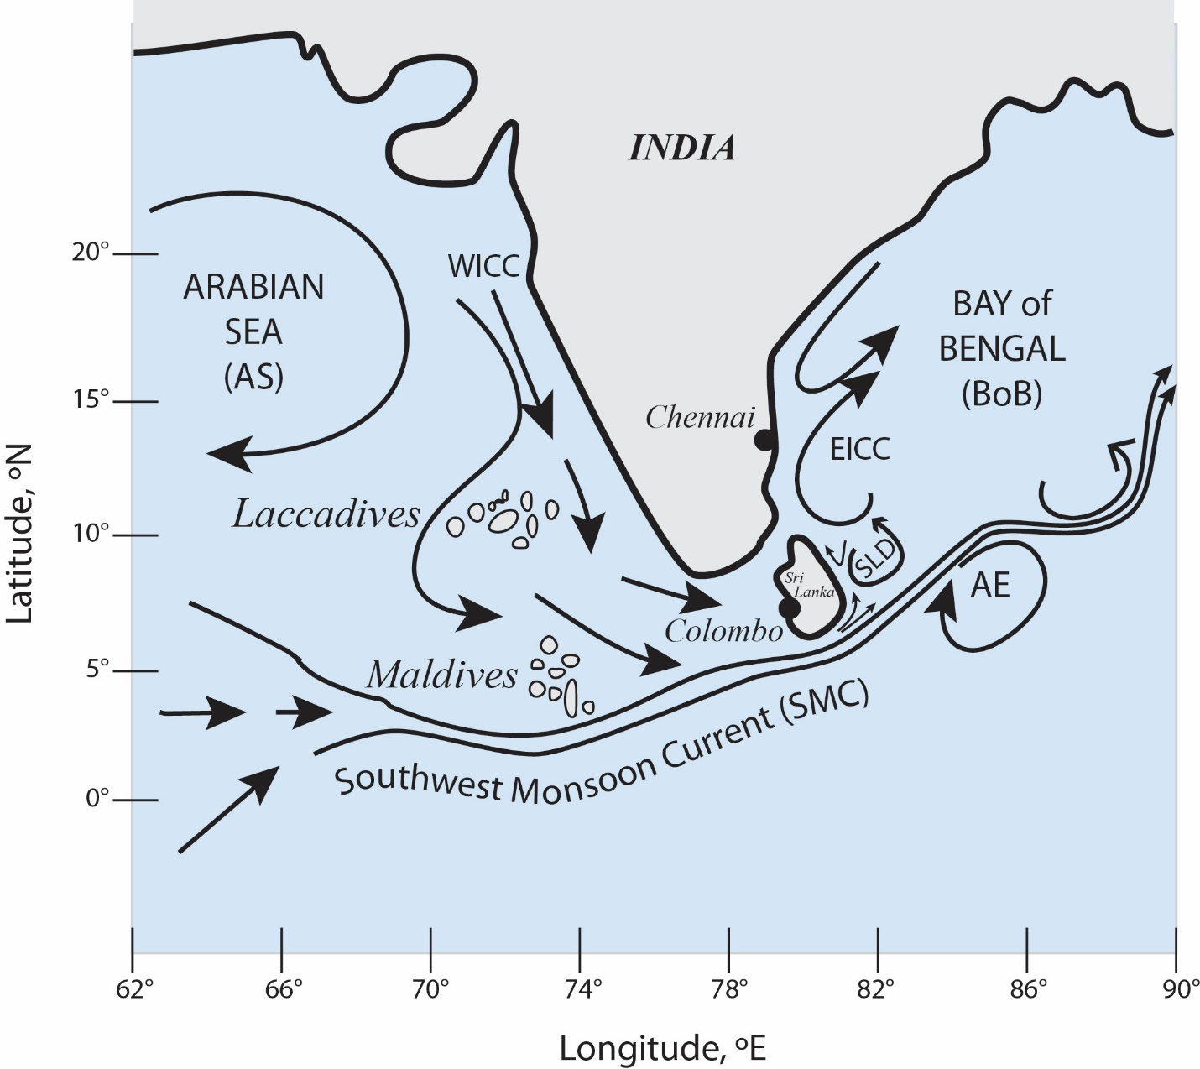
Figure 1: A schematic of surface currents in the Northern Indian Ocean during the Summer Monsoon season.

Cyclonic wind stress-curl over southwestern BoB has been proposed as a plausible formation mechanism for SLD (McCreary at al., 1996; Vinayachandran and Yamagata 1998; Schott et al., 2001). More recently, however, de Vos et al., (2014) argued that SLD is formed due to the separation of SMC from the (southern) boundary of Sri Lanka. Accordingly, where coastal shelf friction is felt, the flow acquires a cyclonic (anticlockwise) relative vorticity$(ω)$, gaining a tendency to turn northward and leading to SLD. As evidence, De Vos et al., (2014) extrapolated the numerical results of Alaee et al., (2004) and also conducted their own numerical simulations using the ROMS model. Simulations with and without Sri Lanka illustrated that flow separation can be a possible mechanism for forming a cyclonic eddy. Curiously, in some of their simulations, SLD was not evident (e.g., their Figure 16 a,b) for flow parameters characteristic of BoB (velocity $U$ ~ 0.2 – 0. 4 m s⁻¹). None of the simulations captured the AE (their Figs 2, 4).
A mechanism for AE formation has been proposed by Vinayachandran and Yamagata (1998), wherein the interaction of SMC with Rossby waves arriving from the Sumatran coast leads to AE. In their simulations, a large AE connected with the SMC is formed during geostrophic adjustment of BoB surface water converged by this interaction. The oncoming Rossby waves carried substantial energy from the (equatorial) Wyrtki Jet that impinged on the Sumatra coast in late spring (Greatbatch, 1985; McCreary et al., 1993; Vinayachandran and Yamagata 1998; Schott & McCreary 2001). The conversion of mean kinetic energy to eddy kinetic energy was evident in the calculations, pointing to the involvement of barotropic instability in AE formation. Simulations of Vinayachandran et al., (1998) found that AE appears first in June, matures into a near-circular shape in July, and then deforms in August.
The focus of this paper is the SMC and contiguous surface eddies, AE and SLD, which appear to have significant impacts on air-sea interactions in BoB and hence the variability of southwest monsoons. SMC is also a conveyor for upwelled chlorophyll-rich colder water from the southern coasts of Sri Lanka and India into BoB, thus impacting biological activity (Vinayachandran et al., 2004; Das et al., 2016). In Section 2, we will discuss the drawbacks of existing hypotheses on the formation of SLD and AE, and propose an alternative hypothesis. Different tools used in our study, including measurements from two research cruises, satellite platforms, numerical modeling and laboratory experiments, are discussed in Section 3. Ship-based observations are given in Section 4, followed by, in Section 5, the results of numerical simulations and satellite imagery analysis employed to obtain details over a larger spatio-temporal swath of BoB. Results of a laboratory experiment designed to mimic SMC while achieving dynamic similitude (i.e., matched salient non-dimensional parameters) are given in Section 6, which allowed investigations under controlled conditions and test the new hypothesis. Conclusions are given in Section 7.

- An Alternative Hypothesis for AE and SLD Formation
Although the separation of SMC from the Sri Lanka southern coast may produce cyclonic vorticity that may be responsible for SLD as argued by de Vos et al., (2014), such a mechanism cannot produce negative vorticity for the genesis of AE. Local wind stress curl can be a factor for cyclonic circulation and upwelling in SLD (McCreary at al., 1996), but sustained presence and evolution of SLD have not been correlated with wind forcing. An new alternative hypothesis is that eastward SMC may trigger Rossby waves that undergo barotropic instability, shedding both cyclonic (SLD) and anticyclonic (AE) eddies on either side of the SMC (e.g., Figure 1). The basic mechanism is that as the SMC flow northeastward as a wind-driven current, subjected to perturbations by Sri Lanka, it encounters an increase of planetary vorticity $f$, which can be quantified by the $β$ plane approximation $f =f_{0}+βy$, where $y$ is the meridional distance and $f_{0}$ the reference planetary vorticity. The conservation of potential vorticity $Π$ in shallow flows requires

${ Π=\left(ω+f\right)}/H$ = constant | (2.1)
where $ω$ is the vertical relative vorticity and $H$ the depth of the flow. If, for simplicity, the unperturbed flow is considered as uniform with negligible $ω$ and the flow is assumed to be of uniform depth $H_{0}$, then (2.1) becomes
$\frac{ω+f_{o}+βy}{H_{o}}=\frac{f_{o}}{H_{o}}$, or $ω+βy≈0.$ | (2.2)
Thus, as the flow moves northward, the relative vorticity $ω$ needs to decrease, becomes anticyclonic$(ω<0$), and turns southward. This north-south meridional deflection recurs as the SMC flows eastward, signifying a barotropic Rossby wave (Batchelor 1967, p. 577) and leading to the meandering of SMC. The coastal topography of Sri Lanka facilitates trapping of these Rossby waves by acting as a source of perturbations. The barotropic instability of the meander may produce eddies on either side of it, as observed in the SMC east of Sri Lanka. The first cyclonic eddy can be construed as the SLD and the anticyclonic eddy as the AE. Modeling studies (Potemra et al., 1991; Yu et al., 1991; McCreary et al., 1993, 1996; Vinayachandran et al., 1996, 1999) are broadly consistent with the above depiction, although details and interpretations vary.
In the general case of trapped Rossby waves associated with an approximately zonal mean flow $\overline{U}$(y) of SMC can be investigated using the linearized form of (2.1). The vertical vorticity $ω$ can be written in terms of the mean $\overline{ω}$ and perturbation vorticity, $ω= \overline{ω}+ ω^{'}$,$\overline{ω}$=${-∂\overline{U}}/{∂y}$, leading to
$\left(\frac{∂}{∂t}+\overline{U}\frac{∂}{∂x}\right)ω'+v'\frac{∂}{∂y}(\overline{ω}+f)=0$, | (2.3)
where $v'$is the meridional velocity fluctuation. Introducing the stream functions $u’$=$\frac{∂ψ}{∂y}$and $v’$=-$\frac{∂ψ}{∂x}$, (2.3) becomes
$\left(\frac{∂}{∂t}+\overline{U}\frac{∂}{∂x}\right)∇^{2}ψ+\frac{∂ψ}{∂y}\frac{∂}{∂y}(\overline{ω}+f)=0$. | (2.4)
If $\overline{U}=U_{0}$ (or $\overline{ω}=0$) for simplicity, for trapped waves of the form $ψ=ψ_{o}e^{i(kx+my)}$, (2.4) on the $β$ plane gives $κ$=${(/{\overline{U}}_{o}) }^{1/2}$, where $κ^{2}=k^{2}+m^{2}$. The wavelength of the Rossby-wave becomes λ=2π${({\overline{U}}_{o}/) }^{1/2}$. According to Gill (1974), such waves are unstable and produce anticyclonic and cyclonic eddies (of the genre of AE and SLD), supporting our hypothesis. Naturally, the wavelength of barotropic instabilities obtained by Gill (1974) is also the same as above.
Accordingly, for SMC, λ ~ 1000 km (β = 2.2 10⁻¹¹ m⁻¹ s⁻¹, $U_{0}\sim 0.7$m s⁻¹), and thus an anticyclonic eddy is expected to appear ${π\left({U_{0}}/β\right)}^{1/2}$ ~ 500 km east of the southern coast of Sri Lanka, which approximately matches with observations as will be described in Section 4. Initially the amplitude of the instability wave is on the order shear layer thickness (~ 125 km), and thus the generated eddy takes an elliptical form but with time eddies evolve into a more circular shape. A zonal flow subject to a constant Coriolis parameter (i.e., $f$plane, $β$ = 0) may also undergo barotropic instabilities. In this case, the instability wave-length is ~ $2.5\left(2πL\right) km$(Gill 1982, p. 567), where $L$ is the width of the current. For SMC with$L$ ~ 150 km (Shetye et al., 1990), half of the wave-length is about 1200 km, which is much larger than typical observations, suggesting the importance of $β$plane dynamics. In all, the above calculations support the notion that AE and SLD are due to instabilities of topographically trapped Rossby waves.

- Methods
Field Measurements
The field data presented in this paper were collected in the summers of 2015 and 2018, in conjunction with the cruises of the US Office of Naval Research’s (ONR) initiatives on Air-Sea Interactions in Northern Indian Ocean (ASIRI, 2012 – 2017; Wijesekera et al., 2016a,b) and Monsoon Intra-Seasonal Oscillations in Bay of Bengal (MISO-BoB, 2017–2022). These initiatives collaborated with the Indian Government’s Initiative of Ocean Mixing and Monsoons (OMM) and a Sri Lankan Initiative on Coastal Currents and Fisheries. ASIRI focused on the role of upper ocean processes in monsoon dynamics, and MISO-BoB on sub-seasonal scale air-sea interaction phenomena and their role in monsoon variability.
The summer 2015 cruise was conducted aboard the R/V Roger Revelle and the 2018 cruise on R/V Tommy G. Thompson. Each had two back-to-back cruises (Legs 1 and 2), and the authors were associated with Leg 1 (August 4 - 15) in 2015 and Leg 2 (June 30 - July 21) in 2018, both operated out of Colombo, Sri Lanka. In 2015, six deep-ocean moorings deployed in a December 2013 cruise were recovered; see Wijesekera et al., (2016a). The winds during the 2015 cruise were consistently southwesterly, from 1.7 to 19.5 m s⁻¹ (Figure 2). The zonal and meridional components of the horizontal current vector were measured along the cruise track using a ship-mounted 150 kHz Acoustic Current Doppler Profiler (ADCP). The shipboard Conductivity, Temperature, and Depth (CTD) profiler (Seabird; 24 Hz sampling rate) was deployed for a period of 24 h at 85.21°E - 6.42°N on August 11 - 12 2015 (yellow square in Figure 2 or black square in Figure 4), with casts taken every 30 minutes down to 250 m and data averaged over 5 m depth intervals. In addition, drifter observations conducted from 2012 to 2015 as a part of ASIRI were available. For this paper we have used Surface Velocity Program (SVP) drifters (Centurioni, 2018), designed to measure ocean currents at a depth of 15 m with an accuracy better than 10⁻² m s⁻¹ for wind speed up to 10 m s⁻¹ (Niiler et al., 1995). The drogue depth of 15 m ensures that the direct (i.e. Stokes Drift) and spurious (e.g. rectification) effects of surface waves are small and the measurements represent ocean currents in the mixed layer.
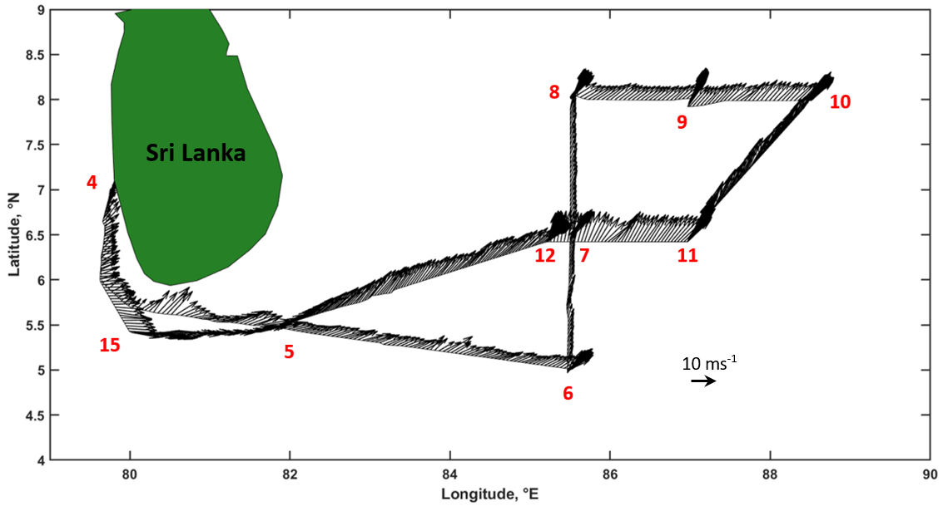
Figure 2: Wind vectors along the ship track measured by the ship’s meteorological mast. In red – the day of August 2015. Magenta (red) stars indicate drifters releasing points for 2015 (2012). Yellow square indicates CTD location.

The 2018 deployment included atmospheric and air-sea measurement systems, but here we focus on those relevant to the present study. Besides the shipboard ADCP measurements, which were obtained in both 2015 and 2018, CTD casts were taken along the ship track for the entire cruise period in 2018. Surface currents were tracked using seven SVP drifters deployed inside the SLD (8°N, 83.75°E) on July 15 while the sea surface temperature (SST) along the ship track was sampled using a Remote Ocean Sensing Radiometer (ROSR; http://rmrco.com/). Meteorological instruments were mounted on the ship’s bow mast (a flux tower). In particular, a sonic anemometer at 16 m was used to measure the fluxes of momentum and heat; a LI-COR® open path infrared gas analyzer measured moisture and latent heat fluxes at 12 m. Moisture and temperature profiles were sampled by the microwave radiometer.
Auxiliary Data Products
Satellite products were used to map overall dynamical features of the area. Daily Sea Surface Height Anomalies (SSHA) data from Archiving, Validation and Interpretation of Satellite Oceanographic (AVISO) with 0.25° spatial resolution (ftp://eddy.colorado.edu) were averaged over the 2015 cruise period as well as for the month of July 2018. Daily Optimum Interpolation Sea Surface Temperature (OISST) data of NOAA’s National Center for Environmental Information (NCEI) with a spatial resolution of 0.25° and daily NOAA Outgoing Longwave Radiations (OLR) with 1° spatial resolution were used in the interpretation of results. Simulations of the Coupled Ocean/Atmosphere Mesoscale Prediction System (COAMPS®) were also used to support the analysis. The model provided velocity, temperature and salinity structure of the region for the 2015 cruise period; see Jensen et al., (2015) for modeling details.
Laboratory Experiments
The laboratory experiments were carried out on a rotating tank with adjustable sloping bottom, where a jet flow (representing the SMC) was set up directed at a scaled model of Sri Lanka. The aim was to investigate possible eddy generation due to interaction of a (nearly) zonal flow (SMC) with an island (Sri Lanka) on the $β$ plane. The experimental design involved satisfying dynamical similitude to the extent possible; that is to match crucial non-dimensional parameters between the nature and laboratory, which could be obtained by non-dimensionalizing the reduced potential vorticity equation (2.2) using characteristic length $L_{0}$ and velocity $U_{0}$ scales, viz.,
$ω^{*}+\frac{βL_{o}^{2}}{U_{o}}y^{*}=0$, $ω^{*}={∇×u}^{*}$, | (3.1)
where $u^{*}= u/{U_{o}}$,${ y}^{*}= y/{L_{o}}$. As such, disregarding the molecular viscosity$ν$, the critical dimensionless parameter for modeling SMC and its spatial evolution in the laboratory is
$π=\frac{βL_{o}^{2}}{U_{0}}$. | (3.2)
Upon generation, the evolution of eddies due to instabilities is governed by the local Coriolis parameter$f$, and thus an additional parameter, the Rossby number $Ro= {U_{0}}/{fL_{0}}$ (<<1) becomes important. In our case, however, the main focus would be the formation of topographically trapped eddies downstream of Sri Lanka, although$Ro$ was kept low to satisfy the Rossby number criterion.
Notwithstanding, it is not simple to simulate $β$ effect (or spatially varying $f$) in a laboratory tank on a rotating table. To this end, Boyer and Davies (1982), among others, have cleverly simulated the β effect in a laboratory water tank using a sloping bottom topography of inclination $α$, with the water depth $h$ linearly reducing northward with (meridional) distance$y$, that is $h=h_{0}-αy$. For barotropic flows, the slope angle $α$ was shown to be dynamically equivalent to the $β$ effect according to
$β=\frac{f_{0} α}{h_{o}}$, | (3.3)
which was used in the experimental design. Boyer and Davies (1982) also showed that viscous effects, signified by the Ekman number $Ek= ν/{f_{0}L^{2}}$, are negligible for $Ek$<< 1.
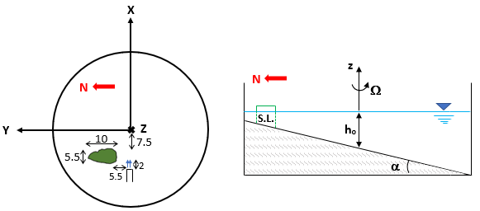
Figure 3: Top view (left) and side view (right) of the laboratory experiment set up. Units in cm.

Figure 3 presents a schematic of the laboratory set up used to mimic the SMC (nearly an eastward jet) past Sri Lanka (an obstacle of similar shape) on the $β$plane. The experiments were carried out in a round Plexiglas tank of diameter 80 cm, located within another water-filled square box to minimize optical distortions introduced when viewed from the sides. The tank was mounted on a rotating table that could operate at a constant speed . The tank bottom was sloping to simulate the$β$ effect, and the coordinate system (x, y, z) was selected so that z is vertically up, x eastward and y northward. A solid model of Sri Lanka was introduced with some offset from the center of the tank, and a jet was introduced to the southwest of Sri Lanka (~ 5 cm away) by a constant-flow-rate pump that drew water from an overhead tank. The jet was mixed with 100 - 350 μm fluorescent particles, which, when illuminated with an Argon-Ion laser sheet, produced clear trajectories of particle streaks that were tracked by an overhead mounted digital camera (0.36 Mpixel) looking downward. The camera, water reservoir and jet pump were all on the rotating platform. The trajectories of particle streaks were analyzed using software developed in Hocut et al., (2015). Only the barotropic case was considered, given that AE is mainly confined to the upper mixed layer and that the dynamical equivalence (3.3) is not valid for baroclinic cases.
The dynamic similarity requires matching of$π$. In nature, $β =$ 2.2 x 10⁻¹¹ m s⁻¹, $U_{0}$~ 1 m s⁻¹ and $L_{0}$= 225 km (the estimated size of perturbations – curvature of Sri Lanka’s southern coast), and hence $π={βL_{0}^{2}}/{U_{0}}$ $≈$ 1.1. This is consistent with the estimates of Boyer and Davies (1982) that for typical geophysical flows π ~ 1. In the experimental design, β in the laboratory was matched by its surrogate, the northward slope α, using β = α f₀/h_{o} ~ 0.01 cm s⁻¹ (α ~ 2.5°, f₀ = 0.25 rad s⁻¹ and h_{o} = 1.5 cm), and then the required velocity was obtained as U_{o} = β L_{o}/π ~ 1.3 cm s⁻¹ for laboratory with L_{o} = 12 cm. While it is entreating to cover a range of π, R_{o} and Ek. such an effort deemed beyond the scope of this paper considering our interest only in the range π ~ 1, Ek << 1 and $Ro$ < 1. Therefore, the selection was $U_{0}$ = (1.3 - 1.7) cm s⁻¹, bottom slope $α$ = (2.3° - 2.5°), the mean water depth $h_{0}$= 1.5 cm, $f_{0}$= 0.26 rad s⁻¹, $Ro$ ~ 0.3 – 0.5 and Ek ~ 4.2 10⁻³. In SMC, $Ro$ varies between 0.3 and 0.5 for $U_{0}$ ~ 1 m s⁻¹, $f_{0}$ = 1.2 10⁻⁵ rad s⁻¹ (latitude 5°N), $L_{0}$ = 225 km and Ek ~ 6.8 10⁻¹².
After ensuring that fluid in the tank and in the supply reservoir and the particles were all spun-up to solid body rotation, the pump introduced an eastward jet at the prescribed velocity. According to Killworth (1980), the current angle to the zonal direction is unimportant for dynamics, when the angle is small. The jet interacted with Sri Lanka topography as a thick current.

- Observations of SMC and Eddies

4.1 Observations during 2015 ASIRI Cruise
Shipboard observations in August 2015 provide space-time sections of currents along the ship tracks. Figure 4 shows velocity measurements averaged over 5 m above and below the indicated depth. The uppermost layer indicates approximately eastward/southeastward flow along 5.62°N and from 80°E to 82°E of magnitude 0.5 - 0.7 m s⁻¹. Thereafter, the flow turns northeastward (82° - 84.6 °E, 5° - 6.25°N) while increasing the current velocity up to ~ 1 m s⁻¹. According to Vinayachandran et al., (1999), a branch of the seasonal SMC flows eastward and another penetrates northeastward, and hence the signatures of SMC could be traced at least up to 8°N and 85.5°E with an averaged surface velocity of ~ 0.7 m s⁻¹. [Currents measured during June 2014 has also shown strong eastward flow, where 15 min averaged velocity in the upper 175 m was as large as 0.8 m s⁻¹; see Figure 7 of Wijesekera et al., 2016b]. Along the northern zonal transect (8°N, 85.5° - 88.5°E), the eastward flow gradually turns southwestward at the eastern end of the transect, pointing to a large AE. The radius of the AE estimated through its center along the meridional section was ~ 250 km, the zonal extent being larger. In the BoB the AE appears roughly at 500 km from the south coast of Sri Lanka, consistent with the theoretical estimates of Section 2.

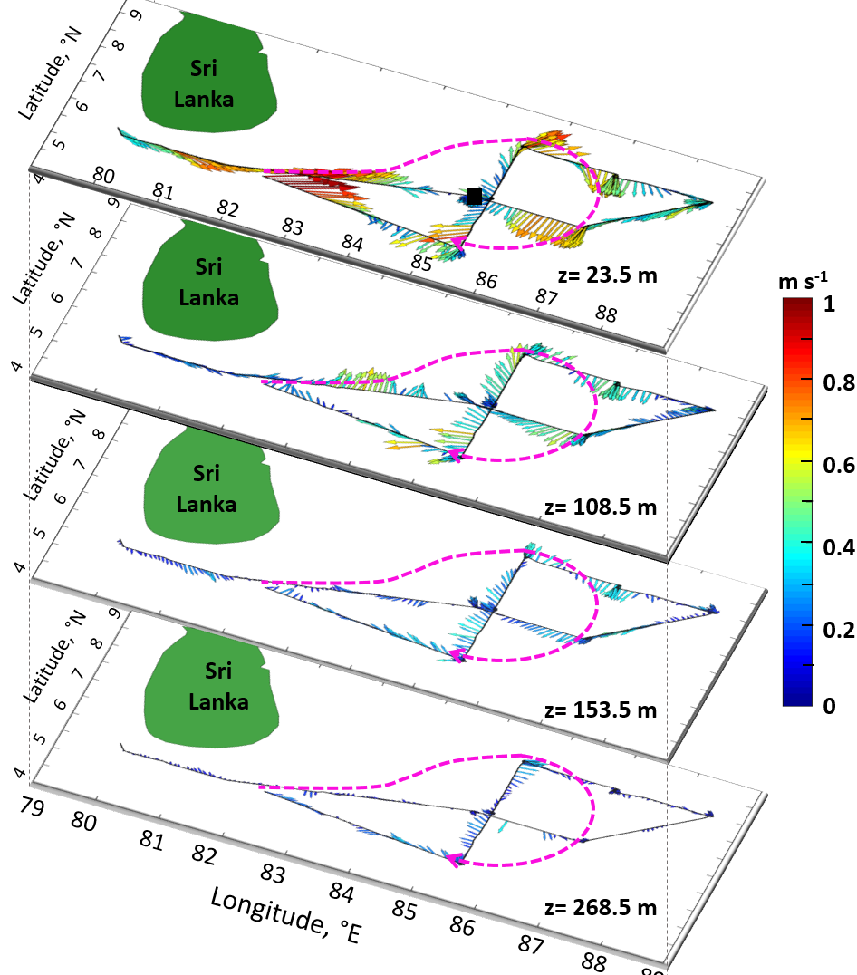
Figure 4: ADCP velocities vectors along the cruise track during the cruise period August 4 - 15 2015. Data are averaged 5 m below and above the indicated depth. Time average is 30 minutes. Magenta broken lines indicate the AE based on isotach of 0.8 m s⁻¹. The black square in the top panel indicates the CTD location.
a)
c))
b))
d))
U)

In Figure 4, the magenta broken line (hand-drawn isotachs) identifies the AE. The velocity field in the AE gradually decreases downward and fades away at z ~ 260 m. The black square in Figure 4a (or, similarly. the yellow square in Figure 2) indicates the CTD sampling location near the anticyclonic eddy, and the (T - S -$σ_{t}$) structure measured therein while the ship is nearly stationary is shown in Figure 5. A strong thermocline is evident over ~ 80 m to 180 m with $N^{2}≈$ 3.74 10⁻⁴ s⁻², where $N$ is the averaged buoyancy frequency. Water of elevated salinity possibly intruding from the AS to BoB in the depth range 60 – 90 m underneath the surface layer is evident, in agreement with previous climatological studies (e.g. Vinyachandran et al. 2013) and moored observations (Wijesekera et al., 2016a; their Figure 3b) where, higher values of salinity (~ 36 PSU) were recorded at 85.5°E - 6.5°N in conjunction with northeastward flow.

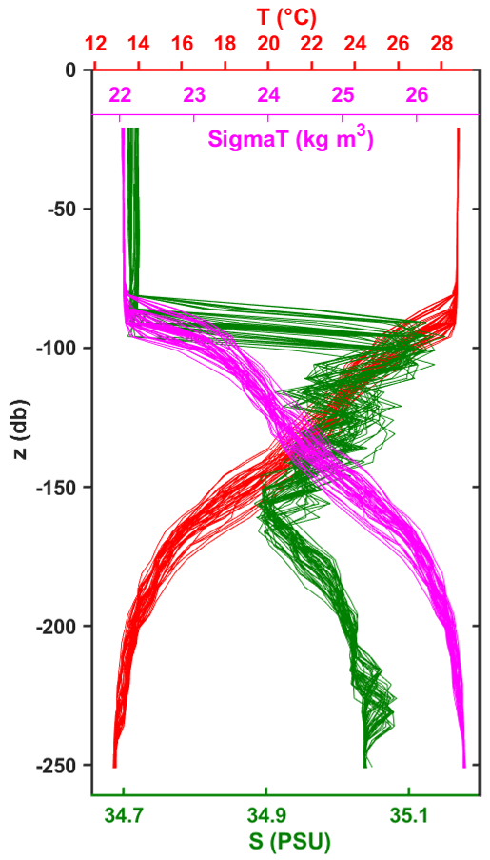

Figure 5: CTD Temperature, Salinity and $σ_{t}$profiles collected at 85.21°E, 6.42°N on August 11-12 2015. Sampling location is indicated in Figure 4a and Figure 2.

Figure 6 concerns August 1 - 15, 2015. Panel (a) shows SSHA averaged over this period, overlaid by ADCP surface currents (averaged over upper 24 m) along the ship track, and drifter trajectories. The yellow area, particularly with 5 - 10 cm positive SSHA identifies the anticyclonic mesoscale feature that extends over the moorings region. This overlaps with the AE inferred by current measurements (Figure 4). The dark blue patch to the west of AE (83° - 85°E, 8° - 10°N) is the SLD with negative SSHA between -20 and -10 cm. The red dotted lines are the trajectories of two drifters deployed simultaneously side-by-side in southern Sri Lanka during a pilot release on August 8, 2012 and recovered on August 31, 2012. Both trajectories reveal a well-defined eastward flow from 80°E, an obvious signature of recurring SMC. One trajectory follows the AE in 82.5° - 86°E, 5° - 7°N, and shows that the surface current turns southwestward around August 12. The second drifter is annexed into another (anticyclonic) mesoscale eddy and then possibly to a cyclonic eddy. The trajectories of drifters released from August 1 to August 31, 2015 are identified by white dotted lines. One travelled northward along the Sri Lanka east coast and the others tracked the AE. Specifically, white trajectories indicate a southwestward flow which, delimited the outer borders of the AE. Trajectories of drifters released from July 16 to August 2 2014 during an earlier cruise (not discussed) are identified by green dots and tracked a southward flow associated with SLD. For brevity, we have not included all drifter trajectories of 2012 and 2014 releases, but those data are available for future work. Note that although we focus on 2015-2018 observations, we have also reported results from the 2012 and 2014 drifters since the currents’ path is expected to be the same during each summer season. Therefore, it is reasonable to allude to data from different years.
Useful properties of AE and SLD are evident in panels (b) and (c) of Figure 6. In (b), a warmer surface area (~ 29.4°- 29.8°C) occupies the area immediate east of Sri Lanka (82° - 82.63°E, 7° - 9°N) while a relatively colder surface temperature (~ 28.2° - 28.8°C) is observed in the region of AE and its vicinity (83°- 89°E, 5° - 10°N). Satellite imagery suggests that surface colder waters (~ 25.8° - 27.92°C) upwelled in the southern coasts of Sri Lanka and India are advected to the southcentral part of BoB via the SMC while dispersing off horizontally by complex eddy structures. The surface waters of the SLD (see SSHA in panel a) are warmer, withe temperatures as high as 29° - 29.8°C, indicating that local upwelling in the SLD is not as effective at this time in determining surface temperature. High OLR (> 220 W m⁻²) in panel (c) is indicative of suppressed convection activities and hence less cloud coverage.

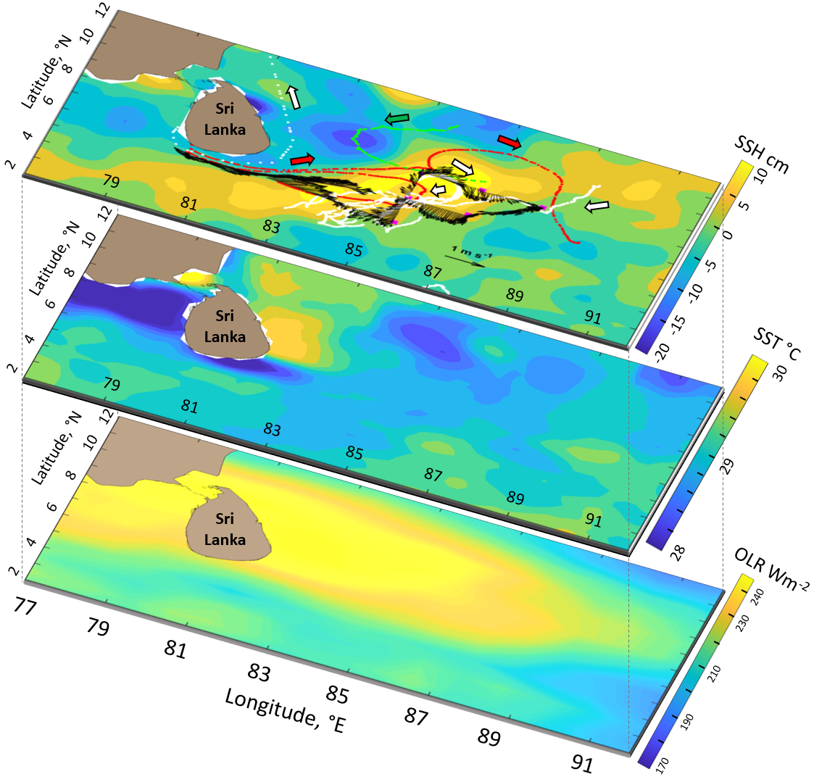
c)
b)
a)
Figure 6: Panel(a) represents the AVISO SSHA averaged values (August 1st-15th 2015). In red, drifters’ trajectories from August 8th to 31st 2012; in green, drifter trajectory from July 16th to August 2nd 2014; in white drifter trajectories from August 1st to 31st, 2015. Colored arrows denote drifters flow direction. Magenta squares and black arrows indicate, respectively, deep mooring locations and the ADCP averaged velocity vectors in the upper 24 m during the cruise period. Panel (b) and panel (c) show satellite Sea Surface Temperature (SST) and Outgoing Longwave Radiation (OLR), respectively.

4.2 Observations during 2018 MISO-BoB Cruise
The 2018 MISO-BoB cruise was designed to collect simultaneous oceanic and atmospheric data. Figure 7 embodies 2018 Leg-2 observations of SSHA, SST and OLR (all July averaged), in-situ currents measured by the shipboard ADCP, and drifter trajectories. While one on one comparison between climatological satellite maps and in-situ observations is not possible because of space-time scale differences in measurements, they are overlaid for rough comparisons. As in the 2015 case, the signatures of larger AE (magenta broken line) and SLD (blue area northwest of AE) are still evident from the mosaic of SSHA, shipboard ADCP current and drifter measurements (Figure 7a). Drifters released within the SLD (yellow circle in Figure 7a) were entrained into the SMC and travelled toward the eastern BoB, however, the eastward branch of the SMC recirculated back, forming small cyclonic eddies at 10°N and 89°E (in red) and 93° - 95°E (in magenta and yellow). In Figure 7b, 10-minute averaged SST measured using ship’s ROSR is overlaid on a satellite SST climatology map, and the atmospheric surface temperature measured by the bow mast (~16 m height, 10-minute averaged) along the ship track is superimposed on a satellite-based OLR in Figure 7c. The wind direction was southwesterly during this cruise period. Latent and sensible heat fluxes (10-minute averaged) measured from the bow mast is shown in Figure (7d).
As in 2015, coastally upwelled cold water was found to be advected by the SMC into the southern BoB. The lower latent heat (104 Wm⁻²) and sensible heat (-5.5 Wm⁻²) in the ship track through the cooler water compared to the turbulent heat fluxes (169 Wm⁻² and 3 Wm⁻²) in the relatively warmer water to the north were measured at 12:00 UTC (but on different days).This indicates that the spread of (coastally) upwelled water via SMC has implications on atmospheric surface layer temperature gradients. For example, in (Figure 7b), the SST difference between most northern and southern points of the meridional ship track (85.45°E, 4° - 14°N) measured by ROSR is ~ ± 1ºC while the ship bow mast (~16 m height) shows an atmospheric surface temperature jump ~ ± 0.5ºC over the same distance (taken at 12:00 UTC).

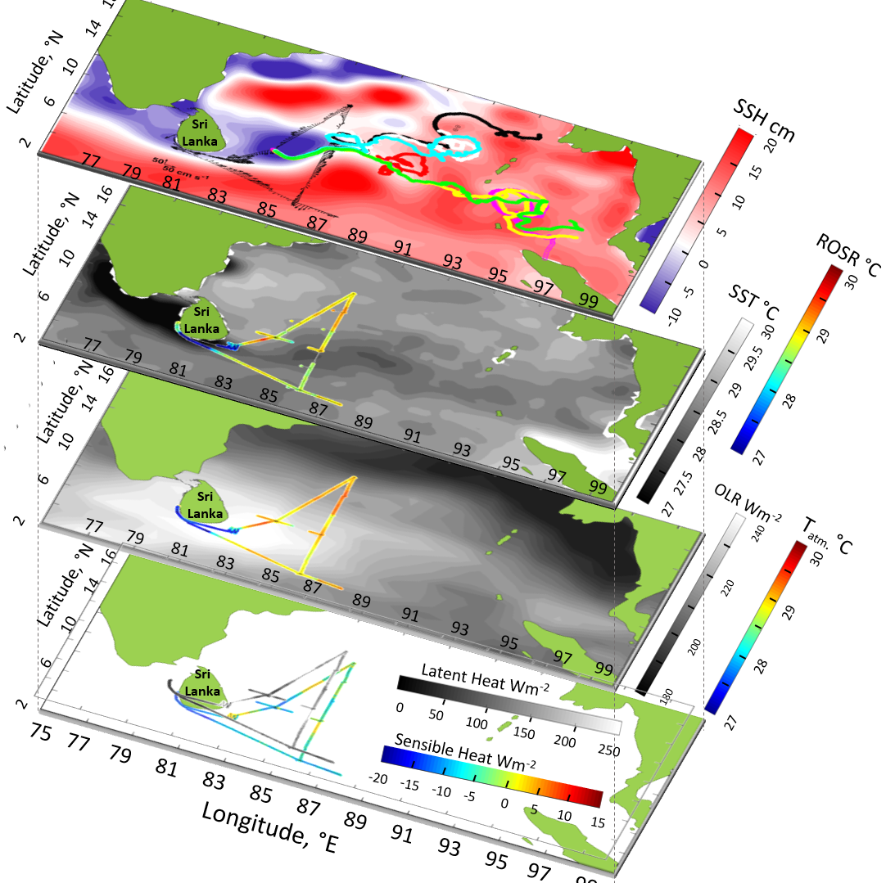
a)
b)
c)
d)

Figure 7: Panel a: AVISO SSHA map averaged over July 2018. Black arrows represent ADCP velocity vectors along ship track (June 30 - July 20 2018) averaged for the upper 60 m and every 45 minutes. Seven drifter’s trajectories (July 15 – October 29) are indicated by the colored dots. Yellow circle represents their releasing point. Magenta broken line highlights the anticyclonic eddy location (based on SSHA). Panel (b): AVISO SST map averaged for July 2018 and ROSR SST along the ship track. Panel (c): NOAA OLR map averaged for July 2018 and atmospheric surface temperature from the bow mast (~ 16 m height) along the ship track. Panel (d): Latent and Sensible Heat fluxes from the bow mast (~ 16 m height) along the ship track
During this cruise, 23 CTD casts were made along the ship track and here we report only the ones taken inside AE (Figure 8a), at the border between two eddies (Figure 8b) and inside the SLD (Figure 8c). Data confirmed that surface waters of AE is colder than the SLD. Specifically, inside the AE (black circles in Figure 8d and Figure 8a) the mixed layer depth (MLD) was ~ 75 m with a nearly homogeneous temperature ~ 28.3°C (MLD was based on the 0.2°C criterion). On the northern periphery of AE (yellow triangles in Figure 8d and Figure 8b) the MLD has decreased, reaching a depth of ~ 20 m while the averaged mixed-layer temperature increasing up to 28.6°C underlain by a shallower pycnocline (~140 m). As expected, the thermocline becomes shallower toward the SLD. Inside it (magenta stars in Figure 8d and Figure 8c), the MLD slightly increased to ~ 35 m along with the surface temperature reaching ~ 29.2°C. This confirms that between the SLD and the AE there is a temperature difference of ~ ± 0.9ºC. The OLR climatology (> 200 Wm⁻²) indicates that southwestern BoB was devoid of high clouds and convective activity (Figure 7c), consistent with the observed negative sensible heat flux (which depends on the SST and atmospheric temperature). In all, the mixed layer properties and SST in the southwestern BoB are determined by an interplay of the SMC advecting colder surface water into BoB, planetary waves, and breaking down of planetary waves into eddies.

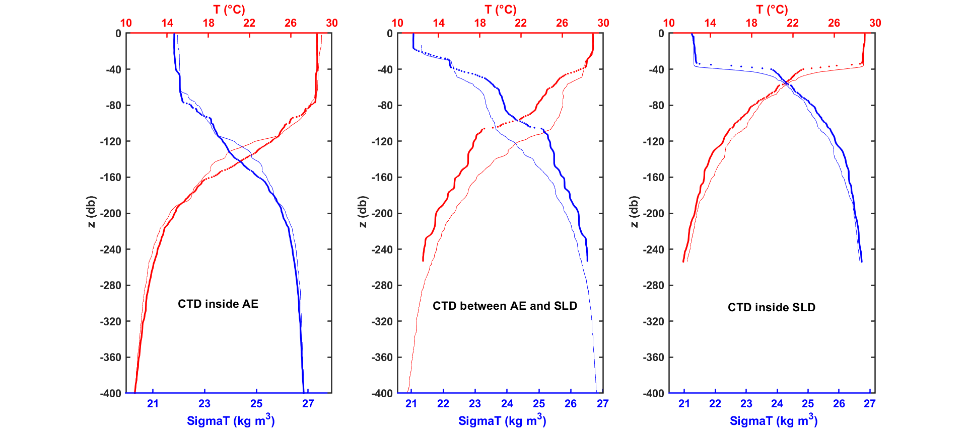
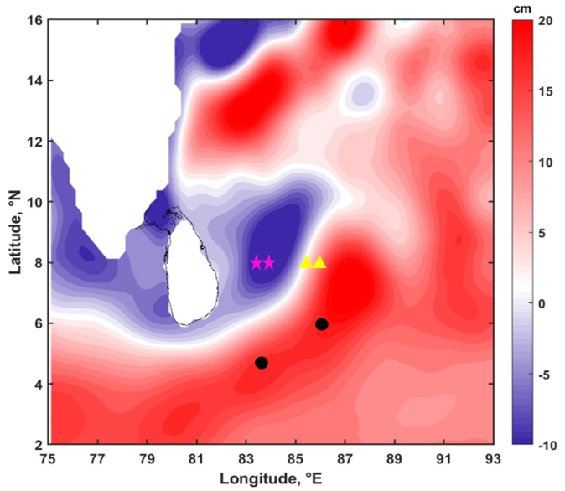
a)
b)
c)
d)
`
CTD inside AE
CTD on the
borders
CTD inside SLD
Τ
σ_{t}
Τ
σ_{t}
Τ
σ_{t}
Figure 8: Temperature (in red) and Sigma T (in blue) profiles (from CTD analysis) inside the AE (panel a), on the borders (panel b) and inside the SLD (panel c). CTD locations are indicated in panel d: black circles indicate CTD locations inside the AE, yellow triangles on the borders, and magenta stars inside the SLD. Map of SSHA (in cm) averaged for July 2018 is presented in panel d.

σ_{t}

- COAMPS® Model Output and AVISO SSHA Data
Figure 9 shows a snapshot of velocity field in the upper 25 m layer for August 25, 2015 based on COAMPS® simulations. A strong jet-like current ~ 1 m s⁻¹ is present south of Sri Lanka. With its origin at ~ (75°E, - 5°N), this northeastward current is perturbed as it flows past the southern coast of Sri Lanka and folds into a strong anticyclonic circulation, evolving into a meander sandwiched between anticyclonic and cyclonic eddies. Also evident is a weaker current (~ 0.5 m s⁻¹) from the north of BoB (magenta circle) that entrains into the anticyclonic eddy. This southward flow is predicted with the same order of magnitude by ROMS simulations described in de Vos et al., (2014) and is represented in green by the drifter trajectory in Figure 6a. Also note the development of SLD east of Sri Lanka almost simultaneously. Here the SLD is distorted by the landmass. Killworth (1980) has pointed out that instabilities of planetary waves can be strongly modified by side and bottom boundaries, and we expect the same here.
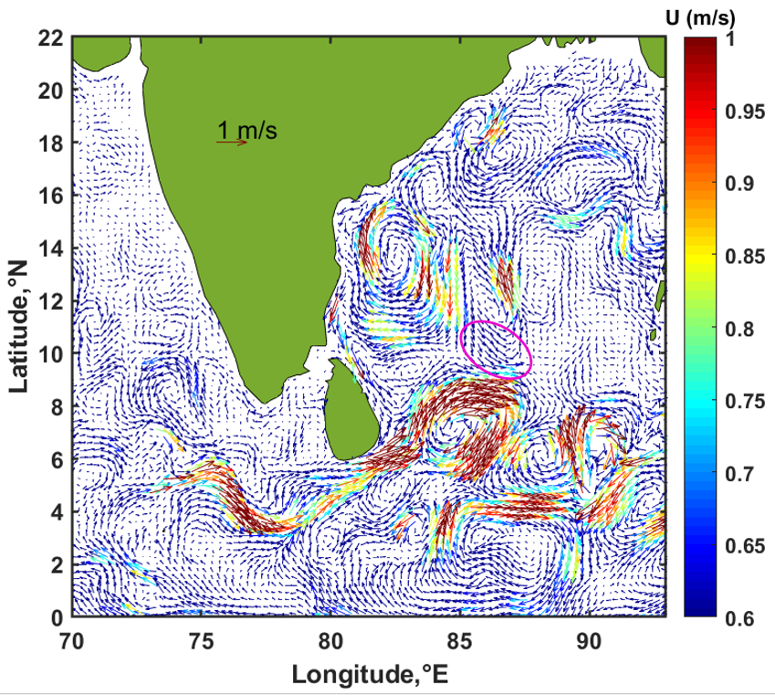
Figure 9: Velocity field snapshot from COAMPS® model for August 25th 2015. Currents vectors are averaged for the upper 25 m depth (and every three hours). Magenta circle indicates a southward current associated with the SLD and representative of the green drifter trajectory in Figure 6a.

To investigate the hypothesis of Vinayachandran and Yamagata (1998), i.e., the arrival of Rossby waves generated off the coast of Sumatra due to impingement of spring Wyrtki jet may be a cause for AE formation, an animation of daily (AVISO) SSHA was constructed (see, supplementary material). It covered the region (70° - 100°E, 5°S - 24°N) for May 1, 2015 to December 31, 2015, which included the entire summer monsoon and a part of the winter monsoon. Six snapshots of this animations (Figure 10) clearly show that the AE is originated alongside the SMC (Figures b and c), simultaneous with the SLD, before the arrival of Rossby waves from southeast in August/September. The SLD is evident from June to August (black ellipse, deep blue region): it originated in early June north of the developing AE (magenta ellipse), is fully developed by the middle of June, slowly pushed westward toward the end of August, and fades away by September. Most probably, the AE, a high-pressure center, ensures the northwestward movement of the SLD, which is a low-pressure system. A similar evolution of the SLD has been noted during 2014 summer Monsoon (Lozovatsky et al., 2016, Wijesekera et al., 2016a).

Positive SSHA, ~ 5 - 20 cm, recorded in the area (80° - 86 °E, 2° - 5°N) in early June, 2015 (Figure 10b) confirms that the AE was generated following the initiation of the SMC around April 26, 2015, identified based on the shift of wind direction. The anti-cyclonic vortex is slowly distorted up to 8°N assuming an elliptical shape with a northeast-southwest major axis in August 2015 (Figure 10, d-e), possibly due to the presence of continental boundaries. The AE exhibited intensification at the beginning of September (Figure 10f), reaching SSHA > 20 cm while becoming more circular. These observations point to the possible contribution of Rossby waves arriving from the southeast to the evolution of the AE after August/September. In fact, Wyrtki (1973) showed that accumulation of water off Sumatra in May disperses slowly during the following two months. A time - longitude section of meridional velocity along 8°N constructed from the modeling results of Vinayachandra et al., (1998; their Figure 9) also confirms that Rossby waves from the southeast do not arrive at the southwestern BoB until September.
Similar SSHA analyses were also conducted for prior years (2010-2014), and the animations confirmed the formation of the AE almost simultaneously with the SLD at the beginning of June, following the genesis of the SMC (not shown). Thereafter, eddies develop in July-August and disappear in September, providing support for our hypothesis proposed in Section 2, that Rossby waves from the southeast impact the southwestern BoB only in the late summer (August-September) and are not an ingredient for generation of the AE.
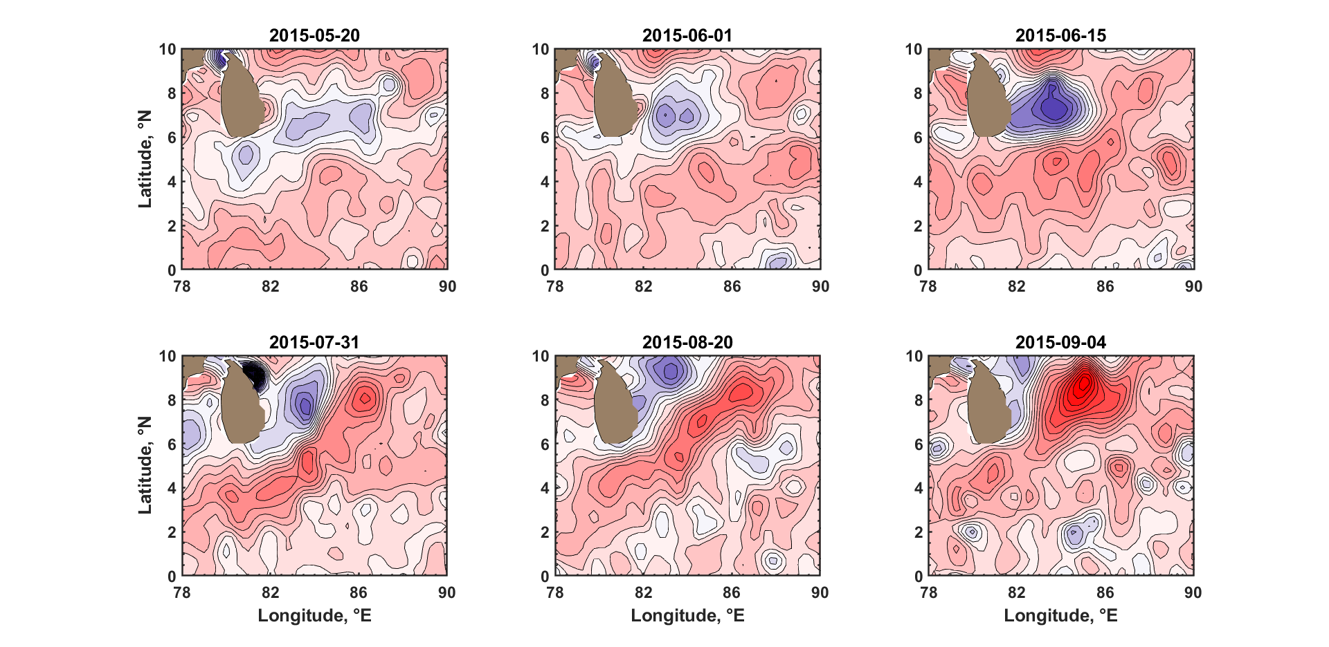
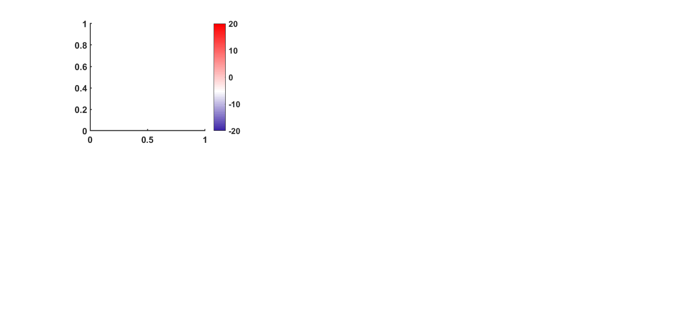
SSHA
(cm)
(d)
(a)
(b)
(c)
(e)
(f)

Figure 10: AVISO SSHA maps. Evolution of SLD (black broken line) in conjunction with the AE (magenta dashed line) from May to September 2015.

The COAMPS® model output was used to further investigate the nature of eddies by evaluating the vertical component of the relative vorticity ω = ∂V/∂x - ∂U/∂y, where U and V are the zonal (x) and meridional (y) velocity components. The daily averaged results for the study area (80° - 90°E, 3° - 9°N) are shown in Figure 11 at a depth of 35 m, selected on the basis of the depth for maximum vertical vorticity. The blue region to the east of Sri Lanka signify the AE ($ω<0$), and it coincides with the area of positive SSHA (~ 15 cm) detected from the AVISO data on the same day and highlighted in Figure 11 by the red-black dotted lines. Negative vorticity values (~ - 2 x 10⁻⁵ s⁻¹) are in agreement with the one captured by moorings observations and discussed by Wijesekera et al., (2016a). Specifically, based on the 3º spatial averaging scale, the AE had a negative vorticity of about (0.5 - 0.8) f_{6.5N}, where the inertial frequency at 6.5°N is f_{6.5N} = 1.65 x 10⁻⁵ s⁻¹, suggesting possible ageostrophic motions.
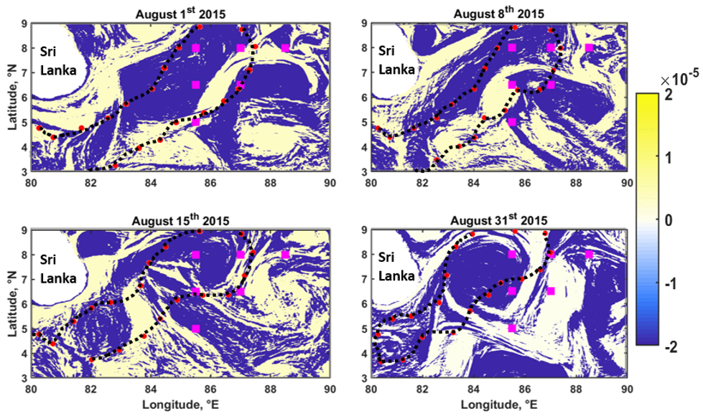
ω, s⁻¹
Figure 11: Vertical component of relative vorticity ω for August 2015 based on COAMPS® velocities at z=-35 m. Magenta squares indicate mooring locations deployed in 2013 and the red-black dotted lines specify the AE from SSHA data (~ 15 cm) for the day indicated.

- Laboratory Experimental Results
Figure 12a shows laboratory observations with approximately matched π and $Ro$ between the SMC and the laboratory jet. The (yellow) particle tracks have been retrieved using Particle Tracking Velocimetry (PTV) based on a frame record of ~ 20 seconds. Note the anticlockwise direction of rotation of the laboratory tank. The topographically-perturbed eastward flow on the β plane (green arrow) develops a negative vorticity due to potential vorticity conservation, leading to the formation of an AE. A cyclonic eddy (SLD) is formed simultaneously, the growth of which is affected by the Sri Lanka topography. Upon formation, the laboratory eddies are influenced by the local Coriolis effects. While other less-pronounced eddies associated with or triggered by the trapped Rossby wave appear in BoB, as marked by drifter tracks (Figure 7a), such multiple eddies are absent in the laboratory possibly because of weak jet forcing at the exit and bottom friction that causes eddy dissipation. The theoretical diameter of the laboratory anticyclonic eddy${(U_{0}/)}^{1/2}$ ranges between 10 and 18 cm, the observed laboratory values are between 12 and 19 cm, and the corresponding AE diameter in BoB is ~ 500 km. The velocity of the laboratory anti-cyclonic eddy (from the PTV analysis) was between 0.11 and 0.34 cm s⁻¹, and based on $π$ similarity this corresponds to an AE oceanic velocity of ~ 0.7 – 0.8 m s⁻¹, which is comparable to what observed during ADCP observations in Sections 4.1 and 4.2.
The same experiment, but conducted without the Sri Lanka model, is shown in Figure 12b. Without the topographic perturbation, the cyclonic/anticyclonic eddy pair (originating from the trapped Rossby-wave) is absent, and the flow simply deflects due to the Coriolis effects and forms a single eddy with a diameter varying between 15 and 21 cm. Eddy velocity remain still within 0.11 and 0.34 cm s⁻¹.
Another controlled experiment was conducted without the simulated $β$ effect (i.e., with a flat bottom, α = 0), but with otherwise identical forcing parameters to the previous cases (Figure 12c). The flow separation generated some cyclonic vorticity but velocities within the eddy were significantly smaller than that in the anticyclonic eddy formed by Coriolis deflection of the jet. On this f plane (i.e., β = 0 case) the AE is smaller and displaced to further south of the island compared to that of Figure 12a, arguably due to the lack of a Rossby wave response. Voropayev et al., (1997) have studied jets on a f plane, and proposed an anticyclonic eddy diameter scale ~ ${U_{0}}/{f_{0}}$. Accordingly, our f plane experiments ought to produce an AE of diameter ~ 5.2 cm, and the observed eddy diameter was ~ 7 cm (distance from the center to the streamline of maximum velocity).
The sensitivity to the shape of the coast was also considered in a set of experiments. In particular, the island was shaped with a cylinder and a parallelepiped. For the same values of bottom slope, flow velocity and tank rotation, the formation of an elliptical anticyclonic eddy was observed southeast of model topography irrespective of the obstacle shape (not shown here), suggesting that indeed the island is a topographic perturbation for planetary waves. However, the velocity magnitude and location of eddies appear to depend on the details of the topography.
The analysis of Pirro et al., (2019, submitted to this issue) estimated the production term, $-<u’v’>dU_{0}/dz$ using data from the moorings described in Wijesekera et al. (2016a). The production term was positive in the upper 100 m for the time period where the AE was observed in August 2014, suggesting that the SMC may undergo barotropic instability and transfers kinetic energy from the main flow to AE and SLD, as suggested in this paper.

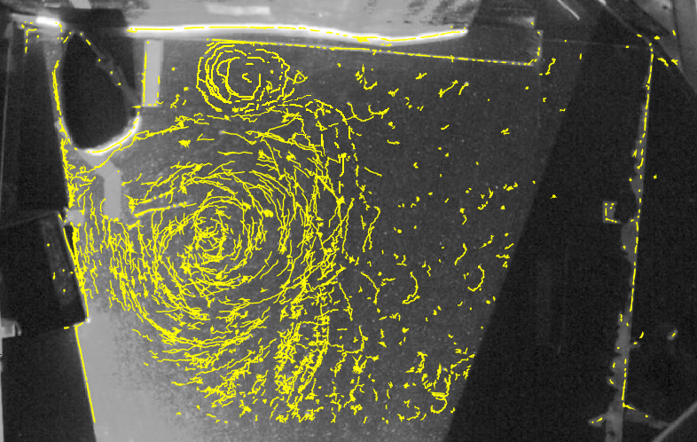
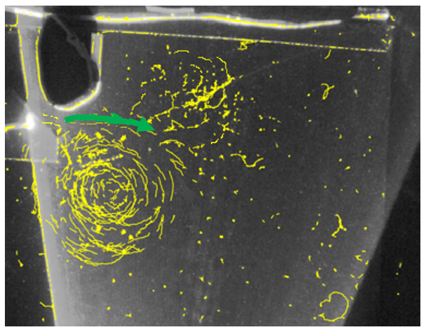
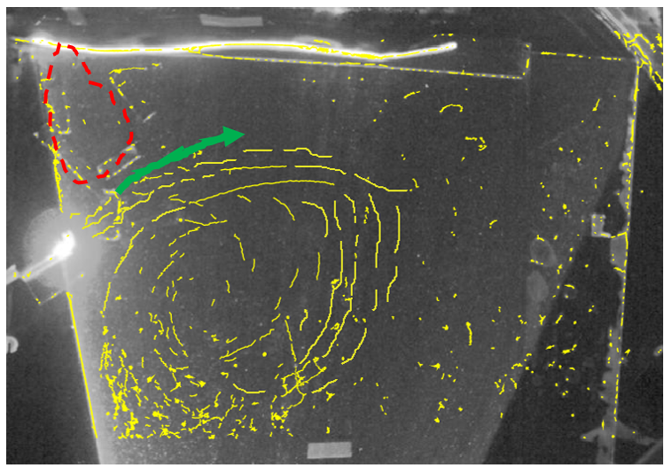
a)
b)
c)
3 cm

Figure 12: Laboratory experimental results, illustrated using particle tracks that follow the flow. (a) For the case of β plane (α ~ 2.3° and 2.5°), southwesterly flow in a rotating tank splits into an AE southeast of Sri Lanka, and a cyclonic (SLD) eddy east of Sri Lanka; (b) For flow in β plane (α ~ 2.3° and 2.5°) with no Sri Lanka, an elliptical AE is formed, triggered by the southwesterly flow. Red dashed line indicates that Sri Lanka was removed. (c) For the f plane case (flat bottom, α=0), southwesterly flow splits into a small, circular and AE south of Sri Lanka, and a weaker cyclonic (SLD) eddy east of the island. Green (blue) arrows indicate AE (SLD) flow direction.

- Summary and Conclusions
This paper concerned the nature and dynamics of eddies and currents in southwestern Bay of Bengal (BoB), in particular, the Sri Lanka Dome (SLD), the Anticyclonic Eddy (AE) and the Southwest Monsoon Current (SMC). These prominent and recurring features of summer monsoons have been studied previously to some extent, and the present work attempts to synthesize information from two recent cruises (2015, 2018), satellite platforms, numerical simulations and laboratory experiments to: (i) identify the formation mechanism of eddies based on a new hypothesis, and (ii) report dynamical attributes of the AE and the SLD identified during the cruises. In the proposed hypothesis, the SLD and the AE are formed by the instabilities of trapped Rossby waves generated by the perturbation of the SMC by southern Sri Lanka shelf. This research hoped to foster modeling efforts as well as improve understanding of air-sea coupling in the BoB. The major findings are as follows:
- A simple theoretical analysis suggests that a trapped Rossby wave response of the SMC may produce the broad eddy features of the southwestern BoB, in that barotropic instability of these waves lead to the SLD and the AE forming on each side of the meandering SMC. This notion is supported by animated satellite imagery and COAMPS® regional simulations that indicate both eddies are formed almost simultaneously with the genesis of the SMC in the early summer. These results, however, differ from the previous proposal of Vinayachandran and Yamagata (1998) for AE formation, that is, a collision between the SMC and southeasterly Rossby waves generated off the coast of Sumatra due to impingement of the spring Wyrtki jet, may be the cause for the AE. According to our work, such waves do not arrive in the southwestern BoB until late in the summer (August/September) whereas the SLD and the AE appear soon after the SMC is formed in our observations as well as our model simulations. Recent work of De Vos et al., (2014) suggest that the SLD is formed due to the separation of SMC from the southern cost of Sri Lanka, and not due to the cyclonic wind curl as has been proposed earlier (McCreary at al., 1996). The mechanism of De Vos et al. (2014), however, does not provide a mechanism for simultaneous AE formation as observed, which require anticyclonic vorticity generation. It is worth noting that Boyer and Davies (1982) and Merkine (1980) have shown that flow separation of an eastward jet from a topography on $β$ plane is inhibited when ${Ek}^{1/2}<Ro\left(H/L\right)$, where $H$ is the depth of flow and $L$ the horizontal scale, $Ro$ the Rossby number and $Ek$ the Ekman number. For the SMC, ${Ek}^{1/2}$= 2.6 x 10⁻⁶ and $R_{o}\left(H/R\right)$= 7 x 10⁻³, and thus the flow separation is assumed to be minor. Considering all evidence, we argue that the $β$effect, and hence Rossby wave dynamics, is the main cause for the existence of the SLD and the AE.
- The predicted half wavelength of the Rossby wave λ=π${({\overline{U}}_{o}/) }^{1/2}$ ~ 500 km matched the distance where the AE appears downstream of Sri Lanka, further supporting our hypothesis. Barotropic Rossby waves are inherently unstable and may generate cyclonic (SLD) and anticyclonic eddies on either side of the jet (SMC). Negative (~ - 2 x 10⁻⁵ s⁻¹) and positive (~ 5 x 10⁻⁶ s⁻¹) values of the vertical component of relative vorticity reckoned by the COAMPS® model at the AE and SLD locations, respectively, confirm this notion. Barotropic instability of a zonal jet on the $f$plane without effect also produces instabilities, but the estimated wave length is too large to be reconciled with the observations, instead pointing to the role of Rossby waves.
- An exploratory laboratory experiment with dynamic similitude (i.e., matched salient dimensionless parameters) between SMC and laboratory further supported the proposed eddy formation mechanism. In the presence of the β effect, the development of the AE together with the somewhat smaller cyclonic eddy (SLD) to the north was observed in the laboratory. An identical experiment but without β effect produced an anticyclonic eddy only, accompanied by a weak cyclonic eddy due to flow separation by the Sri Lanka model. By removing Sri Lanka model while retaining the β effect, the cyclonic eddy disappeared altogether and only the Coriolis deflection of the jet was observed. In all, the results indicate that the SMC on β plane may excite topographically trapped unstable Rossby waves, producing eddy structures that have similarities those in the southwestern BoB. Further observational and modeling work are needed to verify the hypothesis proposed.
- Observations of two research cruises shed light on salient features of eddies and currents in BoB. During the 2015 summer cruise, ADCP current vectors recorded a velocity of ~ 1 m s⁻¹ in the AE, which penetrated to the thermocline depth of ~ 150 m. AVISO SSHA satellite data averaged over the cruise period (August 1st - 15th 2015) confirmed the presence of the AE with positive SSHA of about 5 - 10 cm. Trajectories of drifters followed the SMC and segments of eddies. The SLD was clearly evident in negative SSHA data. Satellite SST maps indicate that colder water advected by the SMC occupies a good fraction of the AE surface water (temperature ~ 28.6°C) while the nearby SLD reaching SST as high as 29.6°C. Upwelling in the southern Sri Lanka and Indian coasts is the source of the colder water in the SMC. Observations in 2018 summer was similar, in that AE and SLD characteristics were confirmed by the SSHA, ADCP vector currents and drifters’ trajectories. Again, SST in the AE (~ 28.5°C) was consistently colder than that of SLD (~ 30°C). The lower latent heat and sensible heat measured by the ship’s flux tower in AE indicate that transport of upwelled water from the south of Sri Lanka by the SMC may have implications on air-sea fluxes in the region.

Acknowledgements
We are grateful to the crew of R/V Roger Revelle and R/V Thomas G. Thompson, and a group of University of Notre Dame and Naval Research Laboratory (NRL) scientists and technical personnel for assistance with shipboard instrumentations. We are grateful to the National Aquatic Resource Research and Development Agency (NARA) scientists for their help. ASIRI and MISO-BoB projects were funded by the US Office of Naval Research (ONR) and NRL. The University of Notre Dame group gratefully acknowledge the support through ONR grant #N00014-17-1-2334. The paper was considerably improved while responding to two thoughtful referees, and we wish to sincerely thank them.

References
Alaee, M.J., Ivey, G. and Pattiaratchi, C., 2004. Secondary circulation induced by flow curvature and Coriolis effects around headlands and islands. Ocean Dynamics, 54(1), 27-38.
Batchelor, G. K., 1967: An Introduction to Fluid Dynamics, Cambridge Univ. Press, Cambridge, U. K.
Boyer, D. L., and P. A. Davies, 1982. Flow past a circular cylinder on a β-plane. Phil. Trans. R. Soc. Lond. A 306.1496: 533-556.
Centurioni, Luca R. 2018. Drifter Technology and Impacts for Sea Surface Temperature, Sea-Level Pressure, and Ocean Circulation Studies. in R. Venkatesan, Amit Tandon, Eric D'Asaro and M. A. Atmanand (eds.), Observing the Oceans in Real Time (Springer International Publishing: Cham).
Das, U., Vinayachandran, P.N. and Behara, A., 2016. Formation of the southern Bay of Bengal cold pool. Climate Dynamics, 47(5-6), 2009-2023. https://doi.org/10.1007 /s00382-015-2947-9
De Vos, A.D., Pattiaratchi, C.B. and Wijeratne, E.M.S., 2014. Surface circulation and upwelling patterns around Sri Lanka. Biogeosciences, 11(20), 5909-5930.
Durand, F., Shankar, D., Birol, F. and Shenoi, S.S.C., 2009. Spatiotemporal structure of the East India Coastal Current from satellite altimetry. Journal of Geophysical Research: Oceans, 114(C2). http://dx.doi.org/10.1029/2008JC004807.
Gill, A.E., 1974. The stability of planetary waves on an infinite beta‐plane. Geophysical and Astrophysical Fluid Dynamics, 6(1), 29-47.
Gill, A.E., 1982. Atmosphere-Ocean Dynamics, Academic Press.
Greatbatch, Richard J., 1985. Kelvin wave fronts, Rossby solitary waves and the nonlinear spin‐up of the equatorial oceans. Journal of Geophysical Research: Oceans 90.C5: 9097-9107.
Hastenrath S. and Greiscahr L., 1991. The monsoonal current regimes of the tropical Indian Ocean: Observed surface flow fields and their geostrophic and wind‐driven components. Journal of Geophysical Research: Oceans 96.C7: 12619-12633.
Hocut, C.M., Liberzon, D. and Fernando, H.J.S., 2015. Separation of upslope flow over a uniform slope. Journal of Fluid Mechanics, 775, 266-287.
Jensen, T.G., 2001. Arabian Sea and Bay of Bengal exchange of salt and tracers in an ocean model. Geophysical Research Letters 28(20): 3,967–3,970, http://dx.doi.org/10.1029/2001GL013422.
Jensen, T.G., 2003. Cross-equatorial pathways of salt and tracers from the northern Indian Ocean: Modelling results. Deep Sea Research Part II 50(12–13): 2,111–2,127. http://dx.doi.org/10.1016/ S0967-0645(03)00048-1.
Jensen, T.G., Shinoda, T., Chen, S. and Flatau, M., 2015. Ocean response to CINDY/DYNAMO MJOs in air-sea-coupled COAMPS. Journal of the Meteorological Society of Japan. Ser. II, 93, 157-178.
Jensen, T. G., Wijesekera, H. W., Nyadjro, E. S., Thoppil, P. G., Shriver, J. F., Sandeep, K. K., & Pant, V., 2016. Modeling salinity exchanges between the equatorial Indian Ocean and the Bay of Bengal. Oceanography, 29(2), 92-101.
Killworth, P.D., 1980. Barotropic and baroclinic instability in rotating stratified fluids. Dynamics of Atmospheres and Oceans, 4(3),143-184.
Lozovatsky, I., Wijesekera, H., Jarosz, E., Lilover, M.J., Pirro, A., Silver, Z., Centurioni, L. and Fernando, H.J.S., 2016. A snapshot of internal waves and hydrodynamic instabilities in the southern Bay of Bengal. Journal of Geophysical Research: Oceans, 121(8), 5898-5915.
Mahadevan, A., Paluszkiewicz, T., Ravichandran, M., Sengupta, D. and Tandon, A., 2016. Introduction to the special issue on the Bay of Bengal: From monsoons to mixing. Oceanography, 29(2), 14-17.
McCreary Jr, J.P., Kundu, P.K. and Molinari, R.L., 1993. A numerical investigation of dynamics, thermodynamics and mixed-layer processes in the Indian Ocean. Progress in Oceanography, 31(3), 181-244.
McCreary, J.P., Han, W., Shankar, D. and Shetye, S.R., 1996. Dynamics of the east India coastal current: 2. Numerical solutions. Journal of Geophysical Research: Oceans, 101(C6), 13993-14010.
Merkine, Lee-Or, 1980: Flow separation on a beta plane. J. Fluid Mech. 99.2, 399-409.
Mukherjee, A., Shankar, D., Fernando, V., Amol, P., Aparna, S.G., Fernandes, R., Michael, G.S., Khalap, S.T., Satelkar, N.P., Agarvadekar, Y. and Gaonkar, M.G., 2014. Observed seasonal and intraseasonal variability of the East India Coastal Current on the continental slope. Journal of earth system science, 123(6), pp.1197-1232. http://dx.doi.org/10.1007/ s12040-014-0471-7.
Murty, V.S.N., Sarma, Y.V.B., Rao, D.P. and Murty, C.S., 1992. Water characteristics, mixing and circulation in the Bay of Bengal during southwest monsoon. Journal of Marine Research, 50(2), 207-228.
Niiler PP, Sybrandy A, Bi K, Poulain PM, Bitterman D, 1995. Measurements of the water-following capability of holey-sock and TRISTAR drifters. Deep-Sea Res 1(42):1951–1964.
Pirro, A., Wijesekera, H.W., Jarosz, E., Fernando, H.J.S., 2019. Dynamics of Intra-seasonal Oscillations in Bay of Bengal during Summer Monsoons Captured by Mooring Observations, Deep Sea Research II, this issue.
Potemra, J.T., Luther, M.E. and O'Brien, J.J., 1991. The seasonal circulation of the upper ocean in the Bay of Bengal. Journal of Geophysical Research: Oceans, 96(C7), 12667-12683.
Rao, T.S. and Griffiths, R.C., 1998. Understanding the Indian Ocean: perspectives on oceanography, UNESCO publishing Paris.
Shankar, D., Vinayachandran, P.N. and Unnikrishnan, A.S., 2002. The monsoon currents in the north Indian Ocean. Progress in oceanography, 52(1), 63-120.
Shetye, S.R., Gouveia, A.D., Shenoi, S.S.C., Sundar, D., Michael, G.S., Almeida, A.M. and Santanam, K., 1990. Hydrography and circulation off the west coast of India during the southwest monsoon 1987. Journal of Marine Research, 48(2), 359-378.
Shetye, S.R., Gouveia, A.D., Shankar, D., Shenoi, S.S.C., Vinayachandran, P.N., Sundar, D., Michael, G.S. and Nampoothiri, G., 1996. Hydrography and circulation in the western Bay of Bengal during the northeast monsoon. Journal of Geophysical Research: Oceans, 101(C6), 14011-14025. http://dx.doi.org/ 10.1029/95JC03307.
Schott, F., Reppin, J., Fischer, J. and Quadfasel, D., 1994. Currents and transports of the Monsoon Current south of Sri Lanka. Journal of Geophysical Research: Oceans, 99(C12), 25127-25141.
Schott, F. A., and J. P. McCreary, 2001. The monsoon circulation of the Indian Ocean. Progress in Oceanography, 51.1: 1-123.
Tomczak, M. and Godfrey, J., 2003. Regional Oceanography: An introduction. 2nd Edition, Elsevier.
Vinayachandran, P.N., Shetye, S.R., Sengupta, D. and Gadgil, S., 1996. Forcing mechanisms of the Bay of Bengal. Curr. Sci, 70(10), 753-763.
Vinayachandran, P. N., and T. Yamagata, 1998. Monsoon response of the sea around Sri Lanka: Generation of thermal domes and anticyclonic vortices. Journal of Physical Oceanography, 28, 1946-1960.
Vinayachandran, P.N., Masumoto, Y., Mikawa, T. and Yamagata, T., 1999. Intrusion of the southwest monsoon current into the Bay of Bengal. Journal of Geophysical Research: Oceans, 104(C5), 11077-11085. http://dx.doi.org/10.1029/1999JC900035.
Vinayachandran, P.N., Chauhan, P., Mohan, M. and Nayak, S., 2004. Biological response of the sea around Sri Lanka to summer monsoon. Geophysical Research Letters, 31(1).
Vinayachandran, P.N., Shankar, D., Vernekar, S., Sandeep, K.K., Amol, P., Neema, C.P. and Chatterjee, A., 2013. A summer monsoon pump to keep the Bay of Bengal salty. Geophysical Research Letters, 40(9), pp.1777-1782. http://dx.doi.org/ 10.1002/grl.50274
Vinayachandran, P.N., Matthews, A.J., Vijay Kumar, K., Sanchez-Franks, A., Thushara, V., George, J., Vijith, V., Webber, B.G., Queste, B.Y., Roy, R. and Sarkar, A., 2018. BoBBLE (Bay of Bengal Boundary Layer Experiment): Ocean–atmosphere interaction and its impact on the South Asian monsoon. Bulletin of the American Meteorological Society 2018.
Voropayev, S.I., Zhang, X., Boyer, D.L., Fernando, H.J. and Chi Wu, P., 1997. Horizontal jets in a rotating stratified fluid. Physics of Fluids, 9(1), 115-126.
Webber, B.G., Matthews, A.J., Vinayachandran, P.N., Neema, C.P., Sanchez-Franks, A., Vijith, V., Amol, P. and Baranowski, D.B., 2018. The dynamics of the Southwest Monsoon current in 2016 from high-resolution in situ observations and models. Journal of Physical Oceanography, 48(10), 2259-2282.
Wijesekera, H.W., Jensen, T.G., Jarosz, E., Teague, W.J., Metzger, E.J., Wang, D.W., Jinadasa, S.U.P., Arulananthan, K., Centurioni, L.R. and Fernando, H.J.S., 2015. Southern Bay of Bengal currents and salinity intrusions during the northeast monsoon. Journal of Geophysical Research: Oceans, 120(10), 6897-6913.
Wijesekera, H.W., Teague, W.J., Wang, D.W., Jarosz, E., Jensen, T.G., Jinadasa, S.U.P., Fernando, H.J.S. and Hallock, Z.R., 2016a. Low-frequency currents from deep moorings in the Southern Bay of Bengal. Journal of Physical Oceanography, 46(10), 3209-3238. http://dx.doi.org/10.1175/JPO-D-16-0113.1.
Wijesekera, H.W., Shroyer, E., Tandon, A., Ravichandran, M., Sengupta, D., Jinadasa, S.U.P., Fernando, H.J., Agrawal, N., Arulananthan, K., Bhat, G.S. and Baumgartner, M., 2016b. ASIRI: An ocean–atmosphere initiative for Bay of Bengal. Bulletin of the American Meteorological Society, 97(10), 1859-1884.
Wyrtki, Klaus, 1973. An equatorial jet in the Indian Ocean. Science 181.4096: 262-264.
Yu, L., O'Brien, J.J. and Yang, J., 1991. On the remote forcing of the circulation in the Bay of Bengal. Journal of Geophysical Research: Oceans, 96(C11), 20449-20454.

