Megazonation of earthquake‑induced soil liquefaction hazard in continental Europe

F. Bozzoni1 · R. Bonì2 · D. Conca3 · C. G. Lai3 · E. Zuccolo3 · C. Meisina2

Abstract
Mapping large territories for earthquake-induced soil liquefaction hazard may sound like an oxymoron since soil liquefaction is by itself a spatially highly localized phenomenon. Thus, the zonation of liquefaction hazard at the continental scale (i.e. megazonation) is a truly hard facing challenge even if accepting a low level accuracy. Yet, the availability of a megazonation chart of liquefaction hazard could be useful to identify territories that in case of an earthquake may display this phenomenon of soil instability distinguishing them from the regions where soil liquefaction is not expected even in case of strong ground shaking. A representation of the spatial variability of liquefaction hazard potential within a single country is within reach considering the resolution and accuracy of geological and geotechnical information that is currently available in the most developed nations. The LIQUEFACT project fully addressed in a specific work package the problem of construct- ing georeferenced, earthquake-induced soil liquefaction hazard maps in continental Europe for various return periods. They were built using homogeneous datasets in Europe on the expected seismic hazard and on the geological, geomorphological, hydrogeological, shal- low lithology and digital terrain information. A probabilistic prediction model based on a logistic regression for liquefaction occurrence was purposely developed using a set of opti- mal geospatial predictors (explanatory variables) which include the weighted-magnitude
peak ground acceleration, the weighted-mean shear-wave velocity in the top 30 m (VS30) and the compound topographic index. The optimal geospatial descriptors were selected based on the Luco and Cornell methodology, namely on the criteria of efficiency, practical-
ity and proficiency. To calibrate and successively validate the logistic regression, a data- base of liquefaction manifestations occurred in continental Europe was used. Although the level of accuracy provided by these models at a local scale is low, still the availability of continental charts of liquefaction hazard may help policy makers and administrators to pri- oritize which urbanized territories should be investigated further to assess the seismic risk of structures and infrastructures associated to the occurrence of soil liquefaction.
Keywords Liquefaction · Earthquake · Zonation · Logistic regression · LIQUEFACT project · Europe

F.Bozzonifrancesca.bozzoni@eucentre.it

Introduction
At a first glance, zonation of a large territory for earthquake-induced liquefaction haz- ard seems to be an almost unachievable goal since liquefaction is a phenomenon of soil instability occurring at a very local scale, that is it may or it may not occur at a specific location and depth from the ground surface depending on whether certain conditions of soil susceptibility and severity of ground shaking are met at that particular depth. Thus, its occurrence or non-occurrence at a given depth in a soil deposit depends on so many different and to a certain extent unknown variables that charting this phenomenon at large geographic scales seems a hopeless task. As such, few are the attempts in the scientific lit- erature and among them are worth mentioning the recent studies carried out by Baise et al. (2012) and Zhu et al. (2015, 2017), who developed regional liquefaction-mapping models exploiting geospatial data available at large scales. These studies were built upon previ- ous works such as that by Youd and Perkins (1978), who characterized the relationship between geologic depositional environments and liquefaction susceptibility, or the analysis by Wald and Allen (2007), who identified a first-order approximation of soil conditions from topography. Knudsen and Bott (2011) found out that liquefaction occurrences often coincide with simple geospatial features such as topographic slope and distance from the closest river. Zhu et al. (2015) developed a logistic model to predict the probability of liq- uefaction after an earthquake by using geospatial parameters as proxies for ground motion intensity, soil density, and degree of saturation. To achieve this goal, they built a liquefac- tion occurrence/non-occurrence unbiased database, namely it provides a complete coverage over the tested area in Japan (Kobe) and New Zealand (Christchurch). In Japan, the work by Matsuoka et al. (2015) followed a similar approach for a Japanese liquefaction dataset, including among others the geomorphological classification map of Japan. Yilmaz et al. (2018) performed a large-scale liquefaction risk assessment of Portugal by applying Zhu et al. approach for estimating damage and economic losses within a probabilistic frame- work. Recently, Zhu et al. (2017) updated their previous model (Zhu et al. 2015) expanding liquefaction database (i.e. data from India, China, and Taiwan were added) and the set of geospatial candidate explanatory variables. The study presents two alternative models and their goodness in the predictions is quantitatively assessed by using the receiver operat- ing characteristic (ROC) method. This is a useful procedure for organizing classifiers and visualize their performance (e.g. Fawcett 2005). Although applications of ROC analysis in geotechnical engineering have been limited, the results obtained so far seem promising (e.g. Maurer et al. 2019).
The aforementioned approaches (e.g. Zhu et al. 2015, etc.) belong to the category of data-driven methods. In a data-driven procedure, an algorithm is implemented based upon existing databases of liquefaction manifestations in historical earthquakes. The algorithm is trained to predict the occurrence or non-occurrence (i.e. the binary outcome) of soil lique- faction under certain conditions specified by a set of explanatory variables. As alternative to the data-driven methods, knowledge-driven approaches can also be adopted. An example is represented by the Analytical Hierarchy Process (AHP) a multi-criteria decision analysis technique, introduced by Saaty (1980) and applied for mapping natural hazards and the associated risk (e.g. Karimzadeh et al. 2014; Panahi et al. 2014; Moustafa 2015; Lai et al 2019b, etc.). AHP is a method where the explanatory variables are ranked, and their rela- tive importance is computed by assigning weights via calculation of a pairwise comparison matrix. A shortcoming of the method is represented by the subjectivity of the assigned rank which is therefore expert-based.

This paper focuses on the application of logistic regression (i.e. a data-driven method) coupled with the geospatial methodology for assessing the liquefaction hazard in continen- tal Europe. The work was carried out within the Work Package 2 of the European LIQUE- FACT project, which addressed the zonation of a territory for earthquake-induced liquefac- tion hazard at different geographical scales (Lai et al. 2019a). The strategy for zoning a vast territory (i.e. megazonation) is to properly combine and process geospatial data, available at the continental scale, representing both ground susceptibility and expected intensity of the seismic hazard. Indeed, mega-zonation means to geospatially identify areas in a con- tinental territory (the whole Europe in this case), that, in case of an earthquake, may be affected by phenomena correlated to soil liquefaction (e.g. sand ejecta, lateral spreading, ground settlement, sand boils, etc.). A description of the methodology herein set-up and applied for megazoning the continental Europe for earthquake-induced liquefaction haz- ard, is illustrated in Sect. 2. The spatial resolution of a megazonation chart of liquefaction hazard is on the order of ~ 1 km and as such the level of accuracy and reliability is fairly low considering the extremely local nature of this phenomenon of soil instability. It may represent a useful tool to boost further studies like for instance promoting the construction of macro- and micro- zonation maps in the territories that in the megazonation chart appear to be the most hazardous.

Methodology
A description of the methodology developed for mapping the liquefaction hazard at conti- nental scale for Europe is shown in Fig. 1.
For the zonation of continental Europe a georeferenced GIS platform was developed to collect and process geological, geomorphological, hydrogeological and seismological information in addition to digital terrain and shallow lithology data available for the whole

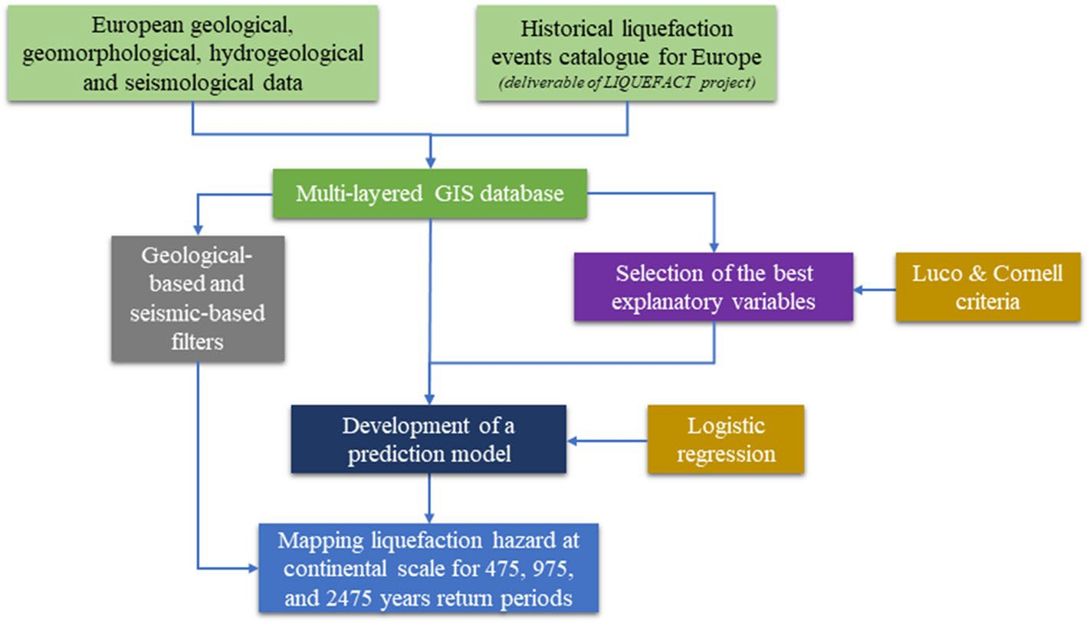
Fig. 1 Flow-chart of the methodology set-up and applied in this study for mapping the liquefaction hazard at continental scale for Europe

European territory (Sect. 3). A crucial step of the work was the selection of the optimal explanatory variables that, at a given point of the territory, are best correlated with liquefac- tion occurrence. The criteria of practicality, efficiency and proficiency have been adopted at this scope using the well-known Luco and Cornell methodology (Luco and Cornell 2007). The selected geospatial optimal explanatory variables were then used to calibrate a logistic regression model to predict liquefaction occurrence (Sect. 4). Different sampling techniques were adopted to build the dataset and thus calibrate and test different models. Finally, the model exhibiting the best performance was applied to compute the European liquefaction hazard map for three levels of severity of the expected ground motion, namely for a seismic hazard with return periods of 475, 975, and 2475 years (Sect. 5). A validation of the outcomes of the study was carried out by superimposing the catalogue of historical manifestations of earthquake-related liquefaction phenomena in Europe (a deliverable of the LIQUEFACT project) to the computed liquefaction hazard charts. It is important to remark that the liquefaction hazard maps were computed by a-priori filtering the datasets in order to exclude from the analysis the territories that are either geologically incompatible with the phenomenon of earthquake-induced liquefaction (e.g. rocky formations) or char- acterized by an expected intensity of ground shaking too low for liquefaction triggering (a value of horizontal peak ground acceleration equal to 0.1 g has been arbitrarily assumed as a threshold in this regard).

GIS database for megazoning the liquefaction hazard in Europe
In this section the geological, hydrogeological and seismological data collected in LIQ- UEFACT along with the European catalogue of historical liquefaction manifestations, will be presented. All the gathered geospatial data were harmonized in a georeferenced GIS environment. This was a key step of the methodology as all the raster data were required to have the same size of each pixel resolution (i.e. 900 m by 900 m) and the same spatial reference system (i.e. the European Terrestrial Reference System 1989, ETRS89/LCC). Moreover, the raster files should be perfectly overlapped (i.e. the edges of the cells of each raster needed to be snapped to those of the other raster files) to properly compute the geospatial fields. Finally, it is remarked that the GIS database is fully accessible via web through the Zenodo platform (https://zenodo.org/).

Collection of geological and seismological datasets at the European scale

    - Geological, hydrogeological and geomorphological data for the European territory

A quaternary geological map of Europe (https://produktcenter.bgr.de) was obtained, allowing to discern soil deposits susceptible and not susceptible to liquefaction. Indeed, soil deposits susceptible to liquefaction are not randomly distributed but occur within a range of specific sedimentary environments. Furthermore, liquefaction resistance increases with age and the mode of deposition has also an influence on liquefaction susceptibility. Thus, geological units and depositional processes may be both used as a screening for identification of liquefaction prone areas. Superficial lithological maps have been also obtained to help with the screening. In particular, the Soil Geographi- cal Database of Eurasia at scale 1:1,000,000 (SGDBE) included in the European Soil

Database (ESDB) v2.0 (Panagos et al. 2012) was used. The lithologies susceptible to liquefaction have been selected using the approach proposed by Youd and Perkins (1978), being a classification of the liquefaction susceptibility based on published lique- faction sites across the world. Furthermore, the Geological Map of Turkey 1:2,500,000 compiled by the General Directorate of Mineral Research and Exploration (MTA) was exploited to cover the ESDB gap for Turkey. Within the artificial deposits, the anthro- pogenic deposits and the redeposited natural materials, sand and gravel fill have been included as liquefiable deposits. It is worth noting that if a soil has already liquefied in the past, its geological clock should be reset and the age to take into account corre- sponds more to the last fabric’s modification. Consequently, the liquefaction response is influenced also by the geotechnical age that represents the time of the most recent criti- cal disturbance of the soil fabric. Therefore, for past liquefied sites the geologic age of a soil could be a source of error in the analysis of the liquefaction susceptibility (Rahimi et al. 2020).
The soil saturation significantly influences the liquefaction susceptibility. In fact, only saturated sediments or sediments capable of becoming saturated with groundwater table are susceptible to liquefaction. Hydrogeological maps were retrieved from the Federal Institute for Geosciences and Natural Resources of Germany (https://produktcenter.bgr.de). The Digital Elevation Model (DEM) obtained from Shuttle Radar Topography Mis- sion (SRTM) dataset (Jarvis et al. 2008) and its by-products were helpful to gather mor- phological and hydrological information (Wilson and Gallant 2000). Indeed, SRTM DEM data were processed in this study to obtain the following GIS layers: local slope; Compound Topographic Index (CTI; Beven and Kirkby 1979); stream network; Euclid-
ean distance from streams network.
The weighted-average shear-wave velocity down to 30 m (VS30) was adopted as a proxy of soil stiffness since soft sandy soils are more susceptible to liquefaction. The global topographic-slope based Vs30 map was obtained from the US Geological Sur-
vey (https://earthquake.usgs.gov/data/vs30/). The applicability of correlations between
topographic slope and VS30 for Europe was tested by Lemoine et al. (2012). The range for Vs30 adopted in this study, was defined according to this reference.

Expected seismic hazard at the European scale

From a seismological viewpoint, the following data were gathered from the deliverables of the European SHARE project (“Seismic Hazard Harmonization in Europe”; http:// portal.share-eu.org):
- Probabilistic seismic hazard maps for Euro-Mediterranean region such as the map for peak ground acceleration (PGA—horizontal component) for various return periods.
- European earthquake catalogue which includes harmonized moment magnitude (Mw) estimates and associated uncertainties. The most recent version of the Italian earthquake catalogue (http://emidius.mi.ingv.it/CPTI15-DBMI15/) was integrated within the GIS platform.
- European database of active faults and seismogenic sources. This digital archive of homogenized European Seismic Source Zone Model (SSZM), featuring over 400 source zones was recently adjusted within the European SHARE project (http://

www.share-eu.org/) to accommodate differences and inconsistencies across national boundaries.

European catalogue of earthquake‑induced liquefaction manifestations

One of the most important outcomes of the LIQUEFACT project was the construc- tion of a GIS-based catalogue of historical liquefaction occurrences in Europe. In this framework, a database containing historical information regarding liquefaction-related phenomena occurred in Europe, including sand ejects and boils, soil settlements and lateral spreading, ground and structural failures, was built. To do so, a critical biblio- graphic review was carried out to identify the most suitable sources of information such as existing databases for specific countries, seismic bulletins, reports, special studies, chronicles, diaries, archival documentation and tales concerning earthquake-induced liquefaction manifestations in European countries. In this effort, the starting step was represented by the earthquake catalogue set up for the European territory by the SHARE project (http://portal.share-eu.org). Detailed descriptions of liquefaction manifestations triggered by earthquakes were gathered from the collected references and used to con- struct a European database under a GIS environment. The catalogue includes two pieces of information: the main seismological features of each seismic event (e.g. date, geo- graphic coordinates, magnitude, focal mechanism if known) and liquefaction site param- eters (i.e. epicentral distance, type of manifestations, etc.). In the GIS-based dataset, all the liquefaction cases were represented as point features associated with all the gathered information. Further details can be found in the deliverable of the LIQUEFACT project (Lai et al. 2018), which illustrates the catalogue spanning a time period from 1117 to 2015 AD. It includes over 920 cases of liquefaction manifestations, induced by earth- quakes with moment magnitude Mw ranging from about 4.5 to about 8 and epicentral distances up to about 490 km. The catalogue only includes well-documented cases of liquefaction occurrences with the sites localized through geographical coordinates.

Geospatial explanatory variables

Similarly to the approach used by Zhu et al. (2015, 2017), the geospatial predictors for liquefaction occurrence (hereinafter named explanatory variables) considered in this study are the following:
- PGA, peak ground acceleration (horizontal component), referred to three different return periods: 475, 975 and 2475 years. The values of peak ground acceleration with reference to standard ground conditions (outcropping bedrock and level site) extracted from the deliverables of the SHARE project were multiplied by the soil coefficient of Eurocode 8 Part 1 (CEN 2004; hereinafter, EC8) to take into account site effects Ground categories of EC8 were assigned by exploiting the global top-
ographic-slope based VS30 chart. In doing so, only 1D lithostratigraphic amplifica- tion is explicitly considered. Accounting for phenomena of 2D–3D ground response such as basin effects would require the adoption of additional explanatory variables,
which have been deliberately overlooked in this study because the subject is com- plex and there is no consensus in the scientific community upon the best explanatory

variables capturing these phenomena. Clearly, this approach causes an increase of the epistemic uncertainty of the corresponding prediction model however it sets the ground for further studies.
- PGAm computed as:

PGAm = PGA ⋅ MWF
where the magnitude-weighting factor is defined in the following equation:
2.56
Mw
MWF =
102.24
(1)

(2)

Mw was defined by using the European seismogenic zoning (SSZM) proposed in the SHARE project. The MWF (Chen and Harmsen 2012) is the inverse of the magnitude- scaling factor (MSF). Indeed, MSF is typically used as a proxy for earthquake duration, which plays a key role in liquefaction occurrence. Different models are available in the literature to define the MSF. Hereinafter, the model proposed by Youd et al. (2001) has been adopted. Due to the limitations of the dataset used in the current study (includ- ing a limited number of events to sample duration effects), the duration effects were not constrained from our dataset. It is worth noting that Eq. (2) corresponds to the lower bound for an earthquake with Mw < 7.5. The latter is compatible with the events included in the dataset to first select the optimal explanatory variables and then cali- brate the prediction model, as illustrated in Sect. 4.
- CTI derived from DEM; it has been used as a proxy for saturation. CTI is defined as the natural logarithm of the ratio of contributing area to the tangent of slope (Moore et al. 1993).
- RD, which is the distance to the nearest river (in km, derived from DEM);
- CD, that is the distance to the nearest coast (in km);
- WBD, distance to the nearest water body (in km, i.e. distance from the nearest river/ coast/lake);
- TPI (Topographic Position Index, derived from DEM). It compares the elevation of each cell in the DEM to the mean elevation of a specified neighbourhood around that cell;
- TRI (Terrain Roughness Index, derived from DEM). It provides a quantitative measure of topographic heterogeneity.
The aforementioned quantities were used to compute the European liquefaction hazard map, presented in Sect. 5. It is important to remark that the geospatial prediction model (Sect. 4), was calibrated by using a specific dataset obtained from four recent European earthquakes selected based on the quality and quantity of available information in terms of seismological data (e.g. moment magnitude, focal depth, shake maps, etc.) and well docu- mented liquefaction phenomena (e.g. precise location, accurate topographic surveys, etc.). Thus, for these earthquakes, the moment magnitude is the Mw officially assigned to the specific event under investigation and the PGA is obtained from accredited shake maps (so it is an event-based i.e. deterministic PGA).

Development of a European prediction model of liquefaction occurrence

A prediction model was defined after constructing a dataset of liquefaction occurrences from four recent European earthquakes whose main characteristics (e.g. ground shaking maps, liquefaction manifestations) will be presented hereinafter (Sect. 4.1). This dataset was functional to identify the optimal explanatory variables best correlated with liquefac- tion occurrences (Sect. 4.2). The last step was the calibration of the logistic regression model to predict liquefaction manifestations in both past (for the validation of the model) and future earthquakes (Sect. 4.3).

Dataset of liquefaction occurrences

A dataset was built from liquefaction manifestations that occurred in four recent earth- quakes in Italy and Greece. The earthquakes were selected based on the quality and quan- tity of available information in terms of seismological data (e.g. moment magnitude, focal depth, shake maps, etc.) and well documented liquefaction phenomena (e.g. precise loca- tion, accurate topographic surveys, etc.). Indeed, the development of a prediction model of liquefaction occurrences requires an accurate definition of the explanatory variables that triggered or did not trigger liquefaction taking into account the geological and geotechnical setting of the epicentral area.
To construct the dataset of liquefaction occurrences, four European earthquakes were selected: three events did cause liquefaction manifestations whereas the fourth earthquake did not trigger liquefaction even though the area affected by the earthquake was susceptible to such type of ground instability due to the geological framework.
The four events are listed below with a link to the websites from which data and meta- data were downloaded:
- May 20, 2012 Mw 6.1 Emilia (Italy) earthquake. This event caused widespread lique- faction phenomena and induced ground deformation (https://earthquake.usgs.gov/earth quakes/eventpage/usp000jkn8/executive);
- January 26, 2014 Mw 6.1 Cephalonia (Greece) earthquake. This event caused moderate liquefaction manifestations (https://earthquake.usgs.gov/earthquakes/eventpage/usb00 0m8ch/shakemap/intensity);
- April 6, 2009 Mw 6.3 L’Aquila (Italy) earthquake. This event caused a few liquefaction cases (https://earthquake.usgs.gov/earthquakes/eventpage/usp000gvtu/shakemap/metad ata);
- December 23, 2008 Mw 5.2 Parma (Italy) earthquake. This event did not trigger any liquefaction phenomenon (http://shakemap.rm.ingv.it/shake/1870169/products.html).
Data from the aforementioned earthquakes were organized as raster files for each explanatory variable (Sect. 3.3) in a GIS environment. For each raster, the dataset of the corresponding cell includes the following data:
- Numerical/logical value of each explanatory variable;
- A binary label (1/0, referred hereinafter as “1 cells” and “0 cells”, respectively) indicat- ing whether liquefaction was detected in that cell or not.

Table 1 An excerpt of the dataset

ID Vs30 (m/s) CTI Event PGA (g) … Y/N

adopted in this study for defining

the model of liquefaction occurrence
0001 150 25 0.2 … 1
0002 700 15 0.18 … 0
… … … … … …

The reason why a label is applied to each record of the dataset is that in the logistic regression model liquefaction occurrence is treated as a binary dependent variable whereas the independent variables are the geospatial explanatory proxies. If a cell is positive for liquefaction manifestation, that cell is labelled as 1 (positive), otherwise is labelled as 0 (negative). Table 1 shows an example of the dataset layout. The last column on the right shows the occurrence/non-occurrence of liquefaction in each pixel.
For each of the four earthquakes, a critical issue to be addressed was the definition of the spatial extension of the region under investigation. In fact, while the number of 1 cells is somehow limited, the amount of the 0 cells could be potentially huge depending on the spatial extension that is taken into account. This situation may lead to an unbalanced data- set, namely a dataset in which 0 cells and 1 cells are strongly disproportioned in number. As suggested by Zhu et al. (2017), two different circular buffers were calculated around each liquefaction feature. One having a radius of 1 km and one with a radius of 15 km. The

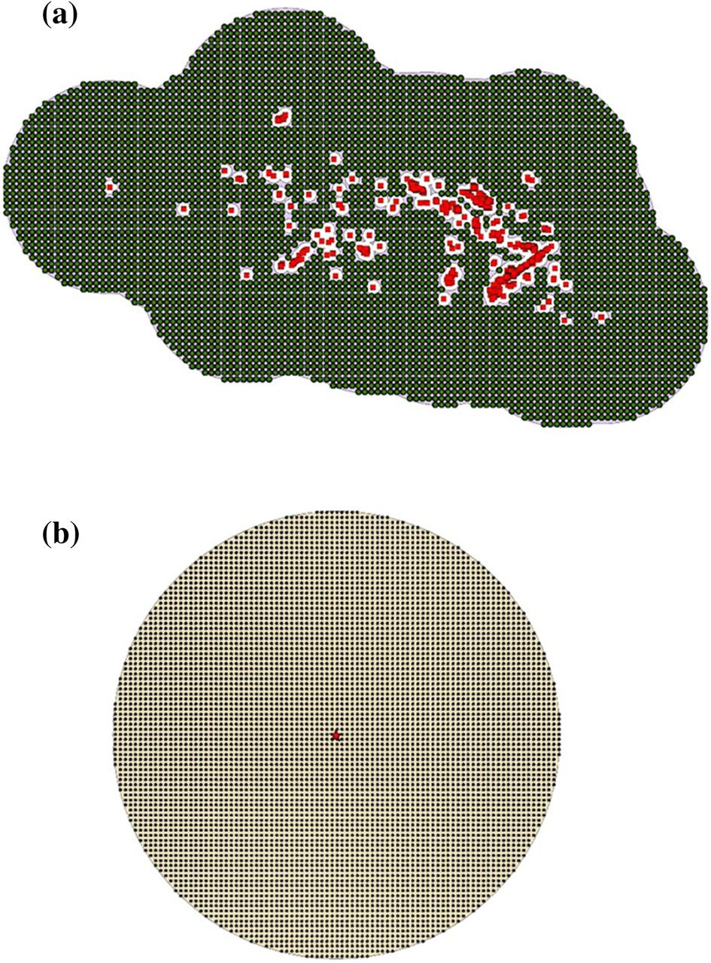
Fig. 2 Definition of 0 cells region for an earthquake that (a) triggered liquefaction (red dots) and that (b) did not trigger lique- faction. According to Zhu et al. (2017), in case (a), 1 km buffer represents the non-sampling
area within the sampling region, which is the zone characterized by a maximum distance of 15 km from the nearest liquefaction feature. In case (b) the sampling region is defined as the area of maximum distance of 40 km around the epicentre of the earth- quake (red star)

1 km buffer represents the non-sampling regions which means that all the 0 cells falling into this buffer are not selected to be part of the dataset. The non-sampling zones represent “holes” in the sampling region, which is defined as the area characterized by a maximum distance of 15 km from the nearest liquefaction feature. In case of events that did not trig- ger liquefaction, the sampling region is defined as the area with a maximum distance of 40 km around the epicentre of the event. Figure 2 shows the three regions as previously defined. Therefore, the dataset was composed by the 0 cells extracted from the sampling region and the 1 cells corresponding to all points with some kind of liquefaction manifes- tation. Each cell is coded as a vector whose components are the values of the explanatory variables along with its label. The final dataset was composed of about 160 cells with label 1 and about 13,000 cells with label 0. Thus, the ratio of 1 cells over the 0 cells is about 1 out of 100. An effort was finally made to further reduce this disproportion in the class size of the dataset through the application of appropriate sampling techniques as illustrated hereinafter.

Identification of the explanatory variables best correlated with liquefaction occurrence

The explanatory variables best correlated with liquefaction occurrence have been identi- fied using the Luco and Cornell methodology (Cornell and Luco 2001; Luco and Cornell, 2007; Padgett et al. 2008), which was originally developed for applications in structural earthquake engineering. The method herein applied is based on implementing the criteria of practicality, efficiency and proficiency in testing the degree of correlation between an independent variable (in our case one of the explanatory proxies) and the selected engi- neering demand parameter (in our case the probability of liquefaction occurrence). The sufficiency measure is not considered in this study because the ranges of magnitudes and source distances are not wide and this lack may impact the reliability of the sufficiency analysis results (Wang et al. 2018). Efficiency and practicality were estimated from the results of a linear regression carried out for each explanatory variable (EV), in the EV vs. probability of liquefaction, PL, space. The adoption of the probability of liquefaction as a dependent variable was devised to transform a binary into a continuous variable. An EV is defined efficient if it allows to obtain a reduced variability in the response (in our case PL) for a given value of the EV. A lower β (i.e. the lognormal standard deviation) yields a more efficient EV. Practicality refers to a possible direct correlation between an EV and the probability of liquefaction PL. A more practical EV is characterized by a larger gradi- ent of the linear regression (the so-called b parameter). Finally, proficiency measures the composite effect of practicality and efficiency. It is also called modified dispersion and it is calculated as the ratio between the dispersion (efficiency) and the gradient (practicality). A lower value of this ratio yields a more proficient EV. In our setting, a linear regression was carried out for each of the selected explanatory variables, in the EV vs PL space according to the procedure illustrated in the flowchart of Fig. 3.
As described in Sect. 4.1, the dataset of liquefaction/non-liquefaction occurrence is characterized by a ratio of 1 cells over the 0 cells of about 1 out of 100. In order to improve the disproportion in the class sizes of 1 and 0 cells and obtain a more balanced sub-dataset, the technique of under-sampling was randomly and uniformly applied to the 0 class (e.g. Fernández et al. 2018). Indeed, with the undersampling method, 0 cells are randomly sampled from the dataset to create a sub-dataset in which the number of 0 cells is equal to that of 1 cell (i.e. a ratio of 1 cells over 0 cells is set equal to 1 out

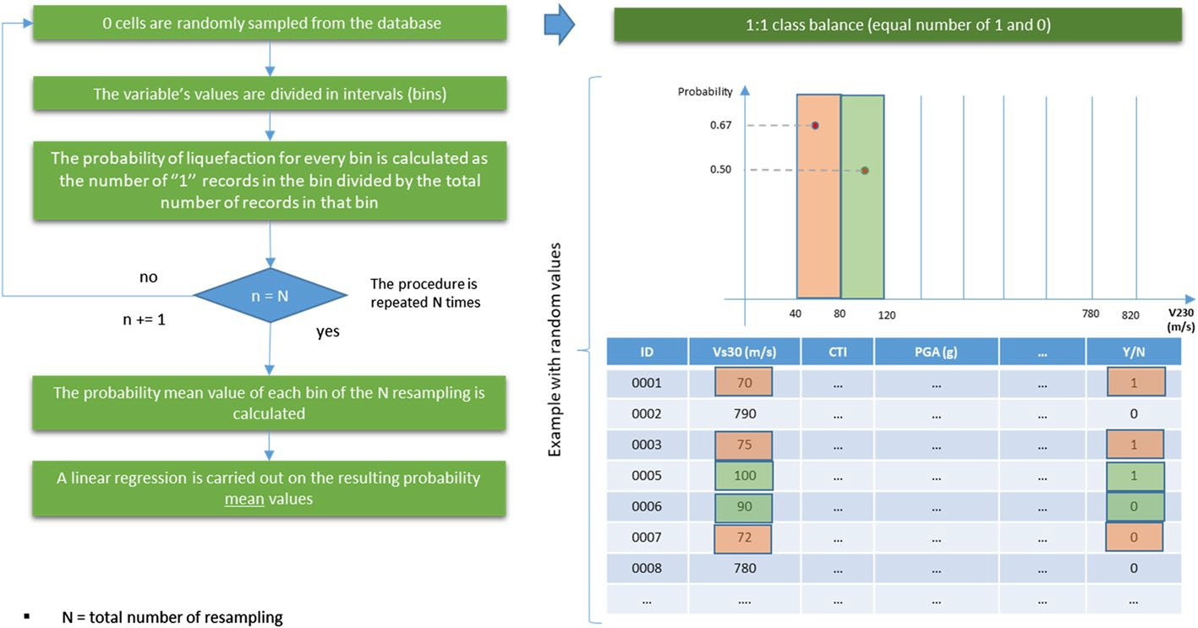

Fig. 3 Flowchart of the procedure adopted to plot the probability of liquefaction for each explanatory vari- able. An example with the calculation of the values of two bins is shown (highlighted in orange and green)

of 1). To ensure the model stability and to avoid the removal of potentially important 0 cells, the sampling procedure was randomly repeated 1000 times. For each resampling and for each explanatory variable, the values of each variable were discretized in inter- vals (bins). The probability of liquefaction for every bin was calculated as the number of 1 cells in the bin divided by the total number of cells in that bin. This procedure was repeated for each resampling. At the end, a mean probability was calculated for every bin. These mean probabilities were finally plotted and a linear regression was carried out. The correlation of the EV with the liquefaction occurrence was assessed also in a
semi-logarithmic space. The outcome was that the variables VS30, PGA, PGAm, WBD, CD, RD showed better correlations when plotting their natural logarithm. On the other hand, the variable TRI appeared to be better correlated with liquefaction occurrence
if replaced by its square root (i.e. TRI0.5). The complete set of results for each EV

Table 2 Results of the Luco and Cornell methodology in terms of practicality, efficiency and proficiency. The values for each criterion are marked with a color in a chromatic scale from green (good results) to red (poor results)

Variable | Practicality* | Efficiency# | Proficiency#
CTI | 0.13 | 0.13 | 1.02
Ln(VS30) | 0.50 | 0.13 | 0.26
TPI | 0.01 | 0.30 | 35.61
TRI0.5 | 0.00 | 0.16 | 144.85
Ln(WBD) | 0.08 | 0.16 | 2.06
Ln(RD) | 0.09 | 0.18 | 2.07
Ln(CD) | 0.11 | 0.25 | 2.21
Ln(PGA) | 0.19 | 0.24 | 1.24
Ln(PGAm) | 0.18 | 0.22 | 1.21
* The highest the value the better is the correlation with the EV
# The lowest the value the better is the correlation with the EV

Table 3 Classification of the

Practicality Efficiency Proficiency

explanatory variables (EV) for

each criterion of the Luco and Cornell methodology. The EV in each column are ordered from the top (optimal EV) to the bottom (worst EV)
Ln(VS30) CTI Ln(VS30)
Ln(PGA) Ln(VS30) CTI
Ln(PGAm) TRI0.5 Ln(PGAm)
CTI Ln(WBD) Ln(PGA)
Ln(CD) Ln(RD) Ln(WBD)
Ln(RD) Ln(PGAm) Ln(RD)
Ln(WBD) Ln(PGA) Ln(CD)
TPI Ln(CD) TPI
TRI0.5 TPI TRI0.5

expressed in terms of practicality, efficiency and proficiency are reported in Tables 2 and 3. It turns out that the optimal variables with respect to proficiency are ln(VS30), CTI and ln(PGAm). These outcomes are in good agreement with the results obtained by Zhu et al. (2015). It is worth noting that the EV Ln(PGA) showed a quite good perfor- mance with respect to ln(PGAm) which seems to be a better proxy.

Calibration of the logistic prediction model

The logistic regression was applied to model the liquefaction occurrence in Europe fol- lowing an approach already proposed by other researchers (e.g. Zhu et al. 2017). Logis- tic regression is a machine learning procedure for analysing a dataset in which several independent variables determine a binary outcome. In this particular case, the outcome is represented by the liquefaction label: 1 stands for “liquefaction”, 0 stands for “no liquefaction”. The independent variables are the explanatory proxies selected with the
Luco and Cornell methodology, namely CTI, ln(PGAm) and ln(VS30). In the logistic regression, the probability of liquefaction is calculated as follows:

where X is computed as:
P(X) = 1
1 + e−X

X = y0 + y1x1 + y2x2 + ⋯ + ykxk

(3)

(4)

with the xk being the explanatory variables and γk the coefficients of the regression. The optimal geospatial predictors, identified in Sect. 4.2 based on proficiency, which considers the composite effect of practicality and efficiency, are ln(PGAm), ln(VS30) and CTI. Thus, these explanatory variables have been integrated into the Eq. (4) which can then be rewrit- ten as follows:

X = A + B ⋅ ln (PGAm) + C ⋅ CTI + D ⋅ ln (VS30)
(5)

The calibration of the coefficients A, B, C and D of the regression was carried out using the dataset of liquefaction occurrences associated with the four European earth- quakes described in Sect. 4.1 balanced after applying the under-sampling technique.

Two alternative algorithms to correct the disproportion in the dataset of the class sizes of 1 and 0 cells have also been adopted:
- SMOTE (Synthetic Minority Over-sampling Technique; Chawla et al. 2002): the original sub-dataset of the 1 class is oversampled so to enforce a prescribed ratio of 1 cells over the 0 cells.
- ADASYN (ADAptive SYNthetic; He et al. 2008): it is an improved version of the SMOTE algorithm where synthetic data of the 1 class are artificially generated to com- ply with a specified ratio of 1 over 0 cells.
In both the SMOTE and ADASYN sampling algorithms the ratio of 1 cells over the 0 cells was set equal to 1 out of 2. Each of the three sampling techniques (i.e. under-sam- pling, SMOTE and ADASYN) was used to construct a different logistic prediction model for Europe. To calibrate the coefficients of the logistic regression the balanced dataset was split into two subsets: a training set and a testing set. In each of these two groups the 1 out of 2 ratio between classes is maintained. The training set, including 75% of the balanced dataset, contains the cells upon which the coefficients of the prediction model were cali- brated. On the other hand, the testing set contains data that were not used to calibrate the model, but to actually test its performance in predicting liquefaction occurrence.
The performance of each model was assessed through a ROC (Receiver Operating Characteristics) analysis and expressed in terms of the parameter AUC (Area Under the Curve). The training set was used in the ROC analysis. In a ROC curve, the true positive rate (sensitivity, y-axis) is plotted against the false positive rate (specificity, x-axis). Each point on the ROC curve represents a sensitivity/specificity pair corresponding to a particu- lar decision threshold. The decision threshold is the value of the probability beyond which a datum is classified as 1. The True Positive Rate (TPR) is calculated using the following expression:

TPR = TP TP + FN
whereas the False Positive Rate (FPR) is calculated as follows:
FPR = FP TN + FP

(6)

(7)

where TP is the number of True Positive data (namely data labelled as 1 and classified by the model as 1), FP is the number of False Positive (namely data labelled as 0 and classi- fied by the model as 1), TN and FN are the number of True Negative and False Negative (namely misclassified positive or negative data). Then, the AUC parameter was calculated as the area under the ROC curve. The AUC ranges between 1, a perfect classifier, and 0.5, a random classifier. The highest the parameter, the better is the performance of the model. Figure 4 shows the ROC curve computed for the model associated with the ADASYN sam- pling algorithm.
The coefficients of the logistic regression are reported in Table 4. From the analysis carried out in Sect. 4.2, it turns out that the optimal geospatial predictors are ln(Vs30), CTI and ln(PGAm). It is worth remarking that these explanatory variables are the same adopted by Zhu et al. (2015) in developing their model although the selection of these proxies was not based on using the Luco and Cornell methodology. In light of the above considerations, the Zhu et al. (2015) logistic regression has been used as an additional

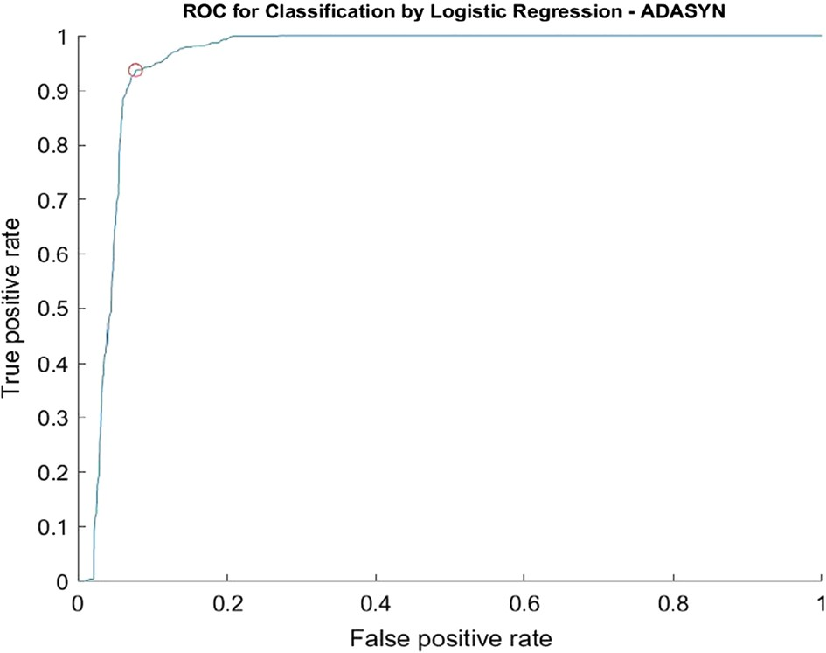
Fig. 4 ROC curve for the model associated with the ADASYN sampling algorithm. Point on ROC curve for optimal threshold is labelled

Table 4 Coefficients obtained from the calibration of the logistic prediction models
Method | A | B | C | D | AUC | Optimal
ADASYN | − 11.489 | 3.864 | 2.328 | − 0.091 | 0.95 | 0.57
SMOTE | 30.281 | 2.348 | 0.22 | − 4.575 | 0.93 | 0.33
Undersampling | 28.371 | 2.248 | 0.223 | − 4.279 | 0.91 | 0.41
Zhu et al. (2015) | 24.1 | 2.067 | 0.355 | − 4.784 | 0.86 | 0.2

threshold

model to compare the results obtained in this study. Values of the AUC and of the opti- mal threshold at which the best performance of the model is achieved are reported as well. Yet, the optimal threshold is used to distinguish areas that may undergo liquefac- tion from areas where the manifestation of this phenomenon is not expected in the meg- azonation chart. The three prediction models developed in this study are compared with the one proposed by Zhu et al. (2015). It turns out that the best model is the one associ- ated with the ADASYN sampling algorithm, although the under-sampling and SMOTE showed good performance as well. The performance of the Zhu et al. (2015) model is not as good as the others; however, this is not surprising since Zhu et al. (2015) adopted a database of liquefaction occurrences from worldwide earthquakes except from Europe.

Charts of the liquefaction hazard in Europe
This section presents the charts for liquefaction hazard in continental Europe with refer- ence to the return periods of 475, 975 and 2475 years and computed with the logistic prediction model described in the previous sections. Some territories in Europe may be susceptible to earthquake-induced liquefaction due to the geological–geotechnical set- ting, however they may be characterized by a very low seismic hazard. Under these conditions, liquefaction will not be triggered. In these areas, the liquefaction hazard is

a priori assumed zero and a filter is applied in the hazard mapping, as described in Sect. 5.1. The charts for liquefaction hazard in continental Europe are presented in Sect. 5.2. Finally, a validation of the megazoning of Europe was carried out by superim- posing the computed maps to historical liquefaction manifestations in Europe as shown in Sect. 5.3.

Geological‑based and seismic‑based filters applied to the liquefaction hazard charts

As mentioned above, the liquefaction hazard maps were computed by a-priori filtering the data in order to exclude from the analysis the territories that are either geologically incom- patible with the phenomenon of earthquake-induced liquefaction (e.g. rocky formations) or characterized by an expected value of PGA (horizontal component) below a certain thresh- old (i.e. 0.10 g) that is deemed too low for triggering liquefaction.
The soil-type filter was defined using the lithological information inferred from the fol- lowing documents:
- Soil Geographical database of Eurasia at scale 1:1,000,000 (Panagos et al. 2012). The lithological classes considered as geomaterials non-susceptible to liquefaction are the bedrock and, in a generic sense, clayey soils (such as plastic clays);
- International Hydrogeological Map of Europe 1:1,500,000 (http://www.bgr.bund.de/ ihme1500/);
- Geological Map of Turkey 1:2,500,000 from the General Directorate of Mineral Research and Exploration (http://www.mta.gov.tr/eng/maps/geological-1250000).
An a-priori filter excluding from the calculation territories in Europe characterized by an expected value of PGA below 0.10 g was also applied. This assumption was based on recommendations from the literature (e.g. Italian Building Code, NTC2018). In fact, exper- imental data show that for values of PGA smaller than 0.10 g, liquefaction triggering is very unlikely (Green and Bommer 2019). Thus, it was assumed that liquefaction occur- rence is very unlikely at any site of the European territory where the expected PGA is smaller than 0.10 g. In the GIS platform both the soil-type and seismic hazard filters were implemented to calculate the liquefaction hazard maps for Europe.

Liquefaction hazard charts for Europe

Figure 5 shows a comparison of the maps of liquefaction hazard for 475-years return period computed with the various models presented in the previous sections (Table 4 in Sect. 4.3). Filters illustrated in Sect. 5.1 were applied as well.
Each map shows the binary outcome of the liquefaction prediction model. Areas where the model predicts liquefaction occurrence (i.e. 1) are distinguished from the areas where the model predicts non-occurrence of the phenomenon (i.e. 0). This distinction was based on the optimal threshold computed for each model and shown in Table 4. The model based on the ADASYN sampling approach is the one showing the best performance in agreement with the conclusions illustrated in Sect. 4.3. It is important to remark that the chart com- puted by using the global approach by Zhu et al. (2015) appears quite different, specifically

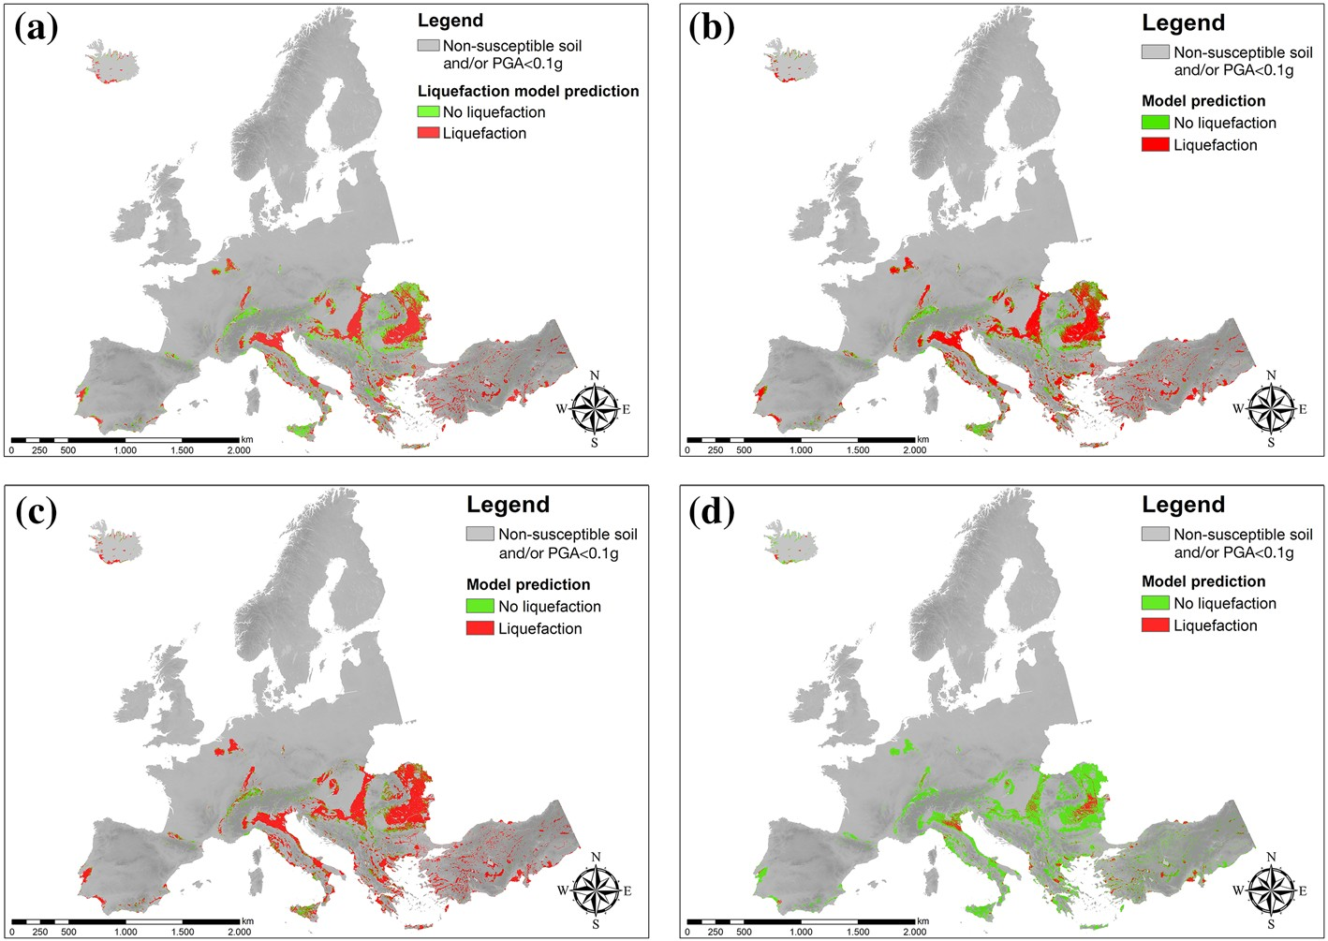

Fig. 5 A comparison of the maps of liquefaction hazard for 475-years return period computed with the vari- ous prediction models, i.e. ADASYN (a), SMOTE (b), under-sampling (c), and Zhu et al. (2015) (d). The grey areas are a priori excluded because of the geological-based and seismic-based filters herein applied (the grey scale is based on the DEM)

it is generally unconservative, if compared with the charts obtained in this study by apply- ing the prediction models calibrated for continental Europe. The Zhu et al. (2015) model applied to the European setting seems to significantly underpredict the liquefaction hazard as shown in Table 4. This could be justified by the limitations of the database upon which the global model developed by Zhu et al. (2015) is built. Indeed, the authors themselves have stated that “a broader database for model development” was required. On the other hand, the adoption in this study of a balanced class approach lead to a better performance of the models if compared with that of Zhu et al. (2015) who used an unbalanced dataset to develop their model. This may also explain why the optimal threshold of the Zhu et al. (2015) model is significantly lower than the ones obtained in this study. Finally, it is worth to highlight that the Zhu et al. (2017) updated model was not adopted herein for compari- son since it uses the Peak Ground Velocity (PGV) as explanatory variable for ground shak- ing (instead of the PGA) and the PGV values are not promptly available for the whole European territory.
With regard to the other comparisons, it appears that the distinction among the various charts does not seem to be evident perhaps because the prediction models calibrated using different sampling algorithms have overall exhibited a good performance (e.g. SMOTE) despite the optimal prediction model turned out to be the one associated with ADASYN, as discussed in Sect. 4.3.
Figure 6 shows the European charts of liquefaction hazard computed in this study for the 975 (a) and 2475 (b) years return period.

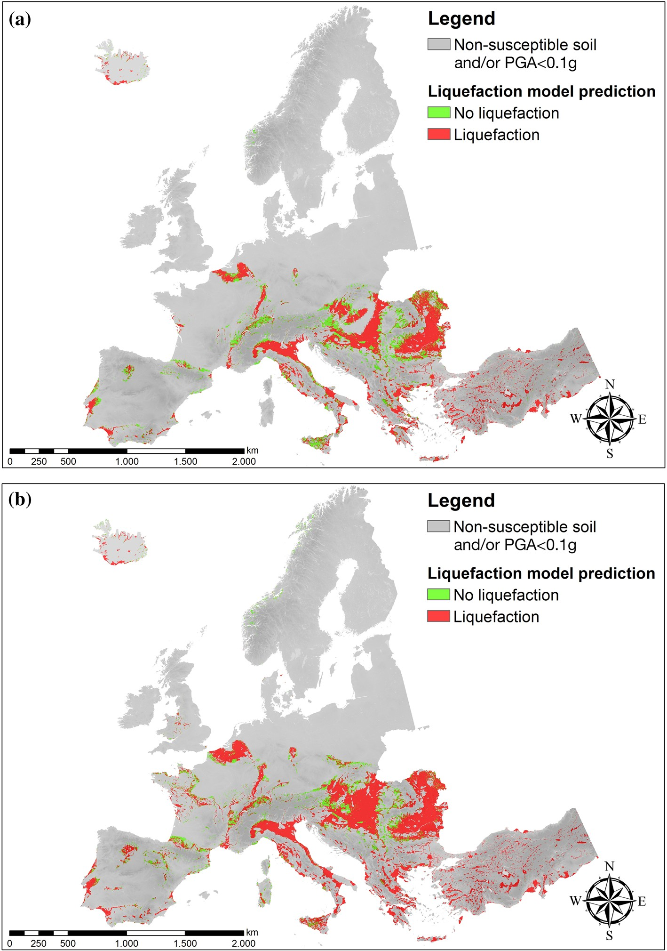

Fig. 6 European liquefaction hazard maps calculated in this study for the return periods of 975 (a) and 2475
(b) years. The grey areas are a priori excluded because of the geological-based and seismic-based filters herein applied (the grey scale is based on the DEM)

Validation of the prediction model for liquefaction occurrence

A validation of the chart of liquefaction hazard for Europe, computed by applying the pre- diction model based on the ADASYN sampling algorithm, was carried out by superim- posing the computed map to historical liquefaction manifestations. As briefly illustrated in Sect. 3.2, the European catalogue of earthquake-induced liquefaction includes about 1,000 cases occurring across the European countries in the latest 1000 years. However, it is important to remark that the completeness of the catalogue is not homogeneous through the various countries.
A return period was associated to each seismic event that induced liquefaction mani- festations included in the catalogue. As described in Lai et al. (2019a, b, c), each seis- mic sequence was identified through the application of the Gardner and Knopoff (1974) algorithm and then the return period of each main shock was assigned based on European seismogenic zoning (SSZM) proposed in the SHARE project. Finally, the return period of each main shock was associated to the entire seismic sequence. The number of liquefaction historical cases included in the catalogue, grouped for different ranges of return periods, are shown in Fig. 7. It seems reasonable to expect that the number of historical liquefaction manifestations increases with the increase of the return period since the moment magni- tude (Mw) associated to the earthquakes increases. However, the numbers of liquefaction occurrences associated to higher return periods decrease in the graph of Fig. 7. This could be explained by considering that liquefaction occurrences in several European countries were recorded only in the most recent years, except for the case of Italy whose earthquake catalogue spans a period of about 1000 years, as shown in Fig. 8. Also the role played by the completeness periods of the earthquake catalogue associated to different Mw bins deserve further research.
The validation of European liquefaction hazard chart was carried out with specific ref- erence to the 475-years return period. The charts of Fig. 9a, b show the megazonation of European territory for liquefaction hazard with reference to a return period of 475 years, superimposed to the locations of historical liquefaction occurrences associated to the same return period ± 10%. It is important to remark that the latter are independent data with respect to the ones used to calibrate the prediction model (Sect. 4). In the map, almost all the historical liquefaction manifestations are located in areas characterized by liquefaction hazard (red areas). This is particularly evident in Italy and in the Balkan region (Fig. 9b). The results are also displayed in Fig. 10 according to a chromatic scale based on the fol- lowing five different classes of probability of liquefaction PL defined by Zhu et al. (2015): PL < 0.01 very low, 0.01 < PL < 0.03 low, 0.03 < PL < 0.08 medium, 0.08 < PL < 0.2 high,
0.2 < PL < 1 very high. It turns out that the black dots are located in areas characterized by

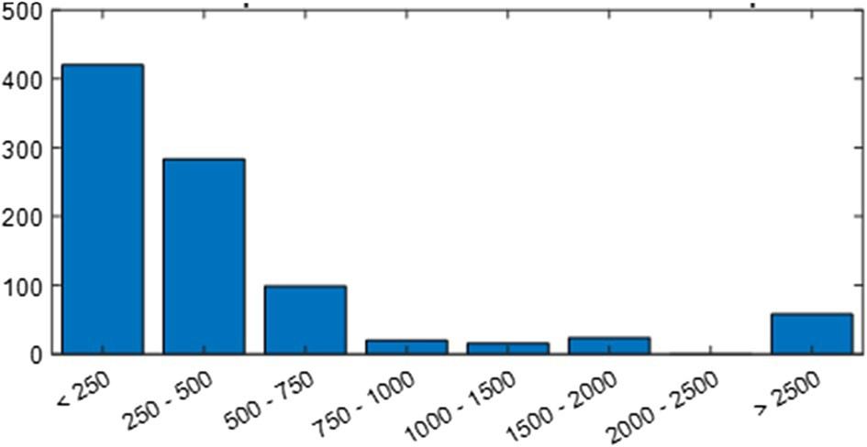
Fig. 7 Number of manifestations of earthquake-induced liquefac- tion included in the European earthquake catalogue grouped for different ranges of return periods (Lai et al. 2019a, b, c)

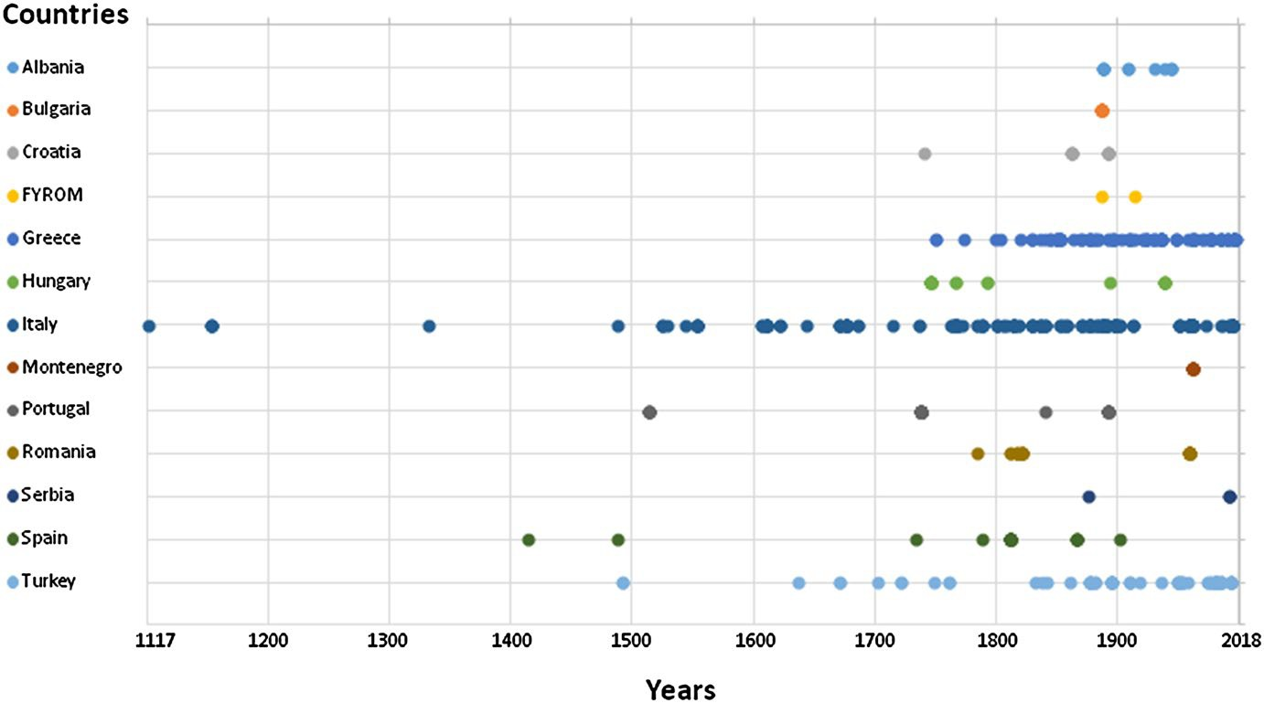

Fig. 8 Distribution of earthquake-induced liquefaction cases included in the catalogue (Lai et al. 2019a, b, c)

a very high probability of liquefaction. Only one case (Fig. 10b) does not appear located in the red area in Southern Italy. This could be explained by the large uncertainty associated with the location of that particular historical liquefaction manifestation, for which, accord- ing to Galli (2000), only an indication relative to a wide/undefined area is available and the coordinates indicate a central point in the possible area.

Conclusive remarks
A megazonation of the European territory for earthquake-induced soil liquefaction haz- ard was presented in this article. This work tackles a task of paramount difficulty which is that of zoning a continental territory for liquefaction hazard as soil liquefaction is by itself a phenomenon that is spatially very localized. Furthermore, its occurrence or non- occurrence depends on a variety of difficult to measure soil parameters and intensity of ground shaking.
A great deal of effort was spent in the preparatory phase of the work in collecting primi- tive geospatial data for the whole European territory. The developed GIS database could be of particular interest for all researchers involved in liquefaction hazard studies in Euro- pean countries. Starting from validated methodologies available in the literature (e.g. Zhu et al. 2015, 2017), a data-driven, machine learning procedure was implemented in this study and a predictive model purposely calibrated after the identification of the optimal explanatory variables correlated with liquefaction occurrence, according to the Luco and Cornell criteria. Indeed, a logistic regression model to predict liquefaction occurrence was developed from a set of explanatory variables purposely selected as geospatial prox- ies optimally correlated with the phenomena of liquefaction manifestation. A significant effort was also spent to build a balanced dataset for developing the prediction model for liquefaction occurrence. An evaluation of the effect of different sampling techniques on

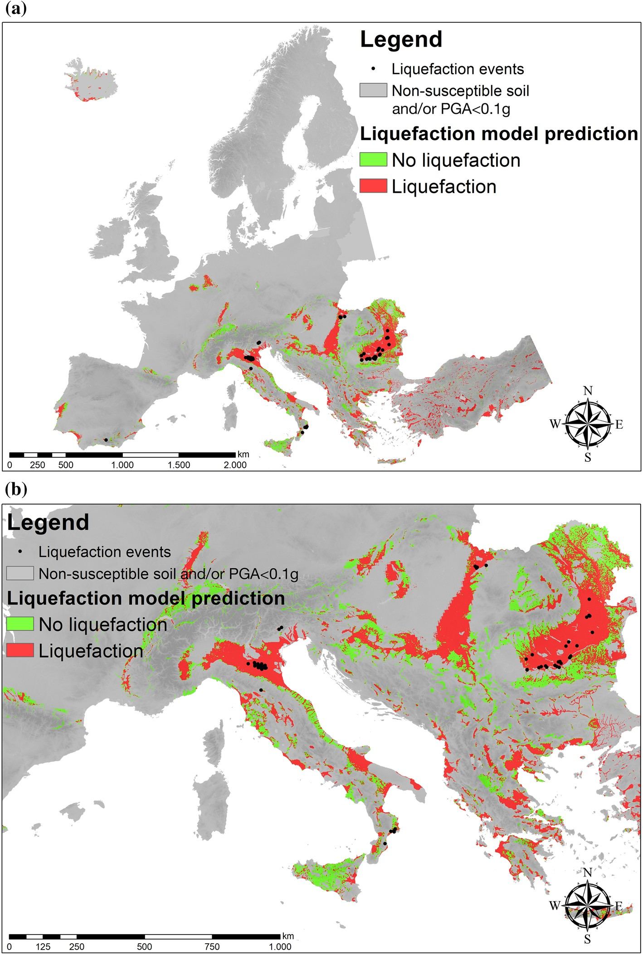

Fig. 9 a Map showing the liquefaction hazard on European territory filtered for soil-type and threshold seis- mic hazard, referred to the return period of 475 years. Locations of liquefaction occurrences (black dots) associated to a return period of about 475 years are superimposed. b Close-up view of Italy and Balkan region. The grey areas are a priori excluded because of the geological-based and seismic-based filters herein applied (the grey scale is based on the DEM).

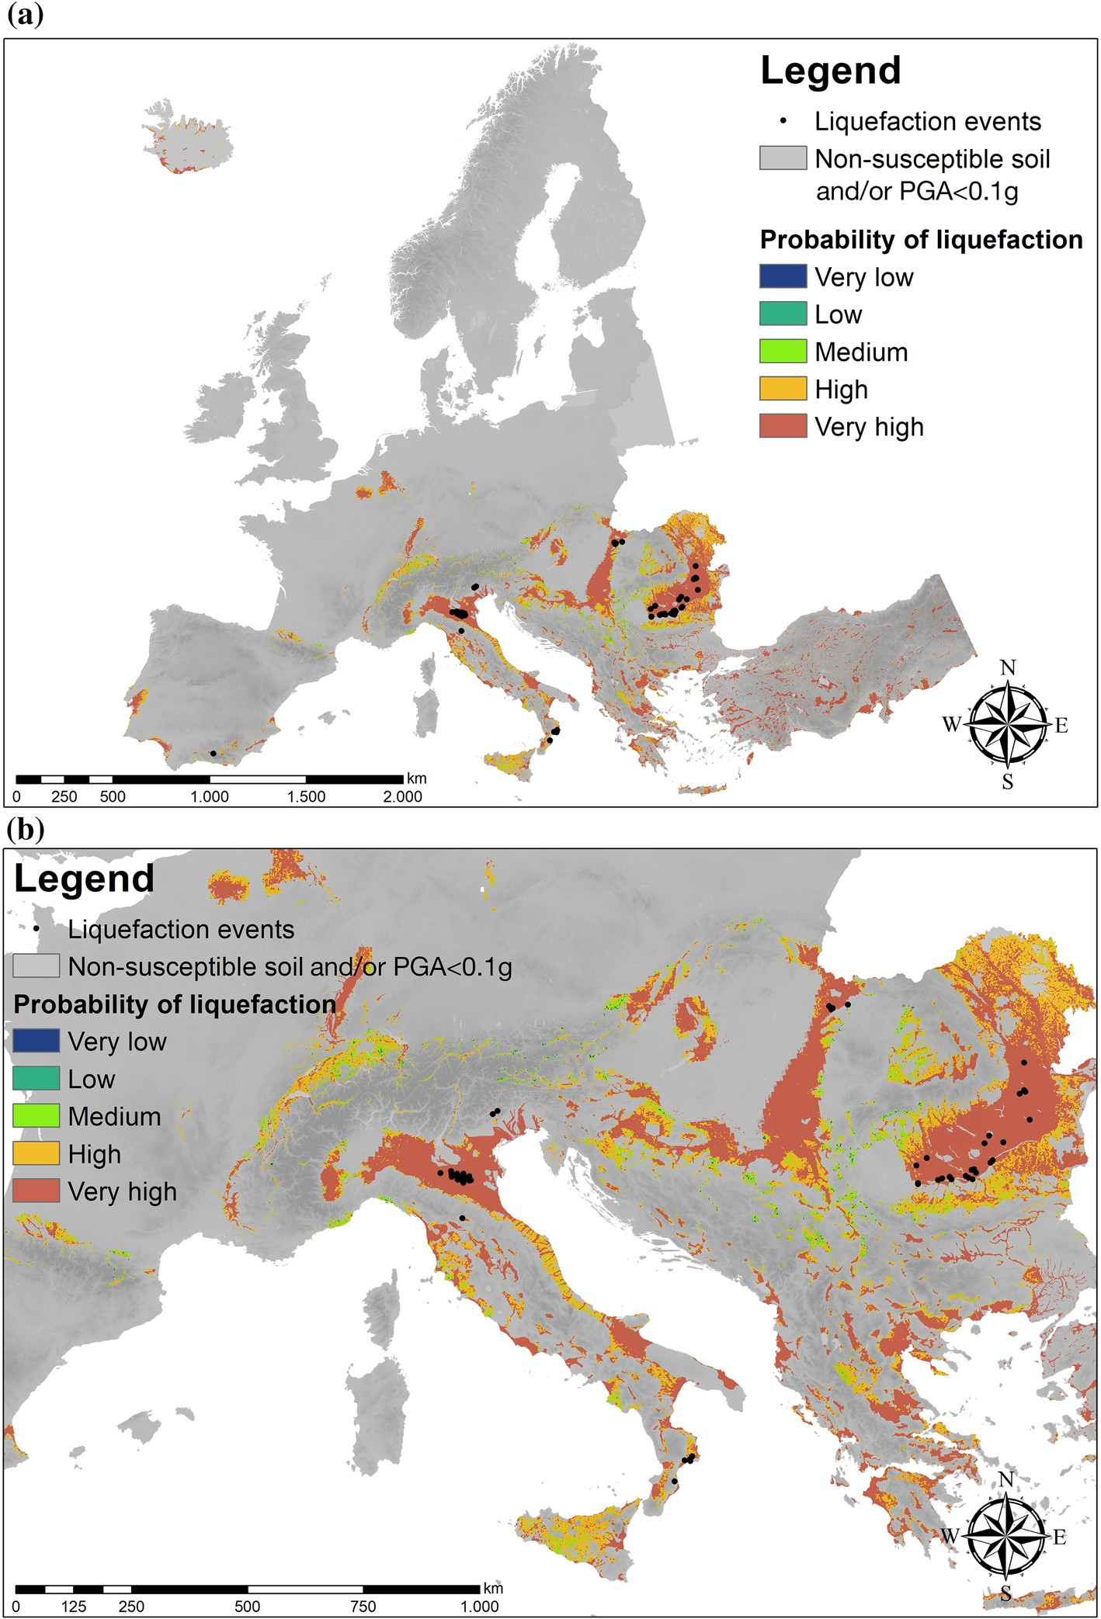

Fig. 10 a Map showing the liquefaction probability on European territory filtered for soil-type and thresh- old seismic hazard, referred to the return period of 475 years. Locations of liquefaction occurrences (black dots) associated to a return period of about 475 years are superimposed. b Close-up view of Italy and Bal- kan region. The grey areas are a priori excluded because of the geological-based and seismic-based filters herein applied (the grey scale is based on the DEM).

liquefaction hazard mapping was carried out and presented in this article. The performance of each model was rigorously assessed by using the ROC analysis and by doing so the opti- mal model was quantitatively identified. European liquefaction hazard maps for the return periods of 475, 975, and 2475 years were calculated by considering geological-based and seismic-based filters a priori applied to the liquefaction hazard charts. Finally, validation of the megazonation map was carried out by superimposing the catalogue of historical occurrences of earthquake-induced liquefaction phenomena in Europe (for the same return period) to the computed liquefaction hazard map.
Despite the rigorous approach adopted to compute the European liquefaction hazard maps and the encouraging results inferred from the validation with independent data, these maps should be used with caution as their level of accuracy is low. Indeed, the spatial reso- lution of the megazonation charts herein proposed is on the order of~ 1 km and as such the level of accuracy and reliability is fairly low considering the extremely local nature of the liquefaction phenomenon. Particular caution should be paid with specific reference to the maps computed for 975 years and 2475 years, because a validation based on superimposing historical liquefaction cases was not possible. A thorough assessment of the completeness of the European catalogue of liquefaction occurrences represents one of the pending tasks which would still deserve an in-depth research. Yet, the availability of megazonation maps of liquefaction hazard with all their limitations, may help decision makers and administra- tors in identifying urbanized territories across Europe or elsewhere that can be potentially, affected by liquefaction-induced damages. This in turn may encourage initiatives for fund- ing projects devoted to more detailed studies in those territories (e.g. meso-zonation charts focusing at a regional scale).
Acknowledgements This research has been carried out within the framework of the European LIQUEFACT project. The LIQUEFACT project has received funding from the European Union’s Horizon 2020 Research and Innovation Programme under Grant Agreement No. 700748. This support is gratefully acknowledged by the authors. The recommendations of three anonymous reviewers have helped to improve the clarity of the manuscript and they are gratefully acknowledged by the authors.

References
Baise LG, Daley D, Zhu J, Thompson EM, Knudsen K (2012) Geospatial liquefaction hazard model for Kobe, Japan and Christchurch, New Zealand. Seismol Res Lett 83:458
Beven KJ, Kirkby MJ (1979) A physically based, variable contributing area model of basin hydrology.
Hydrol Sci Bull 24:43–69
CEN (2004) Eurocode 8. Design of structures for earthquake resistance, Part 1: General rules, seismic actions and rules for buildings, Pr-EN1998-1, European Committee for Standardization (CEN), Brussels
Chawla NV, Bowyer KW, Hall LO, Kegelmeyer WP (2002) SMOTE: synthetic minority over-sampling technique. J Artif Intell Res 16:321–357
Chen R, Harmsen S (2012) Probabilistic ground motion calculations and implementation of PGA scaling by magnitude for assessing liquefaction hazard, Technical Document 2012-1, Seismic Hazard Zonation Program.
Cornell CA, Luco N (2001) Ground motion intensity measures for structural performance assessment at near-fault sites. In: Proceedings U.S.-Japan joint workshop and third grantees meeting, U.S.-Japan Coop. Res. on Urban EQ. Disaster Mit. Seattle, Aug. 15–16 2001, University of Washington
Fawcett T (2005) An introduction to ROC analysis. Pattern Recognit Lett 27:861–874. https://doi. org/10.1016/j.patrec.2005.10.010
Fernández A, García S, Galar M, Prati RC, Krawczyk B, Herrera F (2018) Learning from imbalanced

Galli P (2000) New empirical relationships between magnitude and distance for liquefaction. Tectonophys- ics 324:169–187
Gardner JK, Knopoff L (1974) Is the sequence of earthquakes in southern California, with afteshocks removed, Poissonian? Bull Seismol Soc Am 64(5):1363–1367
Green RA, Bommer JJ (2019) What is the smallest earthquake magnitude that needs to be considered in assessing liquefaction hazard? Earthq Spectra 35(3):1441–1464
He H, Bai Y, Garcia EA, Li S (2008) ADASYN: adaptive synthetic sampling approach for imbalanced learning. In: 2008 international joint conference on neural networks (IJCNN 2008)
Jarvis A, Reuter HI, Nelson A, Guevara E (2008) Hole-filled SRTM for the globe Version 4, available from the CGIAR-CSI SRTM 90m Database. http://srtm.csi.cgiar.org
Karimzadeh S, Miyajima M, Hassanzadeh R, Amiraslanzadeh R, Kamel B (2014) A GIS-based seismic hazard, building vulnerability and human loss assessment for the earthquake scenario in Tabriz. Soil Dyn Earthq Eng 66(10):263–280
Knudsen K, Bott J (2011) Geologic and geomorphic evaluation of liquefaction case histories for rapid hazard mapping. Seismol Res Lett 82:334
Lai CG, Bozzoni F, De Marco M, Zuccolo E, Bandera S, Mazzocchi G (2018) GIS database of the historical liquefaction occurrences in Europe and European empirical correlations to predict the liquefaction occurrence starting from the main seismological information. Deliverable D2.4. V 1.0. Liquefact Project, H2020-DRA-2015, GA no. 700748
Lai CG, Bozzoni F, Meisina C, Poggi V, Zuccolo E, Bonì R, Conca D, Famà A, Cosentini R (2019a) Mapping the liquefaction hazard at different geographical scales. In: Proceedings of the VII ICEGE 7th international conference on earthquake geotechnical engineering, Rome, Italy, 17–20 June 2019
Lai CG, Conca D, Bozzoni F, Bonì R, Meisina C (2019b) Earthquake-induced soil liquefaction risk: macrozonation of the European territory taking into account exposure. In: IABSE symposium 2019 Guimarães. Towards a resilient built environment—risk and asset management. March 27–29, 2019, Guimarães, Portugal
Lai CG, Meisina C, Bozzoni F, Conca D, Bonì R (2019c) Report to describe the adopted procedure for the development of the European liquefaction hazard map. Deliverable D2.6. V 1.0. Liquefact Pro- ject, H2020-DRA-2015, GA no. 700748
Lemoine A, Douglas J, Cotton F (2012) Testing the applicability of correlations between topographic slope and Vs30 for Europe. Bull Seismol Soc Am 102(6):2585–2599
Luco N, Cornell CA (2007) Structure-specific scalar intensity measures for near-source and ordinary earthquake ground motions. Earth Spectra 23(2):357–392
Matsuoka M, Wakamatsu K, Hashimoto M, Senna S, Midorikawa S (2015) Evaluation of liquefaction potential for large areas based on geomorphologic classification. Earthq Spectra 31:2375–2395
Maurer BW, Green RA, van Ballegooy S, Wotherspoon L (2019) Development of region-specific soil behavior type index correlations for evaluating liquefaction hazard in Christchurch, New Zealand. Soil Dyn Earthq Eng 117:96–105. https://doi.org/10.1016/j.soildyn.2018.04.059
Moore ID, Gessler PE, Nielsen GA, Petersen GA (1993) Terrain attributes: estimation methods and scale effects. In: Jakeman AJ, Beck MB, McAleer M (eds) Modeling change in environmental systems. Wiley, London, pp 189–214
Moustafa SSR (2015) Application of the analytic hierarchy process for evaluating geo-hazards in the greater Cairo area. Egypt EJGE 20:6
NTC18. Norme tecniche per le Costruzioni, D.M. 17.1.2018 (Italian Building Code)
Padgett JE, Nielson BG, DesRoches R (2008) Selection of optimal intensity measures in probabilistic seismic demand models of highway bridge portfolios. Earth Eng Struct Dyn 37(5):711–725
Panagos P, Van Liedekerke M, Jones A, Montanarella L (2012) European Soil Data Centre: response to European policy support and public data requirements. Land Use Policy 29(2):329–338. https://doi. org/10.1016/j.landusepol.2011.07.003
Panahi M, Rezaie F, Meshkani S (2014) Seismic vulnerability assessment of school buildings in Tehran city based on AHP and GIS. Nat Hazards Earth Syst Sci Discus 1:4511–4538
Rahimi S, Wood CM, Wotherspoon LM, Green RA (2020) Efficacy of Aging Correction for Liquefaction Assessment of Case Histories Recorded during the 2010 Darfield and 2011 Christchurch Earth- quakes in New Zealand. J Geotech Geoenviron Eng 146(8):04020059
Saaty TL (1980) The analytic hierarchy process. McGraw-Hill, New York
Wald DJ, Allen TI (2007) Topographic slope as a proxy for seismic site conditions and amplification.
Bull Seismol Soc Am 97:1379–1395
Wang X, Shafieezadeh A, Ye A (2018) Optimal intensity measures for probabilistic seismic demand modeling of extended pile-shaft-supported bridges in liquefied and laterally spreading ground.

Wilson PJ, Gallant GC (2000) Terrain analysis: principles and applications. ISBN 0-471-32188-5 Yilmaz C, Silva V, Weatherill G, Rathje E (2018) Probabilistic seismic loss estimation due to ground
failure. In: Proceedings of the VII ICEGE 7th international conference on earthquake geotechnical engineering, Rome, Italy, 17–20 June 2019
Youd TL, Idriss IM, Andrus RD, Arango I, Castro G, Christian JT, Dobry R, Finn WDL, Harder LF, Hynes ME, Ishihara K, Koester JP, Liao SSC, Marcuson WF, Martin GR, Mitchell JK, Moriwaki Y, Power MS, Robertson PK, Seed RB, Stokoe KH (2001) Liquefaction resistance of soils: summary report from the 1996. NCEER and 1998 NCEER/NSF workshops on the evaluation of liquefaction resistance of soils. J Geotech Geoenviron Eng 127:817–833
Youd TL, Perkins DM (1978) Mapping liquefaction-induced ground failure potential. J Geotech Eng Div 104(4):433–446
Zhu J, Baise L, Thompson E (2017) An updated geospatial liquefaction model for global application. Bull Seismol Soc Am 107(3):1365–1385
Zhu J, Daley D, Baise L, Thompson E, Wald D, Knudsen K (2015) A geospatial liquefaction model for rapid response and loss estimation. Earthq Spectra 31(3):1813–1837

Affiliations

F. Bozzoni1 · R. Bonì2 · D. Conca3 · C. G. Lai3 · E. Zuccolo3 · C. Meisina2
1 European Centre for Training and Research in Earthquake Engineering, Eucentre, Pavia, Italy
2 Department of Earth and Environmental Sciences, University of Pavia, Pavia, Italy
3 Department of Civil and Architectural Engineering, University of Pavia, Eucentre, Pavia, Italy

