The Petilia-Sosti Shear Zone (Calabrian Arc, southern Italy): an onshore-offshore regional active structure
Dario Civile^{a,*}, Massimo Zecchinª, Luigi Tosi^{b}, Cristina Da Lio^{b}, Francesco Muto^{c}, Denis Sandronª, Alessandro Affatatoª, Daniela Accettellaª, Giacomo Mangano^{a,c}
ª National Institute of Oceanography and Applied Geophysics OGS, 34010, Sgonico, TS, Italy
^{b} Institute of Geosciences and Earth Resources, National Research Council, Via G. Gradenigo 6, 35131 Padova, Italy
^{c} Department of Biology, Ecology and Earth Sciences, University of Calabria, 87036, Arcavacata di Rende, CS, Italy
* Corresponding author
E-mail address: dcivile@inogs.it (D. Civile).

Abstract
The integrated interpretation of different types of data, consisting of a detailed Digital Terrain Model, field structural and morphotectonic observations, high resolution seismic data, seismological and Synthetic Aperture Radar interferometry information (vertical and horizontal movements), associated with a review of the available literature, has allowed to analyze the shallow expression of the regional-scale Petilia-Sosti Shear Zone (PSSZ). It is one of the major NW-trending tectonic lineaments affecting the Calabrian Arc, and its present-day tectonic and gravity-driven deformation. This study investigated the portion of the PSSZ between the offshore Crotone Peninsula, located along the Ionian sea of Calabria, and the central part of the Sila Massif.
A complex tectonic history is documented since middle Miocene onward for the PSSZ. It consists of an alternation of sinistral and dextral transpressional and transtensional tectonic phases correlated with the geodynamic events occurred during the SE migration of the Calabrian Arc.
The shallow expression of the investigated part of the PSSZ consists of a roughly 14 km wide, ca. 80 km long NW-trending tectonic zone including synthetic NW- to NNW-trending faults and N-NE antithetic minor structures. The main identified NW-trending faults, which show a development between 30 and 50 km, are the Sila and Lakes faults in the Sila Massif, and the Marcedusa-Steccato, Fosso Umbro and Tacina faults located in the SW part of the Crotone Basin and in its offshore area. Currently, the fault segments of the Sila Massif exhibit a prevailing normal kinematics with a small left-lateral component, whereas a more complex geological framework occurs in the south-western part of the onshore-offshore Crotone Basin. The latter is dominated by gravity-driven movements, associated with the SE migration of the Crotone Megalandslide and with the regional uplift of Calabria, whereas normal kinematics with a small left-lateral component of movement, locally replaced by reverse/transpressional tectonics, was observed along the southern coast in the late Pleistocene deposits of the Le Castella marine terrace.
The seismological data highlight that some strong earthquakes occurred in 1638, 1744 and 1832, with magnitude Mw between 5.7 and 6.8, might be associated with the Lakes, Fosso Umbro and Tacina faults respectively. In this frame, the PSSZ is proposed as a new potential NW-oriented active composite seismogenic source for the central-northern Calabria.

Keywords: Petilia-Sosti Shear Zone; Calabrian Arc; tectonic and gravity-driven deformation; seismogenic source; Sila Massif; Crotone Basin

1. Introduction
Most of the lithospheric deformation is concentrated into tabular zones known as shear zones (e.g., Ramsay and Graham, 1970; Ramsay, 1980; Fossen and Cavalcante, 2017). They separate less deformed or undeformed portions of the lithosphere and represent the deeper counterpart of fault zones developed in the crust in contractional, extensional and strike-slip settings (e.g., Wernicke, 1985; Scholz, 1988; Godin et al., 2006; Fossen, 2010; Cottle et al., 2015). Shear zones are generally complex structural discontinuities developed at regional scale that accommodate differential movement of the lithosphere, conditioning the tectonic evolution of orogenic belts and rifting zones (Daly and Quennell, 1986; Powell and Glendinning, 1990; Butler et al., 2008; Bird et al., 2015; Philips et al., 2016; Jaquet et al., 2018; Civile et al., 2018, 2021), and playing an important role in the context of the plate tectonics (Bercovici and Ricard, 2012). Since the tectonic activity along shear zones generally persists for long periods of times accumulating displacement, they grow in width and length mainly following a process of segment linkage that typically produces heterogeneous and composite zones characterized by anastomosing patterns (e.g., Pennacchioni, 2005; Fossen and Cavalcante, 2017).
Therefore, the reconstruction of the polyphasic tectonic evolution of a shear zone can play a crucial role in understanding the deformation phases that led to the formation of an orogenic belt. The current study analyses the Petilia-Sosti Shear Zone (PSSZ), which represents one of the major NW-trending tectonic lineaments affecting the Calabrian Arc (Meulenkamp et al., 1986; Van Dijk and Okkes, 1990) in the central Mediterranea area. The PSSZ extends for over 130 km from the Ionian offshore to the San Sosti village in northern Calabria, and mainly shows a left-lateral displacement (Meulenkamp et al., 1986; Van Dijk, 1994). The PSSZ is part of a set of NW-striking shear zones that dissected the Calabrian Arc during its south-eastward migration from mid-Miocene onward (Knott and Turco, 1991; Van Dijk et al., 2000; Cifelli et al., 2007).
The PSSZ is characterized by an articulated Neogene-Pleistocene tectonic history with an alternation of sinistral and dextral transpressional and transtensional activity (Van Dijk, 1994; Massari and Prosser, 2013). It intersects the SW margin of the Neogene Crotone forearc basin (Meulenkamp et al., 1986; Van Dijk, 1990, 1991, 1994; Van Dijk and Okkes, 1991; Zecchin et al., 2020), and bounds to the SW an offshore-onshore large-scale gravitational collapse, the Crotone Megalandslide (Minelli et al., 2013; Zecchin et al., 2018; Mangano et al., 2020), involving the Messinian-Pleistocene deposits of the Crotone Basin. To the NW, the PSSZ crosses the Sila Massif, mainly constituted by a Paleozoic Hercynian basement of Alpine origin (the Calabria-Peloritani terrane of Bonardi et al., 2001), juxtaposing different tectonic units (Van Dijk and Okkes, 1991; Van Dijk, 1994; Van Dijk et al., 2000).
The study focused on the shallow expression of the PSSZ in the area comprised between the offshore Crotone Peninsula and the central portion of the Sila Massif.
It is based on a revision of the available literature and on the integration of multidisciplinary data, including DTM and field observations, as well as seismological and Synthetic Aperture Radar (SAR)-based interferometry information. The analysed part of the PSSZ develops for over 80 km with a width of about 14 km mainly including a series of NW- to NNW-trending fault zones and fault segments characterized by a prevailing strike-slip movements arranged in an anastomosing patterns. Along this regional structure, the interactions of conjugate antithetic and synthetic fault segments produced uplifted and subsided blocks related to transpressional and transtensional deformations.
A detailed pattern of the major fault segments composing the PSSZ is presented together with the reconstruction of its Neogene-Quaternary tectonic history and its present-day kinematics. Moreover, the PSSZ is proposed as a potential seismogenic source hosting significant historical earthquakes and faults segments characterized by evidence of present-day tectonic activity.

2. Geological setting
The Calabrian accretionary complex (about 300 km wide and 300 km long) is located in the central Mediterranean region. It is an independent arcuate block (Bonardi et al., 2001) that connects two Neogene orogens, the NW-trending Apennine chain to the north and the E-trending Sicilian-Maghrebian chain to the south-west, and separates the Ionian basin from the Tyrrhenian one (Fig. 1).
The Calabrian accretionary complex migrated south-eastward from mid-Miocene onward, inducing the opening of the Tyrrhenian back-arc basin in response of the NW-dipping subduction and progressive SE-ward retreat of the Ionian oceanic slab (Catalano et al., 2001) in the frame of the NW-NNW Cenozoic convergence between Africa and Eurasia plates (Malinverno and Ryan, 1986; Dewey et al., 1989; Sartori, 1990; Faccenna et al., 2001, 2004; Rosembraum and Lister, 2004; Guillaume et al., 2010; DeMets et al., 2015; Critelli, 2018). The SE migration of the Calabrian accretionary complex produced its considerable fragmentation in several blocks with differential movements, separated by regional NW- and WNW-trending shear zones (Fig. 1) (Turco et al., 1990; Knott and Turco, 1991; Tortorici et al., 1995; Van Dijk et al., 2000; Mattei et al., 2002; Cifelli et al., 2007; Tansi et al., 2007; Tripodi et al., 2013, 2018). These structures controlled the development of basins located along both the Ionian and Tyrrhenian sides of Calabria (Knott and Turco, 1991; Lentini et al., 1995; Muto et al., 2017). The major shear zones are generally considered with a prevailing left-lateral kinematic character in the central and northern parts of the Calabrian accretionary complex, and a right-lateral movement in the south (Knott and Turco, 1991; Van Dijk, 1991, 1994; Tansi et al., 2007; Del Ben et al., 2008; Brutto et al., 2016).
The Calabrian accretionary complex consists of two tectonic domains: a submerged accretionary wedge and the Calabrian Arc (Fig. 1). The submerged Calabrian accretionary wedge is composed of SE-verging thrust sheets formed by Mesozoic-Cenozoic sediments scraped off from the subducting Ionian slab (Rossi and Sartori, 1981; Cernobori et al, 1996; Minelli and Faccenna, 2010) and extended from the Malta to the Apulia escarpments (Fig. 1). The active thrust front of the wedge is located in the Ionian abyssal plain (Polonia et al., 2011, 2016). The Calabrian Arc consists of a polymethamorphic and plutonic Hercynian and pre-Hercynian continental basement of Paleozoic age (the Calabria-Peloritani terrane of Bonardi et al., 2001), arranged in a thick pile of stacked nappes locally covered by remnants of Mesozoic to Cenozoic successions (Calabride Complex), resting on a Mesozoic ophiolite-bearing unit (the Liguride Complex) (Ogniben, 1969, 1973; Amodio Morelli et al., 1976, Lanzafame et al., 1979; Knott, 1987; Dewey et al., 1989; Rossetti et al., 2001; Tortorici et al., 2009; Cirrincione et al., 2015). In turn, the Calabride and Liguride complexes overlapped, during the Oligocene and early Miocene, on a basal complex consisting of a thick partly metamorphosed Mesozoic carbonate succession (Apennine Complex) (Perrone, 1996; Ietto and Ietto, 1998; Critelli, 1999; Butler et al., 2004; Iannace et al., 2005; Critelli et al., 2017; Critelli, 2018).
Since middle Pleistocene onward, the Calabrian Arc suffered a rapid uplift of up to ca. 1 mm/yr (Westawey, 1993), which for some authors was the result of an isostatic rebound that followed the breaking of the subducted Ionian slab (Spakman, 1986; Westaway, 1993; Wortel and Spakman, 2000), while for others was related to the decoupling of the Arc from the subducting plate as a consequence of the convective removal of its deep root (Doglioni, 1991; Gvirtzman and Nur, 2001; D’Agostino and Selvaggi, 2004).
The Neogene-Quaternary Crotone Basin is located along the Ionian side of the Calabrian Arc (Fig. 2) and is interpreted as a forearc basin developed since late Serravallian in conjunction with the onset of the spreading of the Tyrrhenian backarc basin. The sedimentary succession of the Crotone Basin is in part exposed onshore (Roda, 1964; Zecchin et al., 2012, 2020; Massari and Prosser, 2013) and in part is documented offshore (Minelli et al., 2013; Zecchin et al., 2018, 2020). The Crotone Basin is intersected to the NE and to the SW by the Rossano-San Nicola and the Petilia-Sosti left-lateral shear zones, respectively (Fig. 2) (Meulenkamp et al., 1986; Van Dijk, 1991, 1994; Van Dijk and Okkes, 1991; Van Dijk et al., 2000). The sedimentary succession of the Crotone Basin recorded an alternation between long-term phases of subsidence, related to spreading events of the Tyrrhenian backarc Basin and forward migration of the Calabrian accretionary complex, and short-term compressional-transpressional phases, characterized by episodes of uplift and formation of regional unconformities, in a context of stopping of Calabrian accretionary complex migration (Roda, 1964; Van Dijk, 1990, 1991; Van Dijk and Scheepers, 1995; Zecchin et al., 2006, 2012, 2015, 2020; Massari et al., 2010; Massari and Prosser, 2013).
The succession of the onshore Crotone Basin lies on the Paleozoic crystalline basement of the Sila Massif (Fig. 2), mainly composed of intrusive and low to high-grade metamorphic rocks with remnants of Mesozoic sedimentary covers (Ogniben, 1973; Amodio-Morelli, 1976; Lanzafame et al., 1979; Messina et al., 2004; Barone et al., 2008; Langone et al., 2010; Muto et al., 2014; Ortolano et al., 2020), whereas well data indicate that the succession lies on Oligocene to middle Miocene ﬂysch deposits in the oﬀshore area (Zecchin et al., 2018, 2020).
The Sila Massif represents the most impressive relief of central Calabria (Fig. 2) and is characterized by a wide summit plateau with an elevation between 1000 and 1600 m above sea level, hosting at present-day several artificial lakes created by dams (e.g., Ampollino, Arvo and Cecita lakes) that occupies ancient lacustrine basins (Galli and Bosi, 2003). The summit plateau is interpreted as a paleolandscape characterized by small plains and gently incised valleys (Dramis et al., 1990; Molin et al., 2004; Olivetti et al., 2012; Scarciglia et al., 2016). The nappe edifice of the Sila Massif is constituted, from bottom to top, by three tectonic complexes, the Apennine, the Liguride and the Calabride, which in turn are subdivided into several tectonic units. The Calabride complex crops-out in large part of the Sila Massif (Fig. 2) and consists of three main tectonic units: the low grade metamorphic basal Bagni Unit (Amodio-Morellli et al., 1976), the overlying mylonitic Castagna Unit (Dubois and Glangeaud, 1965) and, at the top of the complex, the Sila Unit (Dubois, 1976) that includes medium to high grade metamorphic rocks (Polia-Copanello and Monte Gariglione Auct. Units, Amodio-Morellli et al., 1976; Messina et al., 1994) and granitoid rocks (the Sila Batholith; De Vivo et al., 1991; Ayuso et al., 1994; Messina et al., 1994). These crystalline rocks are frequently affected by significant weathering processes (Biondino et al., 2020). The Sila Massif shows straight flanks locally controlled by faults (Tansi et al., 2007; Corbi et al., 2009; Robustelli et al., 2009), while the inner part of the massif is affected by two main active faults with normal and left-lateral strike-slip kinematics, the NNW-trending Cecita Lake Fault (Galli and Bosi, 2003) and the NW-trending Lakes Fault (Fig. 2).

3. Material and methods
The present study is based on a review of the available literature on the PSSZ, including both scientific articles and geological maps (Cassa per il Mezzogiorno, 1971), integrated by field geological data, high resolution seismic data, and by seismological and SAR interferometry information. A detailed Digital Terrain Model (DTM) map, including the onshore and offshore parts of the Crotone Basin and the central-eastern sector of the Sila Massif hosting the Cecita, Arvo and Ampollino lakes, was produced (Fig. 3) in order to better constrain the position of the main fault segments associated with the PSSZ.

The DTM map was generated using the following freely available datasets:
- The land data derived from: SRTM (Shuttle Radar Topography Mission) worldwide digital elevation data with 30 m (1 arc-second) resolution, released by NASA (SRTM PLUS Version 3.0) and made available by the U.S. Geological Survey (https://lpdaac.usgs.gov/search/); TinItaly DEM, a digital elevation model of the whole Italian territory that is available as a 10 m cell size grid (Tarquini et al., 2007, 2012; http://tinitaly.pi.ingv.it/Download_Area2.html).
- The bathymetry data derived from EMODnet Digital Terrain Model (DTM 2020) with a 1/16 * 1/16 arc minutes grid resolution (about 115-115 metres), and extracted from the following link: https://www.emodnet.bathymetry.eu/.
- The vector data (lakes and coastline) derived from Copernicus, which is the European Union’s earth observation programme based on satellite and in situ observations (https://land.copernicus.eu/imagery-in-situ/eu-hydro/eu-hydro-river-network-database).

Morphotectonic observations and field structural measurements were collected along the Lakes Fault and Ampollino River Valley in the Sila Massif, and at the late Pleistocene Le Castella marine terrace located along the southern side of the Crotone Peninsula. In particular, strike, dip-direction and dip of the meso-fault planes and fractures were measured together with kinematic indicators such as shear fractures, slickenlines and calcite shear fibers steps. These structural data have been reported using a stereographic projection for their analysis: the fault and fracture planes are shown as cyclographic traces and the kinematic indicators as poles, with arrows if the slip vector was measured.

A dataset of high-resolution seismic lines (Boomer) was collected on September 2021 by OGS in the Ampollino Lake in order to study the submerged part of the Lakes Fault. The interpretation of these data was performed using the Kingdom Suite® software package (IHS Markit).

A comprehensive picture of the seismic activity along the trace of the PSSZ between the Crotone Peninsula and the central part of the Sila Massif was produced on the basis of both the so-called “historical” earthquakes extracted from the new version of the “Parametric Catalogue of Italian Earthquakes - CPTI15” (Rovida et al., 2021; https://emidius.mi.ingv.it/CPTI15-DBMI15) and the “instrumental” ones, merging together with the entries of “ISIDe: Italian Seismological Instrumental and Parametric Data-Base” (ISIDe Working Group, 2007; http://www.terremoti.ingv.it/iside), and the hypocentral locations reported in the “Catalogue of the Regional Seismic Network of the University of Calabria” (http://www.sismocal.org). For this catalogue only events with a certain degree of “quality”, expressed in terms of Gap ≤ 180° (mutual spatial coverage between stations) and rms (root-mean-square) ≤ 1 s (time residuals associated with the localization process) were selected.
The few available focal mechanisms located along the fault segments of the PSSZ and surrounding area have also been considered using both the data reported in the “Global CMT catalog” (Dziewonski et al., 1981; Ekström et al., 2012; https://www.globalcmt.org) and in the “European-Mediterranean Regional Centroid-Moment Tensors catalog” (European-Mediterranean RCMT) (Pondrelli et al., 2002; http://rcmt2.bo.ingv.it). Also the “Earthquake Mechanisms of the Mediterranean Area database-EMMA” (Vannucci and Gasperini, 2004; Vannucci et al., 2009) was considered with all the available literature fault plane solutions data for Italy and surrounding regions. Moreover, the “ITHACA” (Italy Hazard from Capable faulting) (ITHACA Working Group, 2019; http://sgi2.isprambiente.it/ithacaweb/viewer/), and “DISS” (Database of Individual Seismogenic Sources of Italy version 3.2.1) (Basili et al., 2008; DISS Working Group, 2018; http://diss.rm.ingv.it/diss/index.php/DISS321) databases were consulted.

With the aim to quantify the active land movements, SAR data retrieved from ERS1/2 and COSMO-SkyMed satellite mission were analyzed in the periods 1992-2000 and 2011-2014, respectively, and processed basing on Persistent Scatterer Interferometry (PSI) interferometric approach (Costantini, et al., 2017) to estimate ground Point Targets (PTs) displacements. The PSI products are available via the National Geoportal of the Italian Ministry of the Environment and Protection of Land and Sea (http://www.pcn.minambiente.it/mattm/). ERS1/2 data are based on 24 stripmap images acquired in ascending orbital mode (frame 783) and 52 images acquired in descending mode (frame 2817). COSMO-SkyMed data are based on 44 and 45 stripmap images retrieved from frames 63 and 64, respectively, in ascending orbital mode; 40 stripmap images from both frame 60 and frame 62, in descending mode. Since the datasets are referred to arbitrary points, they require calibration by the use of de-flattening correction planes (e.g., Tosi et al., 2016; Tosi et al., 2018), which are modeled basing on land movements recorded by continuous GPS (CGPS) stations available from MAGNET GPS network (http://geodesy.unr.edu). In detail, de-flattening consisted in projecting the ground-based land velocities recorded by CGPS stations on the Line-of-Sight (LOS) direction accordingly to each acquisition property (e.g., ascending and descending modes, inclination angles), and applying to the SAR products the necessary correction planes to fit the ground-based projected data. The vertical (u_{z}) and horizontal west-east (u_{x}) components of the displacement vectors affecting the PTs were computed by solving the linear system of equations (1) referred to the calibrated SAR velocities:
(1)
where and are the components of the displacement vector on the LOS ascending and descending direction; , , , are the direction cosines identifying the satellite LOS vector for ascending and descending geometries, respectively. Notice that, because of the different spatial distribution of the reflecting PTs acquired in the two modes (i.e. ascending and descending orbits), the components of the displacement vector have been resampled on a common squared grid of 50-m resolution by averaging the calibrated SAR velocities belonging to the same patch.

4. Review of the literature information about the Petilia-Sosti Shear Zone
Structural field studies and analysis of seismic data documented a complex tectonic history for the PSSZ consisting of an alternation of transtensional and transpressional tectonic phases related to regional geodynamic events affecting the Calabrian accretionary complex (e.g., Van Dijk, 1994; Massari and Prosser, 2013). The PSSZ is considered a N130° strike-slip shear zone over 10 km wide developed in northern Calabria for over 130 km, from the Crotone Peninsula, located along the Ionian side of Calabria, to the San Sosti village toward the NW, located close to the Tyrrhenian side of Calabria, (Fig. 2) (Van Dijk, 1994; Massari and Prosser, 2013; Tansi et al., 2016). The PSSZ was generated since middle Miocene by differential movements of two crustal blocks, the Sila Grande to the NE and the Sila Piccola to SW, and would show an overall left-lateral displacement of roughly 50 km (Van Dijk, 1994, Van Dijk et al., 2000). The shallow expression of the PSSZ consists of an articulated pattern of conjugate synthetic NW- to NNW-trending fault segments and N-NE anthitetic faults (Fig. 3) bounding basins and structural highs (Van Dijk, 1994; Massari and Prosser, 2013).

4.1 Sila Massif
In the Sila Massif the main fault associated with the PSSZ, here called Sila Fault (Figs. 2 and 3), represents the NW-trending tectonic contact between the gneisses and granulites of the Polia-Copanello and Monte Gariglione units and the granites of the Sila Batholith (Fig. 2) (Van Dijk and Okkes, 1991; Van Dijk, 1994; Van Dijk et al, 2000). It is a 35 km long tectonic structure developed between the eastern part of the Arvo Lake, to the NW, and the Petilia Policastro village to the SE, with a prevailing left-lateral kinematics (e.g., Spina et al., 2007). In the area comprising the Arvo River Valley and Ampollino Lake was recognized the presence of the active NW-trending, over 15 km long Lakes Faults (Fig. 3), which is characterized by a left-lateral transtensional activity (Galli and Bosi 2003; Galli et al., 2007; Spina et al., 2007). The Lakes Fault consists of two main en-echelon fault segments arranged in a right stepover (e.g., Spina et al., 2007). The northern segment of the fault affects the granites of the Sila Batholith and Holocene continental deposits, while the southern one represents the boundary between gneisses and granites and also offsets Holocene continental deposits. The morphological expression of the Lakes Fault consists of high-angle, SW-dipping tectonic scarps with evidence of reverse/transpressional movements (push-up structures) and oblique normal kinematics that often bound intermontane basins (Galli and Bosi, 2003; Spina et al., 2007). At the base of the fault scarps, sag ponds produced by the damming of the drainage system of the area are locally generated by the recent reactivation of the Lakes Fault (Spina et al., 2007). The Lakes Fault is considered as the seismogenic structure responsible for the June 1638 earthquake (Galli and Bosi, 2003; Galli et al., 2007; Spina et al., 2007) with magnitude Mw= 6.8 (Rovida et al., 2021), and the main capable fault of the Sila Massif (ITHACA Working Group, 2019).

4.2 Crotone area
The portion of PSSZ affecting the south-western onshore part of the Crotone Basin was mainly analyzed by Massari and Prosser (2013), who proposed a detailed Messinian-Pleistocene tectonic evolution for this area. Three major NW-to NNW-trending km-scale strike-slip faults and their antithetic lineaments occur in this sector (Massari and Prosser, 2013; Brutto et al., 2015) and are associated with the PSSZ. These major faults attributed to the PSSZ, from south to north, are: Fosso Umbro, Marcedusa-Steccato and Tacina faults (Fig. 3). The Fosso Umbro and Marcedusa-Steccato faults bound a 12 km long, 2-3 km wide, NW-trending structural ridge composed of late Messinian and lower Pliocene deposits. Northwestward, the two faults merge into a single tectonic structure (Fig. 3). The Fosso Umbro and Marcedusa-Steccato faults dip to NE, wheareas the Tacina fault would show a sub-vertical plane (Massari and Prosser, 2013).
The tectonic activity along the faults of the PSSZ started during the Messinian with a right-lateral transtensional movement mainly associated with the Fosso Umbro Fault, along which a N100-110° striking oblique sinistral fault system and a NE-to ENE-striking extensional system, bounding sub-basins hosting the post-evaporitic shallow-water and continental siliciclastic deposits of the Petilia-Policastro Fm are generated (Massari et al., 2010). During latest Messinian time, a right-lateral transpressional movement is documented along the Fosso Umbro Fault, which produced an inversion of the former extensional features and generated onshore and offshore, local SW-verging thrusts (Massari and Prosser, 2013). This tectonic phase was associated with the formation of a basin-scale unconformity (the Upper Messinian Unconfomity, UMU, of Zecchin et al., 2013a,b, 2020), interpreted as the result of contractional-transpressional tectonics, regional uplift and subaerial exposure (Van Dijk, 1990, 1991; Barone et al., 2008, Massari et al., 2010; Massari and Prosser, 2013; Muto et al., 2014; Zecchin et al., 2020). In particular, Massari and Prosser (2013) suggested that this tectonic phase was related to incipient collision and temporary coupling of the NE part of the Calabrian Arc with the Apulian margin. This event was followed by an overall extensional/transtensional phase with evidence of dextral transtension along the faults forming the PSSZ (Massari and Prosser, 2013), which controlled the accumulation of the upper Messinian Carvane Group (Massari et al., 2010; Massari and Prosser, 2013; Zecchin et al., 2012 2013b, 2020) and of the Zanclean deep-marine deposits of the Cavalieri Marl (Zecchin et al., 2012, 2020).
A mid-Pliocene right-lateral transpressional movement in the frame of a NNE-trending shortening direction, associated with the development of SW-to SSW-verging thrusts and diapiric extrusions forming lenticular bodies of chaotic, gypsum-bearing breccias in restraining bends of the Tacina, Fosso Umbro and Marcedusa-Steccato faults, is documented along the PSSZ (Massari et al., 2010, Massari and Prosser, 2013). This tectonic phase is recognizable at a regional scale and is considered responsible for an overall uplift of the Crotone Basin and for the activation of an over 500 km² wide and up to 1.6 km thick megalandslide, affecting part of the onshore-offshore Messinian-Pleistocene succession of the basin (the Crotone Magalandslide of Minelli et al., 2013, Zecchin et al., 2018 and Mangano et al., 2020).
The gravity sliding includes an onshore up-dip extensional domain and an offshore down-dip compressional domain that are connected through a buried seaward-inclined basal detachment surface lying at a Messinian halite layer. The offshore morphological expression of the megalandslide is represented by a prominent structural high named Crotone Swell (Figs. 3 and 4) (Zecchin et al., 2018). On the basis of the seismic reflection profile F75_115 (data from “Visibility of Petroleum Exploration Data in Italy_ViDEPI Project”; http://www.videpi.com), it is inferred that the SW side of the megalandslide is controlled by the offshore prolongation of the NW-trending, NE-dipping Fosso Umbro and Marcedusa Steccato faults (Fig. 4). The Fosso Umbro Fault represents the SW boundary of the Crotone Swell along which occurs the juxtaposition of the Messinian-Zanclean succession of the Crotone Basin involved in the gravity sliding with Zanclean and Piacenzian deposits of the Squillace Gulf (Fig. 4). The offshore part of the Fosso Umbro Fault consists of a series of minor branch faults, while the undulated plane of the Marcedusa-Steccato Fault separates the Crotone Megalandslide in two lobes characterized by a differential advancement of the fronts and by a different tectonic deformation (Fig. 4). The western lobe is mainly affected by compressional structures typical of the toe of the slide, whereas the succession of the eastern lobe is deformed by gravity-driven extensional and compressional structures (Zecchin et al., 2018). The Fosso Umbro and Marcedusa-Steccato structures seem to have driven the SE-ward migration of the whole Crotone Megalandslide toward the Ionian Sea (Zecchin et al., 2018). Just east of the seaward part of the Marcedusa-Steccato Fault, the gravity-driven thrust front of the Crotone Megalanslide is shifted of at least 8 km to the SE with respect to the thrust segment that is comprised between the Marcedusa-Steccato and Fosso Umbro faults (Figs. 3 and 4). This displacement is inferred to be associated with differential gravity-driven gliding rather than regional strike-slip tectonics (Zecchin et al., 2018).
On the basis of the same profile F75_115, Capozzi et al., (2012) consider the Crotone Swell as the result of a compressional tectonics.
A phase of tectonic subsidence occurred during the early Pleistocene, at ca. 2.1 (Capraro et al., 2006; Zecchin et al., 2012, 2015, 2020). It was coeval with the opening of the Marsili sub-basin in the Tyrrhenian back-arc area (Capraro et al., 2006; Massari et al., 2010; Zecchin et al., 2012; Massari and Prosser, 2013) and with a contemporaneous clockwise rotation of ca. 20° and SE-ward migration of the Calabrian accretionary complex (Sagnotti, 1992; Scheepers et al., 1994; Speranza et al., 2000, 2011; Mattei et al., 2004, 2007; Chiarabba et al., 2008). This tectonic event is associated with an important change in the kinematics of the PSSZ that became a left-lateral strike-slip zone. In particular, sinistral transtension developed along the Tacina and Marcedusa-Steccato faults produced a wide subsiding trough bounded to the north by a SW-dipping normal fault called San Antonio Fault (Fig. 3) (Massari and Prosser, 2013).
The early Pleistocene subsidence phase was interrupted by another transpressional-contractional episode during late Calabrian (ca. 1.2-1.1 Ma), which is generally associated with sinistral transpression along the NW-trending faults of the northern block of Calabria, i.e, the Pollino Shear Zone (Zecchin et al., 2012, 2015; Massari and Prosser, 2013), and was accompanied by spreading slowdown or interruption in the Marsili sub-basin (Nicolosi et al., 2006). Paleomagnetic data showed a counterclockwise rotation of the northern part and the middle to southern part of the Crotone Basin, suggesting that they can be considered distinct blocks after this tectonic event (Speranza et al., 2011), separated by left-lateral motions along NW-to NNW-trending fault zones corresponding to the Rossano-San Nicola Shear Zone and the Fosso Umbro Fault of the PSSZ (Massari and Prosser, 2013).
The mid-Pleistocene transpressional tectonics was replaced along the PSSZ by synsedimentary dextral transtensional tectonics along the major NNW- to NW-trending lineaments, behaving as right-stepping, en echelon faults, which generated rhomboidal pull-apart sub-basins (San Mauro, Foresta, Troiani, Marcedusa sub-basins) bounded by NE-to NNE-trending extensional faults (Massari et al., 2010; Massari and Prosser, 2013).
In recent times, the pull-apart sub-basins seem to be affected by NE- to NNE-striking and SE-dipping listric normal faults between the major NW-trending faults of the PSSZ that would accommodate SE-ward gravity-driven phenomena occurred along a basal detachment surface at the Messinian evaporites in the frame of a pure NW-SE trending extension (Massari and Prosser, 2013).

5. Results

5.1 Field structural investigations
Structural analyses and morphotectonic observations were conducted in the following sites distributed along the PSSZ (Fig. 3): Cagno Basin (site 1 in Fig. 3), eastern coast of the Ampollino Lake (site 2 in Fig. 3) and Fiumarella di Migliarite Valley (site 3 in Fig. 3) located along the Lakes Fault in the Sila Massif; the central sector of the Ampollino River Valley (site 4 in Fig. 3) positioned along the eastern side of the Sila Massif; the late Pleistocene Le Castella terrace (site 5 in Fig. 3) located along the southern part of the Crotone Peninsula close the Le Castella village.

Lakes Fault
A structural survey was conducted along the trace of the Lakes Fault reported in the literature (Galli and Bosi, 2003; Galli et al., 2007; Spina et al., 2007; ITHACA database), between the Cagno Basin to the north, and the Fiumarella di Migliarite Valley (FM in Fig. 3) to the south in the Sila Massif (between structural sites 1 and 3 in Fig. 3). Moreover, high-resolution seismic lines (Boomer) were acquired by OGS in the Ampollino Lake in order to identify the submerged part of the Lakes Fault.
From a morphological point of view, it is possible to identify two sectors, separated by a flat area hosting the Trepidò Soprano-Sottano village, where the Lakes Fault runs across a series of NE-trending impluviums except for the northernmost part of the fault trace that affects the Cagno intermontane basin. The investigated area consists of a Paleozoic crystalline basement, mainly composed of granitoid and high-grade metamorphic rocks (schistose quartz-feldspathic gneisses and biotite schists) of the Sila Unit, locally covered by thin alluvial and colluvial-eluvial deposits. Basic igneous rocks, as diorites and gabbros, were locally recognized along the eastern coast of the Ampollino Lake and the NW flank of the Colle della Giumenta mountain (CG in Fig. 3).
The Cagno Basin (structural site 1 in Fig. 3) is characterized by the presence of isolated narrow ridges up to 3 m high, interpreted as push-up tectonic structures consisting of crystalline basement (Fig. 5a). These ridges develop for 50-100 m in a NW-SE direction (N130°-140°), with a SW scarp more inclined and extended than the NE one. At the base of the ridges the fault scarps dam the drainage forming sag ponds (Fig. 5a). The opening of some paleoseismological trenches in this area has allowed to document several late Holocene displacement events, the last one associated with the June 1638 strong and destructive earthquake (Galli and Bosi, 2003; Galli et al., 2007). On the basis of both the reported morphotectonic evidence and of literature information, the Lakes Fault is considered as an active and capable SW-dipping structure with a left-lateral transtensional kinematics.
Along the NW-trending impluviums that coincide with the fault trace of the Lakes Fault running between the northern coast of the Ampollino Lake and the NE flank of the Colle della Giumenta mountain (CG in Fig. 3), a juxtaposition of the granitoids rocks of the Sila Batholith and the high-grade metamorphic rocks of the Polia-Copanello and Monte Gariglione units occurs. The narrow and elongated impluviums are asymmetrical with an irregular, relatively gently inclined and generally vegetated SW flank, which contrasts with the NE flank, characterized by straight fault scarps in the crystalline bedrock a few meters high and dipping 60°-80° to the SW. Along these scarps, which show a N130°-140° orientation, are often present zones of intense deformation generally forming fault breccias. No kinematic indicators were recognized in this sector of the Lakes Fault. The crystalline basement cropping-out along the eastern coast of the Ampollino Lake (structural site 2 in Fig. 3) is affected by diffuse brittle deformation mainly consisting of rare meso-faults, with planes extending up to 4-5 m, and fractures with orientations ranging between N100° and N140°and dipping 50-80° both to the NE and to the SW (East Ampollino Lake structural site, Figs. 5b and 5c). The rare collected kinematic indicators are represented by dip-slip slickenlines (rake 65°-90°) with local calcite fiber steps, which document normal movements with a small left-lateral component of motion (Fig. 5c). Minor sets of N50°-90° and about N-S trending antithetic fractures with inclination between 50° and 90° were also observed (Fig. 5c).
The tectonic scarps associated with the Lakes Fault are clerly visible in the Ampollino Lake by high-resolution seismic lines (an example of seismic line is reported in Fig. 6). In the flat area of the Trepidò Soprano-Sottano village clues of recent activity related to the Lakes Fault are not recognized.
On the basis of the information reported in the ITHACA database, the N140° trending deeply incised Fiumarella di Migliarite Valley (FM in Fig. 3), located SE of the Trepidò Soprano-Sottano village, is considered as the southern prolongation of the Lakes Fault. This area is characterized by marked vegetation cover and by the lack of significant rock outcrops, except that in the area of the Migliarite Dam (structural site 3 in Fig. 3). The analysis conducted on the dense fractured granitoids rocks of this site has shown that most of the fractures exhibit a N120°-150° orientation and dip 40-80° to the SW (Figs. 7a and 7b). Minor sets of roughly N-S and N30-60° trending fractures were also recognized (Fig. 7b).

Ampollino River Valley
This site is located in the central sector of the Ampollino River Valley (structural site 4 in Fig. 3) and consists of medium to coarse grained Paleozoic granitoid rocks containing well developed k-feldspar and quartz crystals. These rocks are characterized by a pervasive fault and fracture pattern (Figs. 8a and 8b) that locally produced rockfalls. The dominant system includes faults and fractures with a variable orientation between N110° and N150°, and with vertical planes or inclined at an angles of 60°-80° generally dipping to the SW. The rare kinematic indicators testify a left-lateral transtensional activity (rake 20-55°) for this system (Figs 8c-8e).
Antithetic fractures with orientation comprised between roughly N-S and N30°-70° were also observed (Fig. 8e). The lack of recent sedimentary covers does not allow to constrain the timing of the faulting.
In the investigated area, the meandering Ampollino River shows an abrupt change in flow direction, to N140°, with respect to the lower and upstream parts of the valley comprised between the Ampollino Lake and the Neto River that shows a roughly ENE-trend (Fig. 9).
The combination of this geomorphological evidence and of the structural observations suggests a possible tectonic control operated on the fluvial morphology in this area, driven by the presence of a NW-oriented mainly strike-slip fault located about 3,5 km eastward from the Lakes Fault (Fig. 3).

Le Castella terrace
The late Pleistocene Le Castella marine terrace, located along the southern side of the Crotone Peninsula (structural site 5 in Fig. 3), is the youngest terrace of the Crotone area, probably related to the marine isotope stage (MIS) 3 (ca. 50 ka B.P.) (Mauz and Hassler, 2000; Zecchin et al., 2004, 2010; Nalin et al., 2020). It consists of a ca. 10 m thick prograding calcarenitic body lying on shelf carbonate deposits, in turn resting on a basal transgressive lag that mantles uplifted Pleistocene deep-marine clays (Zecchin et al., 2010). These deposits are affected by a pervasive system of WNW-striking sub-vertical meso-faults and fractures, with orientation comprised between N80° and N130°, which are evident at outcrop (Figs. 10a and 10b). The faults have conjugate sets with almost normal kinematics, with a small left-lateral component of motion, and with displacements ranging between 0.5 and 10 cm (Fig. 10c). These faults may display a left-lateral overstepping arrangement (Figs. 10d and 10e). The same system shows locally a reverse component of motion (Fig. 10f), For the geometry of both fractures and faults and for the presence of a double component of movement along the system (left-lateral oblique-slip, almost dip-slip, Fig. 10d), the faults and fractures recognized on the Le Castella terrace are interpreted as tectonic in origin (Fig. 10g). The trend of the measured system agrees with the general trend of the PSSZ and highlights a recent tectonic activity in this sector of the shear zone, surely postdating the MIS 3. Zecchin et al (2010) assumed that this fault system controlled the present-day trend of the coastline as well as the paleo-coastline orientation during the deposition of the Le Castella terrace. In any case, a gravitational component for the formation of these structures cannot be completely ruled out.

5.2 Seismological data

5.2.1 Historical earthquakes
The “Parametric Catalogue of Italian Earthquakes - CPTI15” (Rovida et al., 2021), lists all the known seismic events that occurred in Italy from the year 1000 to 2019. The location of these earthquakes, particularly those that occurred a long time ago, is the result of an analysis, albeit as in-depth as possible, of historical documents of the time that describe the effects and damage suffered in the various localities affected. In the same way, from these data, accurate “empirical” relations (Gasperini et al., 1999; 2010) have been defined to estimate the magnitude of the event, so that it can be completely homogeneous with that obtained directly from instrumental measurements for “modern” earthquakes. Therefore, the epicentral determinations and magnitude estimates are subject to inevitable uncertainty, although reduced over time by increasingly accurate studies.
The historical earthquakes with Mw>3 have been reported in Figure 11. Along the trace of the PSSZ it is possible to identify the presence of three considerable earthquakes: on June 8, 1638 with Mw=6.8; on March 21, 1744 with magnitude Mw=5.7 (Mw=6.2 according to Scionti et al., 2006); on March 8, 1832 with magnitude Mw=6.7. The 1638 earthquake represents the most energetic and catastrophic event occurred along the eastern part of the Sila Massif. Its position has been relocated 20 km WSW, in the area between the Arvo and Ampollino lakes, with respect to the CPTI15’epicenter considering the information reported in Galli and Bosi (2003) and Bosi and Galli (2004) (Fig. 11). In the CPTI catalog, the epicenter is defined as “macroseismic” because it derives from the geographic distribution of the locations for which damage information can be found. The 1638 earthquake is poorly documented (number of locations = 41) and its macroseismic field is asymmetric because the information in the western sector hosting the central part of the Sila Massif are lacking with respect to the epicentral area reported in the CPTI15 catalogue. Moreover, the position of the 1638 earthquake remained substantially unchanged in different versions of the CPTI catalogue from 1999 onward. Galli and Bosi (2003, 2004), on the basis of paleoseismological, morphotectonic and structural analyses integrated by historical description of a long fracture opened during the 1638 event in the area of the Cagno Basin, associated this strong earthquake with the Lakes Fault. Moreover, the 1638 earthquake is associated with the Lakes Fault also by the DISS database.
The 1744 event is positioned along the eastern side of the Sila Massif close to the Petronà village, whereas the 1832 epicenter seems to be located along the Tacina Fault (Fig. 11). The 1744 and 1832 earthquakes have been tentatively associated with unknowm NW-SE striking seismogenic faults (Galli and Scionti, 2006; Galli et al., 2007). These faults might form, together with the Lakes Fault, an active fault system reaching the Ionian coast (Galli and Scionti, 2006; Galli et al., 2007; Spina et al., 2007).

5.2.2 Instrumental earthquakes
The earthquakes with magnitude ≥ 2 recorded along the trace of the PSSZ, since the eighties, and in the surrounding areas are shown in Figure 11. The instrumental seismicity is rather scattered along the PSSZ. A series of events are located in the Ampollino Lake zone and occurred between 1987 and 2007 with magnitudes between Mw=3.0 and 4.2 (Fig. 11). In particular, the main shock occurred in 2002 is located about 2 km NNE from the lake close to the Lakes Fault. A considerable cluster of seismic events, with magnitude between Mw=2.5 and 4.2, is located about 8-9 km WSW from the Ampollino Lake outside the trace of the PSSZ (Fig. 11). The three focal mechanisms available in this area for events occurred on 9/12/2002 (Mw=3.3), 8/04/2008 (Mw=4.4) and 3/08/2015 (Mw=4.3) show a normal motion with a slight strike-slip component of movement and are associated with roughly N-S to NE-trending sources.
A set of seismic events close in time was recorded on 24/01/1990, which in chronological order included: an earthquake near the Petilia Policastro village (Mw=3.3), followed by a main shock (Mw=4.4) located close to Scandale village with a strike-slip focal mechanism, and by an event positoned near Cotronei village (Mw=4.0) (Fig. 11). Finally, in the same day was recorded an offshore event, with Mw=3.5, about 10 km south-westward from Le Castella village (Fig. 11).
Several events quite spread over the years are located WSW from Petilia Policastro village (Fig. 11). These are characterized by a modest magnitude (maximum Mw= 3.2). In the area of the Petronà village, very close to the already mentioned 1744 historical event, another earthquake occurred on 13/4/1973 with magnitude Mw=4.6, and with an associated focal mechanism indicating a vertical dip slip along a NNE-oriented source (Fig. 11). Another seismic event recorded on 23/8/1994 (Mw=4.05) is located close to the Marcedusa village in the northern part of the Marcedusa-Steccato Fault (Fig. 11).
Along the Ionian coast, at the instersection between the Marcedusa-Steccato and Tacina faults, was recorded an event on 17/4/2004 (Mw=4.2) (Fig. 11). Other two earthquakes occurred in 1989 and 1992 respectively and with magnitude Mw= 3.1 and 3.8 are located few kilometers west from the Le Castella village (Fig. 11). The event occurred in 1992 (1//04/1992) at a depth of 3.5 km shows a reverse focal mechanism with a slight strike-slip component of motion associated with a NE-oriented source.
In the southern offshore of the Crotone Peninsula was recorded, along the seaward part of the Fosso Umbro Fault, the strong earthquake of the 15/8/1977 (Mw=5.2) (Fig. 11). The sourced rupture mechanism proposed for this deep event (about 60 km) is characterized by a predominantly reverse kinematics, with a slight strike-slip component of motion, both for RCMT and EMMA catalogues. The two catalogues show a different strike for the possible source from roughly WSW to roughly N-S for RCMT and EMMA respectively (Fig. 11). Another shallow event (about 1 km) located along the offshore part of the Fosso Umbro Fault was recorded on 25/03/2011 (Mw=4.1) in a zone characterized by a discrete concentration of epicenters (Fig. 11).

5.3 SAR interferometry
PSI products allowed quantifying both ground vertical and horizontal movements (Fig. 12) occurred over the periods 1992-2000, for the area of the central Sila Massif (ERS1/2 data), and 2011-2014 for the area between the eastern side of the Sila Massif to the west and the Ionian coastline between Capo Rizzuto and Punta Alice to the east (COSMO-SkyMed data). Two maps with the distribution of zones characterized by land subsidence or uplift and by displcements in the west-east direction, respectively, were generated (Figs. 12a and 12b).
The available data show both subsiding and uplifting zones separated by NW- to NNW-trending lineaments in the south-western part of the Crotone Basin (Fig. 12a). The coastal area south of the Mercedusa village, characterized by overall subsidence with rates lower than 2.5 mm/yr, passes to the NE into an area that undergoes uplift with rates between 0 and 2.5 mm/yr (Fig. 12a). The boundary between these two areas seems to be very close to an alignment consisting of the southernmost part of the Tacina Fault plus the SW-dipping San Antonio Fault, which therefore might currently undergo aseismic extensional activity with consequent downward movement of the hanging wall block to the SW. Also, east of the Petilia Policastro village, a NW-trending lineament separates an uplifting area (to the NE) from a subsiding one (Fig. 12a). The subsiding area has rates comprised between 0 and 2.5 mm/yr, whereas the uplifting area is commonly characterized by rates lower than 2.5 mm/yr, although higher rates are found toward the Tacina River Valley hosting the Tacina Fault (Fig. 12a). Considering its position and the literature information (Massari and Prosser, 2013), this lineament might represent the SE prolongation of the Lakes Fault, ending just SE of the Petilia Policastro village (Figs. 3 and 12a), although no clear evidence of aseismic vertical movements is found NW of the village along the fault.
East of the faults associated with the PSSZ, the Crotone Peninsula is characterized by overall uplift between 0 and 2.5 mm/yr, except for the Ionian coast and in the Isola di Capo Rizzuto village zone, where local subsidence might be produced by a set of WSW-trending normal faults (Zecchin et al., 2004, 2018). The observed uplift is thought to be associated with the regional uplift of Calabria with average rates of ca. 1 mm/yr (Westaway, 1993; Zecchin et al., 2004).
The composite lineament consisting of the southernmost part of the Tacina Fault plus the San Antonio Fault seems also to roughly separate an area to the SW, which shows prevailing westward displacement, from another that shows prevailing eastward displacement (north of the San Antonio Fault) or a westaward displacement with reduced rates (just east of the southernmost part of the Tacina Fault) (Fig. 12b). In the same way, the inferred SE prolongation of the Lakes Fault, east and north of the Petilia Policastro village, separates an area to the NE that shows eastward displacement (up to 3-6 mm/yr) from another that shows overall stationarity (Fig. 12b). In both cases, these relative displacements suggest dextral movements for the composite Tacina and San Antonio faults, as well as for the SE part of the Lakes Fault. Outside the PSSZ area, prevailing eastward displacements are found along the western coastal area (SW of the Marcedusa village) and along the eastern coast (from Capo Colonna to the Neto delta), whereas overall stationarity or westward displacements are found in the rest of the territory (Fig. 12b).

6. Discussion
The review of the available literature information integrated by a detailed DTM (Fig. 3), new field geological data, high resolution seismic profiles (Boomer) acquired in the Ampollino Lake, and seismological and SAR interferometry information (Figs. 5-12) has allowed to produce a map including the main fault segments representing the shallow expression of the regional-scale PSSZ (Fig. 3), and to propose the PSSZ as a potential composite seismogenic source. The PSSZ is considered as prevailing left-lateral structure (Van Dijk, 1994) belonging to the set of NW to WNW-trending shear zones that separate independent blocks of the Calabrian Arc. Unfortunately, the few seismic reflection profiles available along the PSSZ in the framewotk of the ViDEPI project (“Visibility of Petroleum Exploration Data in Italy_ViDEPI”; http://www.videpi.com) are of a very poor quality that does not allow any considerations for the deep parts of the PSSZ.
The current study considered the sector comprised between the Ionian offshore of the Crotone Peninsula and the central part of the Sila Massif hosting the Arvo and Ampollino lakes (Figs 1 and 3). In this area the shallow expression of the PSSZ consists of a 14 km wide, ca. 80 km long NW-trending tectonic zone including an articulated pattern of synthetic NW- to NNW-trending fault segments and N-NE anthitetic faults. The main identified tectonic structures characterized by a prevailing strike-slip movements during the time, from NW to SE, are the Sila and Lakes faults in the Sila Massif, and the Marcedusa-Steccato, Fosso Umbro and Tacina faults in the south-western part of the Crotone Basin, which is also affected by the prevailing extensional San Antonio Fault (Figs. 3 and 13). Part of the Fosso Umbro and Marcedusa-Steccato faults extend seaward where they drove the SE migration of the Crotone Megalandslide (Figs. 3 and 4) (e.g., Zecchin et al., 2018). The main faults, which show a development between 30 (Lakes Fault) and 50 km (Tacina Fault), show an undulated trajectory consisting of straight parts connected by oblique bends (Fig. 3). Indeed, the extensional San Antonio Fault develops for about 15 km showing an arcuate shape (Fig. 3)
Several evidence testify a present-day active faulting along the PSSZ and a complex kinematic frame. Field structural and morphotectonic data (Fig. 5), together with high resolution seismic profiles (Fig. 6), interferometry data (Fig. 12), and literature information indicate that the Lakes Fault in the Sila Massif is an active and capable SW-dipping structure probably responsible for the strong 1638 earthquake (e.g., Galli and Bosi, 2003) with magnitude Mw=6.8. The field meso-structural data collected in the Paleozoic granitoids rocks cropping-out along the eastern part of the Ampollino Lake (Fig. 5) and the interpretation of the high resolution seismic profiles (Fig. 6) show a probably normal kinematics with a left-lateral component of motion. This is in agreement with literature information and structural data derived by another site located along the Ampollino River Valley (Figs 3, 8 and 9), about 3,5 km east of the Apollino Lake, hosting a minor NW-trending tectonic lineament probably associated with the Lakes Fault (Fig. 3). No focal mechanism are available in the part of the PSSZ crossing the Sila Massif, but prevalent extensional focal mechanisms connected to NW-trending sources are located few kilometres to SW from the Ampollino Lake. On the basis of the SAR interferometry data, it is inferred that the Lakes Fault extends southeastward of roughly 14 km compared to what reported in literature, reaching the eastern border of the Sila Massif. Only this part of the structure seems to show a present-day evidence of aseismic movements.
A more complex geological framework occurs in the south-western part of the onshore-offshore Crotone Basin due to the presence of both tectonic and gravitational movements. In particular, the evidence of dextral movements associated with the composite Tacina and San Antonio faults, as well as with the SE part of the SW-dipping Lakes Fault, revealed by the SAR interferometry (Fig. 12b), seem to be in contrast with the left-lateral component of movement indicated by structural and literature data collected along the Lakes and Sila faults in the Sila Massif. This discrepancy is possibly due to a gravity-driven component of movement along the composite Tacina and San Antonio faults plus the SE part of the Lakes fault, which would favor the SE-ward motion of the Crotone Megalandslide, resulting in the observed destral component of movement for these structures. Seaward, the SW boundary of the megalandslide is instead represented by the offshore prolongation of the Fosso Umbro and Marcedusa-Steccato faults (Zecchin et al., 2018) (Fig. 3). The latter fault dislocates the front of the megalandlside exhibiting dextral displacement (Fig. 3). The composite Tacina and San Antonio faults and the SE part of the Lakes Fault also seem to be associated with an extesional component of motion that produced a downward movement of the SW zones (Fig. 12a), leading to local subsidence in areas otherwise affected by the regional uplift. Therefore, these faults would have accommodated the regional uplift of Calabria in this sector. All these evidence suggest that the movements highlighted by the SAR interferometry are mainly gravitational, rather tectonic, in origin.
However, tectonic deformation seems to be documented in the late Pleistocene deposits of the Le Castella marine terrace located along the southern coast of the Crotone Peninsula, very close to the seasward extension of the Marcedusa Steccato Fault (Fig. 3). In this site, similarly to what was observed in the Sila Massif, a normal kinematics with a small left-lateral motion is found along NW-trending meso-faults (Figs. 10c and 10g). A possible recent tectonic reactivation is suggested by reverse-transpressional movements locally exhibited by the same set of meso-faults (Fig. 10f). Moreover, the available shallow focal mechanism occurred in 1992 in the southern offshore of the Crotone Peninsula, and consisting of a reverse kinematics with a small strike-slip component, is possibly associated with a NE-oriented minor structure connected to the Marcedusa-Steccato Fault (Fig. 11).
The analysis of the historical and instrumental seismicity showed the presence of some strong earthquakes distributed along the trace of the PSSZ and occurred in 1638, 1744, and 1832 with magnitude Mw between 5.7 and 6.8 and also of several significant epicenters with magnitude Mw>4 (Fig. 11). Following the DISS database (Basili et al., 2008; DISS Working Group, 2018), the 1744 and 1832 earthqaukes, located along the Ionian side of the Sila Massif, remain without assigned individual sources. The 1832 event might be associated with the Tacina Fault, whereas the 1744 event could be tentatively associated with the northern termination of the Fosso Umbro Fault (Fig. 11). On the basis of these data and previous seismological studies conducted by OGS (Rebez et al., 2014), the PSSZ is tentatively proposed as a potential new NW-SE oriented active composite seismogenic source for the central-northern Calabria (black rectangle in Fig. 11) characterized by the presence of tectonic structures able to generate earthquakes of considerable magnitude such as the main shocks of the 1638 (Mw=6.8) and 1832 (Mw=6.7). In any case, further studies focused on the deep part of the PSSZ will be necessary to better constrain it as a seismogenic structure.
Summarizing, a diffuse present-day activity is well documented along several fault segments of the PSSZ, which seems to be characterized by a normal kinematics with a small left-lateral component in the area of the Sila Massif and by a prevailing gravity-driven deformation in the onshore-offshore Crotone Basin, with local reverse/transpressional tectonics that replaces the normal kinematics with a small left-lateral component. The presence of active transpression has also been documented by Del Ben et al. (2008), Ferranti et al. (2009, 2014) and Gori et al. (2016) in the Ionian offshore along some of the major NW- to EW oriented strike-slip systems affecting the Calabrian Arc. The presence of a transpressional belt along the Ionian side of Calabria would be the combined effects of stalling of Adriatic slab retreat beneath the Southern Apennines and subduction retreat of the Ionian slab underneath Calabria since the middle Pleistocene, which is the result of the transfer of the compressive stresses from the Southern Apennine to the Calabrian accretionary complex on the Ionian dense lithosphere (Del Ben et al., 2008; Ferranti et al., 2014).

7. Conclusions
The integrated interpretation of different types of data, consisting of a detailed Digital Terrain Model, field structural and morphotectonic observations, seismological and SAR interferometry information (vertical and horizontal movements), associated with a review of the available literature, has allowed to study the shallow expression of the regional-scale Petilia-Sosti Shear Zone (PSSZ), which is one of the major NW-trending tectonic lineaments affecting the Calabrian Arc.
A complex tectonic history consisting of an alternation of sinistral and dextral transpressional and transtensional tectonic phases, which are correlated with the geodynamic events occurred during the SE migration of the Calabrian Arc, is documented since middle Miocene onward for the PSSZ.
The portion of the PSSZ investigated in the present work consists of a rougly 14 km wide, ca. 80 km long NW-trending tectonic zone extended from the offshore Crotone Peninsula, located along the Ionian sea of Calabria, to the central part of the Sila Massif. The main identified NW-trending faults included in the PSSZ are the Sila and Lakes faults in the Sila Massif, and the Marcedusa-Steccato, Fosso Umbro and Tacina faults (Fig. 13) in the south-western part of the Crotone Basin and in the offshore Crotone Peninsula.
A present-day activity is well documented along the PSSZ, which shows as a whole a predominatly normal kinematics with a small left-lateral component of movement. This is clearly exhibited by the fault segments of the Sila Massif, whereas a more complex geological framework occurs in the south-western part of the onshore-offshore Crotone Basin. The latter is dominated by gravity-driven movements that mask the tectonic deformations. In particular, the dextral component of movement associated with the composite Tacina and San Antonio faults, as well as with the new identified SE part of the SW-dipping Lakes Fault, is interpreted as the result of a gravity-driven component of movement that favored the SE-ward motion of the Crotone Megalandslide. A dextral displacement is also exhibited by the seaward extension of the Marcedusa-Steccato fault, which dislocates the front of the megalandslide. The composite Tacina and San Antonio faults and the SE part of the Lakes Fault are also charcaterized by an extesional component that produced a downward movement of the SW zones. These faults might have accommodated the regional uplift of Calabria in this sector. On the basis of the data collected at the late Pleistocene Le Castella marine terrace and in its offshore area (Crotone Peninsula), the evidence of a possible recent reverse/transpressional tectonics replacing the normal kinematics with a small left-lateral motion is documented.
The available seismological data highlight that some strong earthquakes occurred in 1638, 1744 and 1832, with magnitude Mw between 5.7 and 6.8, are located along the trace of the PSSZ and, except for the 1638 event, they remain until now without assigned individual sources. The 1832 and 1744 events are tentatively associated with the Tacina and Fosso Umbro faults, respectively. In this frame, the PSSZ is proposed as a potential new NW-oriented active composite seismogenic source for the central-northern Calabria including tectonic structures able to generate main shocks with magnitude Mw>6. Further studies based on new reflection seismic profiles will have to investigate the deep part of the PSSZ in order to better constrain it as a seismogenic structure.

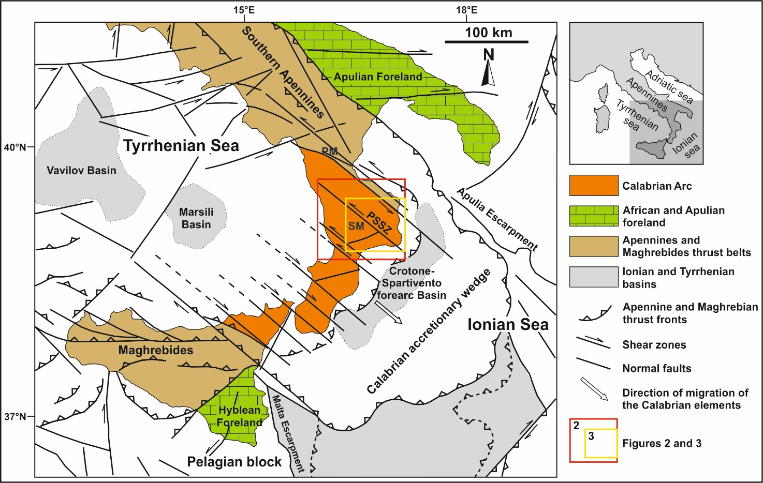
Figure 1. Simplified structural map of the Calabrian Arc, which is located between the Neogene chains of the Southern Apennines to the north and the Maghrebides of Sicily to the south-west (modified from Cifelli et al. 2007; Tansi et al. 2007; Tripodi et al., 2013, 2018; Zecchin et al., 2020). The main basins located in the Ionian and Tyrrhenian seas, and the major NW-trending shear zones affecting the Calabrian Arc are also reported. The Calabrian accretionary complex is composed of the Calabrian Arc and of the Calabrian accretionary wedge. Abbreviations: PM, Pollino Massif; PSSZ, Petilia-Sosti Shear Zone; SM: Sila Massif.

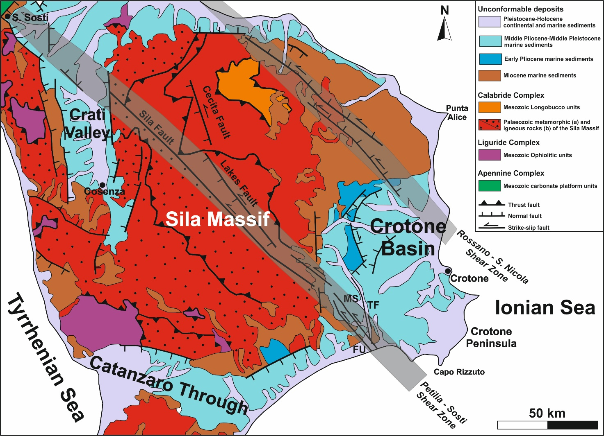
Figure 2. Simplified geologic map of the northern sector of the Calabrian Arc including the Sila Massif, whic is mainly composed of Paleozoic intrusive and low to high-grade metamorphic rocks, and the sedimentary basins of the Crati Valley, Catanzaro Through and Crotone Basin (modified from Olivetti et al., 2012) (see location in Fig. 1). The position of the two main left-lateral shear zones (the Rossano-San Nicola and Petilia Sosti shear zones) affecting this area is also reported together with the major faults. Tectonic features from Van Dijk (1994), Tortorici et al. (1995), Van Dijk et al. (2000), Galli and Scionti (2006), Spina et al. (2007), Massari and Prosser (2013), Zecchin et al. (2020). Abbreviations: FU, Fosso Umbro Fault; MS: Marcedusa-Steccato Fault; TF: Tacina Fault.

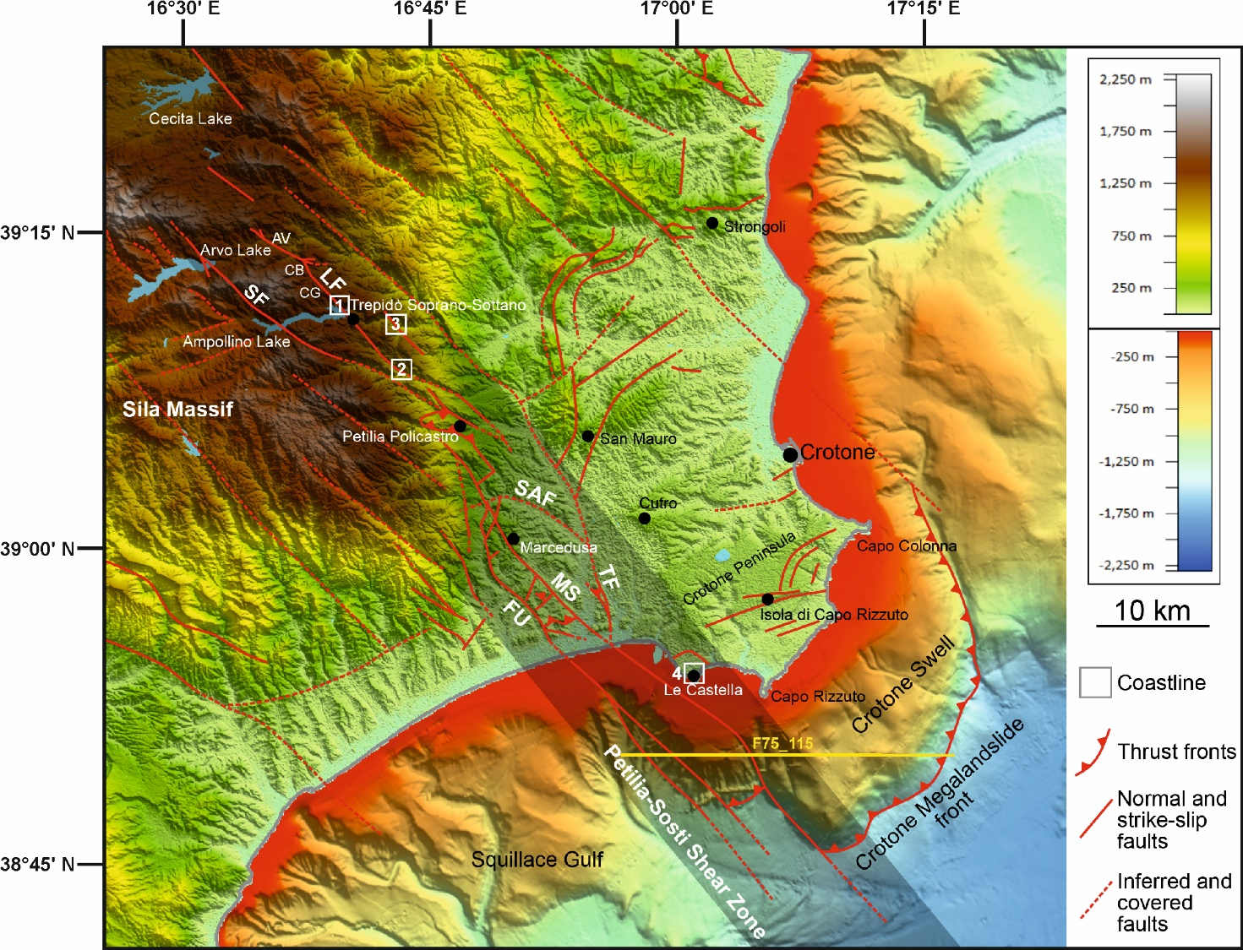
Figure 3. Digital Terrain Model (DTM) map in projection UTM 33 (WGS84) including the onshore and offshore parts of the Crotone Basin and the eastern sector of the Sila Massif hosting the Cecita, Arvo and Ampollino lakes (see location in Fig. 1). The fault segments associated with the Petilia-Sosti Shear Zone (gray zone) as well as the main tectonic structures affecting the surrounding areas are reported from this study and the following literature: Cassa per il Mezzogiorno (1971), Van Dijk (1994), Van Dijk et al. (2000), Galli and Scionti (2006), Spina et al. (2007), Massari and Prosser (2013), Zecchin et al. (2018, 2020). The white squares indicate the position of the structural sites described in the text: 1, Cagno Basin; 2 East Ampollino Lake; 3, Fiumarella di Migliarite; 4, Ampollino River Valley; 5, Le Castella terrace. The yellow line indicates the position of the multichannel ministerial seismic reflection profile F75_115.
Abbreviations: AV, Arvo River Valley; CB, Cagno Basin; CG, Colle della Giumenta mountain; FM, Fiumarella di Migliarite Valley; FU, Fosso Umbro Fault; LF, Lakes Fault; MS, Marcedusa-Steccato Fault; SAF, San Antonio Fault; SF, Sila Fault.
Land data extracted from SRTM (Shuttle Radar Topography Mission) with 30 m (1 arc-second) resolution made available by the U.S. Geological Survey (https://lpdaac.usgs.gov/search/) and TinItaly DEM of the Italian territory made available with a 10 m cell size grid (Tarquini et al., 2007, 2012; http://tinitaly.pi.ingv.it/Download_Area2.html).
Bathymetric data extracted from: EMODnet Digital Terrain Model (DTM 2020) with a 1/16 * 1/16 arc minutes grid resolution (about 115-115 metres) (https://www.emodnet.bathymetry.eu/).
Vector data (lakes and coastline) derived from Copernicus (https://land.copernicus.eu/imagery-in-situ/eu-hydro/eu-hydro-river-network-database).

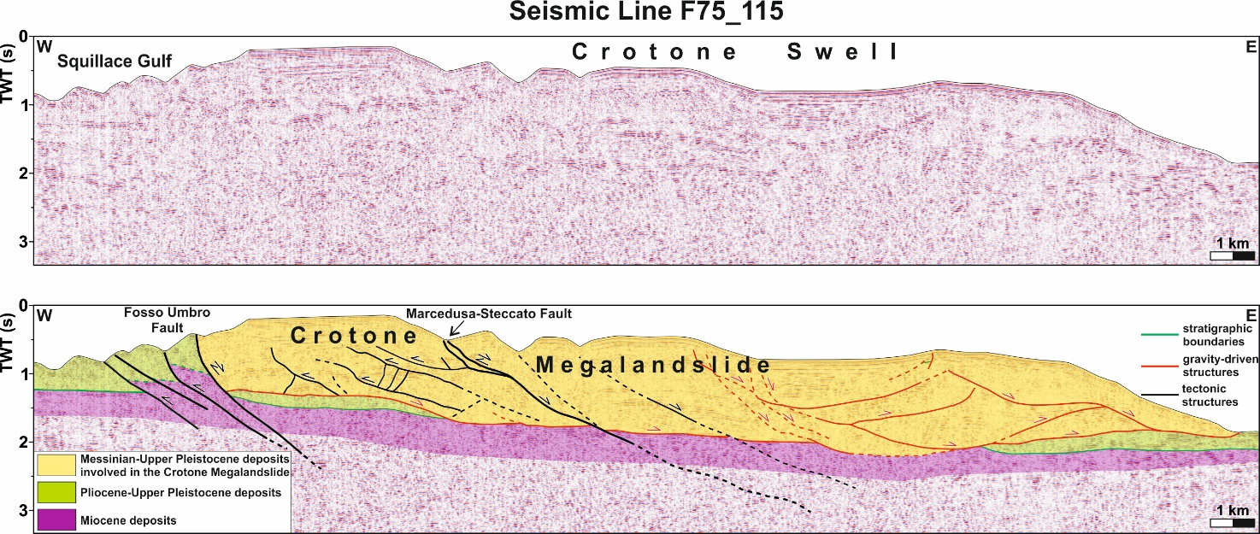
Figure 4. Multichannel ministerial seismic reflection profile F75_115 (see location in Fig. 3) crossing in an E-W direction the southern offshore sector of the Crotone Megalandslide and interpreted line-drawing (modified from Zecchin et al., 2018) (Seismic data from “Visibility of Petroleum Exploration Data in Italy_ViDEPI Project”; http://www.videpi.com). The megalandslide is affected by the possible seaward prolongation of the NW-trending, NE-dipping Fosso Umbro and Marcedusa-Steccato faults associated with the Petilia-Sosti Shear Zone. In particular, the megalandslide consists of two parts separated by the Marcedusa-Steccato Fault, whereas its south-western border is represented by a branch of the Fosso Umbro Fault.

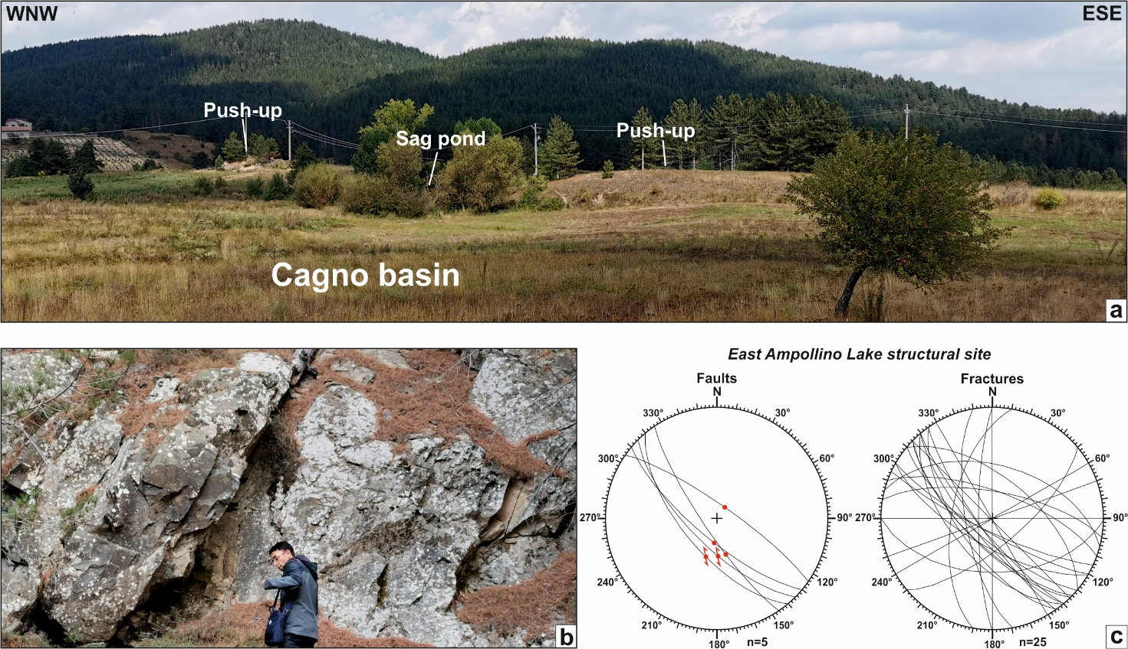
Figure 5. a) Morphotectonic evidence of the Lakes Fault (LF) in the area of the Cagno Basin (structural site 1 in Fig. 3) located northward from the Ampollino Lake in the Sila Massif. This area is characterized by the presence of NW-striking push-up structures associated with the LF. Sag ponds produced by the damming of the drainage system of the area caused by the recent reactivation of the LF are locally located at the base of the fault scarps.
East Ampollino Lake structural site (structural site 2 in Fig. 3): b) NW-trending pervasive fractures affecting the Paleozoic granitoid rocks cropping-out along the eastern part of the Ampollino Lakes and associated to the southern prolongation of the LF; c) Stereographic projections of the meso-faults and fractures measured along the eastern coast of the Ampollino Lake.

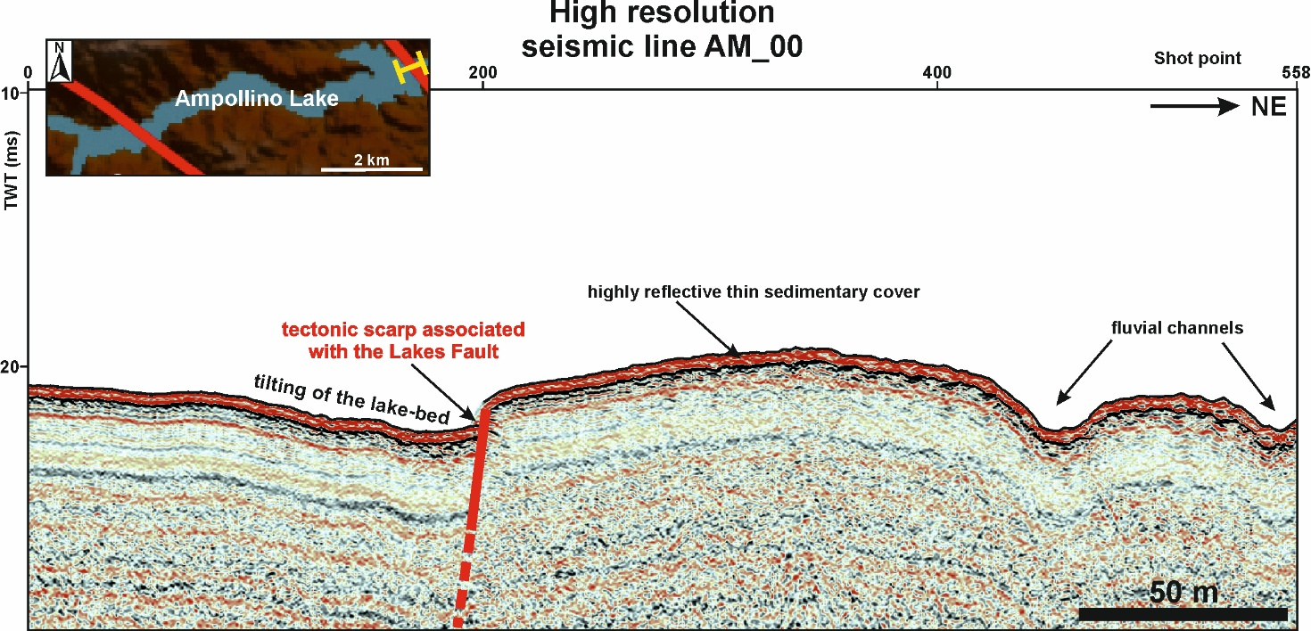
Figure 6. North-eastern part of the high-resolution seismic line AM_00 acquired in 2021 by OGS in the Ampollino Lake (vertical exaggeration 9X). Its postion is reported in the box in the upper left corner. A metric displacement of the lake floor is cleary associated with the presence of a SW-dipping scarp of a probably tectonic origin, which would represent the submerged prolongation of the Lakes Fault found onland from the Cagno Basin to the Colle della Giumenta mountain (CB and CG in Fig. 3). A tilting of the lake floor is recognizable toward the fault scarp, and also this probably indicates a normal component of movement along the Lakes Fault.

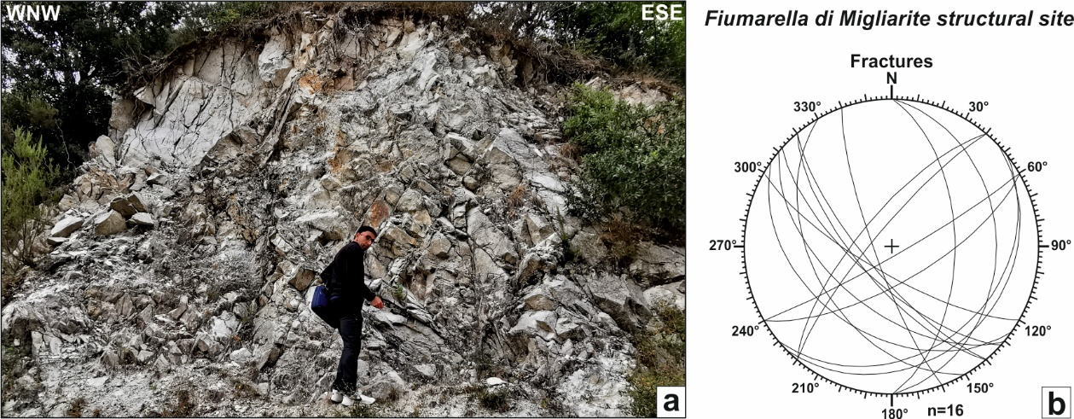
Figure 7. Fiumarella di Migliarite structural site (structural site 3 in Fig. 3): a) Intensely fractured Paleozoic granitoid rocks; b) Stereographic projections of the fractures measured at the Fiumarella di Migliarite structural site.

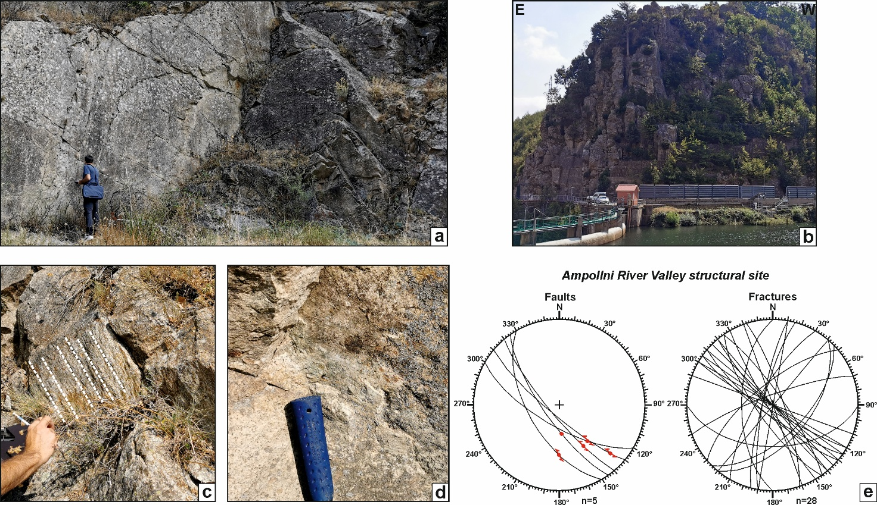
Figure 8. Ampollino River Valley structural site (structural site 4 in Fig. 3): a and b) pervasive brittle deformation affecting the Paleozoic granitoid rocks mainly produced by the presence of high angle NW-trending fault planes and fractures; c) Fault plane with slickelines (white dotted lines) indicating an oblique kinematics; d) Fault plane with calcite fiber steps indicating a left-lateral transtensional kinematics; e) Stereographic projections of the meso-faults and fractures measured at the Ampollino River Valley structural site.

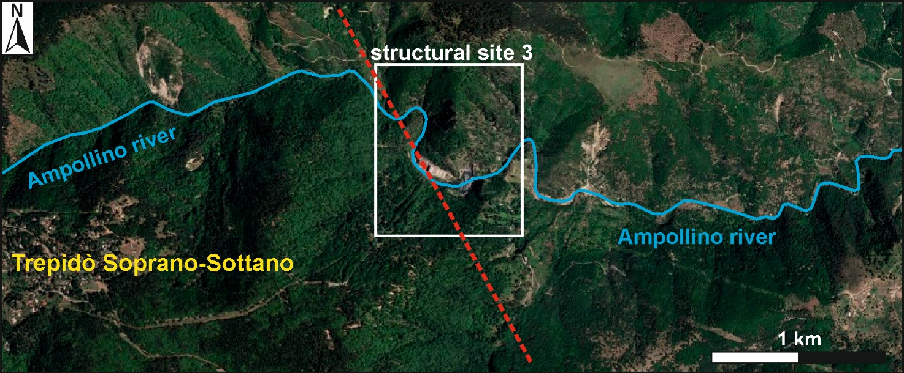
Figure 9. Satellite image (from Google Earth version 9.152.0.1) of the Ampollino River Valley, which is characterized by an abrupt change in flow direction of the Ampollino River in its central part, where the structural site 4 (Ampollino River Valley) described in the text is located. Here, the Ampollino River shows a N140° flow direction that contrasts with its lower and upstream parts, both showing a roughly ENE-trend. This configuration, together with the collected structural data, allow to suppose the presence of a NW-trending fault (red dashed line) parallel to the Lakes Fault.

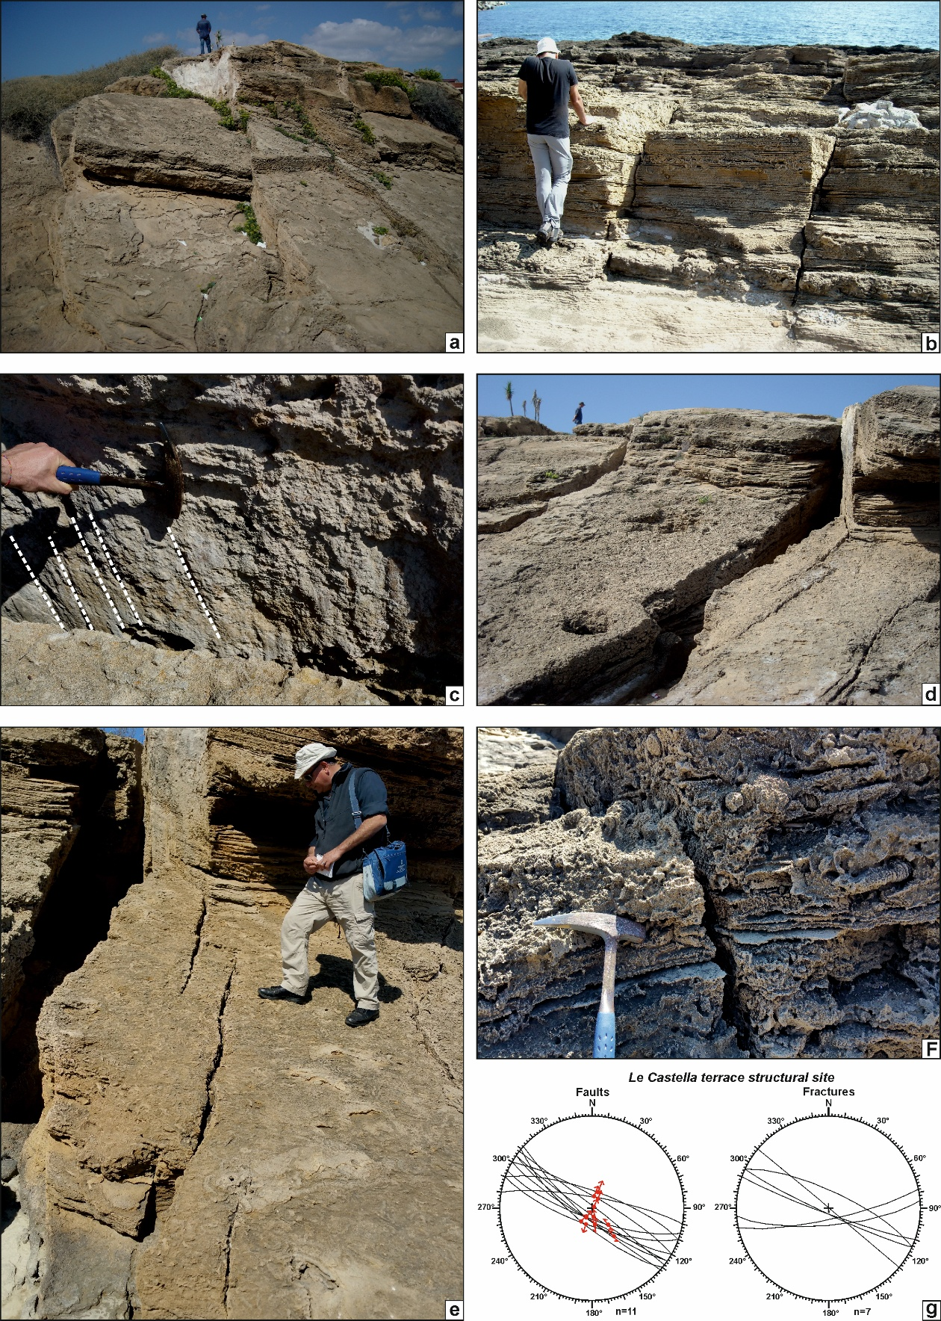
Figure 10. Structural site of the late Pleistocene Le Catella terrace (structural site 5 in Fig. 3): a and b) Sub-vertical NW-trending fault planes and fractures; c) Fault plane with slickelines (white dotted lines) indicating an oblique kinematics with a main dip-slip component of motion; d and e) Examples of predominantly normal fault segments with a left-lateral overstepping arrangement; f) Reverse centimeter displacement visible along a sub-vertical fault plane; g) Stereographic projections of the meso-faults and fractures measured at the Le Castella terrace.

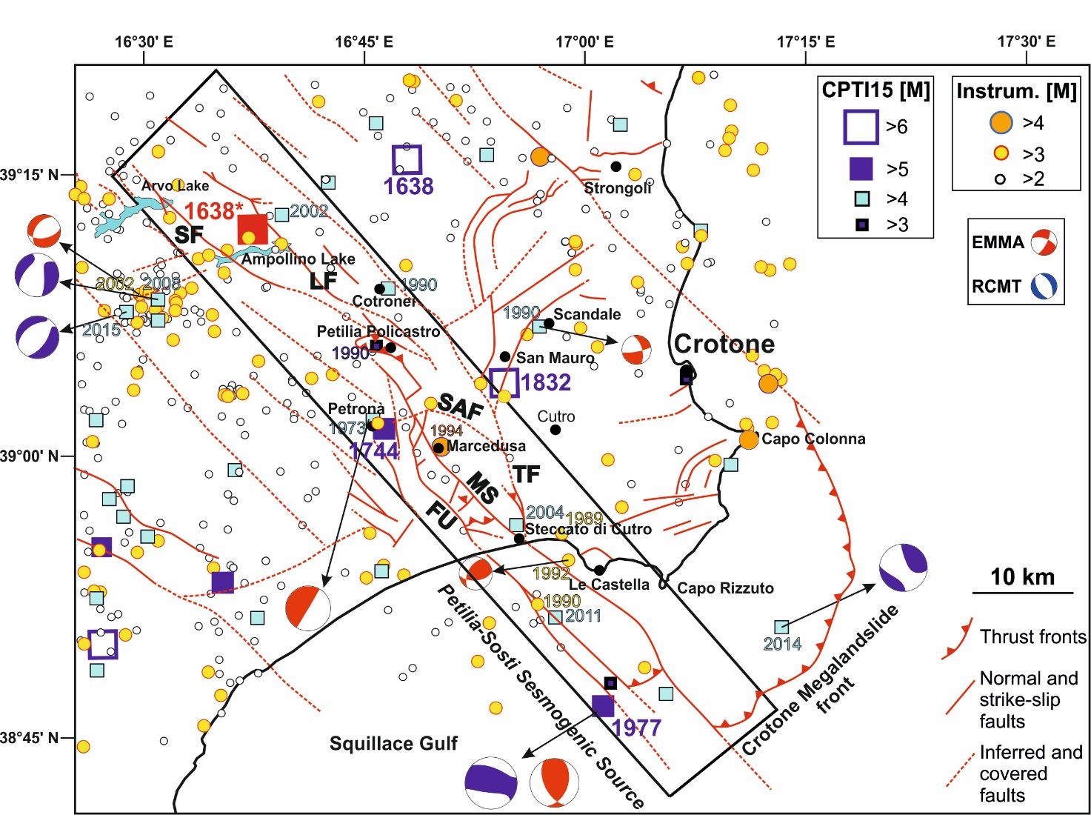
Figure 11. Historical (squares), since 1000 A.D., and instrumental (circles) seismicity and focal mechanisms recorded in the area reported in Figure 3 together with the main tectonic features. The symbol for the most significant earthquakes is associated with the year of occurrence. The location of the 1638* earthquake, which is indicated by a red square, is based on the information reported in Galli and Bosi (2003) and Bosi and Galli (2004). The NW-SE oriented rectangle represents the new seismogenic source proposed for the central Calabria and including the faults associated with the Petilia-Sosti Shear Zone.
Epicenters of the earthquakes derive from the “Parametric Catalogue of Italian Earthquakes - CPTI15” (Rovida et al., 2021; squares; https://emidius.mi.ingv.it/CPTI15-DBMI15), the “ISIDe: Italian Seismological Instrumental and Parametric Database” (ISIDe Working Group, 2007; circles https://www.terremoti.ingv.it/iside); the “Catalogue of the Regional Seismic Network of the University of Calabria” (circles; http://www.sismocal.org).
Focal mechanisms derive from “Global CMT catalog” (Dziewonski et al., 1981; Ekström et al., 2012; https://www.globalcmt.org), the “European-Mediterranean Regional Centroid-Moment Tensors catalog” (European-Mediterranean RCMT) (Pondrelli et al., 2002; http://rcmt2.bo.ingv.it), and the “Earthquake Mechanisms of the Mediterranean Area database-EMMA” (Vannucci and Gasperini, 2004; Vannucci et al., 2009).
Abbreviations: FU, Fosso Umbro Fault; LF, Lakes Fault; MS, Marcedusa-Steccato Fault; SAF, San Antonio Fault; SF, Sila Fault; TF, Tacina Fault.

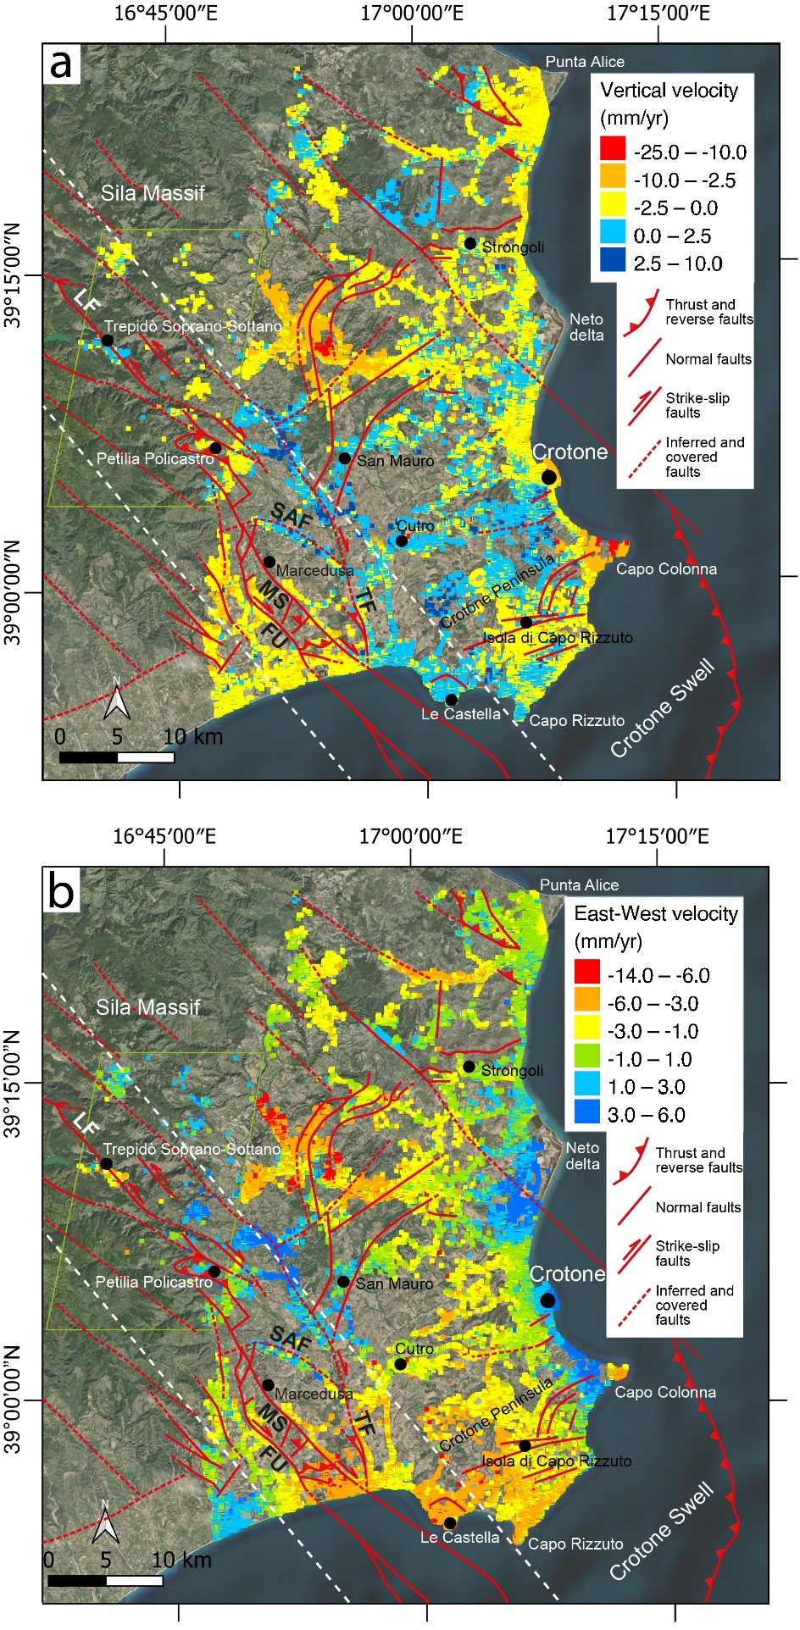
Figure 12. Average vertical (a) and E-W (b) ground movements obtained by SAR-based interferometry over the 2011-2014 period (COSMO-SkyMed data) and over the 1992-2000 period (ERS1/2 data, only within the green polygon). Positive vertical velocities indicate uplift, while positive E-W velocities indicate eastward component of movement. The white dotted lines represent the boundaries of the Petlia-Sosti Shear Zone. Abbreviations: FU, Fosso Umbro Fault; LF, Lakes Fault; MS, Marcedusa-Steccato Fault; SAF, San Antonio Fault; TF, Tacina Fault. The base map is courtesy of Esri, Maxar, GeoEye, Earthstar Geographics, CNES/Airbus DS, USDA, USGS, AeroGRID, IGN, and the GIS User Community. Figure 12b has been modified from Zecchin et al., 2018 including new data from the Sila Massif area.

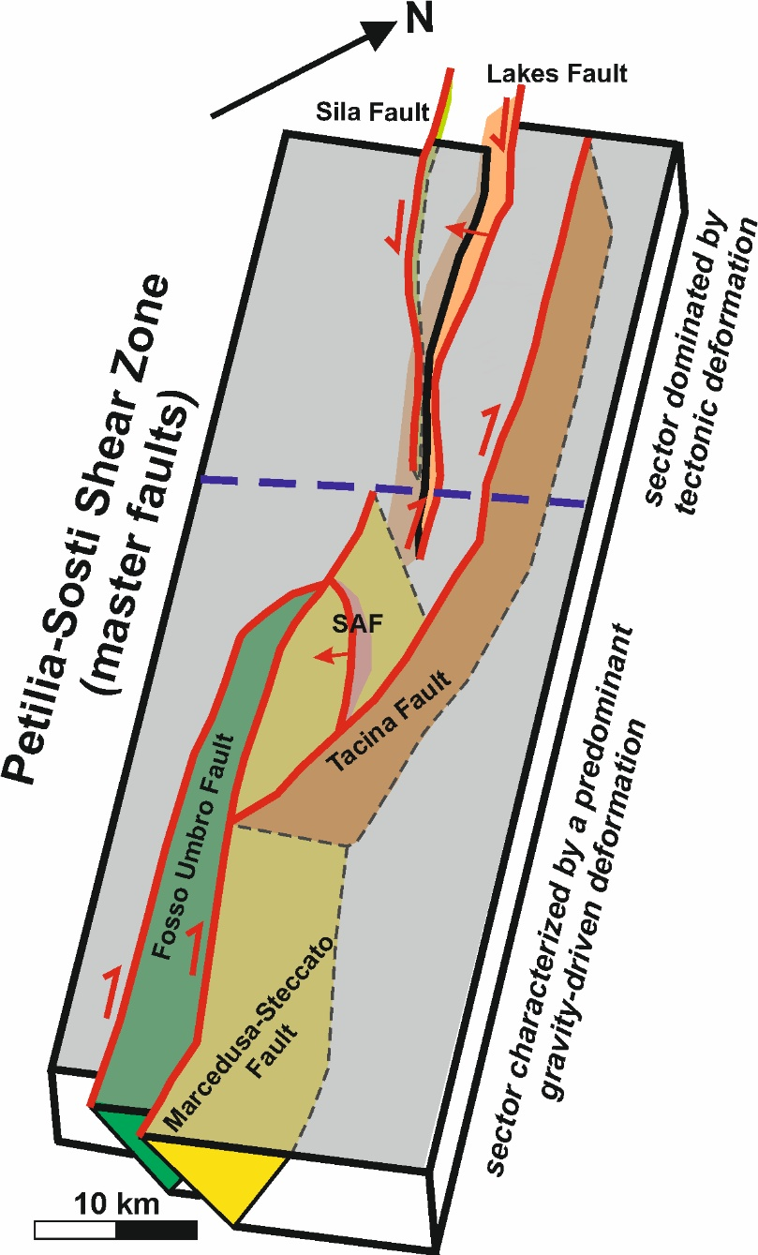
Figure 13. Simplified block diagram showing the master faults that compose the Petilia-Sosti Shear Zone (PSSZ) with their present-day predominat kinematics. The PSSZ can be subdivided in a NW sector (Sila Massif) affected by a tectonic deformation produced by sinistral transtensional faults, and a SE sector dominated by gravity-driven movements along faults with a dextral strike-slip kinematics. Abbreviation: SAF, San Antonio Fault.

Acknowledgements
We warmly thank the Editor Istvan Csato and the reviewers for their suggestions and comments that helped us to improve the original manuscript
References

Amodio Morelli, L., Bonardi, G., Colonna, V., Dietrich, D., Giunta, G., Ippolito, F., Liguori, V., Lorenzoni, S., Paglionico, A., Perrone, V., Piccarreta, G., Russo, M., Scandone, P., Zanettin-Lorenzoni, E., Zuppetta, A., 1976. L’arco calabro-peloritano nell’orogene appenninico-maghrebide. Mem. Soc. Geol. It. 17, 1-60.

Ayuso, R.A., Messina, A., De Vivo, B. et al., 1994. Geochemistry and argon thermochronology of the Variscan Sila Batholith, southern Italy: source rocks and magma evolution. Contrib. Mineral. Petrol. 117, 87-109. https://doi.org/10.1007/BF00307732

Barone, M., Dominici, R., Muto, F., Critelli, S., 2008. Detrital modes in a late Miocene wedge-top basin, Northeastern Calabria, Italy: compositional record of wedge-top partitioning. J. Sed. Res. 78, 693-711.

Basili, R., Valensise, G., Vannoli, P., Burrato, P., Fracassi, U., Mariano, S., Tiberti, M.M., Boschi, E., 2008. The Database of Individual Seismogenic Sources (DISS), version 3: summarizing 20 years of research on Italy's earthquake geology. Tectonophysics 453, 20-43. https://doi.org/10.1016/j.tecto.2007.04.014.

Biondino, B., Borrelli L., Critelli S., Muto, F., Apollaro, C., Coniglio, S., Tripodi, V., Perri, F., 2020.A multidisciplinary approach to investigate weathering processes affecting gneiss rocks (Calabria, southern Italy). Catena 187, 104372. https://doi.org/10.1016/j.catena.2019.104372.

Bird, P.C., Cartwright, J.A., Davies, T.L., 2015. Basement reactivation in the development of rift basins: an example of reactivated Caledonide structures in the West Orkney Basin. J. Geol. Soc. 172, 77-85.

Bercovici, D., Ricard, Y., 2012. Mechanisms for the generation of plate tectonics by two-phase grain damage and pinning. Phys. Earth Planet. Inter. 202–203, 27-55. https://doi.org/10.1016/j.pepi.2012.05.003.

Bonardi, G., Cavazza, W., Perrone, V., Rossi, S., 2001. Calabria-Peloritani terrane and northern Ionian Sea. In: Vai, G.B., Martini, I.P. (Eds.), Anatomy of an Orogen: the Apennines and Adjacent Mediterranean Basins. Kluwer Academic Publishers, Bodmin, pp. 287-306.

Bosi, V., Galli, P., 2004. Incorporatine paleoseismological data in PSHA: the case of Calabria (southern Italy). Boll. Geofis. Teor. Appl. 45, 255-270.

Brutto, F., Muto, F., Loreto, M.F., De Paola, N., Tripodi, V., Critelli, S., Facchin, L., 2016. The Neogene-Quaternary geodynamic evolution of the central Calabrian Arc: A case study from the western Catanzaro Trough basin. J. Geodyn. 102, 95-114. http://dx.doi.org/10.1016/j.jog.2016.09.002.

Brutto, F., Muto, F., Tripodi, V., Critelli, S., 2015. Tectono-stratigraphic evolution of southern margin of the Crotone basin (Calabria, South Italy). Rend, Online Soc. Geol. Ital. 33, 8-12.

Butler, R.W.H., Bond, C.E., Shipton, Z.K., Jones, R.R., Casey, M., 2008. Fabric anisotropy controls faulting in the continental crust. J. Geol. Soc. 165, 449-452.

Butler, R.W.H., Mazzoli, S., Corrado, S., De Donatis, M., Di Bucci, D., Gambini, R., Naso, G., Nicolai, C., Scrocca, D., Shiner, P., Zucconi, V., 2004. Applying thick-skinned tectonic model to the Apennine thrust belt of Italy: limitations and implications. In: McClay K.R. (Ed.), Thrust Tectonics and Hydrocarbon System vol. 82, AAPG Memoir, pp. 647-667.

Capozzi, R., Artoni, A., Torelli, L., Lorenzini, S., Oppo, D., Mussoni, P., Polonia, A., 2012. Neogene to Quaternary tectonics and mud diapirism in the Gulf of Squillace (Crotone-Spartivento Basin, Calabrian Arc, Italy). Mar. Pet. Geol. 35, 219-234.

Capraro, L., Consolaro, C., Fornaciari, E., Massari, F., Rio., D., 2006. Chronology of the middle-upper Pliocene succession in the Strongoli area: constraints on the geological evolution of the Crotone Basin (southern Italy). In: Moratti, G., Chalouan, A. (Eds.), Tectonics of the Western Mediterranean and North Africa, vol. 262. Geol. Soc. Spec. Publ., pp. 323-336.

Cassa per il Mezzogiorno, 1971. Carta Geologica della Calabria in scala 1:25.000, Foglio 237. Legge speciale per la Calabria 26, 11, 1955, n. 1177. Poligrafica & Cartevalori, Ercolano (Napoli).

Catalano, R., Doglioni, C., Merlini, S., 2001. On the Mesozoic Ionian basin. Geophys. J. Int. 144, 49-64.

Chiarabba, C., De Gori, P., Speranza, F., 2008. The southern Tyrrhenian subduction zone: deep geometry, magmatism and Plio-Pleistocene evolution. Earth Planet. Sci. Lett. 268, 408-423.

Cifelli, F., Rossetti, F., Mattei, M., 2007. The architecture of brittle postorogenic extension: results from an integrated structural and paleomagnetic study in north Calabria (southern Italy). Geol. Soc. Am. Bull. 119, 221-239.

Cirrincione, R., Fazio, E., Fiannacca, P., Ortolano, G., Pezzino, A., Punturo, R., 2015. The Calabria-Peloritani Orogen, a composite terrane in Central Mediterranean; its overall architecture and geodynamic significance for a pre-Alpine scenario around the Tethyan basin. Period. Mineral. 84 (3B, Special Issue), 701-749. https://doi.org/10.2451/2015PM0446.

Civile, D., Brancolini, G., Lodolo, E., Forlin, E., Accaino, F., Zecchin, M., Brancatelli, G., 2021. Morphostructural setting and tectonic evolution of the central part of the Sicilian Channel (Central Mediterranean). Lithosphere 2021:7866771. https://doi.org/10.2113/2021/7866771.

Civile, D. Lodolo, E., Accaino, F., Geletti, R., Schiattarella, M., Giustiniani, M., Fedorik, J., Zecchin, M., Zampa, L., 2018. Capo Granitola-Sciacca Fault Zone (Sicilian Channel, Central Mediterranean): Structure vs magmatism. Mar. Pet. Geol, 96, 627-644.

Cernobori, L., Hirn, A., McBride, J.H., Nicolich, R., Petronio, L., Romanelli, M., 1996. Crustal image of the Ionian basin and its Calabrian margins. Tectonophysics 264 (1), 175-189.

Corbi, F., Fubelli, G., Luc, F., Muto, F., Pelle, T., Robustelli, G., Scarciglia, F., Dramis, F., 2009. Vertical movements in the Ionian margin of the Sila Massif (Calabria, Italy). Ital. J. Geosci. 128(3), 731-738. https://doi.org/10.3301/IJG.2009.128.3.731.

Costantini, M., Ferretti, A., Minati, F., Falco, S., et al., 2017. Analysis of surface deformations over the whole Italian territory by interferometric processing of ERS, Envisat and COSMO-SkyMed radar data. Remote Sens. Environ. 202, 250-275. https://doi.org/10.1016/j.rse.2017.07.017.

Cottle, J.M., Larson, K.P., Kellett, D.A., 2015. How does the mid-crust accomodate deformation in large, hot collisional orogens? A review of recent research in the Himalayan orogen. J. Struct. Geol. 78, 119-133.

Critelli, S., 1999. The interplay of lithospheric flexure and thrust accomodation in forming stratigraphic sequences in the southern Apennines foreland basin system, Italy. Rend. Accad. Naz. Lincei 10, 257-326. https://doi.org/10.1007/BF02904390.

Critelli, S., 2018. Provenance of Mesozoic to Cenozoic circum-Mediterranean sandstones in relation to tectonic setting. Earth Sci. Rev. 185, 624-648. https://doi.org/10.1016/j.earscirev.2018.07.001.

Critelli, S., Muto, F., Perri, F., Tripodi V., 2017. Interpreting provenance relations from sandstone detrital modes, southern Italy foreland region: Stratigraphic record of the Miocene tectonic evolution. Mar. Pet. Geol. 87, 47-59. https://doi.org/10.1016/j.marpetgeo.2017.01.026.

D'Agostino, N., Selvaggi, G., 2004. Crustal motion along the Eurasia-Nubia plate boundary in the Calabrian Arc and Sicily and active extension in the Messina Straits from GPS measurements. J. Geophys. Res. 109. https://dx.doi.org/10.1029/2004JB002998.

Daly, M.C., Quennell, A.M., 1986. Crustal shear zones and thrust belts: Their geometry and continuity in central Africa [and discussion]. Phil. Trans. R. Soc. Lond. Series A, Mathematical and Physical Sciences 317 (1539), 111-128.

Del Ben, A., Barnaba, C., Taboga, A., 2008. Strike-slip systems as the main tectonic features in the Plio-Quaternary kinematics of the Calabrian Arc. Mar. Geophys. Res. 29, 1-12. http://dx.doi.org/10.1007/s11001-007-9041-6.

DeMets, C., Iaffaldano, G., Merkouriev, S., 2015. High-resolution Neogene and Quaternary estimates of Nubia-Eurasia-North America Plate motion. Geophys. J. Int. 203, 416-427. https://doi.org/10.1093/gji/ggv277.

De Vivo, B., Ayuso, R.A., Belkin, H.E., Lima, A., Messina, A., Viscardi, A., 1991. Rock chemistry and fluid inclusion studies as exploration tools for ore deposits in the Sila batholith, southern Italy. J. Geochemical Exploration 40, 291-310. https://doi.org/10.1016/0375-6742(91)90044-U.

Dewey, J.F., Helman, M.L., Turco, E., Hutton, D.H.W., Knott, D.S., 1989. Kinematics of the western Mediterranean. In: Coward, M.P., Dietrich, D., Park, R.G. (Eds.), Alpine Tectonic, vol. 45. Geol. Soc. London, Spec. Publ., pp. 265-283.

DISS Working Group, 2018. Database of Individual Seismogenic Sources (DISS), Version 3.2.1: A compilation of potential sources for earthquakes larger than M 5.5 in Italy and surrounding areas. http://diss.rm.ingv.it/diss/, Istituto Nazionale di Geofisica e Vulcanologia. https://doi.org/10.6092/INGV.IT-DISS3.2.1.

Doglioni, C., 1991. A proposal of kinematic modelling forW-dipping subductions. Possible applications to the Tyrrhenian–Apennines system. Terra. Nova 3, 423–434.

Dramis, F., Gentili, B., Pambianchi, G., 1990. Geomorphological scheme of the River Trionto basin. In: Sorriso-Valvo M. (Ed.) Symposium on Geomorphology of Active Tectonic Areas, Excursion Guidebook, pp. 63-66, IGU-COMTAG, Cosenza, Italy.

Dubois, R., 1976. La suture calabro-apenninique Cretace-Eocene et l’ouverture Tyrrhénienne Neogene; étude pétrographique et structurale de la Calabria centrale. Thèse Universitè P. et M. Curie, Paris , 567 pp.

Dubois, R., Glangeaud, L., 1965. Grandes structures, microstructures et sens des chevauchements de matériel cristallin a l’extrémité méridionale du massif de la Sila (Calabre centrale, Italie). C.R. Somm. Géol. France 7, 239-240.

Dziewonski, A.M., Chou, T.-A., Woodhouse, J.H., 1981. Determination of earthquake source parameters from waveform data for studies of global and regional seismicity. J. Geophys. Res. 80, 2825-2852.

Ekström, G., Nettles, M., Dziewonski, A.M., 2012. The global CMT project 2004-2010: Centroid-moment tensors for 13,017 earthquakes. Phys. Earth Planet. Inter. 200-201, 1-9. https://dx.doi.org/10.1016/j.pepi.2012.04.002.

Faccenna, C.F., Funiciello, Giardini, D., Lucente, P., 2001. Episodic back-arc extension during restricted mantle convection in the central Mediterranean. Earth Planet. Sci. Lett. 187, 105-116. http://doi.org/10.1016/S0012-821X(01)00280-1.

Faccenna, C., Piromallo, C., Crespo-Blanc, A., Jolivet, L., Rossetti, F., 2004. Lateral slab deformation and the origin of the western Mediterranean arcs. Tectonics 23, TC1012. http://doi.org/10.1029/2002TC001488.

Ferranti, L., Burrato, P., Pepe, F., Santoro, E., Mazzella, M.E., Morelli, D., Passaro, S., Vannucci, G., 2014. An active oblique contractional belt at the transition between the Southern Apennines and Calabrian Arc: The Amnedolara Ridge, Ionian sea, Italy. Tectonics 33, 2169-2194.

Ferranti, L., Santoro, E., Mazzella, M.E., Monaco, C., Morelli, D., 2009. Active transpression in the northern Calabria Apennines, southern Italy, Tectonophysics 476(1–2), 226–251.

Fossen, H., 2010. Extensional tectonics in the North Atlantic Caledonides: a regional review. In: R.D. Law, R.D., Butler, R.W.H., Krabbendam, M., Strachan, R.A. (Eds.), Continental Tectonics and Mountain Building: The Legacy of Peach and Horne. Geol. Soc. Spec. Publ. 335, pp. 767-793. https://doi.org/101144/SP335.31.

Fossen, H., Cavalcante, G.C.G., 2017. Shear zones - A review. Earth Sci. Rev. 171, 434-455.

Galli, P., Bosi, V., 2003. Catastrophic 1638 earthquakes in Calabria (southern Italy). New insight from paleoseismological investigation. J. Geophys. Res. 108, B1. https://doi.org/10.1029/2002JB01713.

Galli, P., Scionti, V., 2006. Two unknown M>6 historical earthquakes revealed by paleoseismological and archival researches in eastern Calabria (Southern Italy). Seismotectonic implications. Terra Nova 18(1), 43-48.

Galli, P., Scionti, V., Spina, V., 2007. New paleoseismic data from the Lakes and Serre faults: seismotectonic implications for Calabria (Southern Italy). Boll. Soc. Geol. Ital. (Ital. J. Geosci.) 126 (2), 347-364.

Gasperini, P., Bernardini, F., Valensise, G., Boschi, E., 1999. Defining seismogenic sources from historical earthquake felt reports. Bull. Seismol. Soc. Am. 89, 94-110.

Gasperini, P., Vannucci, G., Tripone, D., Boschi, E., 2010. The location and sizing of historical earthquakes using the attenuation of macroseismic intensity with distance. Bull. Seismol. Soc. Am. 100, 2035-2066. https://doi.org/10.1785/0120090330.

Godin, L., Grujic, R.D., Searle, M.P., 2006. Channel flow, ductile extrusion and exumation in continental collision zones: an introduction. Geol. Soc. Spec. Publ. 268, 1-23. https://doi.org/10114/GSL.SP.2006.268.01.01.

Gori, S., Falcucci, E., Fubelli, G., Muto, F., Dramis, F., 2016. Active transpressive surface faulting in north-eastern Calabria, Southern Italy: Early results of geomorphological, stratigraphic and paleoseismological analyses. Alpine and Mediterranean Quaternary 29(1), 91-105.

Gvirtzman, Z., Nur, A., 2001. Residual topography, lithospheric structure and sunken slabs in the central Mediterranean. Earth Planet Sci. Lett. 187, 117-130.

Guillaume, B., Funiciello, F., Faccenna, C., Martinod, J., Olivetti, V., 2010. Spreading pulses of the Tyrrhenian sea during the narrowing of the calabrian slab. Geology 38, 819-822.

Iannace, A., Bonardi, G., D’Errico, M., Mazzoli, S., Perrone, V., and Vitale, S., 2005. Structural setting and tectonic evolution of the Apennine Units of northern Calabria. Comptes Rendus Geoscience 337, 1541–1550. https://doi.org/10.1016/j.crte.2005.09.003.

Ietto, A., Ietto, F., 1998. Sviluppo e annegamento di un sistema carbonatico piattaforma-bacino nel Trias superiore della Catena Costiera calabrese. Boll. Soc. Geol. Ital. 117, 313-331.

ISIDe Working Group, 2007. Italian Seismological Instrumental and Parametric Database (ISIDe). Istituto Nazionale di Geofisica e Vulcanologia (INGV). https://doi.org/10.13127/ISIDE.

ITHACA Working Group, 2019. ITHACA (ITaly HAzard from CApable faulting), A Database of active capable faults of the Italian territory. Version December 2019. ISPRA Geological Survey of Italy. http://sgi2.isprambiente.it/ithacaweb/Mappatura.aspx.

Jaquet, Y., Duretz, T., Grujic, D., Masson, H., Schmalholz, S.M., 2018. Formation of orogenic wedges and crustal shear zones by thermal softening, associated topographic evolution and application to natural orogens, Tectonophysics 746, 512-529.

Knott, S.D., 1987. The Liguride Complex of Southern Italy - a Cretaceous to Paleogene accretionary wedge. Tectonophysics 142, 217-226.

Knott, S.D., Turco, E., 1991. Late Cenozoic kinematics of the Calabrian Arc, southern Italy. Tectonics 10, 1164-1172.

Langone, A., Godard, G., Prosser, G., Caggianelli, A., Rottura, A., Tiepolo, M., 2010. P-T-t path of the Hercynian low-pressure rocks from the Mandatoriccio complex (Sila Massif, Calabria, Italy): new insights for crustal evolution. J. metamorphic Geol. 28, 137-162.

Lanzafame, G., Spadea, P., Tortorici, L., 1979. Mesozoic ophiolites of the northern Calabria and Lucanian Apennine (southern Italy). Ofioliti 4 (2), 173-182.

Lentini, F., Carbone, S., Catalano, S., Di Stefano, A., Gargano, C., Romeo, M., Strazzulla, S., Vinci, G., 1995. Sedimentary evolution of the Peloritani Mts. (NE Sicily). Terra Nova 7, 161-170.

Malinverno, A., Ryan, W.B.F., 1986. Extension in the Tyrrhenian Sea and shortening in the Apennines as a result of arc migration driven by sinking of the lithosphere. Tectonics 5, 227-245.

Mangano, G., Zecchin, M., Civile, D., 2020. Large-scale gravity-driven phenomena in the Crotone Basin, southern Italy. Mar. Pet. Geol. 117, 104386. https://doi.org/10.1016/j.marpetgeo.2020.104386.

Massari, F., Prosser, G., 2013. Late Cenozoic tectono-stratigraphic sequences of the Crotone Basin: insights on the geodynamic history of the Calabrian Arc and Tyrrhenian sea. Basin Res. 25, 26-51. https://dx.doi.org/10.1111/j.1365-2117.2012.00549.x.

Massari, F., Prosser, G., Capraro, L., Fornaciari, E., Consolaro, C., 2010. A revision of the stratigraphy and geology of the south-western part of the Crotone Basin (South Italy). Italian J. Geosci. 129, 353–384.

Mattei, M., Cipollari, P., Cosentino, D., Argentieri, A., Rossetti, F., Speranza, F., Di Bella, L., 2002. The Miocene tectono-sedimentary evolution of the southern Tyrrhenian Sea: stratigraphy, structural and palaeomagnetic data from the on-shore Amantea basin (Calabrian Arc, Italy). Basin Res. 14, 147-168.

Mattei, M., Cifelli, F., D'Agostino, N., 2007. The evolution of the Calabrian Arc: evidence from paleomagnetic and GPS observations. Earth Planet Sci. Lett. 263, 259–274.

Mattei, M., Petrocelli, V., Lacava, D., Schiattarella, M., 2004. Geodynamic implications of Pleistocene ultrarapid vertical-axis rotations in the Southern Apennines. Italy. Geology 32, 789–792.

Mauz, B., Hassler, U., 2000. Luminescence chronology of Late Pleistocene raised beaches in southern Italy: new data of relative sea-level changes. Mar. Geol. 170, 187–203.

Messina, A., Somma, R., Macaione, E., Carbone, G., Careri, G., 2004. Peloritani continental crust composition (southern Italy): geological and petrochemical evidence. Boll. Soc. Geol. Ital. 123, 405-441.

Meulenkamp, J.E., Hilgen, F.J., Voogt, E., 1986. Late Cenozoic sedimentary-tectonic history of the Calabrian Arc. Giorn. Geol. 48 (1-2), 345-359.

Minelli, L., Billi, A., Faccenna, C., Gervasi, A., Guerra, I., Orecchio, B., Speranza, G., 2013. Discovery of a gliding salt-detached megaslide, Calabria, Ionian sea, Italy. Geophys. Res. Lett. 40, 4220-4224. https://doi.org/10.1002/grl.50818.

Minelli, L., Faccenna, C., 2010. Evolution of the Calabrian accretionary wedge (central Mediterranean). Tectonics 29, TC4004. http://dx.doi.org/10.10292009TC002562.

Molin, P., Pazzaglia, F.J., Dramis, F., 2004. Geomorphic expression of active tectonics in a rapidly deforming forearc, Sila Massif, Calabria, southern Italy. Am. J. Sci. 304, 559-589. https://doi.org/10.2475/ajs.304.7.559.

Muto, F., Spina, V., Tripodi, V., Critelli, S., Roda, C., 2014. Neogene tectonostratigraphic evolution of allochthonous terranes in the eastern Calabrian foreland (southern Italy). Italian J. Geosci. 133, (3), 455-473. https://doi.org/10.3301/IJG.2014.23.

Muto, F., Tripodi, V., Chiarella, D., Lucà, F., Critelli S., 2017. Tectono-stratigraphic architecture of the Ionian piedmont between the Arso Stream and Nicà River catchments (Calabria, southern Italy). J. Maps 13, 332-341.

Nalin, R., Lamothe, M., Auclair, M., Massari, F., 2020. Chronology of the marine terraces of the Crotone Peninsula (Calabria, southern Italy) by means of infrared-stimulated luminescence (IRSL). Mar. Pet. Geol. 122, 104645. https://doi.org/10.1016/j.marpetgeo.2020.104645.

Nicolosi, I., Speranza, F., Chiappini, M., 2006. Ultrafast oceanic spreading of the Marsili basin, southern Tyrrhenian Sea. Evidence from magnetic anomaly analysis. Geology 34, 717–720.

Ogniben, L., 1969. Schema introduttivo alla geologia del confine calabro-lucano. Mem. Soc. Geol. Ital. 8, 453–763.

Ogniben L., 1973. Schema geologico della Calabria in base ai dati odierni. Geol. Rom. 12, 243- 585.

Olivetti, V., Cyr, A.J., Molin, P., Faccenna, C., Granger, D.E., 2012. Uplift history of the Sila Massif, southern Italy, deciphered from cosmogenic ¹⁰Be erosion rates and river longitudinal profile analysis. Tectonics 31, TC3007. https://doi.org./10.1029/2011TC003037.

Ortolano, G., Visalli, R., Fazio, E., Fiannacca, P., Godard, G., Pezzino A., Punturo, R., Sacco, V., Cirrincione, R., 2020. Tectono-metamorphic evolution of the Calabria continental lower crust: the case of the Sila Piccola Massif. Int. J. Earth Sci. 109, 1295-1319.

Pennacchioni, G., 2005. Control of the geometry of precursor brittle structures on the type of ductile shear zone in the Adamello tonalites, Southern Alps (Italy). J. Struct. Geol. 27, 627-644. https://doi.org/10.1016/j.jsg2004.11008.

Perrone, V., 1996. Une nouvelle hypothèse sur la position paléogéographique et l’évolution tectonique des Unités de Verbicaro et de San Donato (région Calabro-Lucanienne; Italie): implications sur la limite Alpes-Apennines en Calabre. Comptes Rendus Acad. Sci. Paris 322, 877-884.

Phillips, T.B., Jackson, C.A.L., Bell, R.E., Duffy, O.B., Fossen, H., 2016. Reactivation of intrabasement structures during rifting: a case study from offshore southern Norway. J. Struct. Geol. 91, 54-73. https://doi.org/10.1016/j.jsg2016.08.008.

Polonia, A., Torelli, L., Mussoni, P., Gasperini, L., Artoni, A., Klaeschen, D., 2011. The Calabrian Arc subduction complex in the Ionian Sea: regional architecture, active deformation, and seismic hazard. Tectonics 30, TC5018. http://dx.doi.org/10.1029/2010TC002821.

Polonia, A., Torelli, L., Artoni, A., Carlini, M., Faccenna, C., Ferranti, L., Gasperini, L., Govers, R., Klaeschen, D., Monaco, C., Neri, G., Nijholt, N., Orecchio, B., Wortel, R., 2016. The Ionian and Alfeo-Etna fault zones: new segments of an evolving plate boundary in the central Mediterranean Sea? Tectonophysics 675, 69-90.

Pondrelli, S., Morelli, A., Ekström, G., Mazza, S., Boschi, E., Dziewonski, A.M., 2002. European-Mediterranean regional centroid-moment tensors: 1997-2000. Phys. Earth Planet. Inter. 130, 71-101. https://doi.org/10.1016/S0031-9201(01)00312-0.

Powell, D., Glendinning, N.R.W., 1990. Late Caledonian extensional reactivation of a ductile thrust in NW Scotland. J. Geol. Soc. Lond. 147, 979-987.

Ramsay, J.G., 1980. Shear zone geometry: a review. J. Struct. Geol. 2, 83-99.

Ramsay, J.G., Graham, M.I., 1970. Strain variation in shear belts. Can. J. Earth Science 7, 786-813.

Rebez, A., Sandron, D., Santulin M., Peruzza, L., Tamaro, A., Eusebio, M., Mucciarelli, M., Slejko, D., 2014. Input accelerograms and expected accelerations for some dam sites in southern Italy, in: Proc. of the 33rd Conference of the Gruppo Nazionale di Geofisica della Terra Solida (GNGTS), Bologna, Italy, 25-27.

Robustelli, G., Lucà, F., Corbi, F., Pelle, T., Dramis, F., Fubelli, G., Scarciglia, F., Muto, F., Cugliari, D., 2009. Alluvial terraces on the Ionian coast of northern Calabria, southern Italy: Implications for tectonic and sea level controls. Geomorphology 106, 165-179. https://doi.org/10.1016/j.geomorph.2008.12.010.

Roda, C., 1964. Distribuzione e facies dei sedimenti Neogenici nel Bacino Crotonese. Geol. Rom. 3, 319-366.

Rosenbaum, G.S., Lister, G., 2004. Neogene and quaternary rollback evolution of the Tyrrhenian sea, the Apennines, and the Sicilian maghrebides. Tectonics 23, TC1013. https://dx.doi.org/10.1029/2003TC001518.

Rossetti, F., Faccenna, C., Goffé, B., Monié, P., Argentieri, A., Funiciello, R., Mattei, M., 2001. Alpine structural and metamorphic signature of the Sila Piccola Massif nappe stack (Calabria, Italy): Insights for the tectonic evolution of the Calabrian Arc. Tectonics 20, 112-133.

Rossi, S., Sartori, R., 1981. A seismic reflection study of the external Calabrian Arc in the northern Ionian Sea (eastern Mediterranean). Mar. Geophys. Res. 4 (4), 403-426.

Rovida, A., Locati, M., Camassi, R., Lolli, B., Gasperini, P., Antonucci, A. (eds), 2021. Italian Parametric Earthquake Catalogue (CPTI15), version 3.0. Istituto Nazionale di Geofisica e Vulcanologia (INGV). https://doi.org/10.13127/CPTI/CPTI15.3.

Sagnotti, L., 1992. Paleomagnetic evidence for a Pleistocene counterclockwise rotation of the Sant-Arcangelo Basin, southern Italy. Geophys. Res. Lett. 19, 135–138.

Sartori, R., 1990. The main results of ODP Leg 107 in the frame of Neogene to Recent geology of perytyrrhenian areas. In: Kastens, K.A., Mascle, J., (Eds.), Proceedings of the Ocean Drilling Program, Scientific Results, vol. 107. Ocean Drilling Program, College Station, Texas, pp. 715-730.

Scarciglia, F., Critelli, S., Borrelli, L., Coniglio, S., Muto, F., Perri, F., 2016. Weathering profiles in granitoid rocks of the Sila Massif uplands, Calabria, southern Italy: New insights into their formation processes and rates. Sediment. Geol. 336, 46-67. https://doi.org/10.1016/j.sedgeo.2016.01.015.

Scheepers, P.J.J., Langereis, C.G., Zijderveld, J.D.A., Hilgen, F.J., 1994. Paleomagnetic evidence for a Pleistocene clockwise rotation of the Calabro-Peloritan block (southern Italy). Tectonophysics 230, 19–48.

Scholz, C.H., 1988. The brittle-plastic transition and the depth of seismic faulting. Geol. Rundsch. 77, 319-328.

Scionti, V., Galli, P., Chiodo, G., 2006. The Calabrian seismicity during the Viceroyalty of Naples: sources silence or silent sources? The case of the strong 1744 earthquake. Boll. Geofis. Teor. Appl. 47, 53-72.

Spakman, W., 1986. Subduction beneath Eurasia in connection with the Mesozoic Tethys. Geol. Mijnbouw 65, 145–153.

Speranza, F., Mattei, M., Sagnotti, L., Grasso, F., 2000. Rotational differences between the northern and southern Tyrrhenian domains: palaeomagnetic constraints from the Amantea basin (Calabria, Italy). J. Geol. Soc. London 157, 327–334.

Speranza, F., Macrì, P., Rio, D., Fornaciari, E., Consolaro, C., 2011. Paleomagnetic evidence for a post-1.2 Ma disruption of the Calabria terrane: consequences of slab breakoff on orogenic wedge tectonics. Geol. Soc. Am. Bull. 123, 925–933.

Spina, V., Galli, P., Tondi, E., Critelli, S., Cello, G., 2007. Kinematics and structural properties of an active fault zone in the Sila Massif (Northern Calabria, Italy). Boll. Soc. Geol. Ital. 126, 427-438.

Tansi, C., Gallo, M.F., Muto, F., Perrotta, P., Russo, L., Critelli, S., 2016. Seismotectonics and landslides of the Crati Graben (Calabrian Arc, Southern Italy). J. Maps 12, 363-372.

Tansi, C., Muto, F., Critelli, S., Iovine, G., 2007. Neogene-Quaternary strike-slip tectonics in the central Calabrian Arc (southern Italy). J. Geodyn. 43, 393-414.

Tarquini, S., Isola, I., Favalli, M., Mazzarini, F., Bisson, M., Pareschi, M.T., Boschi, E., 2007. TINITALY/01: a new Triangular Irregular Network of Italy. Ann. Geophys. 50, 407-425.

Tarquini, S., Vinci, S., Favalli, M., Doumaz, F., Fornaciai, A., Nannipieri, L., 2012. Release of a 10-m-resolution DEM for the Italian territory: Comparison with global-coverage DEMs and anaglyph-mode exploration via the web. Comput. Geosci. 38, 168-170. https://10.1016/j.cageo.2011.04.018.

Tortorici, L., Catalano, S., Monaco, C., 2009. Ophiolite-bearing mélanges in southern Italy. Geol. J. 44 (2), 153-166.

Tortorici, L., Monaco, C., Tansi, C., Cocina, O., 1995. Recent and active tectonics in the Calabrian arc (Southern Italy). Tectonophysics 243, 37-55.

Tosi, L., Da Lio, C., Teatini, P., Strozzi, T., 2018. Land Subsidence in Coastal Environments: Knowledge advance in the Venice Coastland by TerraSAR-X PSI. Remote Sensing 10(8), 1191. https://doi.org/10.3390/rs10081191.

Tosi, L., Da Lio, C., Strozzi, T., Teatini, P., 2016. Combining L- and X-Band SAR Interferometry to Assess Ground Displacements in Heterogeneous Coastal Environments: The Po River Delta and Venice Lagoon, Italy. Remote Sensing 8(4), 308. https://doi.org/10.3390/rs8040308.

Tripodi, V., Muto, F., Critelli, S., 2013. Structural style and tectono-stratigraphic evolution of the Neogene-Quaternary Siderno Basin, southern Calabrian Arc, Italy. Int. Geol. Rev. 55, 468-481.

Tripodi, V., Muto, F., Brutto, F., Perri, F., Critelli, S., 2018. Neogene-Quaternary evolution of the forearc and backarc regions between the Serre and Aspromonte Massifs, Calabria (southern Italy). Mar. Pet. Geol. 95, 328-343.

Turco, E., Maresca, R., Cappadona, P., 1990. La tettonica plio-pleistocenica del confine calabro-lucano: modello cinematico. Mem. Soc. Geol. Ital. 45, 519-529.

Van Dijk, J.P., 1990. Sequence stratigraphy, kinematics and dynamic geohistory of the Crotone Basin (Calabria Arc, Central Mediterranean): an intergrated approach. Mem. Soc. Geol. Ital. 44, 259-285.

Van Dijk, J.P., 1991. Basin dynamics and sequence stratigraphy in the Calabrian Arc (Central Mediterranean): records and pathways of the Crotone Basin. Geol. Mijnbouw 70, 187-201.

Van Dijk, J.P., 1994. Late Neogene kinematics of intra-arc oblique shear zones: The Petilia-Rizzuto Fault Zone (Calabrian Arc, Central Mediterranean). Tectonics 13 (5), 1201-1230.

Van Dijk, J.P., Bello, M., Brancaleoni, G.P., Cantarella, G., Costa, V., Frixa, A., Golfetto, F., Merlini, S., Riva, M., Torricelli, S., Toscano, C., Zerilli, A., 2000. A regional structural model for the northern sector of the Calabrian Arc (southern Italy). Tectonophysics 324, 267-320.

Van Dijk, J.P., Okkes, F.W.M., 1990. The analysis of shear zones in Calabria. Implications for the geodynamics of the Central Mediterranean. Riv. Ital. Strat. Paleont. 96 (2-3), 241-270.

Van Dijk, J.P., Okkes, F.W.M., 1991. Neogene tectonostratigraphy and kinematics of Calabrian basins, implications for the geodynamics of the Central Mediterranean. Tectonophysics 196, 23-60.

Van Dijk, J.P., Scheepers, P.J.J., 1995. Neotectonic rotations in the Calabrian Arc; implications for a pliocene-recent geodynamic scenario for the central mediterranean. Earth Sci. Rev. 39, 207–246.

Vannucci, G., Gasperini, P., 2004. The new release of the database of Earthquake Mechanisms of the Mediterranean Area (EMMA Version 2). Ann. Geophys. 47, 307-334.

Vannucci, G., Imprecisa, P., Gasperini, P., 2009. Earthquake Mechanisms of the Mediterranean Area (EMMA) version 3: an improved tool for characterizing the tectonic deformation styles in the Mediterranean. Geophys. Res. Abstracts 11, EGU2009-7974, VI General Assembly of the EGU, Wien, Austria, 2009.

Wernicke, B., 1985. Uniform-sense normal simple shear of the continental lithosphere. Can. J. Earth Sci. 220, 108-125.

Westaway, R., 1993. Quaternary uplift of southern Italy. J. Geophys. Res. 98, 21741–21772.

Wortel, M.J.R., Spakman, W., 2000. Subduction and slab detachment in the Mediterranean-Carpathian region. Science 290, 1910–1917.

Zecchin, M., Accaino, F., Ceramicola, S., Civile, D., Critelli, S., Da Lio, C., Mangano, G., Prosser, G., Teatini, P., Tosi, L., 2018. The Crotone Megalandslide, southern Italy: architecture, timing and tectonic control. Sci. Rep. 8, 7778. https://doi.org/10.1038/S41598.

Zecchin, M., Caffau, M., Civile, D., Critelli, S., Di Stefano, A., Maniscalco, R., Muto, F., Sturiale, G., Roda, C., 2012. The Plio-Pleistocene evolution of the Crotone Basin (southern Italy): interplay between sedimentation, tectonics and eustasy in the frame of Calabrian Arc migration. Earth Sci. Rev. 115, 273–303. https://dx.doi.org/10.1016/j.earscirev.2012.10.005.

Zecchin, M., Caffau, M., Civile, D., Roda, C., 2010. Anatomy of a late Pleistocene clinoformal sedimentary body (Le Castella, Calabria, southern Italy): a case of prograding spit system? Sediment. Geol. 223, 291–309.

Zecchin, M., Caffau, M., Di Stefano, A., Maniscalco, R., Lenaz, D., Civile, D., Muto, F., Critelli, S., 2013b. The Messinian succession of the Crotone Basin (southern Italy) II: facies architecture and stratal surfaces across the Miocene-Pliocene boundary. Mar. Pet. Geol. 48, 474–492.

Zecchin, M., Civile, D., Caffau, M., Critelli, S., Muto, F., Mangano, G., Ceramicola, S., 2020. Sedimentary evolution of the Neogene-Quaternary Crotone Basin (southern Italy) and relationships with large-scale tectonics: A sequence stratigraphic approach. Mar. Pet. Geol. 117, 104381. https://doi.org/10.1016/j.marpetgeo.2020.104381.

Zecchin, M., Civile, D., Caffau, M., Muto, F., Di Stefano, A., Maniscalco, R., Critelli, S., 2013a. The Messinian succession of the Crotone Basin (southern Italy) I: stratigraphic architecture reconstructed by seismic and well data. Mar. Pet. Geol. 48, 455–473.

Zecchin, M., Mellere, D., Roda, C., 2006. Sequence stratigraphy and architectural variability in growth fault-bounded basin fills: a review of Plio-Pleistocene stratal units of the Crotone Basin, southern Italy. J. Geol. Soc. London 163, 471-486.

Zecchin, M., Nalin, R., Roda, C., 2004. Raised Pleistocene marine terraces of the Crotone peninsula (Calabria, southern Italy): facies analysis and organization of their deposits. Sediment, Geol. 172, 165-185.

Zecchin, M., Praeg, D., Ceramicola, S., Muto, F., 2015. Onshore to offshore correlation of regional unconformities in the Plio-Pleistocene sedimentary successions of the Calabrian Arc (central Mediterranean). Earth Sci. Rev. 142, 60–78. https://doi.org/10.1016/j.earscirev.2015.01.006.

