Intelligent Seismic Deblending Through Deep Preconditioner

Weiwei Xu , Vincenzo Lipari, Paolo Bestagini, Matteo Ravasi, Wenchao Chen and Stefano Tubaro

Abstract— Seismic deblending is an ill-posed inverse problem that involves counteracting the effect of a blending matrix derived from the shots’ position and firing time. In this letter, we propose a seismic deblending method based on so-called deep preconditioners. A convolutional autoencoder (AE) is first trained in a patch-wise fashion to learn an effective sparse representation of the common receiver gathers (CRGs) we aim to reconstruct. Then, the decoder branch of the trained AE is used as a nonlinear preconditioner for the deblending problem. Particularly, to avoid the explicit creation of a training dataset, we suggest to use the common shot gathers (CSGs) of the blended dataset itself to train the AE network, as they are not affected by incoherent blending noise. Numerical examples on synthetic and field datasets demonstrate the effectiveness of the proposed method in comparison to significantly comparable techniques: a dictionary-learning-based deblending method; an end-to-end deblending convolution neutral network (CNN).
Index Terms— Autoencoder (AE), blended common shot gathers (CSGs), deep preconditioners, latent space, seismic deblending.

- INTRODUCTION
Conventional seismic data acquisition campaigns may take up to several months to complete and con- sequently are associated with high costs, especially when aiming for high-density, wide-azimuth seismic data surveys. Therefore, seismic blended acquisitions, which allow multiple shots to be fired within a short time interval, have gained popularity in recent years as a way to increase efficiency [1]. However, this kind of acquisition techniques comes with a number of challenges due to the mutual interference between shot records, which prevents the subsequent application of
traditional processing and imaging workflows.
Currently, one option is to directly apply conventional imaging and inversion algorithms to blended data [2]–[5].
Manuscript received 14 March 2022; revised 20 June 2022; accepted 18 July
2022. Date of publication 25 July 2022; date of current version 5 August 2022. This work was supported in part by the National Key Research and Development Program of China under Grant 2021YFA0716904, in part by the National Natural Science Foundation of China under Grant 41974131 and Grant 41774135, and in part by the China Scholarship Council. (Correspond- ing author: Vincenzo Lipari.)
Weiwei Xu and Wenchao Chen are with the School of Information and Com- munications Engineering, Xi’an Jiaotong University, Xi’an 710049, China (e-mail: 544274644@qq.com; wencchen@xjtu.edu.cn).
Vincenzo Lipari, Paolo Bestagini, and Stefano Tubaro are with the Diparti- mento di Elettronica, Informazione e Bioingegneria, Politecnico di Milan, 20133 Milan, Italy (e-mail: vincenzo.lipari@polimi.it; paolo.bestagini@ polimi.it; stefano.tubaro@polimi.it).
Matteo Ravasi is with the Earth Science and Engineering, King Abdullah University of Science and Technology, Thuwal 23955, Saudi Arabia (e-mail: matteo.ravasi@kaust.edu.sa).
Digital Object Identifier 10.1109/LGRS.2022.3193716
Although these methods reduce the impact of crosstalk without any explicit deblending, sometimes the information contained in the unblended single shots is crucial. Furthermore, most of the mature processing workflows are carefully designed for unblended data. Therefore, another strategy is to develop deblending methods to separate the blended data into indi- vidual shots and exploit the existing standard processing workflows.
Deblending methods can be roughly classified into two cat- egories: filtering and inversion. The filtering methods exploit the idea that after pseudo-deblending, the blending noise is coherent in the common shot domain and is random-like in the nonshot domain, whereas the useful signal is coherent in every domain. The inversion methods work by explicitly reversing the blending process, which is an ill-posed inverse problem that needs regularization. Within these two categories, deblending methods may build upon different methodologies: median filtering [6]–[8], rank reduction [9], [10], sparse rep-
resentation [11]–[16], and deep learning [17]–[19].
It is worth mentioning that approaches based on sparse representations look for the solution of the deblending inverse problem into a domain where useful signal can be explained by few nonzero coefficients. This projection can be accomplished via fixed-basis transforms, such as Fourier transform [11], generalized windowed transforms [12], and curvelet trans- form [13]. Alternatively, it can also be obtained from a dictionary directly learned from the dataset itself [14]–[16].
In recent years, owing to the ability of convolutional neural networks (CNNs) to learn representative features from large amount of training data, end-to-end deblending methods trained on pairs of pseudo-deblended data and unblended data have been proposed [17] and further integrated into deblending iterative strategies [18], [19]. However, the performance of these methods largely depends on the training data, and collecting proper training data to avoid generalization issues is a challenging task.
In this letter, we propose to exploit deep precondition- ers [20] to drive the solution of the inverse problem of seismic deblending. This approach combines the advantages of an explicit and interpretable inversion with the ability of deep CNNs to learn compact representations of seismic data. Specifically, rather than collecting high-quality synthetic or field dataset to construct the training pairs, we use the common shot gathers (CSGs) of the blended dataset itself to train a convolutional autoencoder (AE) [21]. Patches of blended CSGs share abundant features with target common receiver gathers (CRGs), thereby mitigating the generalization

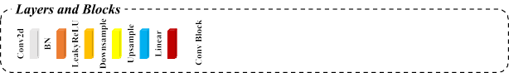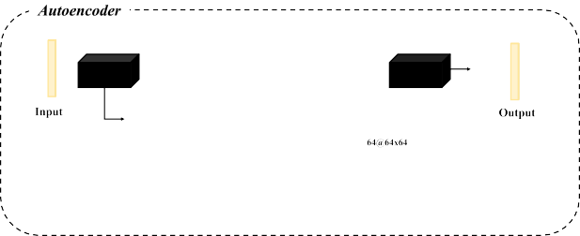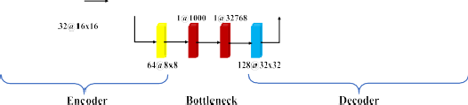problem [28]. The decoder branch of the trained AE is subse- quently used as a nonlinear preconditioner for the deblending inverse problem which is cast as a nonlinear optimization in the latent space of the decoder and can be effectively solved by second-order nonlinear solvers. The synthetic and field datasets are used to test the performance of our presented method against well-known techniques belonging to different families: a dictionary-learning-based deblending method [15]; an end-to-end deblending CNN [19].

- METHOD
- Blending Process Formulation
In a seismic blended acquisition, multiple sources fire their respective shots in a short time interval according to a predesigned random dithering code. Therefore, the shots of different sources are blended together and further recorded by the same receiver arrays. For one fixed receiver, the blended seismic data b can be formulated as
b = rd (1)
where d Rmn×1 is a vector containing the unblended CRG with n shots and m time samples. r R f ×mn denotes the blending operator [15]. Determined by the blending effect, the
∈
∈
measurement b denotes a single long vector of length f , where
f < (m × n).
- Preconditioner-Based Deblending
The goal of seismic deblending is to recover the unblended seismic data d from the blending measurement b. This can be accomplished by inverting the relationship in (1). As this problem is generally ill-posed, a proper prior has to be added. From the Bayesian perspective, this problem can be formulated as a maximum a posteriori (MAP) estimation [27]
dˆ = arg max log p(b|d) + log p(d) (2)
d
where log p(b d) is the log-likelihood of measurement b, and log p(d) defines the probability distribution of the unblended
|

Fig. 1. Used AE architecture.

As mentioned earlier, based on the concept of sparsity promoting inversion [22], one preconditioner widely used in seismic deblending is the fixed-basis transform [11]–[13] that projects the unblended data d into a space where d can be expressed as a small number of nonzero coefficients. However, fixed-basis transforms sometimes fail to accurately describe complex vector spaces spanned by seismic data. Dictionary learning can overcome this limitation to some degree by learning a vector space directly from the data itself. Nev- ertheless, these learned dictionaries are linear, which makes them unable to adapt to seismic data with more complex structures [14]–[16].

- Deep Preconditioner-Based Deblending
Deep AE [21] is a nonlinear dimensionality reduction technique which has the capability of learning a mapping from high-dimensional data to a lower dimensional representation space, such that its decoder part can be seen as a nonlinear deep preconditioner [20]. Compared with fixed-basis trans- forms and learned dictionaries, this deep preconditioner pro- vides a more accurate vector space spanned by seismic data. To combine the advantages of an explicit and interpretable inversion and the ability of deep AE to learn precise represen- tations of seismic data, we introduce the deep preconditioner
into (4) and get

data d. As shown in [27], if the likelihood term p(b d) is
|
assumed to be Gaussian-distributed, solving the MAP problem nb
�
= {
b H

n

nb

2

in (2) is equivalent to solving an optimization problem defined as

2
{xˆ j } j 1 = min b − r
x j } j =1
where D
∈ Rk → Rq is the decoder branch of a trained
R j
j =1
Dθˆ (x j)

2

dˆ = arg min ||b − rdl + λR(d) (3)
d
s.t. 11x j 111 ≤ t j = 1, 2, ... , nb (5)
θˆ

where b rd 2 denotes the data fidelity term, (d) is the regularization term, and λ is an adjustable scale parameter. Alternatively, instead of directly finding the optimal solution
dˆ in (3), we can try to solve for its optimal projected variable xˆ
|| − l R
in a certain preconditioner (i.e., the projected space P ∈ Rk →
AE. θˆ denotes the trained parameters of the decoder. Here, the sought deblended data d are decomposed in overlap- ping patches and the inversion is performed over the latent representation of each of these patches. More specifically,
{D ˆ(xˆ j)}nb are the recovered patches of the final deblended
= n

R(m×n)), such that the regularization term can be replaced
θ j 1
data dˆ , and {x j } j b 1 are their corresponding latent variables.

nb

by special properties of the projected variable x restricted by
{R j H }

=
=
∈ R(m n)×q are the backward patching operators

suitable norms as
j 1 ×
which a semble

recovered patches together. Note that

s the

xˆ = arg min ||b − rPxl2 + εp||xlp (4)
x
where ||·lp denotes the l p norm, and εp is a tunable parameter. The desired solution dˆ is found by dˆ = Pxˆ .
because the decoder optimization problem in (5) becomes nonlinear, the second-order nonlinear solver L-Broydena– Fletchera–Goldfarba–Shanno algorithm (BFGS) [23] is used here.

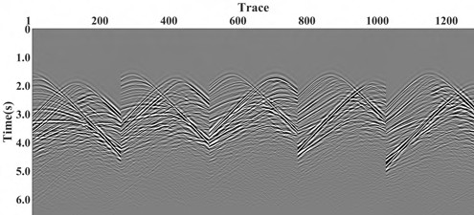
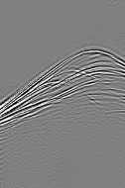Fig. 2. Random dithering codes. (a) Random dithering code of synthetic data. (b) Random dithering code of field data.

Fig. 4. Some blended CSGs of synthetic data.

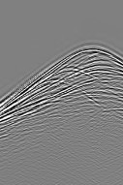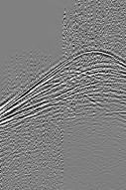Fig. 3. Synthetic data. (a) Unblended CRG. (b) Pseudo-deblended CRG.

- AE Training
To get the optimal parameters θˆ of the above decoder Dθ , a complete deep convolutional AE Dθ (Eθ ( )) should be trained properly. This is accomplished by minimizing the following
·
ns
loss function over a training dataset of n samples {u }
Fig. 5. Deblending results of different methods on the synthetic CRG.
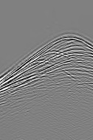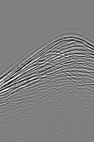(a) Dictionary learning [15]. (b) Deblending CNN. (c) Proposed method.

geological information. On the other hand, despite the acquired CSGs being blended, we can still find that the data are coherent, and thus they share similar characteristic with the unblended data.
3) Other Training Details: For both the presented synthetic
ns
and field data examples, the size of training samples {ui } is

s i i=1
set as 64 × 64. We train the AE using the ADAM al
i=1 m

that is representative of the conventional CRG d we wish to recover
:
n
gorith for 30 epochs, with a batch size of 256. The learning rate is
0.001, and the weight decay is 0.0001.

θˆ = arg min
1 's

||ui − Dθ (Eθ (ui))l2 + εθ ||θ l2 (6)
- EXPERIMENTS

θ ns
i=1
In this section, we use synthetic and field datasets with

where Eθ Rq Rk denotes the encoder part of AE, and εθ
∈ →
is the adjustable weight decay parameter.
- AE Architecture: The used architecture of AE is shown in Fig. 1. It consists of three parts: an encoder, a decoder, and a bottleneck. To alleviate the vanishing gradient problem, the encoder is composed of two residual blocks (ResBlocks) [24] and two downsampling layers. Besides two ResBlocks and two upsampling layers, a convolutional layer with batch normal- ization is used as the final part of the decoder to reduce the number of output channels to that of the input. The bottleneck consisting of two fully connected layers restricts the flow of information from the encoder to the decoder and represents the latent vector space of the seismic data.
- Training Dataset: A good training dataset is key to train an effective AE. A standard practice is to construct high-quality synthetic dataset or collect an appropriate field dataset, but neither is easy to implement for the problem of seismic deblending. To solve this issue, we rely on the
blended dataset itself and use its CSGs to construct the training
complex subsurface structures to demonstrate the performance of our method. For both the datasets, we mimic a blending strategy usually referred to as half blending: two seismic acquisition vessels move in the same direction firing almost simultaneously, each covering half of the acquisition area. Therefore, each blended shot gather can be seen as the superposition of the two individual shot gathers. Here, the first source always fires at nominal time, while the second source fires at dithered times according to the predesigned random dithering codes. The classical dictionary-learning- based deblending method [15] and the end-to-end deblending CNN are used for comparisons. For the latter comparative method, we follow the same training strategy in [19], which uses the pseudo-deblended data and original unblended data as “noisy-clean” training pairs and specially use the blended CSGs for the network training. The network architecture is the widely used DnCNN [26]. To quantitatively assess the recovery performance, the signal-to-noise ratio (SNR) is used
||dl2

samples [28]. This means that no extra data are required.
SNR = 10 log 10 ˆ 2
(7)

Based on the reciprocity theorem [25], [28], unblended CSGs are similar to unblended CRGs as they both capture similar
||d − dl2
where dˆ is the deblending result, and d is the unblended data.
2

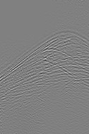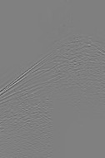

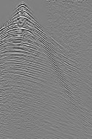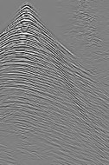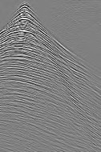Fig. 6. Corresponding errors of different methods on the synthetic CRG.
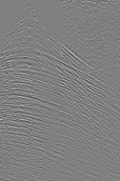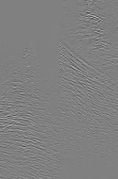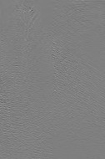(a) Dictionary learning [15]. (b) Deblending CNN. (c) Proposed method.
Fig. 9. Deblending results of different methods on the field CRG.
(a) Dictionary learning [15]. (b) Deblending CNN. (c) Proposed method.

Fig. 7. Field data. (a) Unblended CRG. (b) Pseudo-deblended CRG.

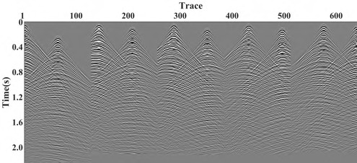
Fig. 8. Some blended CSGs of field data.

- Synthetic Data Example
The synthetic dataset is created using the central part of the 2-D Marmousi model. It includes 256 shots and 256 receivers. The number of time samples is 768, and the temporal sampling is 8 ms. To make sure that the first shooting source always fires ahead of the other, the random time delay is predefined as [0, 3.2 s], which is shown in Fig. 2(a). One unblended CRG is shown in Fig. 3(a), and it can be seen that it contains complex seismic events with multiple dips and a wide range of amplitudes. Its corresponding pseudo-deblended CRG is displayed in Fig. 3(b). Because of the special structure of the blending matrix, the pseudo-deblended CRG is the super- position of the unblended CRG and the blending noise [28]. We can also observe that the blending noise masks the useful seismic events which will bring many difficulties to effective deblending. Fig. 4 displays some blended CSGs, in which we can see that the blended CSGs are the results of paired dislocation overlap of shots produced by different sources, but the shots are coherent, and the seismic events are quite similar to those in Fig. 3(a). Therefore, it is reasonable to use blended CSGs as the training dataset. Fig. 5(a) to (c) shows
Fig. 10. Corresponding errors of different methods on the field CRG.
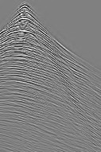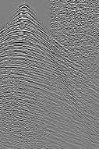(a) Dictionary learning [15]. (b) Deblending CNN. (c) Proposed method.

the deblending results of different methods on the synthetic CRG in Fig. 3(b) and the corresponding errors are shown in Fig. 6(a) to (c), respectively. As shown in Figs. 5(a) and 6(a), the deblended data from the dictionary-learning-based deblending method present both blending noise residue and signal damage. For deblending CNN, although we can barely see the blending noise in Fig. 5(b), there is distinct event leakage. Our proposed method can effectively remove almost all the blending noise with minimal signal leakage. The SNR results of the different methods for this synthetic CRG are summarized in Table I. We can see that the proposed method achieves the best SNR result.

- Field Data Example
The field dataset from Gulf of Suez comprises 128 shots, 128 receivers, and 512 time samples with spatial and temporal sampling intervals of 12.5 m and 4 ms, respectively. Blending is performed here in a similar fashion, with the only difference that the random time delay lies in the time range [0, 0.8 s], as shown in Fig. 2(b). One unblended CRG and its correspond- ing pseudo-deblending data are shown in Fig. 7(a) and (b), respectively. It can be seen that the blending noise severely masks the useful signal especially in the deep area of the first few traces. After blending simulated acquisition, we can also get the blended CSGs, and some of them are shown in Fig. 8. We can see that these blended CSGs have similar features to the conventional CRG in Fig. 7(a), which we aim to recover, particularly in parts where the energy from the two shots does not overlap. The deblending results of different methods on the field CRG in Fig. 7(b) and the corresponding errors are shown in Figs. 9(a)–(c) and 10(a)–(c), respectively. As shown in Fig. 9(a), the dictionary-learning-based deblending method

TABLE I
SNR (dB) RESULTS OF DIFFERENT METHODS ON THE SYNTHETIC AND FIELD CRGS

only smoothed some of the blending noise, and we can
- Y. Chen, H. Chen, K. Xiang, and X. Chen, “Preserving the disconti- nuities in least-squares reverse time migration of simultaneous-source data,” Geophysics, vol. 82, no. 3, pp. S185–S196, May 2017.
- S. Huo, Y. Luo, and P. G. Kelamis, “Simultaneous sources separation via multidirectional vector-median filtering,” Geophysics, vol. 77, no. 4, pp. V123–V131, Jul. 2012.
- Y. Chen, “Deblending using a space-varying median filter,” Explor. Geophys., vol. 46, no. 4, pp. 332–341, Dec. 2015.
- W. Huang, R. Wang, X. Gong, and Y. Chen, “Iterative deblending of simultaneous-source seismic data with structuring median constraint,” IEEE Geosci. Remote Sens. Lett., vol. 15, no. 1, pp. 58–62, Jan. 2018.
- J. Cheng and M. D. Sacchi, “Separation and reconstruction of simul- taneous source data via iterative rank reduction,” Geophysics, vol. 80,

clearly observe remaining noise which breaks the continuity of useful events. Severe signal leakage can also be observed in Fig. 10(a). Deblending CNN suppresses the blending noise
along with a small part of useful signal and creates some fake

no. 4, pp. V57–V66, Jul. 2015.
- Zhou, W. Mao, D. Zhang, Q. Ge, and H. Wang, “Deblending of simultaneous source with rank-reduction and thresholding constraints,” in Proc. 79th EAGE Conf. Exhib. Houten, The Netherlands: European Association of Geoscientists & Engineers, 2017, pp. 1–5.

events in Fig. 9(b). Useful signal residue is also clearly visible in Fig. 10(b). Our proposed method almost removed all the blending noise in Fig. 9(c). Fig. 10(c) shows the corresponding error section that has little residual error. From Table I, we can see that our method has the best quantitative performance.

- CONCLUSION
In this letter, we solve the ill-posed inverse problem of seismic deblending via deep preconditioners. A convolutional AE is trained to learn the latent space representation of the seismic data, and then the decoder branch of the trained AE is subsequently used as a preconditioner for deblending nonlinear optimization. Particularly, instead of constructing synthetic dataset or collecting field dataset for network training, the blended CSGs of the dataset we aim to recover are used as the training dataset. Our experiments have shown that the latent space learned from the blended CSGs can well represent the clean CRGs we wish to recover. Furthermore, as the input and the output of the AE are identical, unlike most existing deep-learning-based deblending methods, “noisy-clean” data pairs are not needed in our approach. Synthetic and field data examples show that the proposed method can get bet- ter deblending performance compared with the dictionary- learning-based method and the deblending CNN. In the future, we may use transfer learning to speed up AE training.

ACKNOWLEDGMENT
Graphics processing unit (GPU) computation has been made available, thanks to the GPU Grant Program, by NVIDIA Corporation, to which the authors express deep gratitude.

REFERENCES
  - A. J. Berkhout, “Changing the mindset in seismic data acquisition,”
Lead. Edge, vol. 27, no. 7, pp. 924–938, Jul. 2008.
  - D. J. E. Verschuur and A. J. G. Berkhout, “Seismic migration of blended shot records with surface-related multiple scattering,” Geo- physics, vol. 76, no. 1, pp. A7–A13, Jan. 2011.
  - Y. Tang and B. Biondi, “Least-squares migration/inversion of blended data,” in Proc. 79th Annu. Int. Meeting SEG, Expanded Abstr., 2009, pp. 2859–2863.
  - W. Dai, X. Wang, and G. T. Schuster, “Least-squares migration of multisource data with a deblurring filter,” Geophysics, vol. 76, no. 5, pp. R135–R146, Sep. 2011.
- A. Mahdad, P. Doulgeris, and G. Blacquière, “Separation of blended data by iterative estimation and subtraction of blending interference noise,” Geophysics, vol. 76, no. 3, pp. Q9–Q17, May 2011.
- C. Li, C. C. Mosher, and Y. Ji, “An amplitude-preserving deblend- ing approach for simultaneous sources,” Geophysics, vol. 84, no. 3, pp. V185–V196, May 2019.
- H. Mansour, H. Wason, T. Lin, and F. J. Herrmann, “Randomized marine acquisition with compressive sampling matrices,” Geophys. Prospecting, vol. 60, no. 4, pp. 648–662, Jul. 2012.
- Y. Zhou, W. Chen, and J. Gao, “Separation of seismic blended data by sparse inversion over dictionary learning,” J. Appl. Geophys., vol. 106, no. 7, pp. 146–153, Jul. 2014.
- Y. Zhou, J. Gao, W. Chen, and P. Frossard, “Seismic simultaneous source separation via patchwise sparse representation,” IEEE Trans. Geosci. Remote Sens., vol. 54, no. 9, pp. 5271–5284, Sep. 2016.
- S. Zu, H. Zhou, R. Wu, W. Mao, and Y. Chen, “Hybrid-sparsity constrained dictionary learning for iterative deblending of extremely noisy simultaneous-source data,” IEEE Trans. Geosci. Remote Sens., vol. 57, no. 4, pp. 2249–2262, Apr. 2019.
- J. Sun, S. Slang, T. Elboth, T. L. Greiner, S. McDonald, and L.-J. Gelius, “A convolutional neural network approach to deblending seismic data,” Geophysics, vol. 85, no. 4, pp. WA13–WA26, Jul. 2020.
- S. Zu, J. Cao, S. Qu, and Y. Chen, “Iterative deblending for simultaneous source data using the deep neural network,” Geophysics, vol. 85, no. 2, pp. V131–V141, Mar. 2020.
- B. Wang, J. Li, J. Luo, Y. Wang, and J. Geng, “Intelligent deblending of seismic data based on U-Net and transfer learning,” IEEE Trans. Geosci. Remote Sens., vol. 59, no. 10, pp. 8885–8894, Oct. 2021, doi: 10.1109/TGRS.2020.3048746.
- M. Ravasi, “Seismic wavefield processing with deep preconditioners,” in Proc. 1st Int. Meeting Appl. Geosci. Energy Expanded Abstr., Sep. 2021, pp. 2859–2863.
- M. A. Kramer, “Nonlinear principal component analysis using autoas- sociative neural networks,” AIChE J., vol. 37, no. 2, pp. 233–243, Feb. 1991.
- E. J. Candès, J. Romberg, and T. Tao, “Robust uncertainty principles: Exact signal reconstruction from highly incomplete frequency informa- tion,” IEEE Trans. Inf. Theory, vol. 52, no. 2, pp. 489–509, Feb. 2006.
- J. Nocedal, “Updating quasi-Newton matrices with limited storage,”
Math. Comput., vol. 35, no. 151, pp. 773–782, 1980.
- K. He, X. Zhang, S. Ren, and J. Sun, “Identity mappings in deep residual networks,” in Proc. ECCV, 2016, pp. 630–645.
- B. Wang, N. Zhang, W. Lu, J. Geng, and X. Huang, “Intelligent missing shots’ reconstruction using the spatial reciprocity of Green’s function based on deep learning,” IEEE Trans. Geosci. Remote Sens., vol. 58, no. 3, pp. 1587–1597, Mar. 2020.
- K. Zhang, W. Zuo, Y. Chen, D. Meng, and L. Zhang, “Beyond a Gaussian denoiser: Residual learning of deep CNN for image denoising,” IEEE Trans. Image Process., vol. 26, no. 7, pp. 3142–3155, Jul. 2017.
- W. Xu, Y. Zhou, X. Wang, and W. Chen, “MoG-based robust sparse representation for seismic erratic noise suppression,” IEEE Geosci. Remote Sens. Lett., vol. 19, pp. 1–5, 2022.
- W. Xu, Y. Zhou, D. Liu, X. Wang, and W. Chen, “Seismic intelligent deblending via plug and play method with blended CSGs trained deep CNN Gaussian denoiser,” IEEE Trans. Geosci. Remote Sens., vol. 60, pp. 1–13, 2022.

