The Terza Torre Seismic Array in Bologna, Italy: a monitoring infrastructure for soil-structure systems analysis

Authors: L. Cataldi¹, G. Capotosti¹, D. Ertuncay¹, B. Petrovic², M. Romanelli¹, C. Scaini¹, L. Martelli³, S. Parolai¹, V. Poggi¹

Affiliations:
- National Institute of Oceanography and Applied Geophysics - OGS, Sgonico, Italy
- GFZ Helmholtz Centre for Geosciences, Potsdam, Germany
- Emilia-Romagna Region, Geological, Seismic and Soil Survey, Bologna, Italy
Corresponding author:
Laura Cataldi
Centre for Seismological Research
National Institute of Oceanography and Applied Geophysics - OGS
Borgo Grotta Gigante 42/C
34010 Sgonico (TS) - Italy
+39 3394087492
lcataldi@ogs.it
Keywords: Building seismic monitoring; Dynamic characterization; Strong motion dataset; Ambient vibration analysis; Vertical seismic array; Soil–structure interaction
Declaration of competing interests: The authors acknowledge there are no conflicts of interest recorded.

Abstract
Hybrid seismic arrays composed of co-located building-borehole sensors are essential for gaining better insight into the behavior of soil-structure systems using real data; however, they remain infrequent and are rarely supported by open, long-duration datasets. To help address this gap, we present a new long-term seismic monitoring installation and the associated seismic dataset.
The network is installed on and around Terza Torre, a 20-story reinforced concrete building located in Bologna, Northern Italy. It comprises eight three-component stations deployed along the building’s height, including a basement reference station, and a nearby borehole station equipped with a surface and a downhole sensor at 50 m depth. The array was deployed in 2023 as part of a collaborative effort between the Emilia-Romagna Regional Government and the National Institute of Oceanography and Applied Geophysics - OGS to investigate the seismic response of a strategic building and possible SSI effects in urban environments typical of the Po Plain.
The dataset includes recordings of 30 local and regional earthquakes (ML 3.0–4.8) and continuous ambient vibration. The quality of the dataset is analyzed in terms of signal-to-noise ratio, including possible applications and limitations. Three applications are exemplified, demonstrating its potential to estimate the building’s fundamental frequencies and the corresponding modes, and to assess the local site response. Should stronger seismic events be recorded in the future, soil-structure interactions effects may be studied using earthquake recordings from the infrastructure.
The dataset provides a rare opportunity to investigate the dynamic response of a tall building founded on soft soil and serves as a reference for validating numerical models and studying nonstationary structural behavior. Data and metadata of the first two years of the network operativity are made publicly available under FAIR principles within two years from publication.

Introduction
During an earthquake, a structure responds to incoming seismic waves, which can be influenced by near-surface propagation effects caused by variations in near-surface geology (e.g., Aki, 1993), and to feedback mechanisms between the building and the ground, the so-called soil-structure interaction (SSI; e.g., Bard et al., 1996). Understanding seismic wave propagation in soils and buildings as well as SSI is fundamental for improving the assessment of seismic risk and expected damage in urban environments. SSI can alter ground motion amplitudes and frequency content, influence structural response, and even lead to localized amplification or deamplification effects that are not predicted by free-field models (e.g., Gueguen et al., 2000; Skłodowska et al., 2023). In dense urban environments, these effects may be compounded by interactions among multiple structures, a phenomenon known as site-city interaction (SCI; e.g., Gueguen et al., 2002; Bard et al., 2008; Semblat et al., 2008).
Over the past three decades, these interactions have been extensively investigated using two- and three-dimensional numerical simulations, significantly advancing our theoretical understanding of how buildings respond to, and influence, seismic waves. The numerical analyses shed light on the many possible characteristics of SSI and SCI, such as the role of building density and city configuration in the energy distribution (Kham et al., 2006), the dependency of the effects from the number and dynamic properties of the buildings, their separation, and their impedance with respect to the soil (Isbiliroglu et al., 2015), and the variability effects that the buildings generate all around their foundations as well as in the entire area where they are located, with both amplifying SSI effects and contrasting de-amplifying SCI effects (Varone et al., 2021). In fact, it has also been shown that even when the influence of SCI on amplification levels is small, it could modify both main amplification frequencies and location of the maximum amplification areas (Semblat et al., 2002). To support the numerical results, which could be affected by limitations related to the necessary modelling simplifications, the models should be validated using empirical data. In some cases, this was possible thanks to recordings of damaging earthquakes recorded by chance on adjacent buildings (Laurenzano et al., 2010). Nonetheless, empirical validation of such models remains limited due to the scarcity of long-term, high-quality observational datasets including both recordings at the ground and at different floors in the building.
Complementing the numerical modeling studies, observational studies have confirmed that buildings can radiate seismic energy back into the surrounding soil, modifying the wavefield and contaminating free-field recordings (e.g., Jennings, 1970; Wirgin and Bard, 1996; Gueguen et al., 2000; Petrovic and Parolai, 2016; Petrovic et al., 2018, Petrovic et al., 2019; Skłodowska et al., 2023, 2025). A well-known example is the 1985 Michoacán earthquake, where anomalous amplification and damage patterns in Mexico City could only be explained by SCI phenomena (Wirgin and Bard, 1996).
While seismic monitoring networks often include sensors installed either in buildings (e.g., Snieder and Şafak, 2006; Rahmani and Todorovska, 2021) or in boreholes (e.g., Mehta et al., 2007; Parolai et al., 2009; Raub et al., 2016), only a limited number of arrays combine both in a co-located configuration (e.g., Cardenas et al., 2000; Wen and Kalkan, 2017; Petrovic et al., 2018). Petrovic and Parolai (2016) and Petrovic et al. (2018) demonstrated the potential of co-located building-borehole arrays for capturing SSI effects and wavefield modifications. Such hybrid arrays are essential for direct SSI analysis, but remain sparse and are rarely supported by open, long-duration datasets.
To address this gap, we present a new long-term seismic monitoring installation in Bologna, Northern Italy. The instrumented building, known as Terza Torre (“Third Tower”), is a 20-story office building that hosts the headquarters of the regional government. The monitoring project was developed through a collaborative agreement between the National Institute of Oceanography and Applied Geophysics - OGS and the General Directorate for Environment and Territory of the Emilia-Romagna Regional Government.
Although the building is not statistically representative of the regional building stock, it is considered a strategic facility for emergency management and governance. Its structural complexity and strategic importance for civil protection purposes make it an ideal benchmark for a wide range of studies, spanning from the seismic characterization of the building and underlying soil to the investigation of wave propagation within the building-soil system, subsequently providing a basis for investigating SSI effects under realistic conditions.
The building is located within the Po Plain, a tectonically active foreland basin bounded by the Southern Alps to the north and the Northern Apennines to the south. The region experiences crustal shortening due to the convergence between the Adria microplate and the Eurasian plate, accommodated by a system of blind thrust faults at shallow to intermediate depths (Vannoli et al., 2015). Although characterized by moderate seismicity, the Po Plain has experienced damaging earthquakes, such as the 2012 Emilia sequence (main shock ML 5.9; ISIDe Working Group, 2007), which caused widespread damage to buildings and infrastructure (Rovida et al., 2020, 2022).
The area is also prone to significant site amplification effects due to the presence of thick Quaternary alluvial deposits with low shear-wave velocities (Molinari et al., 2015). Several studies have demonstrated that post-critically reflected S-waves and multiples from the Moho discontinuity can enhance ground motion in the Po Plain at distances between 80 and 200 km (Bragato et al., 2011; Sugan and Vuan, 2014). These effects contribute to the complexity of seismic hazard assessments in the region.
Recent investigations using ambient vibration measurements have mapped the depth of the seismic bedrock across the Po Plain, revealing high spatial variability linked to the complex sedimentary and tectonic evolution of the basin (Mascandola et al., 2019). These characteristics underline the need for site-specific monitoring to support seismic risk assessments and ground motion modeling in the area.
The monitoring system (Figure 1) consists of eight coupled velocimeter-accelerometer stations deployed in a 20-story reinforced concrete building, with six sensors forming a vertical array on the eastern façade. An additional borehole station, equipped with a downhole sensor at 50 m and a surface sensor, was installed 20 m from the building. This configuration enables joint analysis of structural and soil response.
The installation was performed between March and September 2023 and has been operating continuously since then, with an overall data completeness exceeding 90% for most stations. The system acquires ambient vibrations and seismic waveforms from local and regional earthquakes, which are continuously recorded and transmitted in near real time to the Seismological Research Center (CRS) of the OGS via dedicated broadband connections. At the data center, seismic streams are archived, monitored, and systematically analyzed. Waveform segments corresponding to earthquakes are periodically extracted from the continuous recordings and archived for long term storage and distribution. As of July 2025, the dataset includes 30 earthquake recordings (ML 3.0 – 4.8) and a continuous archive of ambient vibration data, enabling a wide range of scientific investigations. These data support the evaluation of cost-effective instrumentation for long-term structural monitoring and the study of the seismic response of a strategic urban infrastructure. As the monitoring infrastructure is a long-term project, the dataset will continue to grow over time with additional events, potentially including recordings of stronger ground shaking. Future recordings of stronger seismic events would enable investigations of wave propagation within soil-structure systems and would support future validation and calibration of SSI models. Long-term open access is planned to facilitate collaborative scientific use.

Instrument Deployment and Details

Building Description
The target building is the so-called Terza Torre, designed in 1999 to house the regional government’s administrative offices. It is located in the heterogeneous urban setting of the Fiera district in Bologna. The surrounding area includes other high-rise buildings of similar structural characteristics, as well as densely populated residential areas. The building was selected based on (i) the availability of detailed structural and geotechnical documentation, including design reports and previous dynamic analyses; (ii) its logistical suitability for continuous monitoring, with secure access, power supply, and data connectivity; and (iii) its location within a complex of buildings with similar construction typologies, enabling future investigations of SCI effects.
The 20 story reinforced concrete building consists of three interconnected units - referred to as towers A, B, and C (87, 29 and 18 m height, respectively; see Figure 2) - which are linked via reinforced concrete decks supported by beams and pillars. Structural joints with viscoelastic couplers are included between the main tower (A) and the two lateral wings (B and C) to accommodate differential movements and dissipate energy during seismic shaking. The structural system is composed of moment-resisting reinforced concrete frames with infill panels, forming a semi-regular floor plan. Tower A is the tallest unit, with a height of 87 meters above ground level, comprising 20 stories above ground and two underground levels. An additional technical compartment is located on the tower rooftop. Towers B and C are significantly lower, with four and three above-ground floors respectively and two basement levels. Considering both the expected dynamic contribution as a function of mass and height, and the limited number of sensors, the lower unit (tower C) was not instrumented.
The ground floor of both towers A and B is almost twice the height of the other floors, and is divided into two sub-floors where the towers are joined. The foundation system consists of shallow footings resting on thick Quaternary alluvial sediments which are characterized by low shear-wave velocities (Molinari et al., 2015). The seismic refraction analyses carried out during the building construction (Regione Emilia-Romagna, 1999) identified three subsoil layers: a shallow layer (depth up to 4-5.5 m) with shear-wave velocity ($v_{s}$) of 250-350 m/s, an intermediate layer (depth from 4-5.5 m up to 11-15 m) with $v_{s}$ 600-800 m/s, and a third layer below 11-15 m with $v_{s}$ 1600-1800 m/s.
The building was designed in accordance with the Italian structural regulations in force at the time (Ministerial Decree of January 9, 1996; Ministero dei Lavori Pubblici, 1996), as well as with Eurocode 2 for concrete design (CEN, 2004), Eurocode 4 for composite steel-concrete systems (CEN, 2005), and Eurocode 8 for seismic loading (CEN, 2006). A static load test campaign comprising five load scenarios was conducted in January 2011 to validate the as-built structural performance.
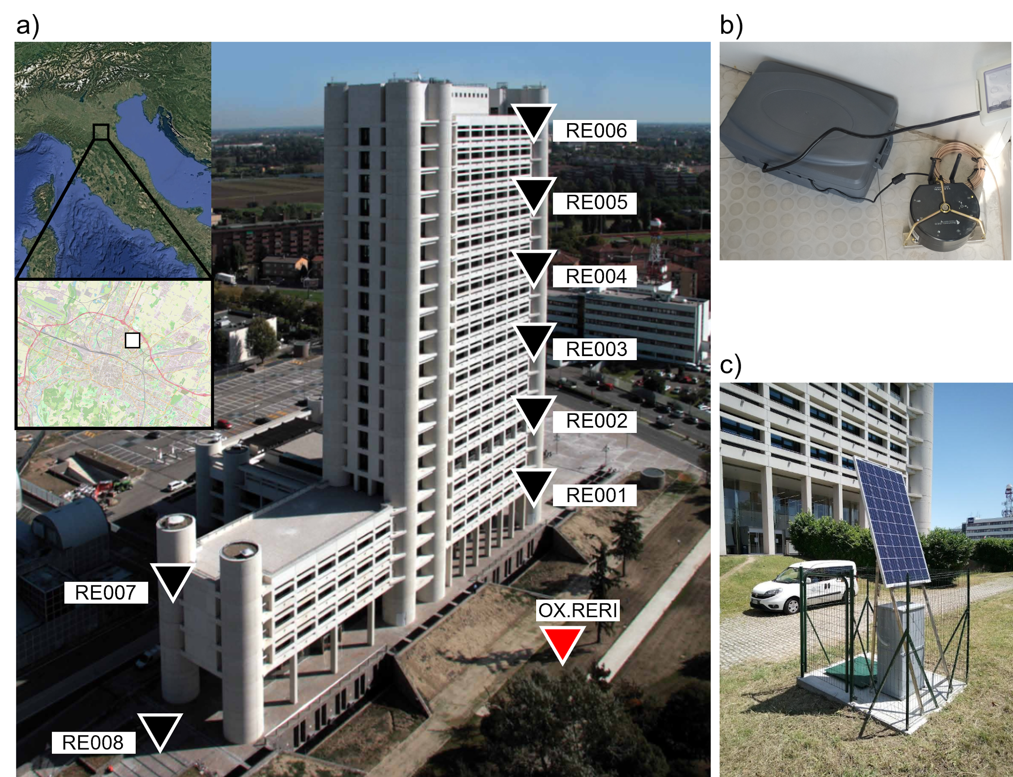
Figure 1. a) Location of the Terza Torre monitoring infrastructure in Bologna (see inset map). The sensor positions are marked by triangles: in black for the vertical array on the eastern façade (stations RE001-RE006) and for the array on the western side (RE007 and RE008), in red for the nearby borehole station (OX.RERI). b) Instrumentation installed in the building. c) The borehole station, hosting one sensor on the surface and one sensor in well. The photo of the building is courtesy of Regione Emilia-Romagna (2025). Satellite data in the upper left maps are from Google Earth (Landsat/Copernicus) and OpenStreetMap. The color version of this figure is available only in the electronic edition.
[Alt Text: A picture of the Terza Torre building taken from above, with the location of the sensors marked, and an inset to show the location of Bologna; a picture of one of an on-building sensor; a picture of the borehole casing, in front of the building]
A finite element model (FEM) of the building was developed during the structural design phase in 1999 to estimate its dynamic properties (Redesco, 1999), although some caution is necessary in interpreting its results as the technical documentation does not provide detailed information on the applied modeling assumptions and boundary conditions. The results of the modal analysis reported in the design documentation include five fundamental vibration modes, characterized by periods ranging from 2.59 s to 0.61 s, and involving both translational and torsional deformation patterns (Table 1). These correspond to the modes with the highest mass participation, which are typically the most relevant for seismic design.
Table 1. Fundamental vibration modes of the Terza Torre building, with corresponding periods (in seconds) and frequencies (in Hz), as identified from the 1999 finite element model developed during the design phase.
Mode | Period (Frequency)
1a | 2.59 s (0.39 Hz)
1b | 2.42 s (0.41 Hz)
2 | 1.45 s (0.69 Hz)
3 | 0.66 s (1.52 Hz)
4 | 0.61 s (1.64 Hz)

The Terza Torre Structural Array
The “L1” monitoring network, dedicated to the Terza Torre building, was deployed on March 28, 2023, and remains operational as of the end of 2025. It consists of eight three-component seismic stations based on compact, low-power Lunitek Sentinel GEO units. Each station integrates a short-period triaxial velocimeter (EHE/EHN/EHZ components) and a MEMS triaxial accelerometer (HNE/HNN/HNZ components), combined with a digitizer, internal memory, and LTE-based transmission module. This coupled configuration ensures high sensitivity to low-amplitude signals and prevents saturation during strong shaking, covering a wide dynamic range essential for both ambient vibration and strong-motion monitoring.
The sensor layout was designed to support detailed building characterization and wave propagation studies along the structure’s height. Six stations were installed on terraces along the eastern façade of Tower A at the 1st (RE001), 5th (RE002), 8th (RE003), 12th (RE004), 15th (RE005) and 19th floor (RE006). One additional sensor (RE007) was placed on the upper terrace (3rd floor) of Tower B, while the RE008 station was installed at the second basement level of the same tower, serving as a reference for input motion. All sensors were aligned such that the east-west horizontal components (EHE and HNE) match the longitudinal axis of the building, ensuring consistency across stations and enabling a direct interpretation of the recordings in terms of the building’s dynamic behavior.
The sampling frequency was progressively optimized during the first months of operation. Initially set at 125 Hz, it was increased to 200 Hz on April 26, 2023, for system testing, and finally configured to 250 Hz on August 30, 2023. This final setting was selected to ensure adequate time resolution for both low-frequency modal behavior and higher-frequency transients associated with local events or structural resonances. Data is continuously recorded on local SD cards and transmitted in real time via SeedLink protocol through a VPN connection. Centralized acquisition is managed by a SeisComP server installed at the CRS of the OGS in Udine, Italy. The CRS facility serves as the main hub for the acquisition and processing of real-time seismic and geodetic data in northeastern Italy.

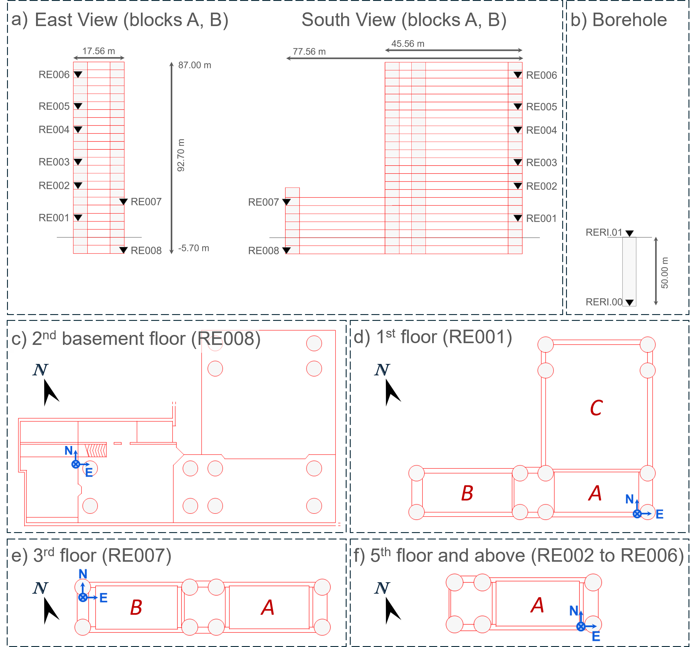
Figure 2. Layout of the Terza Torre monitoring system, including both the on-building seismic array and the borehole station. a) External views from the East and South sides showing Towers A and B of the Terza Torre building, with the vertical distribution of sensors indicated by black triangles and grey horizontal line showing the ground level; b) Configuration of the borehole station, hosting sensors RERI.01 (at surface) and RERI.00 (in well); c)-f) Floor plans of the Terza Torre building showing sensor positions (blue markers); the black arrow marks the geographic North. The color version of this figure is available only in the electronic edition.
[Alt Text: A schematic layout of the building, shown from the East and from the South, and of the borehole, with the position of the sensors marked, and additional layouts for individual floors at which instruments are installed.]

The RERI Borehole Station
To complement the seismic monitoring of the Terza Torre building, a permanent borehole station (code RERI), consisting of one sensor on the surface and one sensor in well, was installed approximately 20 meters from the main structure, on the edge of the overlooking Kenzo Tange public garden. The RERI station is part of the permanent OX network, managed by CRS as part of the Northeastern Italy Seismic and Deformation Network (SMINO; Bragato et al., 2021), which includes hundreds of stations across the Friuli Venezia Giulia and Veneto regions, integrating seismic, strong-motion, and GNSS sensors for civil protection and scientific purposes. In contrast, the on-building structural array (network code L1) is operated independently and not integrated into the OX registry. The combination of L1 and OX.RERI provides a hybrid monitoring infrastructure designed for investigating the building’s dynamic behavior, the site shaking and the soil-structure system.
The 50-meter-deep borehole (elevation 43 m a.s.l.) was drilled using rotary methods with bentonite muds and lined with 4” PVC casing, cemented in place to prevent fluid migration and ensure solid coupling between sensor and formation.
Two SARA SS05 triaxial short-period velocimeters (0.5-50 Hz) were deployed, one at the surface (location code 01) and one at the bottom of the borehole (location code 00). Both are connected to a 24-bit SL06 digital acquisition system, configured at a sampling frequency of 250 Hz and full scale of 40 V peak-to-peak. The downhole sensor is mechanically anchored to the casing using custom brackets to ensure coupling and preserve depth integrity. Due to the lack of grid access in the park, the station is powered via solar panels and dedicated batteries, with data transmitted in real time to the OGS acquisition server via LTE and SeedLink protocol.
A preliminary lithostratigraphic profile was derived during drilling, based on visual inspection of cuttings. The stratigraphy shows alternating clay layers, sometimes silty, with variable sand and gravel beds that become finer with depth. No sharp impedance contrasts were identified within the 0-50 m interval that could produce significant site resonance. This interpretation is consistent with previous direct (e.g., cone penetration testing, boreholes) and indirect investigations (e.g., multichannel analysis of surface waves, horizontal-to-vertical spectral ratio) performed in nearby areas, which indicate similar stratigraphic profiles in the upper tens of meters.

Overall data quality and availability
Seismic data acquisition began on 28 March 2023 for the on-building array and on 13 September 2023 for the RERI borehole station. Throughout the monitoring period, the system was manually checked on a weekly basis, with daily inspections during periods of increased seismic activity. In cases of temporary communication loss between sensors and the central server, efforts were made to recover missing data manually from local storage.
Sensors located in the building have relatively larger seismic background noise levels with respect to the borehole sensors. The noise levels of the sensors in the building are close to the new high noise model defined by Peterson (1993) and have a linear increasing trend for periods longer than 2 s, with consistent exceedance of the Peterson model for periods longer than 5 s (i.e., for frequencies below 0.2 Hz). Borehole sensors have the same trend for periods longer than 15 s (see Supplemental Material, Figure S1).
Between March 2023 and July 2025, the region surrounding the Terza Torre monitoring site experienced hundreds of earthquakes in the range ML 1.0 - 4.8. We compiled an event dataset consisting of the waveforms recorded by the Terza Torre monitoring network for a selection of 30 earthquakes with local magnitude ML ≥ 3.0, which occurred within 80 km from the site (Table 2 and Figure 3; see Data and Resources). Event hypocenters and magnitudes are taken from the INGV national seismic catalog (see Data and Resources). The magnitude and hypocentral distance constraints were applied to avoid smaller events (ML<3.0) which are often not clearly identifiable in the recordings due to the elevated background noise in the urban environment of Bologna. Moreover, we excluded clustered events that occurred too close in time, for which the noise and/or signal windows would be contaminated by the waveforms generated by other events (see Data and Resources).
For each event, waveforms were cut using theoretical P-wave arrivals, starting 30 s before and ending 80 s after the arrival time. Instrumental response metadata are provided for each waveform to enable correction and conversion into physical units. The dataset includes both raw and processed recordings and will be made available following a two-year embargo period from the publication of the article (see Data and Resources). Three continuous 24-hour recordings (on 18 September 2023, 28 October 2023 and 1 January 2025) are also included to provide reference examples of pre-event and background ambient noise. Recording coverage for the event dataset across stations is generally high, despite occasional malfunctioning, as documented in Figure 4.
Table 2. List of the 30 seismic events with local magnitude ML ≥ 3.0 that occurred between March 2023 and March 2025 within 80 km epicentral distance from the Terza Torre building. Event parameters (origin time, location, hypocentral depth, and magnitude) are taken from the INGV catalog (see Data and Resources).
ID | Origin time (UTC) | distance (km) | depth (km) | ML
1 | 2023-04-30T14:04:23 | 62.15 | 9.6 | 3.1
2 | 2023-06-21T06:01:49 | 50.51 | 22.4 | 3.2
3 | 2023-06-21T07:25:39 | 49.87 | 22.6 | 3.2
4 | 2023-07-01T14:47:16 | 49.97 | 22.7 | 3
5 | 2023-07-04T09:23:59 | 49 | 21.1 | 3
6 | 2023-07-28T17:38:20 | 49.89 | 23.9 | 3.1
7 | 2023-08-07T23:32:24 | 74.84 | 21 | 3.1
8 | 2023-09-18T02:38:04 | 53.84 | 8.2 | 3.3
9 | 2023-09-18T03:10:14 | 53.9 | 8.1 | 4.8
10 | 2023-09-18T03:11:39 | 55.08 | 6.9 | 3.4
11 | 2023-09-18T04:56:23 | 56.77 | 7.9 | 3
12 | 2023-09-18T07:35:48 | 53.15 | 8.1 | 3
13 | 2023-09-19T03:40:47 | 55.81 | 7.1 | 3
14 | 2023-09-19T22:50:12 | 53.81 | 6.7 | 3.2
15 | 2023-09-19T23:02:15 | 53.33 | 7.1 | 3
16 | 2023-10-25T13:45:37 | 56.47 | 8.5 | 4.2
17 | 2023-10-28T15:29:23 | 56.34 | 8.3 | 4.2
18 | 2023-10-30T05:25:54 | 48.76 | 19.1 | 3.4
19 | 2024-02-07T05:02:02 | 76.89 | 4.1 | 3.2
20 | 2024-02-17T11:49:35 | 55.42 | 7.6 | 3.5
21 | 2024-04-26T22:58:47 | 55.97 | 9.5 | 3.1
22 | 2024-04-26T23:56:24 | 54.95 | 9.7 | 3
23 | 2024-08-18T20:19:47 | 65.64 | 59.9 | 3.2
24 | 2024-08-18T23:30:50 | 69.33 | 36.1 | 3
25 | 2024-08-24T11:34:43 | 38.72 | 21.8 | 3.2
26 | 2024-08-25T23:45:43 | 36.11 | 24.5 | 3.8
27 | 2024-12-16T09:16:43 | 57.22 | 24.1 | 3
28 | 2025-01-15T15:34:51 | 40.11 | 7.9 | 3.5
29 | 2025-05-03T03:08:23 | 41.4 | 60.5 | 3.8
30 | 2025-07-09T07:43:21 | 41.63 | 3.3 | 3.5
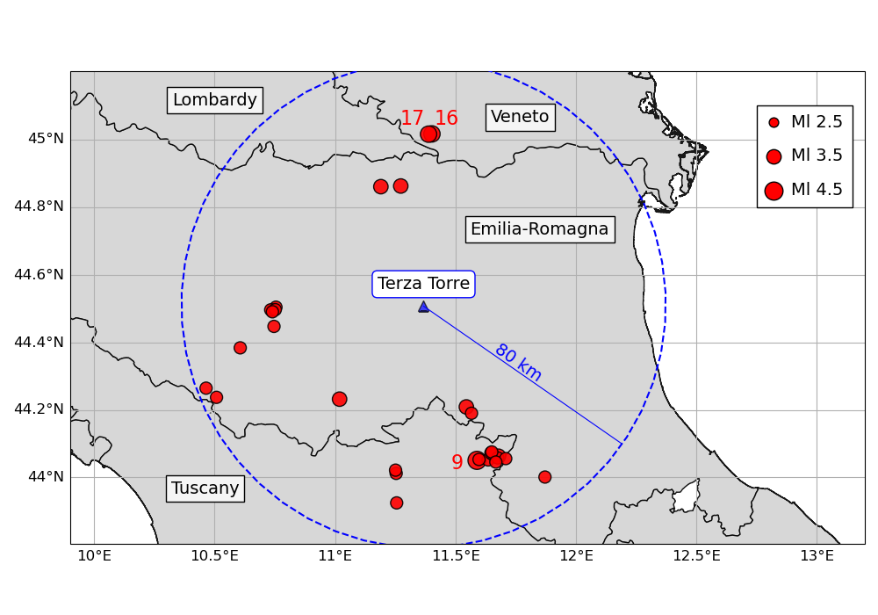
Figure 3. Map of the epicenters of the 30 seismic events listed in Table 2 (red dots, with size proportional to event magnitude). The three highest-magnitude events (IDs 9, 16, and 17) are highlighted. The location of the Terza Torre monitoring array is marked by a blue triangle. The dashed line marks the circular area of 80 km radius used for event selection. The color version of this figure is available only in the electronic edition.
[Alt Text: A map of Northern Italy displaying the position of the Terza Torre building together with the epicenters of the 30 events contained in the dataset, and the 80 km radius area in which they were selected.]

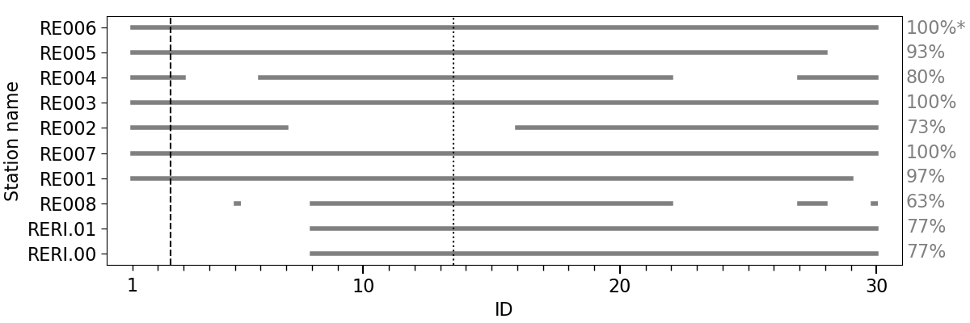
Figure 4. Data availability for each station for the 30 selected events recorded by the Terza Torre experiment (see also Supplemental Material, Figure S2). The vertical dashed and dotted lines indicate the change of sampling rate configuration, first from 125 to 200 Hz and then from 200 to 250 Hz. The EHE component of station RE006 (marked with an asterisk) was affected by a sensor malfunction until October 2023 and has 50% total availability. Stations RE002 and RE008 experienced system interruptions due to software malfunctioning and connectivity issues, respectively.
[Alt Text: A chart displaying the availability of data for each station in the monitoring array, for each event in the dataset, together with the total availability in percentage.]

Initial observations
Among the 30 earthquakes composing the dataset, only three events (IDs 9, 16 and 17) generated peak horizontal velocities above 0.1 cm/s within the building. The strongest event in the dataset is the 18 September 2023 earthquake (ID 9), which had ML 4.8 and occurred at an epicentral distance of 54 km, near the Emilia-Romagna - Tuscany border. During this event, the peak horizontal velocity recorded on the building was 0.47 cm/s on the EHE component of station RE005 (15th floor; see Figure 5), compared to 0.16 cm/s on the EHE component at the surface borehole sensor RERI.01.

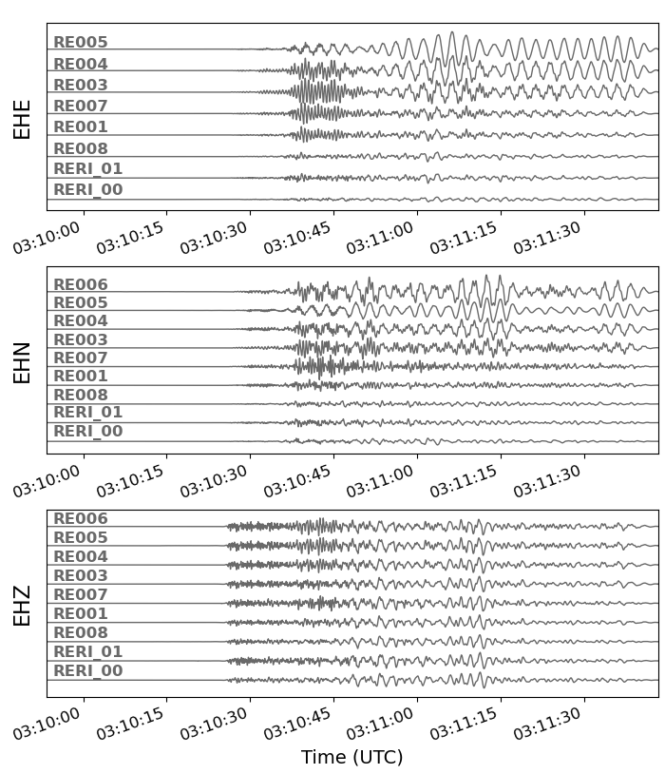
Figure 5. Recorded three-component ground velocity (EHE, EHN, EHZ) for the ML 4.8 earthquake on 18 September 2023 (event ID 9). The waveforms have been corrected for instrumental sensitivity and bandpass filtered between 0.3 and 30 Hz.
[Alt Text: A plot of the waveforms recorded by the monitoring array for the ML 4.8 earthquake occurred on 18 September 2023; both the horizontal and the vertical components are shown.]
Preliminary analyses were conducted on both local earthquake records and ambient vibration data, exploiting all available earthquake recordings from the dataset and complementing them with six hours of ambient vibration recorded prior to the ML 4.2 event of 28 October 2023 (event ID 17), and focusing on velocimetric data.
The main aspect of these analyses consists in a detailed inspection of the dataset in the frequency domain, to provide the potential user with preliminary information on the quality of the dataset in terms of signal-to-noise ratio (SNR) and with an indication of the usable frequency range for different magnitude and distance classes of events. We subsequently show some possible usage of the dataset: (i) to characterize the building’s fundamental frequencies, (ii) to identify the corresponding mode shapes under linear-elastic conditions, and (iii) to evaluate the local site response.
These preliminary results are not comprehensive and do not capture the nonlinear response of either the soil or the building under strong shaking, where effects such as cracking, stiffness degradation, or loss of connectivity in non-structural components may occur. As they are, the preliminary results obtained with the analyzed dataset offer essential constraints for calibrating numerical models under elastic conditions. Furthermore, dynamic behavior results of the building can establish a reference dynamic state of the building in its undamaged condition, which can be used as a benchmark for future monitoring or post-event assessments.

Spectral analysis of earthquake data
Since the Lunitek velocimeters are short-period sensors which display a low corner-frequency at 4.5 Hz, correcting for the full instrumental response introduces a trend in the low frequency band, which becomes visible in the frequency domain. This trend does not affect any of the subsequent analyses, in which only relative measurements are considered. In the dataset we provide both the raw data and the full instrumental response, along with corrected data, allowing users to make their own data processing depending on their needs.
We first checked the quality of the dataset in terms of signal-to-noise ratio (SNR), to investigate the usable frequency range for the earthquake data. For each sensor, channel-wise SNR calculation was carried out in the frequency band between 0.3 and 30 Hz by using the 20s long noise signal that is recorded before the event and the 20s long signal that starts from the theoretical S-wave arrival calculated by using the 1D global velocity model defined by Kennett and Engdahl (1991). Frequency bands with SNR larger than 3 were estimated by following the procedure developed by Gallo et al. (2014); some examples of signal and noise spectra are provided in the Supplemental Material (Figure S3-S4). We chose a threshold of 3 to exemplify a reasonable SNR condition, in which the frequency content of the earthquake motions can be identified.
The results of the SNR analysis are exemplified in Figure 6 for station RE006, where for each event only the frequencies at which the threshold condition is met are considered. For this reason, the average earthquake spectra shown as black lines in Figure 6 are calculated over a different number of data points for each frequency. Earthquake-wise analysis was carried out for all stations in the building and the results are given in the Supplemental material (Figure S5-S6; see also Data and Resources). The analysis shows that best SNR values are generally retrieved above 1 Hz, whereas for lower frequencies the number of usable data points tends to decrease, especially for low magnitude events. This does not prevent from detecting the expected fundamental modes below 1 Hz, provided that the analyst is aware of the growing bias as frequency decreases. According to the PPSD analyses, the expected lowest usable frequency is around 0.2 Hz, where the signal consistently exceeds the Peterson high noise model.
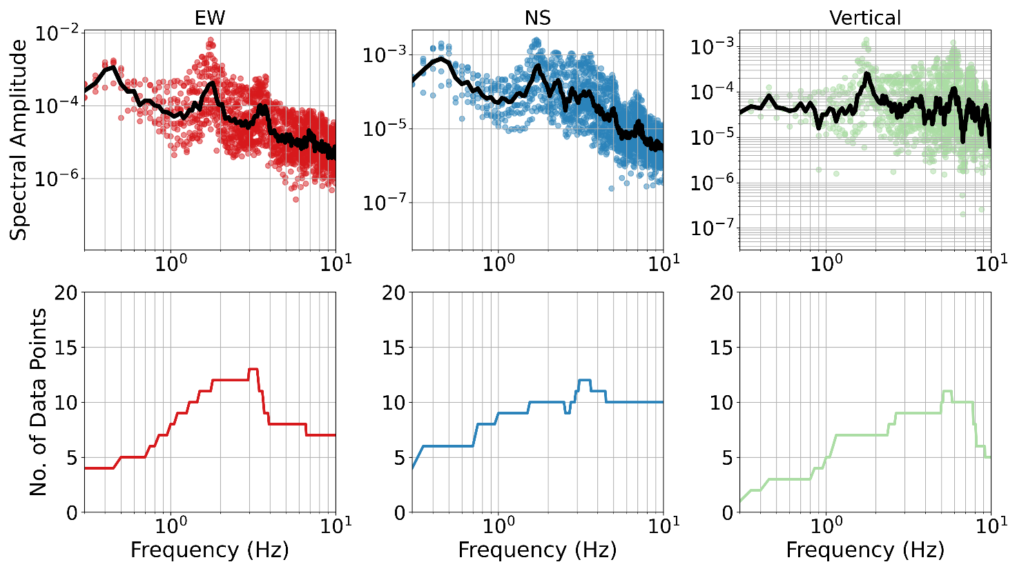
Figure 6. top) Spectral content of earthquake data recorded by RE006 station. Spectra for each event are shown as dots, and their mean as a black line. bottom) Number of data points used for each frequency to calculate the mean value given in the top panel. The color version of this figure is available only in the electronic edition.
[Alt Text: Plots of the mean spectral amplitude curve obtained for each component of station RE006 over the event dataset, and corresponding distribution of the number of available points for each frequency based on the signal to noise ratio.]

Spectral ratio analysis
To isolate the structural response from the combined building-soil system behavior, Fourier amplitude spectral (FAS) ratios (FASRs) can be computed by normalizing the Fourier spectra of the motion recorded at each floor to that of a reference sensor. In spectral ratio analyses the reference is commonly assumed to extract the free-field motion. In our case, the chosen reference was sensor RE008, located at the base of the building (2nd basement floor). In adopting this approach, we are aware that RE008 partially includes the propagation effect in the building, as the downgoing waves re-radiated from the structure can influence the recordings at the base. The resulting spectral ratios should thus not be interpreted as true transfer functions; nevertheless, for the purpose of the estimation of the vibrational frequencies, this approximation is commonly employed and considered adequate (e.g., Michel et al., 2008).
This analysis utilized velocity waveforms recorded consistently across all stations and components of the building, focusing on frequencies below 10 Hz, where the dominant modal energy is expected. For ambient vibrations, the data were divided into ten-minute windows, highpass filtered above 0.05 Hz, and tapered with a 5% taper ratio. The same time windows as described in Spectral analysis of earthquake data were used. For each time window the FAS of the station of interest was divided by the FAS of the reference station. Finally, the medians of all spectral ratios were calculated.
As shown by the spectral analysis, earthquake signals are mostly excited at higher frequencies (>1Hz). To ensure the reliability of the spectral ratio analysis, we take into consideration the number of data points with good SNR available for station RE008. An example for station RE006 is shown in Figure 7. It can be seen that the number of data points available for FASR analysis is lower for the lowest frequencies with respect to higher frequencies, with a decrease in the number of data for each frequency due to the SNR scores of RE008 data. In Figure 7, it can be seen that for frequencies lower than 0.4 Hz in the vertical component it is not possible to carry out the FASR due to the absence of high SNR data. This does not affect the contribution related to low magnitude earthquakes, for which higher frequencies are expected to be amplified (Ditommaso et al., 2012).
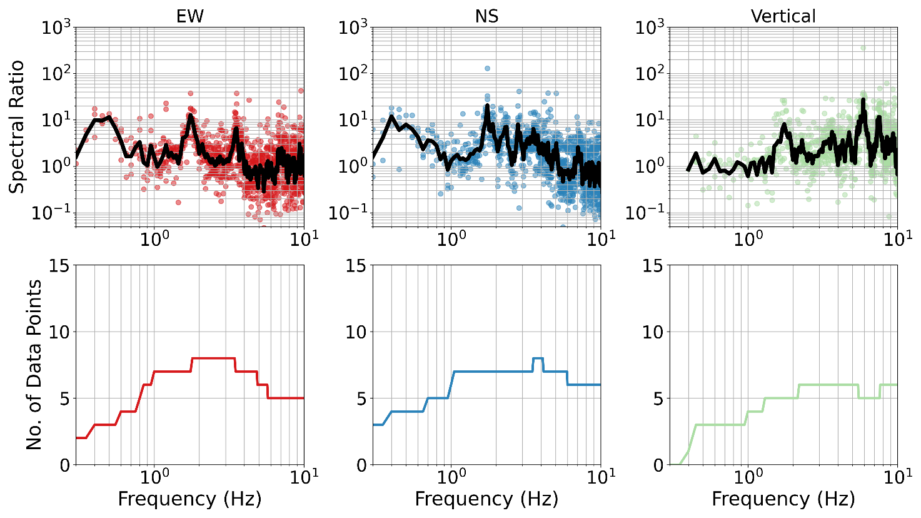
Figure 7. top) Earthquake spectral ratio of RE006 station with respect to RE008 station. Spectral ratios for each event are shown as dots, and their mean as a black line. bottom) Number of data points used for each frequency to calculate the corresponding mean value in the top panel. The color version of this figure is available only in the electronic edition.
[Alt Text: Plots showing the mean spectral ratio curve obtained by dividing the mean amplitude at station RE006 by that of station RE008, for each component, and corresponding distribution of the number of available points for each frequency based on the signal to noise ratio.]
The results of the spectral ratio analysis are presented in Figure 8 for both ambient vibrations and earthquake records. The first two resonance peaks are identified with ambient noise vibration at 0.45 Hz and 0.73 Hz (Figure 8a), with significant energy observed on horizontal components. For the first mode, the east-west (EW) and north-south (NS) components exhibit similar amplitudes, whereas the second mode shows a stronger response in the NS direction. Additional spectral peaks are observed at higher frequencies, specifically at 1.77, 2.34, 2.8, and 3.6 Hz. As for the results based on earthquake data (Figure 8b), peaks detected at higher frequencies between 1.7 Hz and 3.0 Hz are in agreement with the ambient noise measures. The two lowermost resonance frequencies below 1 Hz are still present also in the earthquake data, but less clearly defined than in the ambient vibration analysis. This is likely due to the fact that lower frequencies are more weakly constrained due to the limited length of the analyzed signal time windows. Moreover, ambient excitation has a broadband and continuous nature, which tends to activate a wider range of vibration modes regardless of their directional orientation or modal mass participation. Ambient noise recordings offer greater temporal stability, enabling more effective spectral averaging and sharper identification of resonance peaks (Clinton et al., 2006).

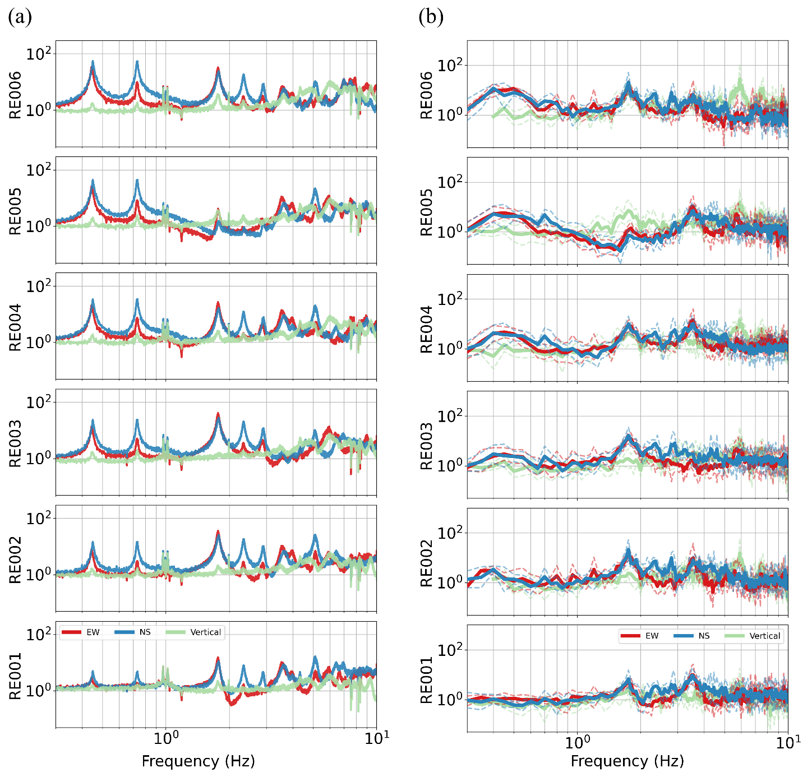
Figure 8. Fourier spectral ratios computed using the RE008 sensor (located at the base of the building) as a reference. a) Average spectral ratios from ambient vibration recordings, based on 10-minute time windows. b) Spectral ratios from local earthquake recordings; bold curves indicate the average spectrum for each component (red for EHE, blue for EHN, green for EHZ) and dashed lines represent the ±1𝜎 interval. The color version of this figure is available only in the electronic edition.
[Alt Text: Two plots showing the Fourier spectral ratios obtained for each component from the analysis of the ambient vibration recordings and from the analysis of earthquake recordings; sensor RE008 was used as a reference.]

Modal analysis
Another possible application of the dataset is the identification of the vibrational frequencies and corresponding mode shapes of the building using a modal analysis, i.e. the frequency domain decomposition (FDD) technique (Brincker et al., 2001). An example of FDD analysis is shown based on the same six hours of synchronous ambient vibration recordings used in the spectral ratio analysis (see Spectral ratio analysis), considering all sensors in the vertical array located on Tower A (RE001-RE006) and excluding sensors RE007-RE008 that are located on Tower B of the building. For each horizontal component, all sensors are considered simultaneously.
The signals were divided into approximately eight-minute windows and processed with standard preprocessing steps, including linear trend removal, tapering, and bandpass filtering between 0.3 and 30 Hz. For each window, the power spectral density matrix was computed at discrete frequencies, and the corresponding spectra were averaged. Singular value decomposition was then applied to the averaged matrices to extract the dominant modal responses (Brincker et al. 2001).
The resulting singular values of the power spectral density matrix in the frequency range of 0.3 to 10 Hz and the associated shape of the first vibrational mode are shown in Figure 9. The lowermost main frequencies of the building can be identified at 0.44, 0.71, 1.76, 2.30, 2.80 and 3.60 Hz, using FDD. These values are in very good agreement with the frequencies obtained through spectral ratio analysis (0.45, 0.73, 1.77, 2.34, 2.80 and 3.60 Hz), with deviations below about 3%, confirming the consistency between the two experimental approaches. A comparison with the frequencies obtained from the FEM (0.39, 0.41, 0.69, 1.52 and 1.64 Hz) shows a reasonable agreement for the lower modes, although the numerical model generally predicts slightly lower frequencies than those identified experimentally. The differences are mostly within about 3–14%, which can be attributed to modelling simplifications, uncertainties in material properties, stiffness assumptions, the contribution of non-structural components, and idealized boundary conditions in the FE model.
The amplitudes of the first mode, observed at 0.44 Hz, increase with height for both directions, reaching their maxima at the roof. FDD analysis also has the potential to extract information on the classification of the modes (e.g., translational or torsional). Although the FDD method can be extended to estimate damping ratios using the Enhanced Frequency Domain Decomposition (EFDD) approach (Brincker, Ventura and Andersen, 2001), damping identification was not pursued in the present study due to its higher sensitivity to noise and modal overlap, as well as the larger uncertainties generally associated with damping estimates from ambient vibration measurements (e.g., Cruz and Miranda, 2019). Therefore, the present analysis focuses on the more robustly identifiable parameters, namely the natural frequencies and associated mode shapes.

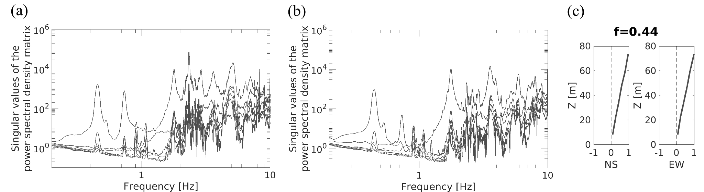
Figure 9. a) Singular values of the power spectral density matrix for the north-south direction, computed from ambient vibration recordings at sensors RE001–RE006 using the FDD method. The curves represent the energy eigenvalues (singular values) obtained from the spectral decomposition of the cross-spectral density matrix. b) Same as a), for the east-west direction. c) Mode shape corresponding to the first dominant spectral peak at 0.44 Hz for the north-south and east-west directions. The mode shape is derived from the singular vectors associated with the largest eigenvalues at the respective peak frequencies.
[Alt Text: Two plots displaying the singular values of the power spectral density matrix obtained using the FDD methodology, both for the north-south and the east-west components, together with a visual representation of the mode shape corresponding to the first dominant mode at 0.44 Hz.]

Evaluation of the local seismic site response
To assess the local site response at the RERI borehole location, we computed Fourier amplitude spectral ratios between the surface (RERI.01) and the downhole sensor at 50 m depth (RERI.00). This approach is commonly used to provide a first-order estimate of the seismic site amplification; however, it is well known that the resulting ratios are inherently affected by the effect of downgoing wavefields. Consequently, spurious spectral features may arise from interference between direct and reflected phases rather than from true 1-D resonance of the shallow column (e.g., Mehta et al., 2007; Parolai et al., 2009; Petrovic & Parolai, 2016). Potential contamination from soil–structure interaction is also relevant here: seismic energy re-radiated by the Terza Torre can propagate back into the shallow subsurface and affect recordings even outside the building footprint (Petrovic & Parolai, 2016; Petrovic et al., 2018).
Processing applied to ambient-vibration ratios display a smooth, quasi-monotonic increase in amplitude with frequency and no distinct peaks (Figure 10a). This behavior is consistent with the lithostratigraphic observations at RERI, which indicate a gradual increase in stiffness with depth and no sharp impedance contrasts down to 50 m. In contrast, earthquake-based ratios exhibit a narrow-band enhancement around 1.6–1.7 Hz (Figure 10b). We interpret this feature (based on first deconvolution analysis between surface and borehole station) primarily as an interference effect due to downgoing waves (near-surface reflections and/or conversions) that combine with the upgoing motion, rather than as a resonance frequency of the shallow layer stack. This interpretation is supported by the lack of a corresponding peak in the ambient-vibration ratios (whose sources are normally located nearby surface) and by the stratigraphic evidence of a velocity gradient rather than discrete contrasts.
From an interpretative standpoint, frequency bounds can be inferred heuristically from a quarter-wavelength argument. For a 50 m depth and representative shallow shear-wave velocities (Vs) in the 250–330 m/s range (regional studies and nearby investigations), reliable 1-D amplification estimates are expected above ~1.25–1.65 Hz. At lower frequencies, wavelengths exceed the borehole depth and the two sensors record nearly the same wavefield (ratios approaching ~1), rendering the estimate uninformative for site response. The observed enhancement at 1.6–1.7 Hz thus falls within the nominally reliable band but, given the mixed up/down content and possible SSI influence, it should not be taken as evidence of a well-defined 1-D resonance.
To further quantify the degree of interference and reduce bias from downgoing energy, waveform deconvolution and up/down separation on the vertical array are recommended. A systematic use of upgoing-wave transfer functions (Bindi et al., 2010), together with time–frequency analysis, directional polarization, and (where applicable) magnitude-squared coherence filtering between the two sensors, will provide a more robust estimate of the local site amplification and help disentangle SSI-related contributions from true free-field response.
Uncertainty bounds in Figure 10 (±1σ) show limited dispersion, indicating stable ratios across events; however, low variability does not by itself validate a 1-D resonance interpretation when mixed wavefields are present. Taken together, the ambient-noise and earthquake results support a picture of weak to moderate, broadband amplification attributable to a smooth velocity gradient over 0–50 m, with no clear shallow resonance and with earthquake-only narrow-band enhancements plausibly explained by downgoing waves. These findings justify a cautious use of conventional surface-to-downhole ratios in dense urban settings and motivate the adoption of deconvolution-based estimates for future analyses at RERI.

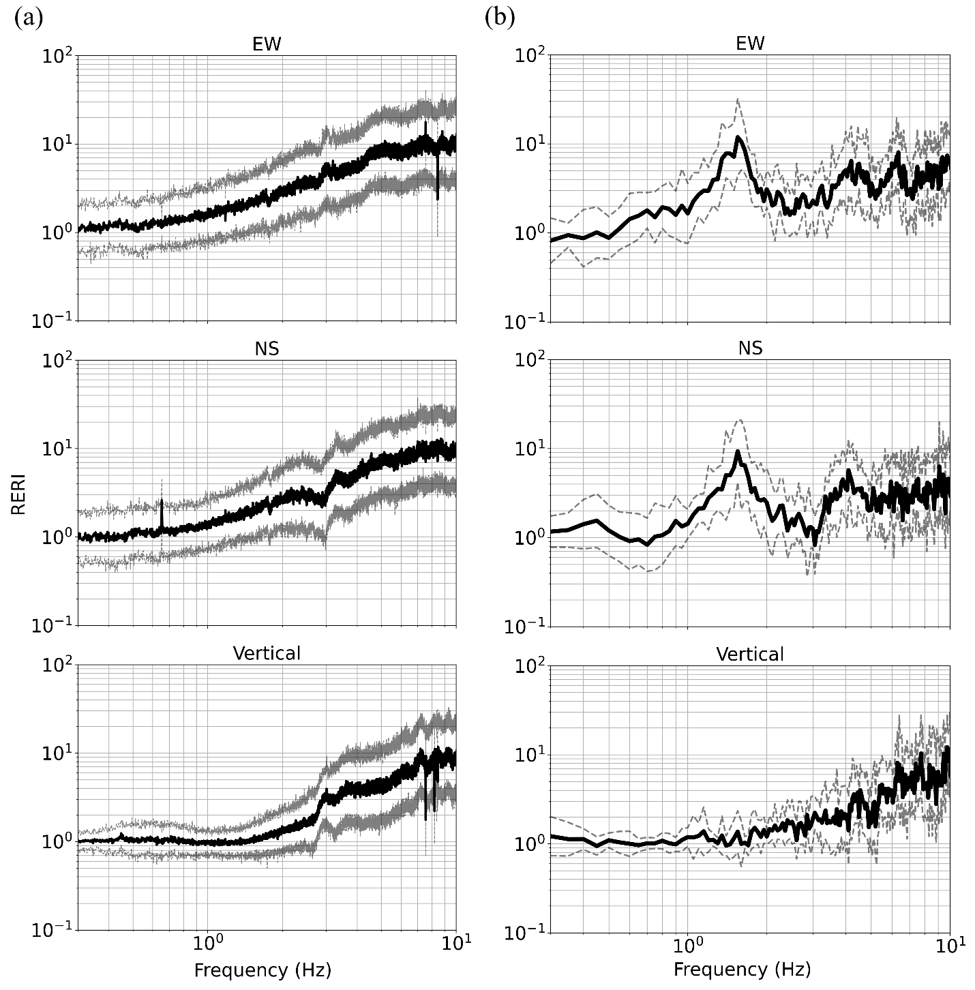
Figure 10. Fourier spectral ratios computed using the RERI.00 sensor (located at the base of the borehole) as a reference. a) Average spectral ratios from ambient vibration recordings, based on 10-minute time windows. b) Spectral ratios from local earthquake recordings; bold curves indicate the average spectrum for each component (EHE, EHN, EHZ) and dashed lines represent the ±1𝜎.
[Alt Text: Two plots representing the average Fourier spectral ratios computed using ambient vibration and earthquake recordings from the borehole, for the three motion components; station RERI.00 was used as a reference.]

Summary
The “Terza Torre” experiment was designed as a long-term monitoring installation to characterize a target strategic building, while also enabling the study of soil-structure systems such as wave propagation and possible soil-structure interaction phenomena in an urban, seismically active area of Northern Italy. The monitoring infrastructure combines eight co-located velocimetric and accelerometric stations (compact and cost-effective units) installed as a vertical array along the main tower, with a two-level borehole installation equipped with high-quality velocimetric sensors at 0 and 50 m depth. The sensor configuration was selected to maximize vertical resolution and sensitivity to both structural response and local ground motion, while maintaining real-time data transmission and robust acquisition performance.
Over the first two years of continuous operation (since March 2023), the network recorded dozens of local and regional earthquakes, including events up to ML 4.8. Despite elevated background noise due to the urban environment, the system has demonstrated good stability and coverage. We compiled a selected dataset of recordings for 30 events that occurred between March 2023 and July 2025 within 80 km from the test site, with magnitudes in the range ML 3.0-4.8. To suit both seismological and engineering communities, we provide the dataset as raw and corrected data, with an embargo of two years from the article publication.
A detailed inspection conducted on the spectra of local earthquake records provides the potential user with information on the quality of the dataset in terms of SNR, and on its possible applications and limitations. Three possible applications of the dataset are exemplified, showing the potential to extract information on the building’s fundamental frequencies and the corresponding modes, by applying spectral ratio analysis and FDD on the on-building recordings, and to investigate the local site response using the data recorded by the borehole installation. The initial observations gathered through these analyses are not meant to provide an exhaustive description of the dynamic properties of the building and the subsoil; they are aimed at testing the quality and applicability of the dataset while providing a starting point for further analyses. Over time, the dataset is expected to be enriched with additional seismic events, potentially including strong-motion events. Combined with a more detailed site characterization, which is currently planned, these data could support more advanced simulations such as SSI studies accounting for nonlinear SSI effects. They could furthermore be exploited for damage assessment, the analysis of damage progression, and the development of associated methodologies.
Although preliminary, some interesting observations can be made from the analyses carried out to exemplify the possible applications of the dataset. The initial observations determined on the Terza Torre building show that FEM and both FASR and FDD are in agreement, as the observations from ambient noise analysis provide a clear amplification in 0.44 Hz and 0.71 Hz which are similar to the 0.39-0.41 and 0.69 Hz peaks reported in the FEM. Observations from the building also allow us to identify higher modes around 1.76 Hz, 2.30 Hz, 2.80 Hz, and 3.60 Hz. In the borehole no specific soil amplification is observed in the FASR analysis with ambient noise vibration, whereas in the earthquake data a clear peak is observed around 1.6 - 1.7 Hz which can be linked to the downgoing and upgoing earthquake waves.
The continuous operation of the Terza Torre network offers a valuable opportunity to investigate temporal variations in structural response, which may occur as variations in dynamic behavior due to environmental conditions (Clinton et al., 2006; Pitilakis et al., 2016) and transient shaking (Herak and Herak, 2010; Williams et al., 2022). The current configuration provides high-resolution data along the height of the building, allowing detailed assessments of parameters such as inter-story drift, peak horizontal velocity, and changes in vibrational frequencies and wave propagation velocities. Future strong events may enable the investigation of non-linear behavior under moderate to large ground motions (Guéguen et al., 2023), while ambient vibration records of the velocimeters could help detect seasonal or progressive changes in stiffness. The geometry of the infrastructure, with synchronized building-borehole recordings, also enables the study of wave propagation both in the building and soil.
Given the vertical resolution and co-located velocimetric–accelerometric instrumentation, the current array is also well-suited for estimating dynamic response indicators directly linked to potential damage in the building and/or surrounding areas (e.g., Scaini et al., 2021; Petrovic et al., 2022). In particular, inter-story drift can be computed with high accuracy, allowing for the evaluation of drift-based damage metrics during moderate to strong ground shaking. This enables both a prior evaluation of the building’s structural vulnerability, by directly assessing the structural parameters, and a post-event inference of actual damage. The dataset can support analyses that relate maximum drift or displacement to structural and non-structural performance limits, in line with recent approaches in performance-based earthquake engineering (Chou et al., 2023).
The preliminary dynamic characterization presented here lays the foundation for future improvements. Additional sensors deployed with a denser or differently configured spatial configuration could improve the mode identification, enhancing sensitivity to torsional and out-of-plane motion components (e.g. Rahmani and Todorovska, 2013). Dedicated geophysical surveys are currently in the planning phase to refine the shallow velocity profile, which will support more accurate modeling of site and SSI effects. These developments will enable more detailed numerical simulations, including fully coupled structure-soil models.
The authors hope that the Terza Torre infrastructure and the associated dataset will serve the engineering seismology and earthquake engineering communities as a reference for validating numerical models of the building and of SSI effects, evaluating seismic design assumptions, and fostering collaborative research in the field of structural monitoring and site response analysis.

Data and Resources
Figures were made with Matplotlib version 3.8.4 (Hunter, 2007; The Matplotlib Development Team, 2024), available under the Matplotlib license at https://matplotlib.org/, with Cartopy version 0.24.1 (Met Office, 2024), available under the 3-Clause BSD license at https://scitools.org.uk/cartopy, and with MATLAB version 23.2.0.2365128 (R2023b) (https://www.mathworks.com). Data was collected using the SeisComP seismological software (GFZ and GEMPA GmbH, 2008). Software packages from ObsPy (Beyreuther et al., 2010) were used for data analysis. Moreover, data processing and analysis were performed using custom MATLAB code developed by the authors. The earthquake solutions were retrieved from the INGV national seismic catalog, the Italian Seismological Instrumental and Parametric Database (ISIDe; https://terremoti.ingv.it/, https://webservices.ingv.it/fdsnws/event/1; ISIDe Working Group, 2007). All websites were last accessed in April 2025. The L1 temporary network has not been officially registered with the International Federation of Digital Seismograph Networks (FDSN, https://www.fdsn.org/), while the permanent borehole station RERI was registered as part of the OX network (Istituto Nazionale di Oceanografia e di Geofisica Sperimentale - OGS, 2016; https://doi.org/10.7914/SN/OX). The dataset for this monitoring experiment is provided in Cataldi et al. (2025) and includes all seismic data recorded by the monitoring network (both L1 and OX.RERI) for the events reported in Table 2, both as raw miniSEED data (with the associated xml metadata) and as corrected miniSEED data. All waveforms in this dataset are cut starting at 30 s before the theoretical P-wave arrival and ending 80 s after. The only exception is that of the waveforms associated with the event ID 10 in Table 2; since the event occurred too close to the previous one (ID 9), no pre-event noise window was available and the 30 s of pre-event data were padded to zero. In addition to event recordings, the dataset includes three day-long recordings, to provide an example of pre-event noise (2023-09-18 and 2023-10-28) and of background noise (2025-01-01), again both as raw and as corrected miniSEED data. The corrected data is obtained from the raw data through baseline correction, instrument response removal, tapering and filtering in the 0.3 - 30 Hz range; the code used for the correction is also provided in Cataldi et al. (2025). We provide both raw and corrected waveforms to suit both seismology and engineering communities and to support multiple analysis purposes. The dataset is released with an embargo period of two years from the article publication. Additional recordings, such as continuous ambient noise measurements for specific time periods, can be provided upon request. Supplemental Material for this article includes additional figures regarding noise levels, data availability, and SNR scores.

Acknowledgements
The authors acknowledge the Emilia-Romagna Regional Government, and the General Directorate for Environment and Territory in particular, for hosting the network and providing long-term support to the monitoring experiment. We are grateful to the SRL Editors and to two anonymous reviewers for their constructive comments and suggestions. We also wish to thank the colleagues at National Institute of Oceanography and Applied Geophysics – OGS (in particular Lavinia Tunini, Michele Bertoni, Helga Siracusa) for help in the instrumental setup and data acquisition. Professor Stefano Parolai is currently at University of Trieste, Department of Mathematics, Informatics, and Geosciences, Trieste, Italy, while also maintaining his affiliation to OGS.

References
Aki, K. (1993). Local site effects on weak and strong ground motion, Tectonophysics 218, no. 1–3, 93–111, doi: 10.1016/0040-1951(93)90262-I.
Bard, P.-Y., J. L. Chazelas, Ph. Guéguen, M. Kham, and J. F. Semblat (2008). Site-City Interaction, in Assessing and Managing Earthquake Risk C. S. Oliveira, A. Roca, and X. Goula(Editors), Springer Netherlands, Dordrecht, Geotechnical, Geological And Earthquake Engineering, 91–114, doi: 10.1007/978-1-4020-3608-8_5.
Bard, P.-Y., P. Gueguen, and A. Wirgin (1996). A note on the seismic wavefield radiated from large building structures into soft soils, in Proceedings of the eleventh world conference on earthquake engineering, Acapulco, Mexico.
Beyreuther, M., R. Barsch, L. Krischer, T. Megies, Y. Behr, and J. Wassermann (2010). ObsPy: A Python Toolbox for Seismology, Seismological Research Letters 81, no. 3, 530–533, doi: 10.1785/gssrl.81.3.530.
Bindi, D., S. Parolai, M. Picozzi and A. Ansal (2010). Seismic input motion determined from a surface-downhole pair of sensors: a constrained deconvolution approach. Bulletin of the Seismological Society of America 100, no. 3, 1375–1380, doi: 10.1785/0120090306
Bragato, P. L., P. Comelli, A. Saraò, D. Zuliani, L. Moratto, V. Poggi, G. Rossi, C. Scaini, M. Sugan, C. Barnaba, et al. (2021). The OGS–Northeastern Italy Seismic and Deformation Network: Current Status and Outlook, Seismological Research Letters 92, no. 3, 1704–1716, doi: 10.1785/0220200372.
Bragato, P. L., M. Sugan, P. Augliera, M. Massa, A. Vuan, and A. Saraò (2011). Moho Reflection Effects in the Po Plain (Northern Italy) Observed from Instrumental and Intensity Data, Bulletin of the Seismological Society of America 101, no. 5, 2142–2152, doi: 10.1785/0120100257.
Brincker, R., Ventura, C. E., and P. Andersen (2001). Damping Estimation by Frequency Domain Decomposition. In Proceedings of IMAC 19: A Conference on Structural Dynamics, Kissimmee, Florida (pp. 698-703).
Brincker, R., L. Zhang, and P. Andersen (2001). Modal identification of output-only systems using frequency domain decomposition, Smart Mater. Struct. 10, no. 3, 441–445, doi: 10.1088/0964-1726/10/3/303.
Cardenas, M., P.-Y. Bard, P. Gueguen, and F. J. Chávez-Garcia (2000). Soil–structure interaction in Mexico City. Wave field radiated away from Jalapa Building: data and modelling.
Cataldi, L., B. Petrovic, D. Ertuncay, G. Capotosti, M. Romanelli, C. Scaini, L. Martelli, S. Parolai, and V. Poggi (2025). Supplements to “The Terza Torre Seismic Array in Bologna, Italy: A Dataset for Soil–Structure Interaction Studies in Urban Settings”, Zenodo, doi: https://doi.org/10.5281/zenodo.15520147.
CEN (2004). Eurocode 2: Design of concrete structures, EN 1992, Brussels.
CEN (2005). Eurocode 4: Design of composite steel and concrete structures, EN 1994, Brussels.
CEN (2006). Eurocode 8: Design of structures for earthquake resistance, EN 1998, Brussels.
Chou, J., C. Liu, and C. Chang (2023). Story drift and damage level estimation of buildings using relative acceleration responses with multi‐target deep learning models under seismic excitation, Earthq Engng Struct Dyn 52, no. 8, 2554–2571, doi: 10.1002/eqe.3856.
Clinton, J. F., S. C. Bradford, T. H. Heaton, and J. Favela (2006). The Observed Wander of the Natural Frequencies in a Structure, Bulletin of the Seismological Society of America 96, no. 1, 237–257, doi: 10.1785/0120050052.
Cruz, C., and E. Miranda (2019). Reliability of damping ratios inferred from the seismic response of buildings, Engineering Structures 184, 355–368, doi: 10.1016/j.engstruct.2019.01.056.
Ditommaso, R., M. Mucciarelli, S. Parolai, and M. Picozzi (2012). Monitoring the structural dynamic response of a masonry tower: comparing classical and time-frequency analyses, Bull Earthquake Eng 10, no. 4, 1221–1235, doi: 10.1007/s10518-012-9347-x.
Gallo, A., G. Costa, and P. Suhadolc (2014). Near real-time automatic moment magnitude estimation, Bull Earthquake Eng 12, no. 1, 185–202, doi: 10.1007/s10518-013-9565-x.
Guéguen, P., A. Astorga, and M. Langlais (2023). Amplitude–Frequency Noise Models for Seismic Building Monitoring in a Weak-to-Moderate Seismic Region, Seismological Research Letters 94, no. 5, 2231–2243, doi: 10.1785/0220230009.
Gueguen, P., P.-Y. Bard, and F. J. Chávez-Garcia (2002). Site-City Seismic Interaction in Mexico City-Like Environments: An Analytical Study, Bulletin of the Seismological Society of America 92, no. 2, 794–811, doi: 10.1785/0120000306.
Gueguen, P., P.-Y. Bard, and C. S. Oliveira (2000). Experimental and Numerical Analysis of Soil Motions Caused by Free Vibrations of a Building Model, Bulletin of the Seismological Society of America 90, no. 6, 1464–1479, doi: 10.1785/0119990072.
Helmholtz-Centre Potsdam-GFZ German Research Centre For Geosciences and GEMPA GmbH (2008). The SeisComP seismological software package, GFZ Data Services, doi: 10.5880/GFZ.2.4.2020.003.
Herak, M., and D. Herak (2010). Continuous monitoring of dynamic parameters of the DGFSM building (Zagreb, Croatia), Bull Earthquake Eng 8, no. 3, 657–669, doi: 10.1007/s10518-009-9112-y.
Hunter, J. D. (2007). Matplotlib: A 2D Graphics Environment, Comput. Sci. Eng. 9, no. 3, 90–95, doi: 10.1109/MCSE.2007.55.
Isbiliroglu, Y., R. Taborda, and J. Bielak (2015). Coupled Soil-Structure Interaction Effects of Building Clusters during Earthquakes, Earthquake Spectra 31, no. 1, 463–500, doi: 10.1193/102412EQS315M.
ISIDe Working Group (2007). Italian Seismological Instrumental and Parametric Database (ISIDe), Istituto Nazionale di Geofisica e Vulcanologia (INGV), 366000 earthquakes, 500 stations, doi: 10.13127/ISIDE.
Istituto Nazionale di Oceanografia e di Geofisica Sperimentale - OGS (2016). North-East Italy Seismic Network, FDSN, doi: 10.7914/SN/OX.
Jennings, P. C. (1970). Distant motions from a building vibration test, Bulletin of the Seismological Society of America 60, no. 6, 2037–2043, doi: 10.1785/BSSA0600062037.
Kennett, B. L. N., and E. R. Engdahl (1991). Traveltimes for global earthquake location and phase identification, Geophysical Journal International 105, no. 2, 429–465, doi: 10.1111/j.1365-246X.1991.tb06724.x.
Kham, M., J.-F. Semblat, P.-Y. Bard, and P. Dangla (2006). Seismic Site-City Interaction: Main Governing Phenomena through Simplified Numerical Models, Bulletin of the Seismological Society of America 96, no. 5, 1934–1951, doi: 10.1785/0120050143.
Laurenzano, G., E. Priolo, M. R. Gallipoli, M. Mucciarelli, and F. C. Ponzo (2010). Effect of Vibrating Buildings on Free-Field Motion and on Adjacent Structures: The Bonefro (Italy) Case History, Bulletin of the Seismological Society of America 100, no. 2, 802–818, doi: 10.1785/0120080312.
Mascandola, C., M. Massa, S. Barani, D. Albarello, S. Lovati, L. Martelli, and V. Poggi (2019). Mapping the Seismic Bedrock of the Po Plain (Italy) through Ambient‐Vibration Monitoring, Bulletin of the Seismological Society of America 109, no. 1, 164–177, doi: 10.1785/0120180193.
Mehta, K., R. Snieder, and V. Graizer (2007). Downhole Receiver Function: a Case Study, Bulletin of the Seismological Society of America 97, no. 5, 1396–1403, doi: 10.1785/0120060256.
Met Office (2024). Cartopy: a cartographic python library with a Matplotlib interface, UK.
Michel, C., P. Guéguen, and P.-Y. Bard (2008). Dynamic parameters of structures extracted from ambient vibration measurements: An aid for the seismic vulnerability assessment of existing buildings in moderate seismic hazard regions, Soil Dynamics and Earthquake Engineering 28, no. 8, 593–604, doi: 10.1016/j.soildyn.2007.10.002.
Ministero dei Lavori Pubblici (1996). DECRETO MINISTERIALE 9 gennaio 1996: Norme tecniche per il calcolo, l’esecuzione ed il collaudo delle strutture in cemento armato, normale e precompresso e per le strutture metalliche.
Molinari, I., A. Argnani, A. Morelli, and P. Basini (2015). Development and Testing of a 3D Seismic Velocity Model of the Po Plain Sedimentary Basin, Italy, Bulletin of the Seismological Society of America 105, no. 2A, 753–764, doi: 10.1785/0120140204.
Parolai, S., A. Ansal, A. Kurtulus, A. Strollo, R. Wang, and J. Zschau (2009). The Ataköy vertical array (Turkey): insights into seismic wave propagation in the shallow-most crustal layers by waveform deconvolution, Geophysical Journal International 178, no. 3, 1649–1662, doi: 10.1111/j.1365-246X.2009.04257.x.
Peterson, J. R. (1993). Observations and Modeling of Seismic Background Noise, Open-File Report, U.S. Geological Survey, Open-File Report.
Petrovic, B., and S. Parolai (2016). Joint Deconvolution of Building and Downhole Strong‐Motion Recordings: Evidence for the Seismic Wavefield Being Radiated Back into the Shallow Geological Layers, Bulletin of the Seismological Society of America 106, no. 4, 1720–1732, doi: 10.1785/0120150326.
Petrovic, B., S. Parolai, G. Pianese, S. U. Dikmen, B. Moldobekov, S. Orunbaev, and R. Paolucci (2018). Joint deconvolution of building and downhole seismic recordings: an application to three test cases, Bull Earthquake Eng 16, no. 2, 613–641, doi: 10.1007/s10518-017-0215-6.
Petrovic, B., S. Parolai, M. Romanelli, A. Affatato, L. Petronio, A. Barbagallo, D. Sorgo, M. Stefani, and R. Caputo (2019). Un approccio innovativo per una migliore comprensione dell’interazione sismica tra suolo e strutture: il test site di Ferrara, Bollettino di Geofisica Teorica ed Applicata 60, 140–147.
Petrovic, B., C. Scaini, and S. Parolai (2022). Applying the damage assessment for rapid response approach to the august 24 M6 event of the seismic sequence in central Italy (2016), Front. Earth Sci. 10, 932110, doi: 10.3389/feart.2022.932110.
Pitilakis, K., S. Karapetrou, D. Bindi, M. Manakou, B. Petrovic, Z. Roumelioti, T. Boxberger, and S. Parolai (2016). Structural monitoring and earthquake early warning systems for the AHEPA hospital in Thessaloniki, Bull Earthquake Eng 14, no. 9, 2543–2563, doi: 10.1007/s10518-016-9916-5.
Rahmani, M., and M. I. Todorovska (2013). 1D system identification of buildings during earthquakes by seismic interferometry with waveform inversion of impulse responses—method and application to Millikan library, Soil Dynamics and Earthquake Engineering 47, 157–174, doi: 10.1016/j.soildyn.2012.09.014.
Rahmani, M., and M. I. Todorovska (2021). Structural health monitoring of a 32‐storey steel‐frame building using 50 years of seismic monitoring data, Earthq Engng Struct Dyn 50, no. 6, 1777–1800, doi: 10.1002/eqe.3422.
Raub, C., M. Bohnhoff, B. Petrovic, S. Parolai, P. Malin, K. Yanik, R. F. Kartal, and T. Kiliç (2016). Seismic‐Wave Propagation in Shallow Layers at the GONAF‐Tuzla Site, Istanbul, Turkey, Bulletin of the Seismological Society of America 106, no. 3, 912–927, doi: 10.1785/0120150216.
Redesco srl (1999). Relazione di calcolo generale – Progetto esecutivo (Publication No. R5765/GAD/00501)
Regione Emilia-Romagna (1999). Progetto esecutivo delle strutture – Relazione geologica. Internal report – unpublished.
Rovida, A. N., P. Albini, M. Locati, and A. Antonucci (2020). Insights into Preinstrumental Earthquake Data and Catalogs in Europe, Seismological Research Letters 91, no. 5, 2546–2553, doi: 10.1785/0220200058.
Rovida, A., A. Antonucci, and M. Locati (2022). The European Preinstrumental Earthquake Catalogue EPICA, the 1000–1899 catalogue for the European Seismic Hazard Model 2020, Earth Syst. Sci. Data 14, no. 12, 5213–5231, doi: 10.5194/essd-14-5213-2022.
Scaini, C., B. Petrovic, A. Tamaro, L. Moratto, and S. Parolai (2021). Near-Real-Time Damage Estimation for Buildings Based on Strong-Motion Recordings: An Application to Target Areas in Northeastern Italy, Seismological Research Letters 92, no. 6, 3785–3800, doi: 10.1785/0220200430.
Semblat, J.-F., M. Kham, and P.-Y. Bard (2008). Seismic-Wave Propagation in Alluvial Basins and Influence of Site-City Interaction, Bulletin of the Seismological Society of America 98, no. 6, 2665–2678, doi: 10.1785/0120080093.
Semblat, J.-F., M. Kham, P. Gueguen, P.-Y. Bard, and A.-M. Duval (2002). Site-city interaction through modifications of site effects.
Skłodowska, A. M., C. Amendola, S. A. Mohammed, S. Sangaraju, C. Barnaba, D. Pitilakis, P. Roux, A. Compagno, B. Petrovic, V. Schindelholz, et al. (2025). EuroMASS Soil-Structure Interaction Experiment: A Semi-Dense Array for the Analysis of Wave Propagation from a Single-Degree-of-Freedom Structure to Its Surroundings, Seismological Research Letters 96, no. 2A, 1201–1213, doi: 10.1785/0220240018.
Skłodowska, A. M., S. Parolai, B. Petrovic, and F. Romanelli (2023). Soil-structure interaction assessment combining deconvolution of building and field recordings with polarization analysis: application to the Matera (Italy) experiment, Bull Earthquake Eng 21, no. 13, 5867–5891, doi: 10.1007/s10518-023-01750-7.
Snieder, R., and E. Şafak (2006). Extracting the Building Response Using Seismic Interferometry: Theory and Application to the Millikan Library in Pasadena, California, Bulletin of the Seismological Society of America 96, no. 2, 586–598, doi: 10.1785/0120050109.
Sugan, M., and A. Vuan (2014). On the ability of Moho reflections to affect the ground motion in northeastern Italy: a case study of the 2012 Emilia seismic sequence, Bull Earthquake Eng 12, no. 5, 2179–2194, doi: 10.1007/s10518-013-9564-y.
The Matplotlib Development Team (2024). Matplotlib: Visualization with Python, Zenodo, doi: 10.5281/ZENODO.10916799.
Vannoli, P., P. Burrato, and G. Valensise (2015). The Seismotectonics of the Po Plain (Northern Italy): Tectonic Diversity in a Blind Faulting Domain, Pure Appl. Geophys. 172, no. 5, 1105–1142, doi: 10.1007/s00024-014-0873-0.
Varone, C., L. Lenti, S. Martino, and J. F. Semblat (2021). Spatial variability of the urban ground motion in a highly heterogeneous site-city configurations, Bull Earthquake Eng 19, no. 1, 27–45, doi: 10.1007/s10518-020-00965-2.
Wen, W., and E. Kalkan (2017). System Identification Based on Deconvolution and Cross Correlation: An Application to a 20‐Story Instrumented Building in Anchorage, Alaska, Bulletin of the Seismological Society of America 107, no. 2, 718–740, doi: 10.1785/0120160069.
Williams, E. F., T. H. Heaton, Z. Zhan, and V. R. Lambert (2022). Variability in the Natural Frequencies of a Nine-Story Concrete Building from Seconds to Decades, The Seismic Record 2, no. 4, 237–247, doi: 10.1785/0320220032.
Wirgin, A., and P.-Y. Bard (1996). Effects of buildings on the duration and amplitude of ground motion in Mexico City, Bulletin of the Seismological Society of America 86, no. 3, 914–920, doi: 10.1785/BSSA0860030914.

Mailing addresses
Laura Cataldi lcataldi@ogs.it
Giorgio Capotosti gcapotosti@ogs.it
Deniz Ertuncay dertucay@ogs.it
Bojana Petrovic bp@gfz.de
Marco Romanelli mromanelli@ogs.it
Chiara Scaini cscaini@ogs.it
Luca Martelli luca.martelli@regione.emilia-romagna.it
Stefano Parolai stefano.parolai@units.it
Valerio Poggi vpoggi@ogs.it

List of figure captions
Figure 1. a) Location of the Terza Torre monitoring infrastructure in Bologna (see inset map). The sensor positions are marked by triangles: in black for the vertical array on the eastern façade (stations RE001-RE006) and for the array on the western side (RE007 and RE008), in red for the nearby borehole station (OX.RERI). b) Instrumentation installed in the building. c) The borehole station, hosting one sensor on the surface and one sensor in well. The photo of the building is courtesy of Regione Emilia-Romagna (2025). Satellite data in the upper left maps are from Google Earth (Landsat/Copernicus) and OpenStreetMap. The color version of this figure is available only in the electronic edition.
Figure 2. Layout of the Terza Torre monitoring system, including both the on-building seismic array and the borehole station. a) External views from the East and South sides showing Towers A and B of the Terza Torre building, with the vertical distribution of sensors indicated by black triangles and grey horizontal line showing the ground level; b) Configuration of the borehole station, hosting sensors RERI.01 (at surface) and RERI.00 (in well); c)-f) Floor plans of the Terza Torre building showing sensor positions (blue markers); the black arrow marks the geographic North. The color version of this figure is available only in the electronic edition.
Figure 3. Map of the epicenters of the 30 seismic events listed in Table 2 (red dots, with size proportional to event magnitude). The three highest-magnitude events (IDs 9, 16, and 17) are highlighted. The location of the Terza Torre monitoring array is marked by a blue triangle. The dashed line marks the circular area of 80 km radius used for event selection. The color version of this figure is available only in the electronic edition.
Figure 4. Data availability for each station for the 30 selected events recorded by the Terza Torre experiment (see also Supplemental Material, Figure S2). The vertical dashed and dotted lines indicate the change of sampling rate configuration, first from 125 to 200 Hz and then from 200 to 250 Hz. The EHE component of station RE006 (marked with an asterisk) was affected by a sensor malfunction until October 2023 and has 50% total availability. Stations RE002 and RE008 experienced system interruptions due to software malfunctioning and connectivity issues, respectively.
Figure 5. Recorded three-component ground velocity (EHE, EHN, EHZ) for the ML 4.8 earthquake on 18 September 2023 (event ID 9). The waveforms have been corrected for instrumental sensitivity and bandpass filtered between 0.3 and 30 Hz.
Figure 6. top) Spectral content of earthquake data recorded by RE006 station. Spectra for each event are shown as dots, and their mean as a black line. bottom) Number of data points used for each frequency to calculate the mean value given in the top panel. The color version of this figure is available only in the electronic edition.
Figure 7. top) Earthquake spectral ratio of RE006 station with respect to RE008 station. Spectral ratios for each event are shown as dots, and their mean as a black line. bottom) Number of data points used for each frequency to calculate the corresponding mean value in the top panel. The color version of this figure is available only in the electronic edition.
Figure 8. Fourier spectral ratios computed using the RE008 sensor (located at the base of the building) as a reference. a) Average spectral ratios from ambient vibration recordings, based on 10-minute time windows. b) Spectral ratios from local earthquake recordings; bold curves indicate the average spectrum for each component (red for EHE, blue for EHN, green for EHZ) and dashed lines represent the ±1𝜎 interval. The color version of this figure is available only in the electronic edition.
Figure 9. a) Singular values of the power spectral density matrix for the north-south direction, computed from ambient vibration recordings at sensors RE001–RE006 using the FDD method. The curves represent the energy eigenvalues (singular values) obtained from the spectral decomposition of the cross-spectral density matrix. b) Same as a), for the east-west direction. c) Mode shape corresponding to the first dominant spectral peak at 0.44 Hz for the north-south and east-west directions. The mode shape is derived from the singular vectors associated with the largest eigenvalues at the respective peak frequencies.
Figure 10. Fourier spectral ratios computed using the RERI.00 sensor (located at the base of the borehole) as a reference. a) Average spectral ratios from ambient vibration recordings, based on 10-minute time windows. b) Spectral ratios from local earthquake recordings; bold curves indicate the average spectrum for each component (EHE, EHN, EHZ) and dashed lines represent the ±1𝜎.

