An inter-disciplinary and multi-scale approach to assess the spatial variability of ground motion for seismic microzonation: the case study of Cavezzo municipality in Northern Italy
C.G. Laia,b, V. Poggic,⁎, A. Famàa,b, E. Zuccoloa,b, F. Bozzonib,⁎, C. Meisinad, R. Bonìd, L. Martellie,
M. Massaf, C. Mascandolaf, L. Petronioc, A. Aﬀatatoc, L. Baradelloc, D. Castaldinig,
R.M. Cosentinih

a Department of Civil and Architectural Engineering, University of Pavia, Italy
b European Centre for Training and Research in Earthquake Engineering, EUCENTRE, Via Ferrata 1, Pavia 27100, Italy
c National Institute of Oceanography and Applied Geophysics, OGS, Italy
d Department of Earth and Environmental Sciences, University of Pavia, Italy e Geological, Seismic and Soil Survey, Emilia-Romagna Region, Bologna, Italy f National Institute of Geophysics and Volcanology, INGV, Milano, Italy
g Department of Chemical and Geological Sciences, University of Modena and Reggio Emilia, Italy
h Department of Structural, Building and Geotechnical Engineering, Politecnico di Torino, Italy

A B S T R A C T
Seismic microzonation represents a basic tool for prevention activity planning and land management. An extensive and detailed microzonation study was performed with reference to the territory of the Municipality of Cavezzo, damaged during the seismic sequence hitting Emilia-Romagna Region, Northern Italy, in 2012. In this paper, we discuss the work carried out to characterize the spatial variability of ground motion ampliﬁcation due to local soil conditions in the municipality area. An inter- and multi-disciplinary approach is presented, involving geotechnical engineers, geophysicists, geologists and seismologists from diﬀerent institutions, to thoroughly characterize the territory using complementary techniques with diﬀerent level of resolution and conﬁdence. A considerable amount of geomorphological, geological, hydrogeological, seismological, geotechnical and geophysical investigations was collected and processed for the purpose. A GIS-based (Geographic Information System) platform was initially setup to manage the gathered data, which now includes the results of about 1000 geotechnical and geophysical tests. Such an extended dataset was then used as a primary constraint for the creation of a comprehensive pseudo-3D geotechnical and seismo-stratigraphic model of the territory, consisting of a dense grid of one-dimensional vertical proﬁles to depict the variability of the soil properties over the area. The model was ﬁnally used as input for linear-equivalent ground response analysis. For the calculation of the ampliﬁcation factors, special emphasis was given to the treatment and propagation of
the uncertainties of the model parameters, whose diﬀerent realizations have been accounted through a logic tree approach.

- Introduction

The seismic microzonation of a territory is the process that aims at identifying and mapping the subsoil seismic response and earthquake- induced phenomena of the study area. Typically, the spatial scale at which the zonation is performed is that of a municipality (urban scale) and it involves both the phenomenon of ground shaking ampliﬁcation and ground instabilities. In this framework, the seismic microzonation plays a crucial role in earthquake risk reduction, providing valuable input for urban planning (e.g., Ansal et al., 2009, 2010; Crespellani, 2014; Celikbilek and Sapmaz, 2016; Aversa and Crespellani, 2016).
In the last few decades, eﬀorts were made to perform microzonation in diﬀerent earthquake-prone areas. Fäh et al. (1997) carried out a detailed microzonation of the city of Basel to compute expected ground
motion during seismic events. Tuladhar et al. (2004) performed a seismic microzonation for the city of Bangkok by using micro-tremor observations. Anbazhagan et al. (2009) proposed a site classiﬁcation for the Bangalore area in India and then mapped the surface level seismic hazard starting from geophysical data. Cox et al. (2011) presented a seismic site classiﬁcation microzonation of the city of Port-au-Prince based on shear wave velocity of the soil and provided a code-based classiﬁcation scheme for the city. Murvosh et al. (2013) carried out shear wave velocity proﬁling to enhance the existing microzonation of Las Vegas. Motalleb Nejad et al. (2018) developed a microzonation algorithm that combines neural networks and geographic information system (GIS), in which ﬁeld and laboratory data are used as inputs to deﬁne zones of homogeneous shear wave velocity and soil type. Among the most recent and signiﬁcant experiences in the ﬁeld of seismic

⁎ Corresponding authors.
E-mail addresses: vpoggi@inogs.it (V. Poggi), francesca.bozzoni@eucentre.it (F. Bozzoni)

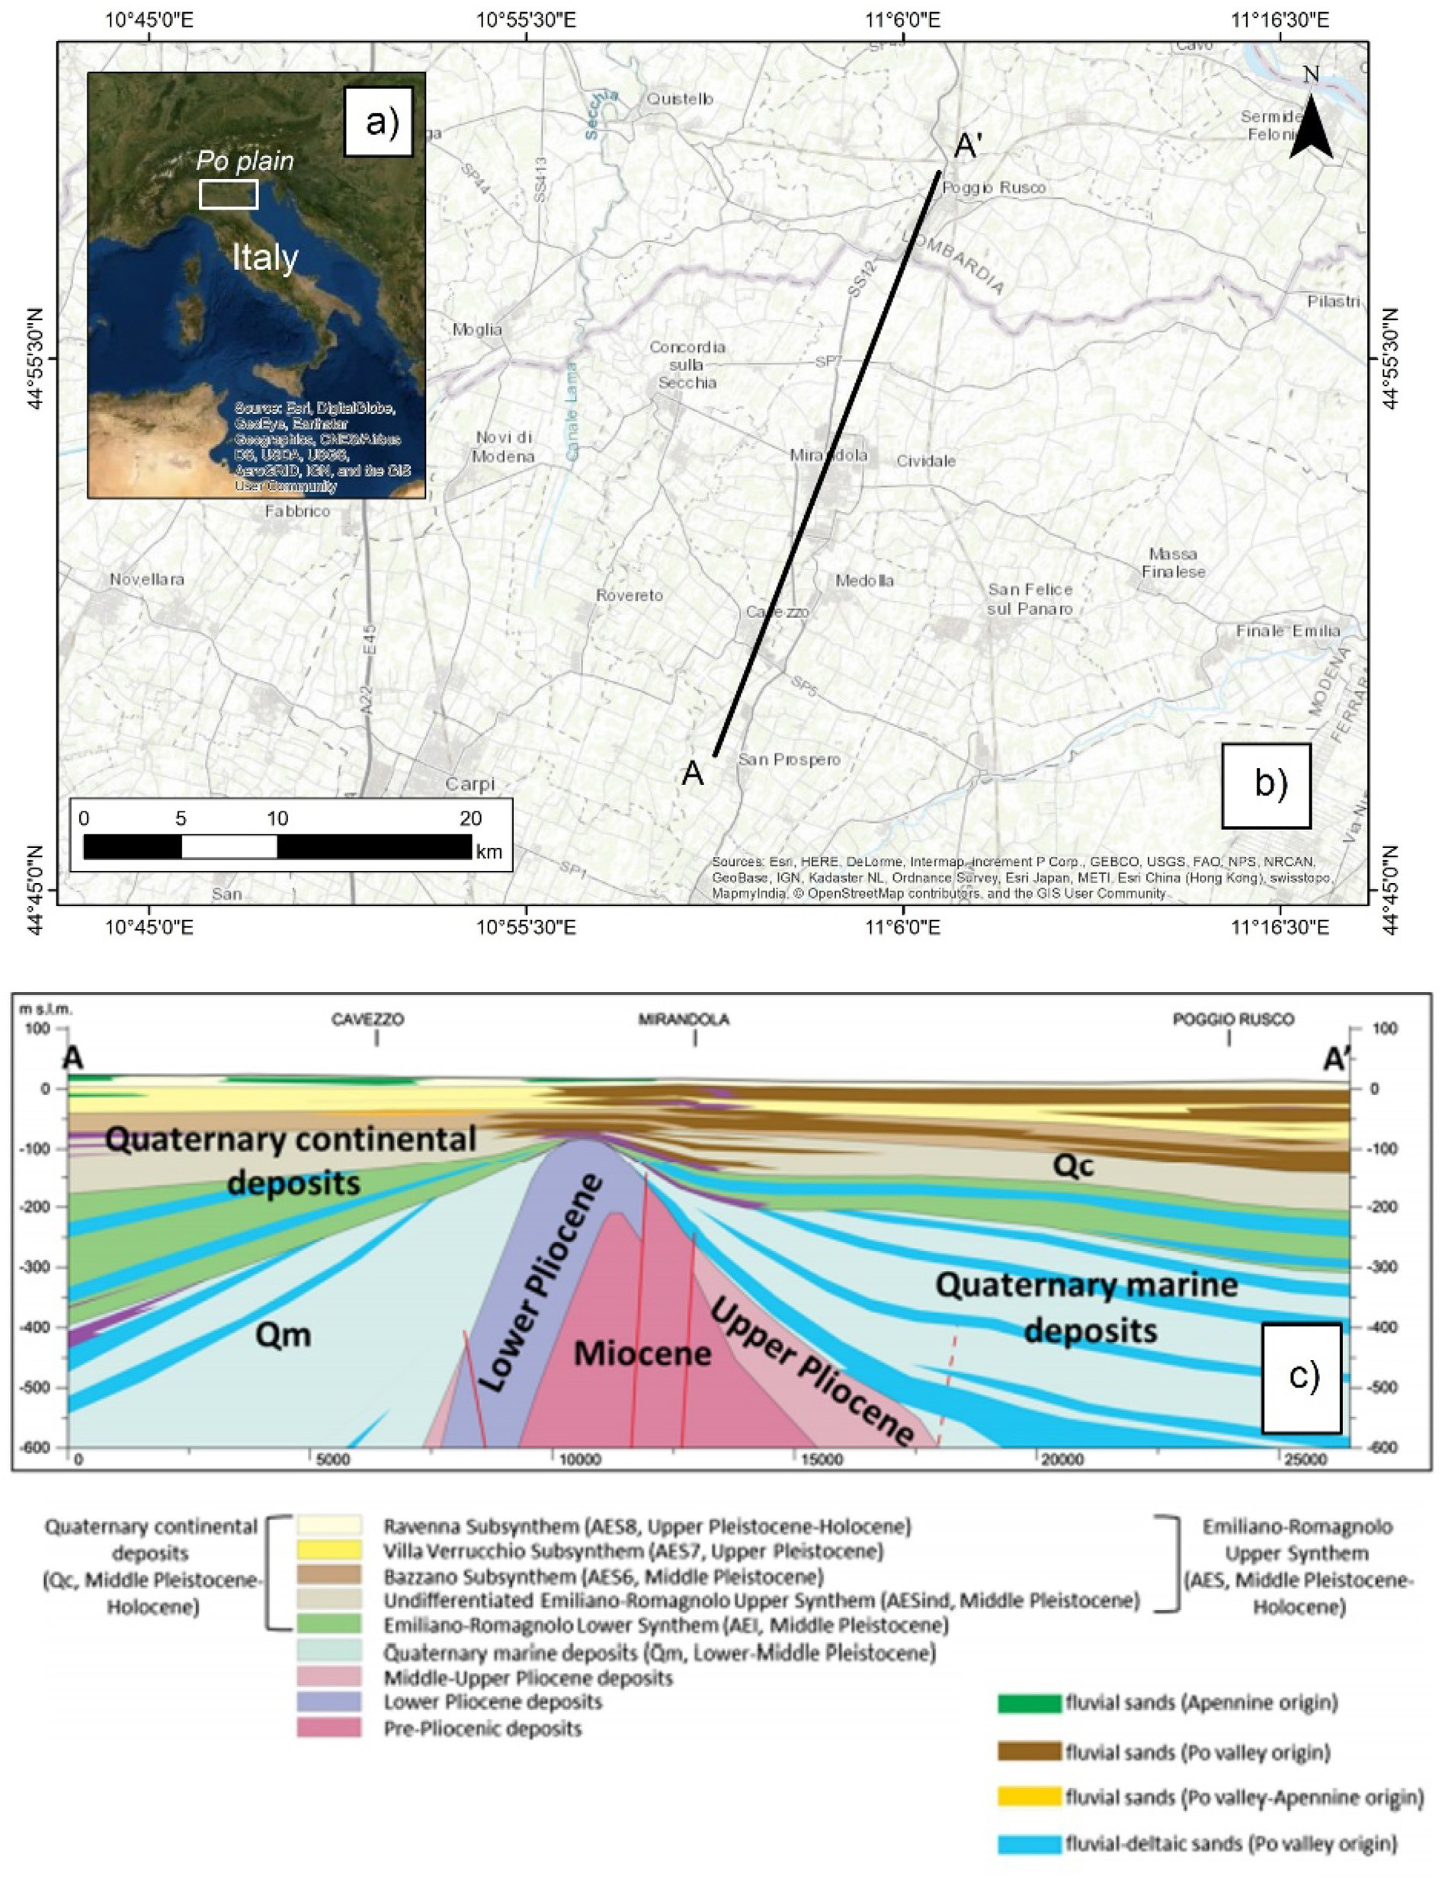
Fig. 1. a) Geographical location of the study area. b) Localization of the geological cross section. c) Geological section AA’ (modiﬁed from Paolucci et al., 2015).

microzonation for ground shaking, it is worth mentioning the intensive studies that have been performed after the 2016–2017 Central Italy seismic sequence to obtain detailed microzonation maps in the 137 municipalities most damaged by the earthquakes (Pergalani et al., 2019).
In Italy, guidelines and criteria to achieve seismic microzonation
have been standardized and published in Working Group ICMS (2008) by the Conference of Italian Regions and Autonomous Provinces, and the Italian Civil Protection Department. It establishes criteria and op- erational instructions for the identiﬁcation of areas subjected to ground ampliﬁcation and ground instabilities (i.e., slope instability, soil li- quefaction and ground failures) to guide the urban planning of local

administrators. Similarly, to the guidelines of seismic microzonation issued by the TC4-ISSMGE (1999), three levels of microzonation studies are identiﬁed: level 1 is the basic level and it relies on gathering existing geologic, geomorphologic and hydrogeological data which are pro- cessed to roughly subdivide the investigated territory into a certain number of homogeneous zones, where seismic hazard is supposed to be uniform. Level 2, is based on using existing geologic data and abaca containing coeﬃcients for ground ampliﬁcation. Non-invasive geo- physical surveys are encouraged. Level 3 is the most detailed level of microzonation. As such, it requires purposely-planned geotechnical and geophysical investigations as well as numerical ground response ana- lyses for a quantitative deﬁnition of seismic hazard and geological- geotechnical risks. Whereas level 1 and 2 of seismic microzonation are commonly performed in Italy, a level 3 study is restricted to a few target areas of special interest, given the considerable time and ﬁnancial in- vestment required, and where potentially hazardous conditions (e.g., liquefaction, slope instability, active faults) are identiﬁed from previous investigation levels.
One of the main goals of the H2020 European project LIQUEFACT 2016–2019 (http://www.liquefact.eu/) is the deﬁnition of objective criteria to assess liquefaction hazard at diﬀerent geographic scales. LIQUEFACT Work Package 2, led by University of Pavia and EUCEN- TRE, deals with zonation of a territory both at continental (macro-zo- nation) and sub-municipal scale (micro-zonation). In this framework, four European test territories were selected as case-studies in which to perform seismic microzonation for earthquake-induced liquefaction hazard. The territory of the Municipality of Cavezzo has been chosen as Italian case-study since it experienced the 2012 seismic sequence oc- curred in Emilia-Romagna Region (e.g., Tertulliani et al., 2012; Locati et al., 2016; Rovida et al., 2016), where widespread liquefaction eﬀects occurred (e.g., Martelli and Romani, 2013; Fioravante et al., 2013; Lai et al., 2015). In this framework, an inter-institutional agreement was signed in July 2017 involving the University of Pavia, EUCENTRE, the administration of Emilia-Romagna Region, the administration of the Province of Modena and the Municipality of Cavezzo to perform a level 3 microzonation study of the territory, according to the Regional and Italian guidelines for seismic microzonation to support territorial and urban planning (Pagani et al., 2006; Working Group ICMS, 2008). Al- though the study was focused on the assessment of liquefaction hazard at urban scale, this paper presents a summary of the research activities carried out in performing the seismic microzonation of Cavezzo, with special reference to ground response analysis. In particular, the creation of a detailed seismo-stratigraphic model from the analysis of existing and newly acquired geotechnical and geophysical data will be illu- strated. Special attention is given to the treatment and propagation of the uncertainties due to both the overall variability of the input data and that associated with data processing and modelling assumptions. The interdisciplinary nature of the work is highlighted, discussing the adopted methodological approaches, the diversity of data calibration and the way challenges have been collectively handled to create a uniﬁed yet comprehensive ground motion ampliﬁcation model.

- Geological and seismotectonic setting

Cavezzo municipality is located within the northern sector of the Modena province (Italy), on the right side of the Secchia River (Fig. 1a). The study area sits within the Po plain, a large foreland sedimentary basin originated by the progressive convergence of the Africa/Adria and Eurasia plates initiated during the late Cretaceous and still ongoing. Such a compressional regime led to the development of large thrust and folds structures with roughly WNW-ESE trending, but of opposing vergence to the North and to the South of the longitudinal valley axis. Some of the southern buried structures have demonstrated to be still under active shortening, causing non-negligible historical seismicity, whose noticeable expression was the recent 2012 Emilia sequence. For
further details, the reader can refer, among others, to Pieri and Groppi
(1981), Toscani et al. (2009), Boccaletti et al. (2010), Fantoni and Franciosi (2010), Bignami et al. (2012), Turrini et al. (2014).
The sedimentary inﬁll of the Po plain consists of a thick sequence of sediments of Tertiary-Quaternary age, from ﬁne Pliocene muds to course silt, sand and gravel alternations, due to transition from marine to continental environment started in the Pleistocene. The depositional sequence is heavily perturbed by the ongoing deformation process and by alternating episodes of erosion and glaciation, which have generated several noticeable unconformities and gaps (e.g., Muttoni et al., 2003; Scardia et al., 2012; Mascandola et al., 2019).
At the local scale, Cavezzo is on the southern limb of the buried Mirandola antiform (Martelli et al., 2017, Fig. 1c). The lithostrati- graphic succession of the area is composed of alluvial deposits ranging in thickness from around 130 m in the northern area to 280 m in the southern one (RER-ENI, 1998). The geological bedrock, as proposed by Mascandola et al. (2019), is constituted by interbedded marlstones and sands of the Pliocene and Lower Pleistocene “Argille Azzurre” Forma- tion and Middle Pleistocene “Imola Sands” Formation (RER-ENI, 1998). The alluvial deposits in the Cavezzo area are characterized by inter- bedded ﬁne silty-clayey soils with layers rich of peat and interbedded sands and silty sands. These surﬁcial sediments were deposited by the Secchia River, whereas the deeper sand layers were deposited by the Po River (Castaldini, 1989).
From the morphological point of view, the study area is located in the alluvial plain of the Secchia River, ranging in elevation from 34 m a.s.l. in the southern and western sectors to around 20 m a.s.l. in the northern part. It is worth noting that the highest topographic level is reached in correspondence of the recent artiﬁcial levees of the Secchia River, which raise about 7–8 m above the surrounding area (Fig. 2). The study area includes diﬀerent geomorphological features interpreted as ﬂoodplain, ﬂuvial ridges and crevasse splays. The subsoil of Cavezzo is mainly characterized by silty-clayey sequences including channel-ﬁlling and crevasse splay sand layers (Pellegrini and Zavatti, 1980).

- Methodology

The seismic response of the study area was performed following four major steps, which are here brieﬂy summarized.

- First, all existing geotechnical and geophysical measurements al- ready available for the territory have been collected and organized in a comprehensive GIS database. This database has been subse- quently extended with a number of new ad-hoc geophysical in- vestigations on selected strategic locations.
- A 3D geological/lithological model for the uppermost 30 m was then constructed integrating boreholes and CPT data. The resulting model, extending over an area of approximately 27 km2, has been used for the identiﬁcation of major surface lithological units (LU) and for the assessment of the liquefaction potential.
- Next, a large-scale seismo-stratigraphic model was developed based on a combination of passive and active seismic data, including ambient vibration measurements in single-station and array con- ﬁguration, and high-resolution P- and S-wave seismic reﬂection surveys, respectively. The model consists of a grid of 2984 nodes with 0.001 degrees spatial resolution (about 100 m). For each grid node, a set of 11 complementary 1D vertical seismo-stratigraphic S- wave velocity proﬁles was identiﬁed to account for the uncertainties associated to the investigations. The resulting pseudo-3D model extends down to about 200 m depth.
- The previous geological/lithological and seismo-stratigraphic models were ﬁnally combined for the calculation of the seismic ampliﬁcation factors through numerical ground response analyses by addressing the uncertainties associated to the input parameters. Seven spectrum-compatible accelerograms deﬁned for 475, 975, and 2475 years return periods were selected as input motion (referred to
outcropping rock conditions). The 1D soil ampliﬁcation function

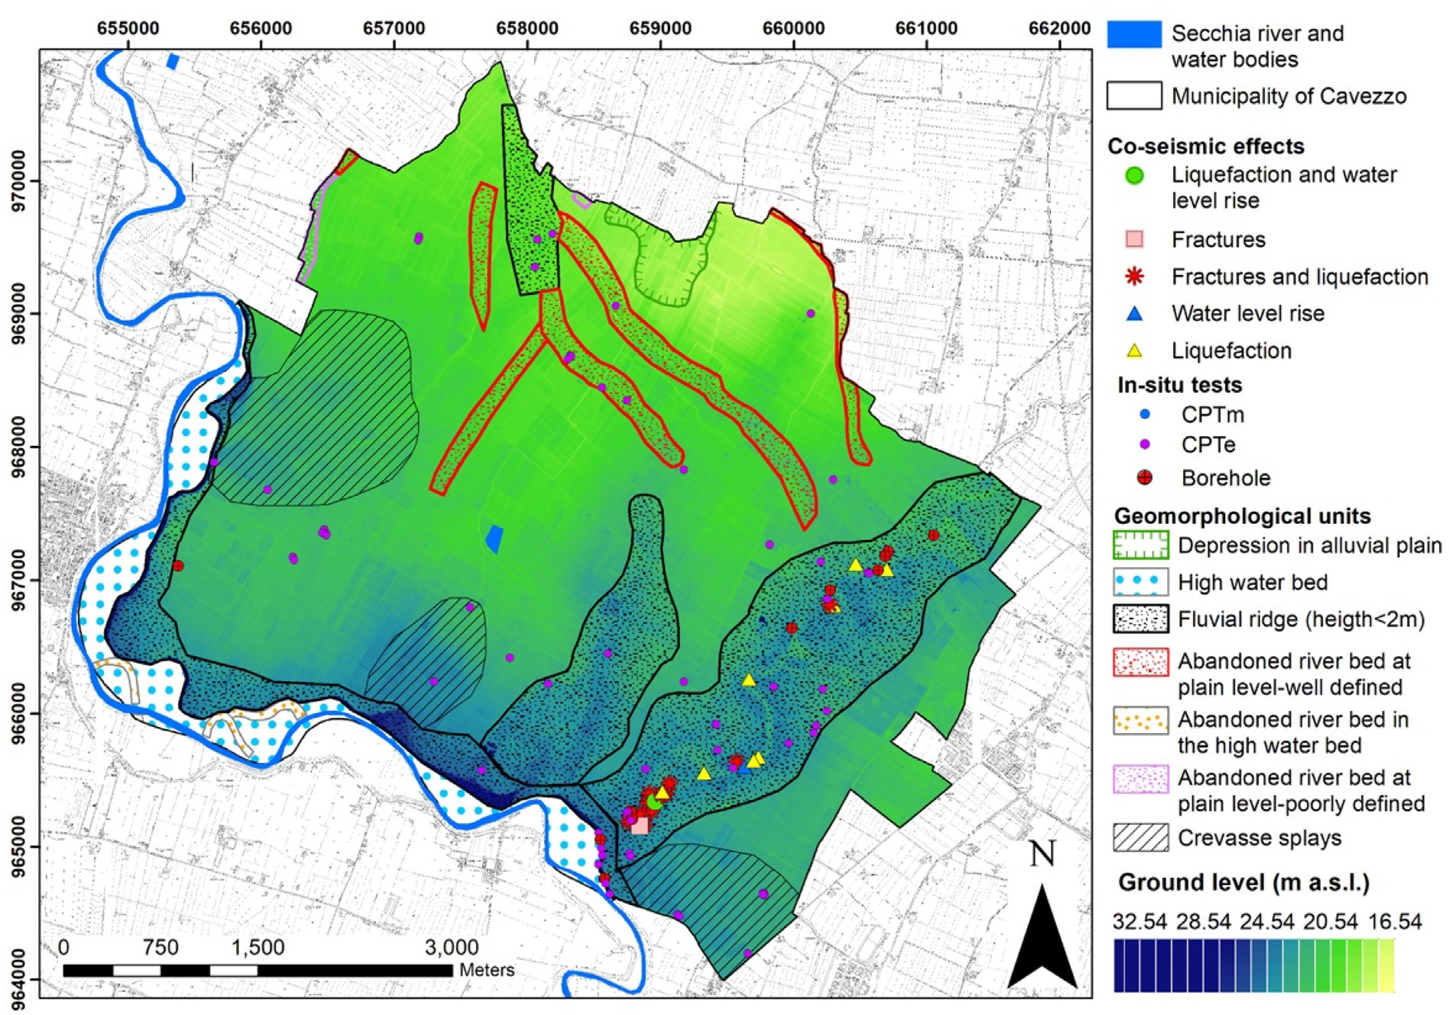
Fig. 2. Main geological and geomorphological features of the Cavezzo area (modiﬁed from Meisina et al., 2019). The ground level is derived from the digital terrain model (DTM) characterized by 1 m resolution.

was then computed for each grid node and each velocity proﬁle using a linear-equivalent soil constitutive model, for a total of 229,768 analyses. The diﬀerent ampliﬁcation results were ﬁnally combined using the logic-tree approach to rationally account for the epistemic uncertainty associated to the velocity model and the re- ference input variability.

In the following sections, the diﬀerent steps of the proposed meth- odology are discussed in details.

- Ground characterization dataset

To carry out ground response analyses, an accurate knowledge of the geotechnical characteristics of the shallow subsoil is required. At this purpose, the territory of Cavezzo was thoroughly characterized by geomorphological, geological, hydrogeological, seismological, geo- technical and geophysical viewpoints.
As a start, existing data retrieved from trench pits, boreholes, pie- zometric, in situ and laboratory geotechnical and geophysical in- vestigation campaigns were gathered. Fig. 3 (a) shows the existing data available for ground characterization of the territory of Cavezzo before the LIQUEFACT project started. Based on the quality and quantity of the retrieved existing data, complementary ground investigation campaigns were purposely devised.Table 1 includes the type and number of tests adopted for the ground characterization of the territory of the Cavezzo Municipality. In-situ geotechnical investigations included cone pene- tration tests with the acquisition of the excess pore water pressure (CPTu) and the shear wave velocity Vs (SCPTu), standard penetration tests (SPT) and drilling of boreholes. Laboratory tests were also per- formed on undisturbed soil samples retrieved with the standard Os-
terberg sampler and the innovative gel-push technique for coarse-
grained materials (Cubrinovski et al., 2016).
A number of non-invasive geophysical measurements were also performed. These included 3D electric tomography, passive and active seismic surveys. In this regard, the National Institute of Geophysics and Volcanology (INGV, Milano) and the National Institute of Oceanography and Applied Geophysics (OGS, Trieste) respectively led a large-scale ambient vibration survey (including single-station and 2D array measurements) and a S-/P-wave high-resolution reﬂection seismic survey. Such combined geophysical surveys allowed in- vestigating large volumes of soils and large depths (> 200 m from the ground surface), to identify the S- and P-wave vertical velocity proﬁles, while providing a mean to correlate the results obtained at diﬀerent locations from the conventional geotechnical tests.
All data gathered on the subsoil of Cavezzo were organized into a purposely-developed GIS database, which now includes the data of more than 1000 geotechnical and geophysical tests, as shown in Fig. 3b,
c. Data of both 1 m and 5 m resolution DEM were also included.

- Modelling of the subsoil

  - Geotechnical/lithological model

Based on a joint analysis of stratigraphic, lithological and geomor- phological data, the territory of Cavezzo was tentatively subdivided into a number of geologically homogeneous zones (MOPS, “Microzone Omogenee in Prospettiva Sismica” sensu Working Group ICMS, 2008), identiﬁed using an approach described in detail in a previous work by Meisina et al. (2019), which includes also the typical stratigraphic logs derived for each zone. Speciﬁcally, 9 main geological domains have been identiﬁed based on joint stratigraphic analysis of boreholes and
water wells and from the interpretation of CPTu/CPT tests. These

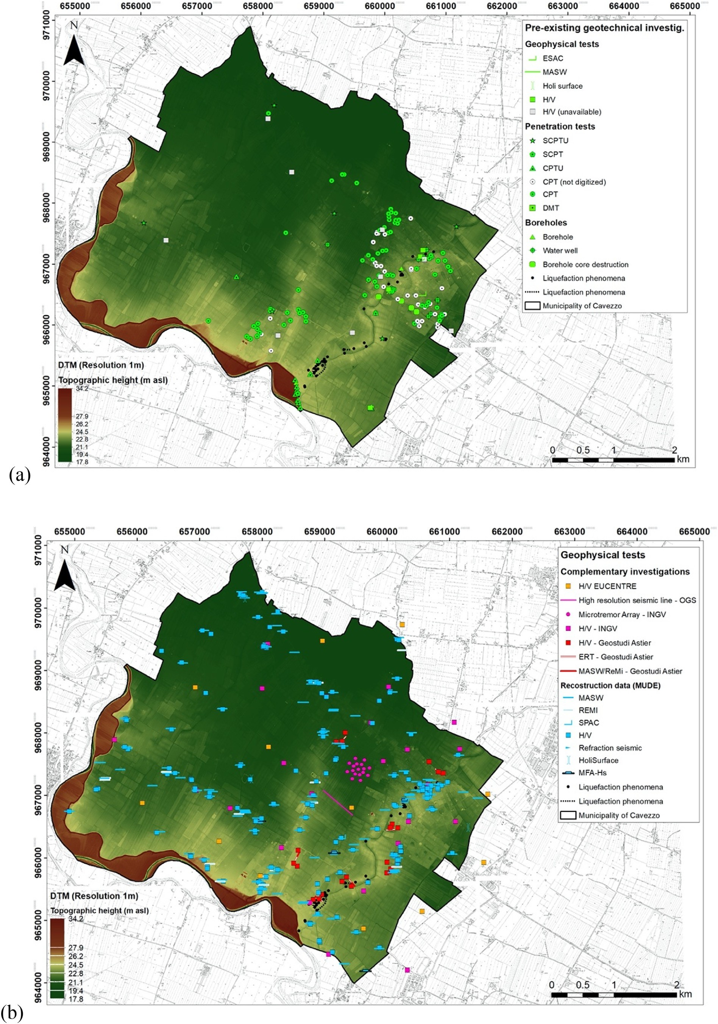
Fig. 3. Location of the data available for the ground characterization of Cavezzo territory before this study (a) and newly acquired geophysical (b) and geotechnical
(c) tests. The manifestations of soil liquefaction occurred in the 2012 sequence (black dots) and a 1 m resolution digital elevation model is superimposed. Modiﬁed from Lai et al. (2019).

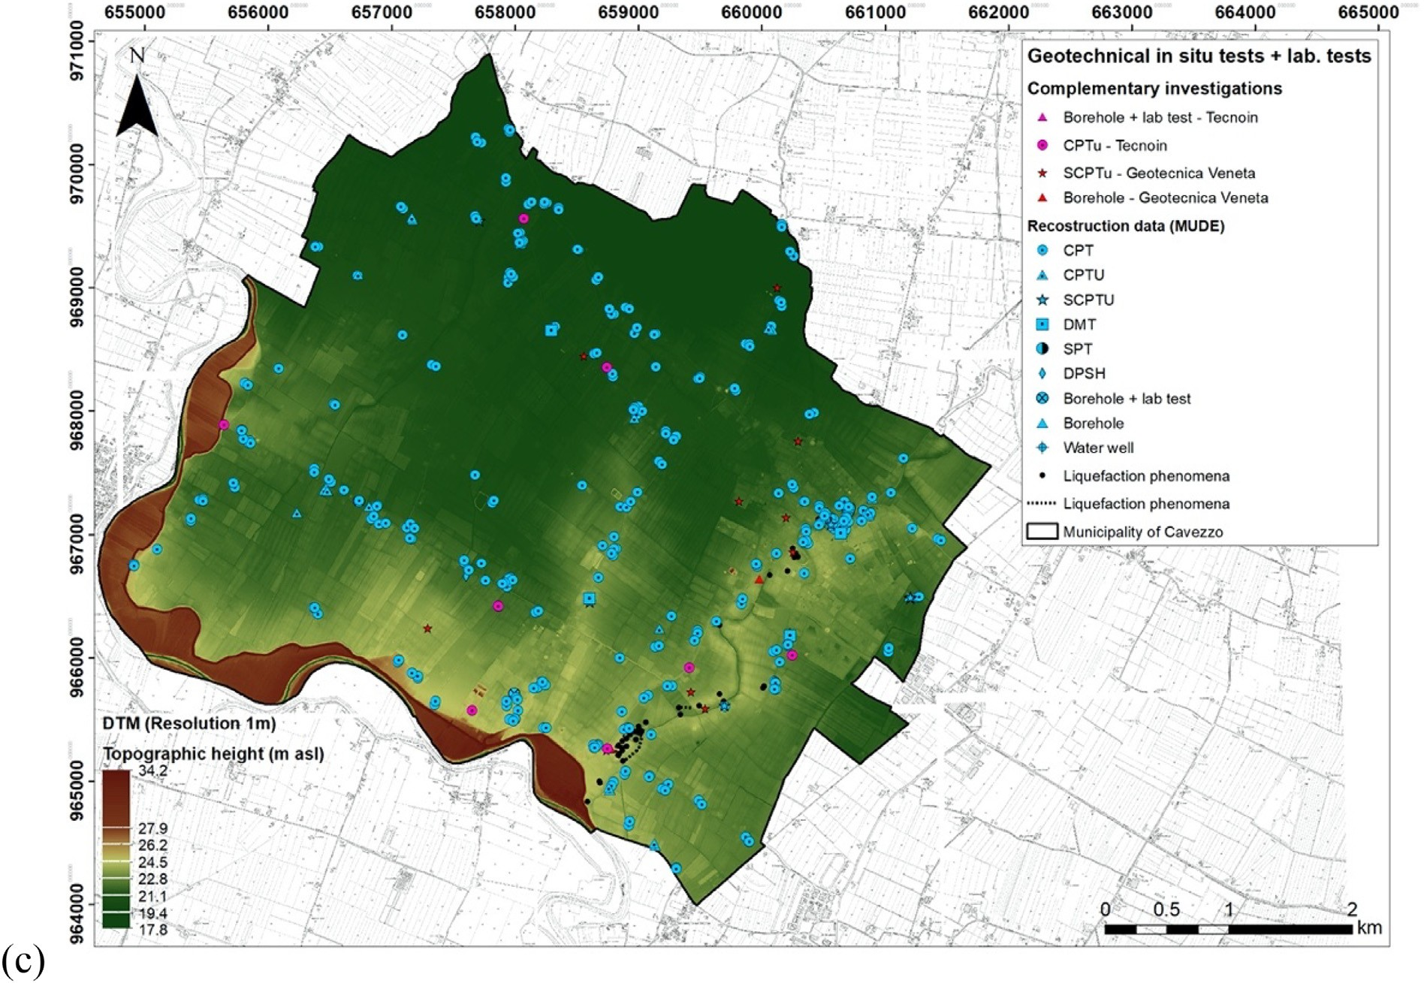
Fig. 3. (continued)

Table 1
Type and number of tests performed in this study to characterize the ground of the Cavezzo Municipality.
Geotechnical in situ tests Cone Penetration Tests CPT 419 502
Cone Penetration Tests with Vs 25
measurements SCPT
Standard Penetration Tests SPT 25
DilatoMeter Tests DMT 5
Boreholes 27
available CPTu tests and boreholes data (Meisina et al., 2019) in order to identify the mixture layers falling within the transition zone of the reference chart (Robertson, 2009).

  - Seismo-stratigraphic model

The previously described lithological model was preliminary to the deﬁnition of the seismo-stratigraphic idealization of the subsoil, which

Dynamic Probing Super Heavy tests DPSH
Geophysical measurements P- and S-wave high resolution seismic
reﬂection line
1

1 409
was obtained by integrating the existing geophysical data (mostly from shallow MASW investigations) with purposely-planned active and passive seismic acquisitions. In the following, the diﬀerent steps for the

Seismic refraction 2
creation of the seismo-stratigraphic model are described.

Multichannel Analysis of Surface Waves MASW
144
    - Calibration of the reference velocity model

HoliSurface 12
2D arrays ambient vibration analyses 2
Single station H/V spectral ratio 211
Extended Spatial Autocorrelation 1
ESAC
Spatial Autocorrelation SPAC 4
Refraction Microtremor ReMi 21
Multiple Filter Analysis MFA-Hs 4
Electrical resistivity tomography ERT 7
Geotechnical laboratoy tests Grain-size analysis 41 73
Atterberg limits 20
Direct shear 2
Oedometer consolidation 1
Cyclic triaxial test 1
Resonant column tests 5
Cyclic simple shear test 3
domains were used to separate zones of supposedly homogeneous li- thological and genetic depositional characteristics (Fig. 4). For the stratigraphic interpretation of CPTu/CPT data, it was used a correction of Soil Behaviour Index (Ic, Robertson, 2009) calibrated using the
As a ﬁrst step, assuming a smooth lateral variability of the geo- physical parameters over the investigated area, a set of reference one- dimensional seismic velocity proﬁles were established at selected re- presentative locations. The diﬀerent proﬁles were derived from two independent although complementary geophysical approaches, based respectively on the array analysis of ambient vibrations (hereinafter called the EUCENTRE model) and on the S- and P-wave seismic re- ﬂection data processing (hereinafter called the OGS model).
Concerning the analysis of ambient vibration data, the velocity proﬁles were obtained from combined inversion of multi-component surface wave information (Poggi and Fäh, 2010). Love and Rayleigh velocity dispersion curves were ﬁrst derived using the high-resolution frequency-wavenumber analysis on the three-component of motion (3CFK) as proposed by Poggi and Fäh (2010). This technique is bene- ﬁcial in that it allows an eﬃcient separation of the transversal (Love) and radial (Rayleigh) surface wave motion from the horizontal com- ponents (Fig. 5), providing the dispersion information of both wave types and, at the same time, an unbiased estimate of the Rayleigh el-
lipticity (or polarization) function within the resolved frequency band.

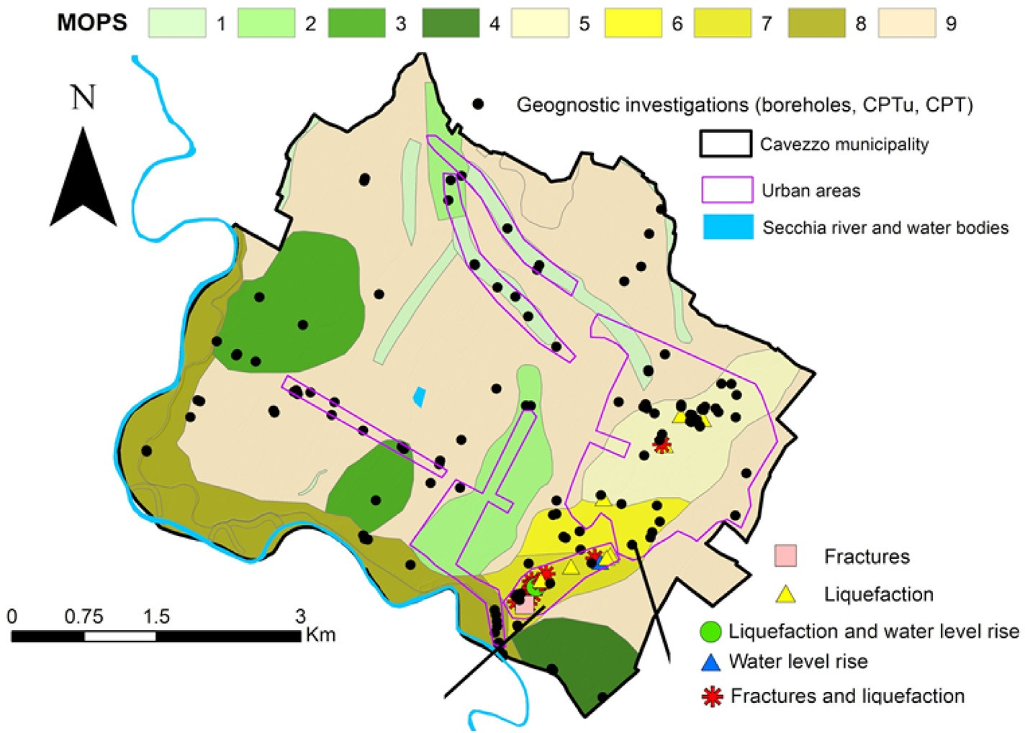
Fig. 4. Map of 9 homogeneous geological zones (MOPS) deﬁned for Cavezzo municipality. Modiﬁed from Meisina et al. (2019), which the interested reader can refer to for a detailed description of the zonation process.

The one-dimensional seismic velocity proﬁle is then obtained by com- bined inversion of Love and Rayleigh wave dispersion, including higher modes, the Rayleigh wave polarization function and fundamental fre- quency of resonance of the site (f0) from H/V analysis. The Open Source software Dinver (Wathelet et al., 2008) is used to perform inversion though an enhanced version of the neighbourhood algorithm. The use of Love wave dispersion curves, which is generally uncommon, has the particular advantage to provide a unique constraint to the S-wave ve- locity of the medium. In combination with Rayleigh wave information (dispersion and ellipticity), then, it allows a more reliable estimation of the seismo-stratigraphic model. Complementary, the OGS velocity model corresponds to the interval velocities obtained by the P- and SH- wave seismic reﬂection data processing (see Petronio et al., 2018 for more details).
The two seismic techniques have shown to produce consistent re- sults down to about 160–170 m depth from the ground surface, while some deviations were observed at larger depths (Fig. 6). Such dis- crepancy is likely due to the intrinsic limitations of passive seismic analysis, whose resolution decreases progressively with increasing wavelength and investigated depth. Seismic reﬂection data can provide reliable velocity information in the presence of horizontal stratiﬁca- tions and with a suﬃcient acquisition oﬀset apertures able to accurately compute the NMO corrections.
previous surveys available for the study area. It should be noted that being the results from available MASW data heterogeneous (e.g. they were obtained from diﬀerent contractors and using diﬀerent processing schemes), it was decided to homogeneously reassess the VS30 of each measurement by means of a simpliﬁed procedure as proposed by Brown et al. (2000) and further developed by Martin and Diehl (2004) and Albarello and Gargani (2010) (see also Comina et al., 2011 for clar- iﬁcations). In short, the VS30 at each site was obtained empirically from the Rayleigh wave dispersion curve (Fig. 8a) by extracting the phase velocity corresponding to a wavelength (λ) of 40 m, which provided estimates of VS30 (Fig. 8b) comparable with those obtained from in- dependent processing.
Spatial interpolation of the VS30 values was subsequently performed using widely used geostatistic algorithm, i.e. ordinary Kriging (Isaaks and Srivastava, 1989). This provided a mean shear wave velocity and the corresponding residual uncertainty at each point of the interpolated grid. Finally, at each location of the gridded model, the reference ve- locity proﬁles have been adjusted to match the interpolated VS30 value from MASW analysis (Fig. 9a). The adjustment was performed by ap- plying a depth-dependent velocity correction factor (γ), whose eﬀect progressively decreases with the increase of depth, following a negative exponential function, ensuring that the observed shallow variability of VS does not sensibly impact the seismo-stratigraphic model at large
depth:

Models agree with the observed data (e.g. Fig. 7). Since it was not possible to resolve the ambiguity of the interpretation, the models have
γ (α, z) = α ∗ e−z/β

(1)

been therefore considered both equally reliable and representative of the epistemic uncertainty of the reference seismo-stratigraphic models. Such variability is accounted for in the data processing by means of a
logic-tree calculation approach.
where α is a free coeﬃcient, while β is a ﬁxed curvature parameter used to tweak the sensitivity of the correction to depth. The adjustment coeﬃcient α is found by solving the minimization problem:
⎛ ⎞
5.2.2. Spatial variability of the area under study
In a subsequent step, at each point of the pseudo-3D model the shear
α
⎝ 0
γ (α, z) ∗ Vs (z) dz
z
⎠
(2)
30

argmin ⎜⎜ ∫30 30
− Vs Obs.⎟⎟

wave velocity proﬁles have been adjusted to match the observed variability of both the shallow subsoil and the deepest resonating layer interface (which was assumed as the local seismic bedrock). To con- straint the shallow portion of the velocity model, a map of the VS30
variability was ﬁrst obtained from existing MASW analyses from 83

The curvature parameter β was empirically set to 100 after direct inspection of the modiﬁed velocity proﬁles.

5.2.3. Mapping the seismic bedrock
The variability of the seismic bedrock was obtained using an

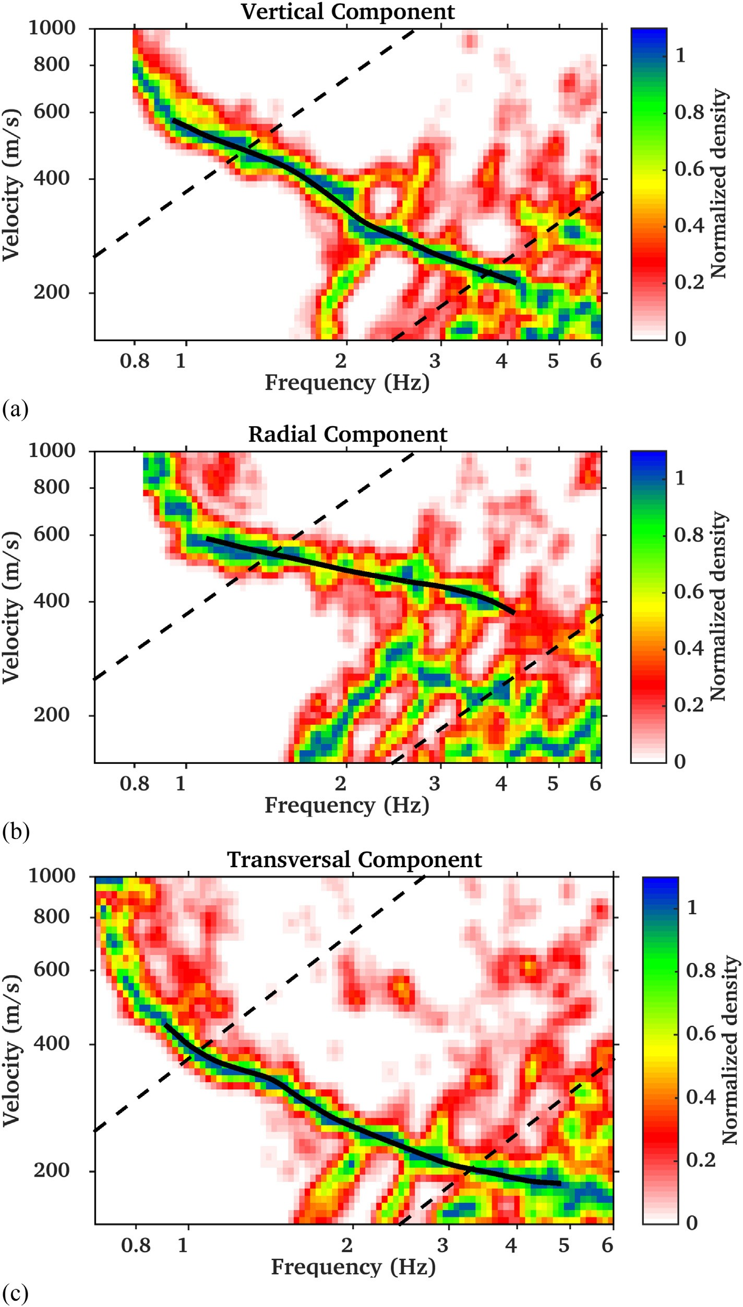
Fig. 5. Retrieved Rayleigh [vertical (a) and radial (b) motion] and Love [transversal (c) motion] dispersion curves (in black) obtained from three-component f-k analysis of ambient vibration array data using the approach described in Poggi and Fäh. (2010). Dashed lines are the min.-max. Resolution limits of the investigated 2D seismic array.

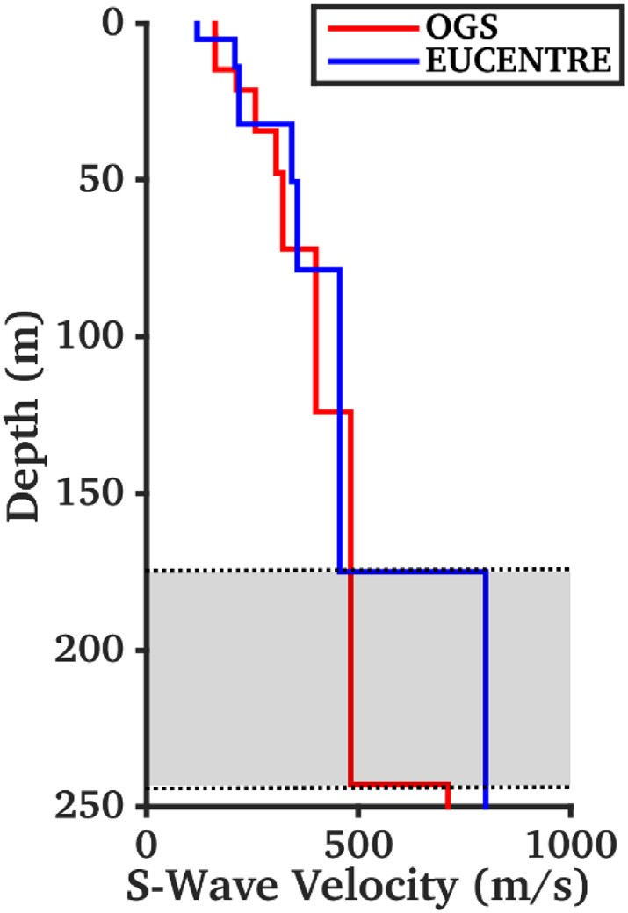
Fig. 6. Comparison between two sample models from surface wave inversion of ambient vibration data (EUCENTRE) and from high-resolution S-/P-wave seismic reﬂection survey (OGS). The models show an overall good match down to a depth of about 170 m (from topographic surface), but with diﬀerent in- terpretations of the seismic bedrock location and velocity. Since the two models match equally well observations, the grey area is therefore considered as epistemic uncertainty of the performed analyses.

adaptation of the procedure proposed by Poggi et al. (2012), based on Rayleigh wave ellipticity peak matching.
As a starting point, a map of the fundamental frequency of the area was created by interpolation of 26 f0 values from single station ambient vibration measurements obtained using horizontal-to-vertical-ratio spectral analysis (e.g., Nogoshi and Igarashi, 1971; Nakamura, 1989; Haghshenas et al., 2008). Consistently with the procedure used to map shallow velocity variability, spatial interpolation of the sparse f0 values was performed using ordinary Kriging, accounting also for the asso- ciated uncertainty.
Subsequently, the one-dimensional velocity proﬁles at each grid point of the seismo-stratigraphic model have been adjusted to match the observed (thus interpolated) resonance frequencies. However, in contrast to what was previously done to account for VS30 variability, in this case the adjustment was not performed directly on velocity, but by applying a depth migration coeﬃcient to the proﬁle's layer interfaces. It must be noted that using a coeﬃcient instead of a simple depth shift has the advantage to impact mostly the deep layer interfaces, while leaving substantially unmodiﬁed the uppermost portions of the velocity proﬁle, already constrained by other information (e.g., surface wave dispersion, VS30).
The proposed geophysical bedrock corresponds with a main geolo-
gical interface (top of the marine Quaternary deposits) in the study area. This feature shows a moderate south dip, related to the southern ﬂank of the nearby Mirandola anticline, although with a noticeable irregularity in a small region in the central part of the model (Fig. 9b).

5.3. Final geotechnical-seismo-stratigraphic model

The ﬁnal geotechnical-seismic model of the study area was deﬁned starting from the pseudo-3D seismo-stratigraphic model, consisting of
10 VS EUCENTRE proﬁles each with an associated weight of 0.05
(overall weight equal to 0.5), and an OGS VS proﬁle from seismic

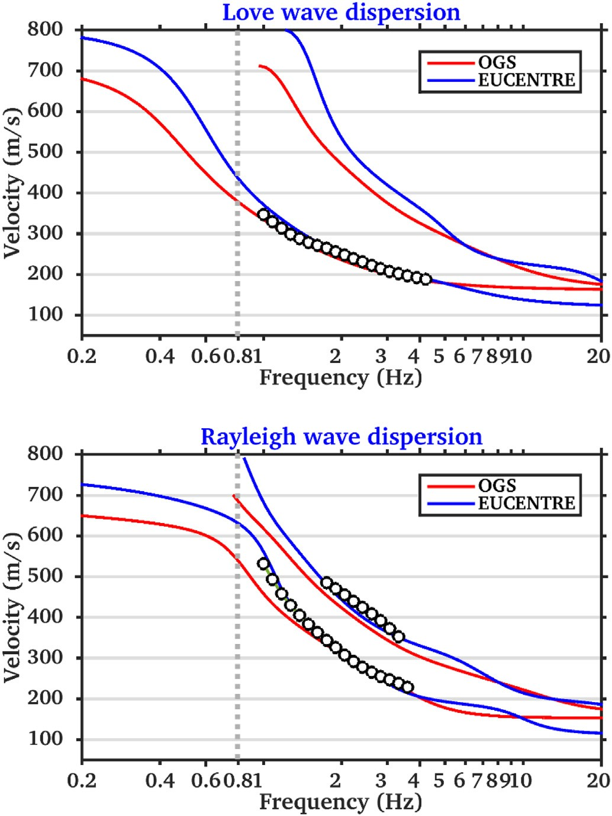
Fig. 7. Comparison between Love and Rayleigh dispersion curves from three- component f-k analysis of ambient vibration array data (black dots) and the modelled results of the EUCENTRE and OGS velocity proﬁles. The former model was further constrained by the use of Rayleigh ellipticity and the fundamental frequency of resonance of the site (f0, dashed grey line), as described more in detail in the text.

reﬂection survey to which a weight of 0.5 was associated. Each in- dependent 3D model consisted of 2984 1D VS-proﬁles at each node of a reference grid that covers the territory of Cavezzo. Therefore, a total of 32,824 VS proﬁles (2984 × 11) were deﬁned and used for ground re- sponse analysis. Furthermore, for each proﬁle a unique seismo-geo- technical model was created by merging the soil properties of the geological/lithological and geophysical models. At this purpose the 9 geologically homogeneous zones discussed in § 3.2 were used jointly with their associated uncertainties. In each homogeneous zone, the nodes of the reference grid falling within its boundaries have been identiﬁed for each layer of 11 seismo-stratigraphic models and a sta- tistical analysis of the corresponding thicknesses was performed.
An equivalent-linear approach has been adopted to approximate the non-linear, inelastic behaviour of soils. For such purpose, laboratory tests aimed at evaluating the evolution of shear modulus and damping ratio with shear strain should be ideally available for each soil layer. The experimental data from laboratory tests performed in the southern part of the Cavezzo in December 2017, were referred to a limited area of the whole territory under investigation, thus appropriate literature relationships have been adopted. Indeed, a purposely-devised calibra- tion of the shear modulus and damping ratio decaying curves was ac- complished following the methodology proposed by Darendeli (2001) coupled with the results of resonant column (RC) tests available for a few samples taken in Cavezzo.

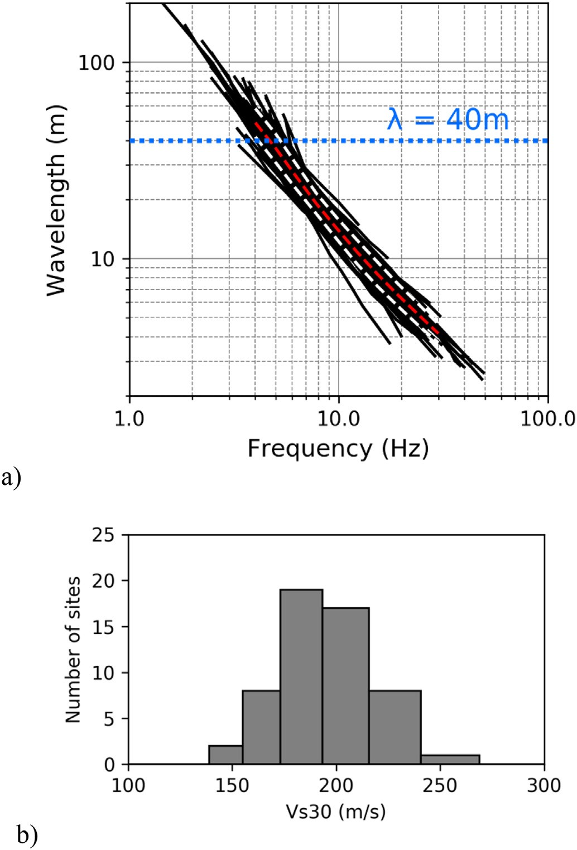
acceleration spectrum and TC⁎ is the upper limit of the oscillator period of the constant spectral acceleration branch.
For each return period, a suite of 7 independent natural accel- erograms recorded on free-ﬁeld rock ground conditions, spectrum- compatible with the elastic response spectrum deﬁned by the NTC (2018) for the territory of Cavezzo was selected. The selection was made using an updated version of ASCONA computer program (Corigliano et al., 2012), which provides a set of strong motion re- cordings satisfying speciﬁc seismological criteria (e.g., magnitude and distance ranges, spectral shape), with the additional requirement of being compatible with a target spectrum (in this case, the elastic ac- celeration response spectrum prescribed by the current Italian building code), in a speciﬁed oscillator period range (in this case, from 0.15 s to 2 s). Regarding record scaling, the PEER (2010a, 2010b) approach was adopted. Among diﬀerent accelerogram sets that satisfy the require- ments, the set returned by ASCONA is the one characterized by the minimum average deviation of the average response spectrum (of the 7 accelerograms) with respect to the target spectrum.

6.2. Ground response analyses

One-dimensional ground response analyses were carried out in Cavezzo territory using SHAKE91 (Schnabel et al., 1972; Idriss and Sun, 1992) coupled with the linear-equivalent soil constitutive model. The analyses were conducted for 3 return periods, 7 accelerograms, 2984 nodes of the reference grid for which the geotechnical-seismic pseudo 3D (P3D) model was deﬁned and 11 VS proﬁles, for a total of 229,768 analyses. For each analysis, ampliﬁcation factors (Fi) in terms of peak ground acceleration, Housner intensity ratio (computed considering 4 diﬀerent oscillator period ranges) and acceleration response spectrum integral ratio in the spectral interval between 0.1 s and 0.5 s were computed. At each node of the grid and for each return period, the Fi values computed from the 7 accelerograms and 11 VS proﬁles were
averaged as follows:
Fig. 8. (a) Rayleigh wave dispersion curves form MASW analysis available for Fi = ∑ w_acc ∑ w_mod Fi
7 11
the territory (in black). Mean (red dots) and standard deviation (white dots) of
j=
j
=k 1
k jk
(3)
the territory (in black). Mean (red dots) and standard deviation (white dots) of
j

the distribution is also presented to show the overall variability. (b) Distribution of the VS30 values obtained from the λ40m empirical approximation. (For in- terpretation of the references to colour in this ﬁgure legend, the reader is re-
1
ferred to the web version of this article.)
where w_accj is the weight of the accelerogram, assumed to be the same for all accelerograms (w_accj = 1/7), w_modk is the weight of the P3D model (w_modk = 0.05 for each of the 10 models based on EUCENTRE

data and w_modk = 0.5 for the OGS model), while Fi is the ampliﬁ-
jk

- Seismic response for purposes of microzonation

  - Deﬁnition of the reference seismic input and its uncertainty

Emilia-Romagna region issued in 2007 regional guidelines to sup- port territorial and urban planning (Pagani et al., 2006; DAL 112, 2007), which are consistent with the national guidelines for seismic microzonation available in Italy (Working Group ICMS, 2008). These regional guidelines provide 3 real accelerograms recorded on out- cropping bedrock to be used as input motion for ground response analyses. It must be noted, however, these signals are not independent from each other; in addition, they are referred only to the 475 years return period. Thus, they are unsuitable to the scope of the study. Consequently, the seismic hazard at the site was deﬁned in terms of seismo- and spectrum- compatible natural accelerograms for three re- turn periods (475, 975 and 2475 years). Spectrum-compatibility was enforced with reference to 5% damped, elastic acceleration response spectra (horizontal component of motion) referred to stiﬀ ground conditions speciﬁed by the current Italian building code (NTC, 2018). Table 2 summarizes, for each considered return period, the para- meters required to deﬁne the elastic response spectra for soil class A with reference to Cavezzo: ag is the horizontal peak ground acceleration on a rigid reference site, F0 is the ampliﬁcation factor of the horizontal
cation factor Fi associated with the j-th accelerogram and the k-th P3D model.
It should be remarked that the suitability of 1D modelling in Cavezzo, mostly characterized by a stack of homogeneous ﬂat and parallel layers with a negligible slope of the bedrock roof (around 5% in its steepest part), was conﬁrmed by a 2D ground response analysis performed with QUAD4M (Hudson et al., 1994). In fact, the 2D ana- lyses, which were performed with reference to a 110 m – long section crossing Cavezzo along the NS direction (i.e. the one with the largest variability in the sloping of the bedrock roof), allowed to obtain am- pliﬁcation factors similar to those obtained by 1D analyses. From the comparison of the results from 1D and 2D ground response analyses it was inferred that for the frequencies of interest in the microzonation study, 2D eﬀects are negligible.

- Results

Fig. 10 shows the ground motion ampliﬁcation factors computed for the municipality of Cavezzo for the 475 years-return period. According to the prescription of the 2007 and 2015 (DAL 112/2007 and DGR 2193/2015) Emilia Romagna guidelines, the ampliﬁcation factors (Fi) have been computed in terms of both peak ground acceleration (FPGA, expressed as PGA/PGA0 ratio) and Housner intensity ratio (expressed
as SI/SI0), for three diﬀerent ranges of oscillator periods: FH0.1-0.5 s,

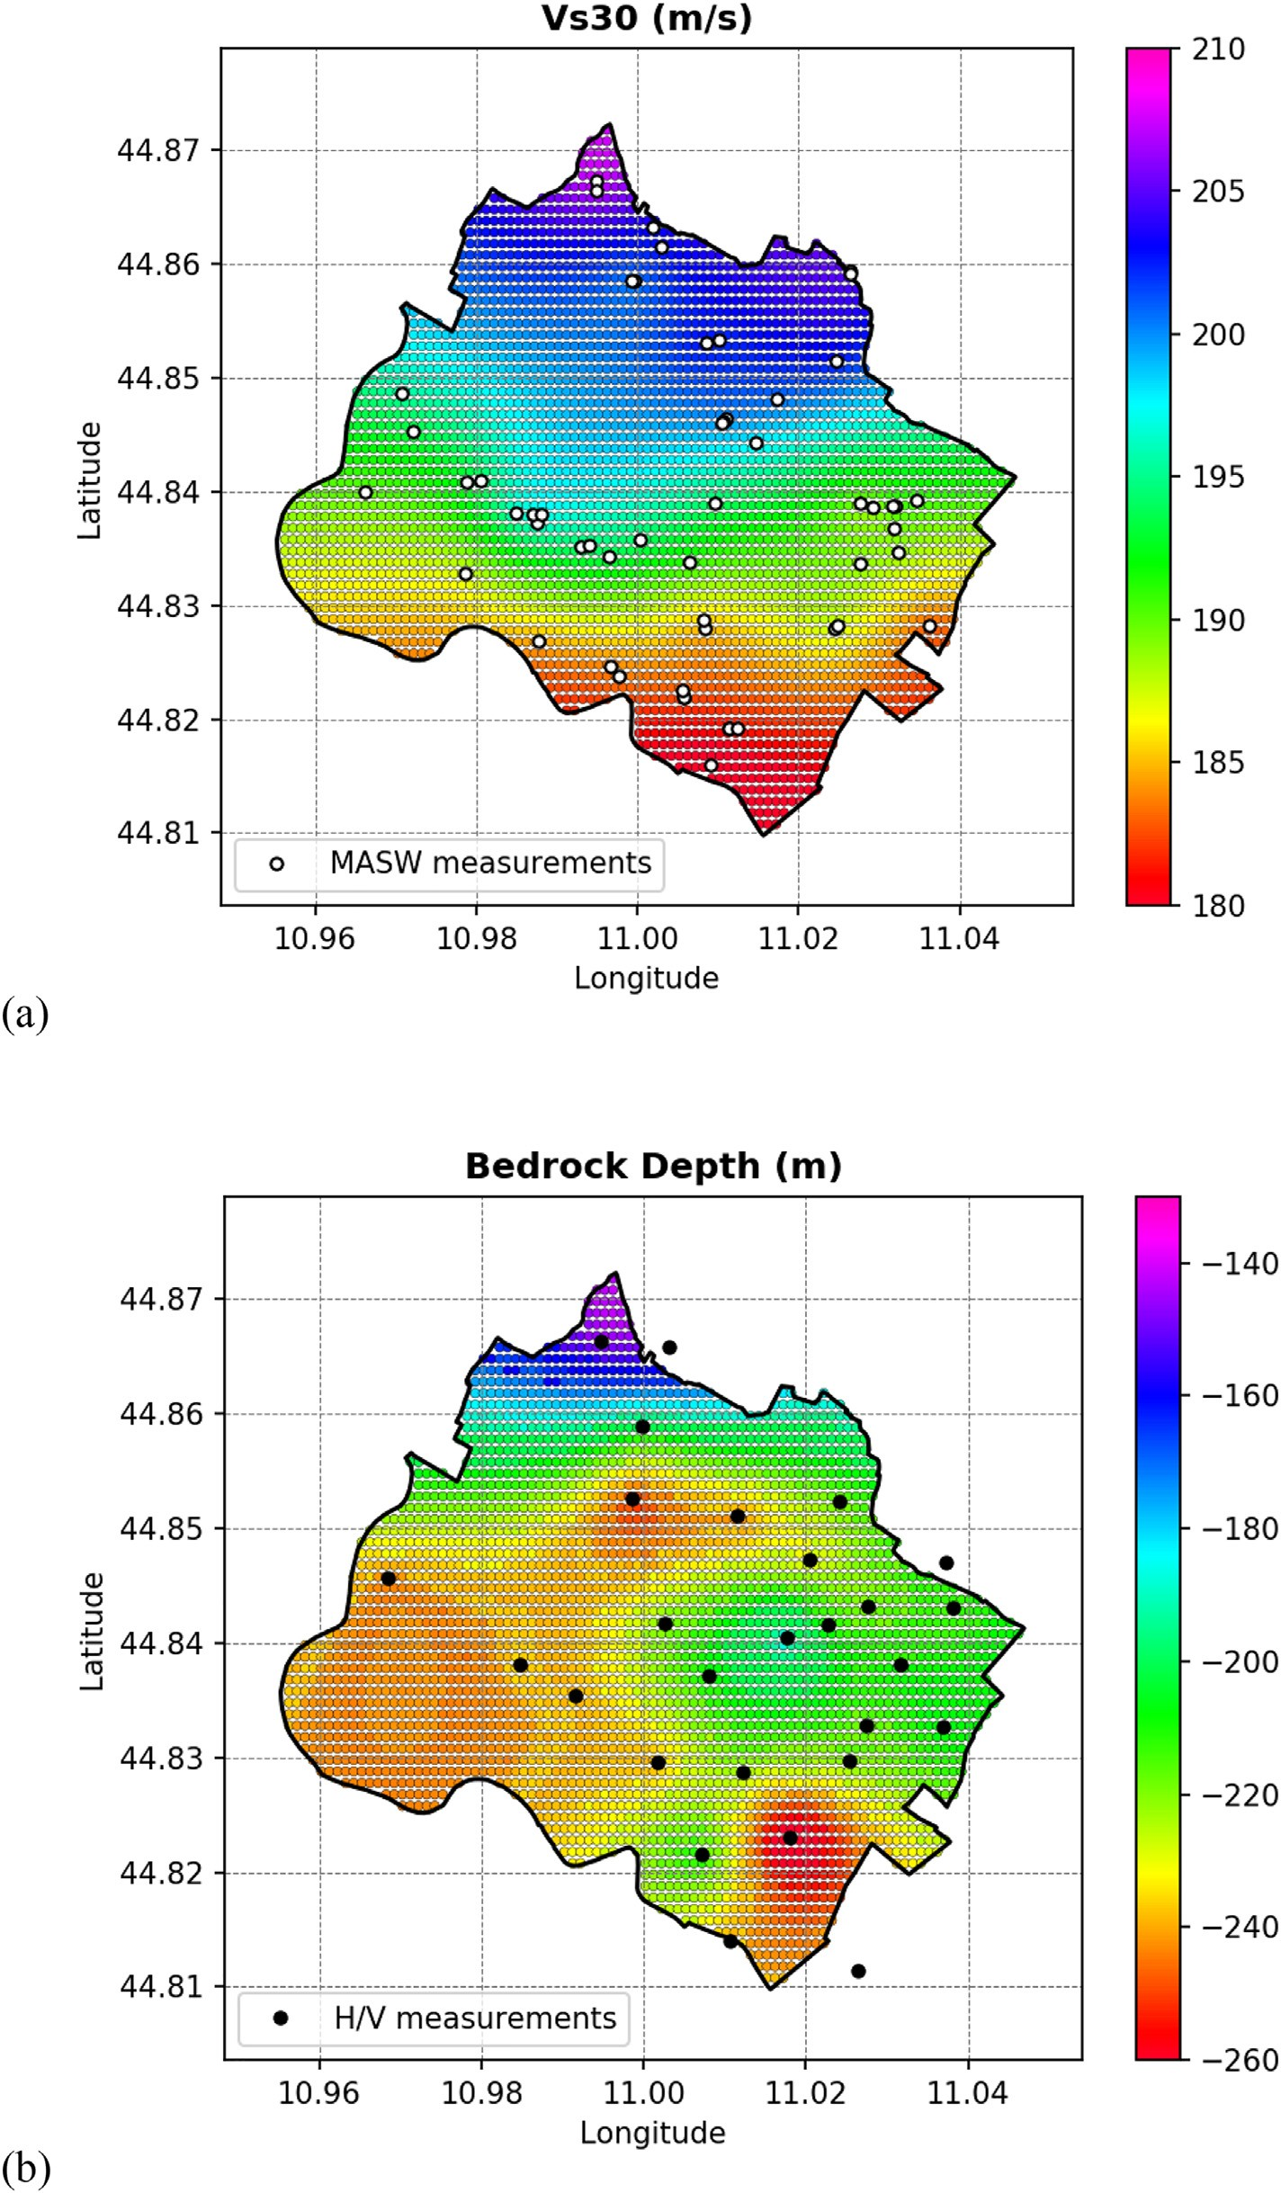
Fig. 9. Maps of the VS30 distribution compute from the actual 1D velocity proﬁles (a) and seismic bedrock depth (b) of the pseudo-3D model developed for Cavezzo. Location of the active (MASW) and passive (single station H/V) tests is superposed to highlight the spatial distribution of the model constraints.

FH0.5 s-1.0 s, FH0.5-1.5. The terms PGA0 and SI0 denote respectively the peak ground acceleration and Housner intensity related to the re- ference input motion. It is readily apparent from the ﬁgure that high- frequency ground motion (i.e. PGA and FH0.1 s–0.5 s) is characterized by lower ampliﬁcation factors as they range between 1.0 and 1.5 for PGA and between 1.3 and 1.9 for FH0.1 s–0.5 s. Higher ampliﬁcation
factors are obtained for the long period range, namely FH0.5 s–1.0 s and FH0.5–1.5. Indeed, ampliﬁcation factors for FH0.5 s–1.0 s are greater than 3 for the whole territory under investigation reaching values of 3.9 in the northern part of the territory. Housner Intensity at longer periods (FH0.5–1.5) exhibits ampliﬁcation factors ranging from
2.6 and 3.3.

Table 2
Parameters adopted for the deﬁnition of the seismic hazard in Cavezzo, ac- cording to NTC (2018).
Return period (years) ag (g) F0 (−) Tc* (s)

475 0.151 2.588 0.270
975 0.202 2.535 0.276
2475 0.290 2.436 0.291
- Discussion and conclusions

From the results of ground ampliﬁcation analyses, it is readily ap- parent the correlation between the spatial variability of surface ground motion within Cavezzo territory and the characteristics of the adopted geotechnical and seismo-stratigraphic models. This clearly highlights the importance of the interplay and complementarity among diﬀerent

methodological approaches and spatial resolution scales characterizing
a seismic microzonation study when tackled from a geological, geo-

As expected, the largest absolute ampliﬁcation factors are experi- enced in the northern part of the municipality, in the proximity of the culmination of the Mirandola anticline, where the seismic bedrock is shallower and the resonance eﬀects became signiﬁcant in the periods of engineering interest. The ground motion variability exhibited by the map is due to the combined eﬀect of VS30-constrained uppermost seismic velocity variability and the diﬀerences in lithological and ge- netic depositional environments.
It is interesting to note that the variability of the ground motion shown by Fig. 10 reﬂects the geometry of the MOPS illustrated in Fig. 4. The boundaries of these areas can be seen to correspond to the values of the ampliﬁcation factors. The impact on the ground motion is however diﬀerent for the diﬀerent intensity measures. For instance, this fact is clearly visible in the long period range, namely FH0.5 s–1.0 s (bottom left) and FH0.5–1.5 (bottom right) whereas lower values of the am- pliﬁcation factors were obtained in homogeneous zones 3 and 4 which are the crevasse splays identiﬁed within the Cavezzo territory.
physical, seismological and geotechnical perspective. The challenge to succeed in such a study consists in explicitly recognizing its intrinsic multi-disciplinary, inter-disciplinary and multi-scale nature in pursuing the goal of deﬁning a uniﬁed subsoil model that harmonizes coherently the diﬀerent scales at which it can be deﬁned.
It must be remarked however that the procedure illustrated in this article, strictly applies to situations where the geological setting is such that a smooth spatial variation of the subsoil properties over the terri- tory, is an acceptable approximation, at the points of the calculation grid. In case of evident 2D/3D response, the use of more advanced numerical models will be unavoidable. Nonetheless, such condition must be evaluated carefully on a case by case scenario, considering the frequencies of interest for engineering applications, e.g. by a pre- liminary inspection of the H/V spectral ratio variability across the area, in order to justify the increased investment required for such advanced and computationally very expensive analysis. So far, few attempts are available in the literature to objectively quantify the possibility of 2D/ 3D morphological eﬀects, which makes this subject an open ﬁeld of

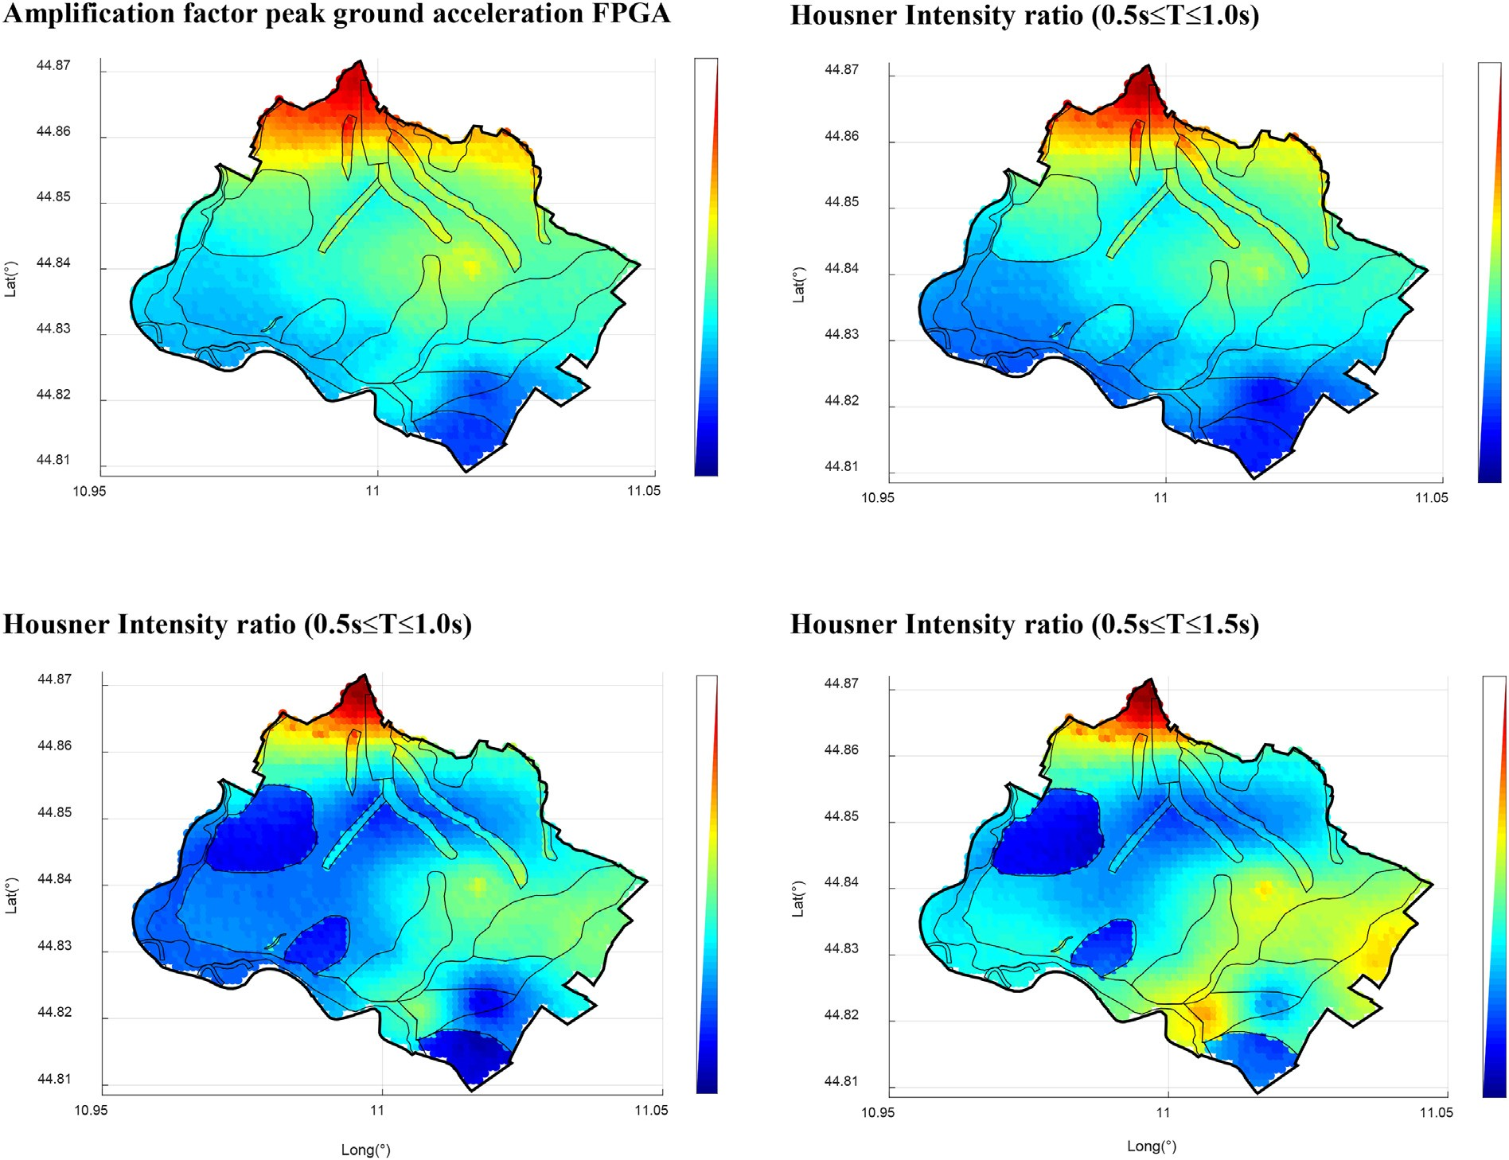
Fig. 10. Map of ampliﬁcation factors computed for Cavezzo considering the 475-years return period. Top left: FPGA; Top right: Housner intensity ratio (0.1 s ≤ T ≤ 0.5 s); Bottom left: Housner intensity ratio (0.5 s ≤ T ≤ 1.0 s); Bottom right: Housner intensity ratio (0.5 s ≤ T ≤ 1.5 s). The 9 homogeneous geological zones (MOPS) deﬁned for Cavezzo municipality are superimposed.

research.
It is also important to underline that ground response analyses were conducted using a linear equivalent soil constitutive model. This ap- proach of adopting one-constituent, equivalent-linear viscoelastic rheology for the soil is inadequate to correctly reproducing the seismic response of geomaterials exhibiting strong nonlinearities in the hydro- mechanical behaviour. An example is constituted by liqueﬁable soils, which require ground response analyses to be more correctly conducted using eﬀective stress-based soil constitutive models. In the territory of Cavezzo, widespread liquefaction phenomena were observed during the 2012 seismic sequence with speciﬁc reference to the south-eastern part of the municipality. Thus, at least for these sites, eﬀective-stress ground response analyses are required. This type of analysis is currently on- going for the areas in Cavezzo prone to exhibit liquefaction occur- rences.
Finally, an advancement of the current achievements in the seismic microzonation of Cavezzo territory could be represented by complete randomization of all soil parameters, position of the water table and other input data for ground response analyses so to produce a fully stochastic set of ampliﬁcation factors.

Declaration of Competing Interest

The authors declare that they have no known competing ﬁnancial interests or personal relationships that could have appeared to inﬂu- ence the work reported in this paper.

Acknowledgments

This research has been carried out within the framework of the European LIQUEFACT project. The LIQUEFACT project has received funding from the European Union's Horizon 2020 Research and Innovation Programme under Grant Agreement No. 700748. This sup- port is gratefully acknowledged by the authors. The study herein pre- sented has been carried out by a multi-disciplinary working group. In this framework, the authors would like to acknowledge:

Sonia Lorini, Daniele Conca, Alì G. Ozcebe, Massimiliano Bordoni, Pina Persichillo, Juan C. Gòmez Zapata, Giuseppe Cerra, Giacomo Perotti and Simone Ciaﬀaroni from University of Pavia;
•
•
Daniela Fontana, Stefano Lugli and Alessandro Ghinoi from University of Modena and Reggio Emilia;
•
Sara Lovati, Simona Carannante, Paola Morasca, Ezio D'Alema, Gianlorenzo Franceschina and Antonio Gomez from INGV (Milan Section);
•
Alﬁo Barbagallo, Gino Cristofano and Daniele Sorgo from OGS; Giulio Ercolessi from Emilia-Romagna Region;
•
•
the Major of the Cavezzo Municipality and the technical staﬀ in particular Agnese Malagoli.

A ﬁnal word of appreciation goes to the two anonymous reviewers for their suggestions and constructive criticisms, which helped in im- proving substantially the quality of our manuscript.

References

RER–ENI, 1998. Riserve idriche sotterranee della Regione Emilia-Romagna. G. M. Di Dio. Regione Emilia- Romagna, ENI Agip Divisione Esplorazione e Produzione. S.EL.CA, Firenze, pp. 120.
TC4-ISSMGE, 1999. Manual for Zonation on Seismic Geotechnical Hazards (Revised Version). In: Technical Committee for Earthquake Geotechnical Engineering, TC4, ISSMGE. The Japanese Geotechnical Society ISBN 4-88644-809-7.
DAL 112/2007, 2007. Deliberazione dell'Assemblea Legislativa della Regione Emilia- Romagna n.112 del 2/5/2007: Approvazione dell'atto di indirizzo e coordinamento tecnico ai sensi dell'art.16 comma 1, della L.R. 20/2000 per “Indirizzi per gli studi di microzonazione sismica in Emilia-Romagna per la pianiﬁcazione territoriale e urba- nistica”. Boll. Uﬀ. Reg. Emilia-Romagna n. 64 del 17/5/2007. http://ambiente. regione.emilia-romagna.it/it/geologia/sismica/indirizzi-per-studi-microzonazione-

sismica.
DGR 2193/2015, 2015. Deliberazione della Giunta della Regione Emilia Romagna n.
2193 del 21 dicembre 2015: “Art. 16 della L.R. n. 20 del 24/3/2000. Approvazione aggiornamento dell'Atto di coordinamento tecnico denominato «Indirizzi per gli studi di microzonazione sismica in Emilia-Romagna per la pianiﬁcazione territoriale e urbanistica» di cui alla Deliberazione dell'Assemblea Legislativa 2 maggio 2007, n. 112”. Boll. Uﬀ. Reg. Emilia-Romagna n. 4 del 8/1/2016 (parte seconda). http:// ambiente.regione.emilia-romagna.it/it/geologia/sismica/indirizzi-per-studi- microzonazione-sismica.
NTC, 2018. Norme tecniche per le costruzioni. Ministero delle Infrastrutture e dei Trasporti. Decreto Ministeriale del 17 gennaio 2018, Supplemento ordinario alla
G.U. n. 8 del 20 febbraio 2018 (in Italian).
Albarello, D., Gargani, G., 2010. Providing NEHRP soil classiﬁcation from the direct in- terpretation of eﬀective rayleigh-wave dispersion curves Bull. Seismol. Soc. Am. 100 (6), 3284–3294.
Anbazhagan, P., Sitharam, T.G., Vipin, K.S., 2009. Site classiﬁcation and estimation of surface level seismic hazard using geophysical data and probabilistic approach. J. Appl. Geophys. 68 (2), 219–230.
Ansal, A., Tönük, G., Kurtuluş, A., 2009. Microzonation for urban planning. In: Tankut,
A.T. (Ed.), Earthquakes and Tsunamis, Geotechnical, Geological, and Earthquake Engineering. 11. Springer, Dordrecht, pp. 133–152.
Ansal, A., Kurtuluş, A., Tönük, G., 2010. Seismic microzonation and earthquake damage scenarios for urban areas. Soil Dyn. Earthq. Eng. 30, 1319–1328.
Aversa, S., Crespellani, T., 2016. Seismic Microzonation: an essential tool for urban planning in seismic areas. UPLanD J Urban Plann Landsc Environ Des 1 (1), 121–152.
Bignami, C., Burrato, P., Cannelli, V., Chini, M., Falcucci, E., Ferretti, A., Gori, S., Kyriakopoulos, C., Melini, D., Moro, M., Novali, F., Saroli, M., Stramondo, S., Valensise, G., Vannoli, P., 2012. Coseismic deformation pattern of the Emilia 2012 seismic sequence imaged by Radarsat-1 interferometry. Ann Geophys 55 (4). https:// doi.org/10.4401/ag-6157.
Boccaletti, M., Corti, G., Martelli, L., 2010. Recent and active tectonics of the external zone of the Northern Apennines (Italy). Int. J. Earth. Sci. (Geol. Rundsch.) 100, 1331–1348. https://doi.org/10.1007/s00531-010-0545-y.
Brown, L.T., Diehl, J.G., Nigbor, R.L., 2000. A simpliﬁed procedure to measure average shear-wave velocity to a depth of 30 m (VS30). In: Twelfth World Conf. on Earthquake Engineering. New Zealand Society for Earthquake Engineering, Auckland, New Zealand.
Castaldini, D., 1989. Evoluzione della rete idrograﬁca centropadana in epoca protostorica e storica. Atti Conv. Naz. Studi "Insediamenti e viabilità nell'alto ferrarese dall'Età Romana al Medioevo". Cento 8-9 May 1987 Acc. delle Sc. di Ferrara, Ferrara, pp. 115–134.
Celikbilek, A., Sapmaz, G., 2016. Risk management and microzonation in urban planning: an analysis for Istanbul. Disaster Sci. Eng. 2 (2), 59–66.
Comina, C., Foti, S., Boiero, D., Socco, L.V., 2011. Reliability of VS,30 evaluation from surface-wave tests. J. Geotech. Geoenviron. Eng. 137 (6), 579–586.
Corigliano, M., Lai, C.G., Rota, M., Strobbia, C.L., 2012. ASCONA: automated selection of compatible natural accelerograms. Earthquake Spectra 28 (3), 965–987.
Cox, B.R., Bachhuber, J., Rathje, E., Wood, C.M., Dulberg, R., Kottke, A., Green, R.A., Olson, S.M., 2011. Shear wave velocity- and geology-based seismic microzonation of port-au-prince, Haiti. Earthq. Spectra 27, 67–92.
Crespellani, T., 2014. Seismic microzoning in Italy: a brief history and recent experiences.
Ing Sism. 31 (2), 3–31.
Cubrinovski, M., Stringer, M., Haycock, I., 2016. Experience with gel-push sampling in New Zealand. http://www.nzgs.org.
Darendeli, M.B., 2001. Development of a New Family of Normalized Modulus Reduction and Material Damping Curves. Doctor of Philosophy. University of Texas at Austin. Fäh, D., Rüttener, E., Noack, T., Kruspan, P., 1997. Microzonation of the city of Basel. J.
Seismol. 1, 87–102.
Fantoni, R., Franciosi, R., 2010. Tectono-sedimentary setting of the Po Plain and Adriatic foreland. Rendiconti Lincei Sci Fis Nat 21, 197–209. https://doi.org/10.1007/ s12210-010-0102-4.
Fioravante, V., Giretti, D., Abate, G., Aversa, S., Boldini, D., Capilleri, P.P., et al., 2013.
Earthquake geotechnical engineering aspects of the 2012 Emilia-Romagna earth- quake (Italy). In: Proceedings of the 7th International Conference on Case Histories in Geotechnical Engineering, Chicago, Illinois, USA.
Haghshenas, E., Bard, P.-Y., Theodulidis, N., SESAME WP04 Team, 2008. Empirical evaluation of microtremor H/V spectral ratio. Bull. Earthq. Eng. 6 (1), 75–108.
Hudson, M.B., Beikae, M., Idriss, I.M., 1994. QUAD4M, a Computer Program to Evaluate the Seismic Response of Soil Structures Using Finite Element Procedures and Incorporating a Compliant Base Center for Geotechnical Modeling. Department of Civil and Environmental Engineering, University of California, Davis.
Idriss, J., Sun, J.I., 1992. SHAKE91 - a Computer Program for Conducting Equivalent Linear Seismic Response Analyses of Horizontally Layered Soil Deposits. University of California, Davis, USA.
Isaaks, E.H., Srivastava, R.M., 1989. An Introduction to Applied Geostatistics. Oxford University Press, New-York.
Lai, C.G., Bozzoni, F., Mangriotis, M.D., Martinelli, M., 2015. Soil liquefaction during the May 20, 2012 M5.9 Emilia earthquake, Northern Italy: ﬁeld reconnaissance and post- event assessment. Earthquake Spectra 31 (4), 2351–2373.
Lai, C.G., Meisina, C., Bozzoni, F., Conca, D., Famà, Özcebe, Zuccolo, E., Bonì, R., Poggi, V., Cosentini, R.M., 2019. Mapping the liquefaction hazard at diﬀerent geographical scales. In: Proceedings 7th International Conference on Earthquake Geotechnical Engineering, 7ICEGE, Rome, Italy, 17–20 June 2019.
Locati, M., Camassi, R., Rovida, A., Ercolani, E., Bernardini, F., Castelli, V., Caracciolo, C.H., Tertulliani, A., Rossi, A., Azzaro, R., D’Amico, S., Conte, S., Rocchetti, E., 2016. DBMI15, the 2015 version of the Italian Macroseismic Database. Istituto Nazionale di

Geoﬁsica e Vulcanologiahttps://doi.org/10.6092/INGV.IT-DBMI15.
Martelli, L., Romani, M., 2013. Microzonazione sismica e analisi della condizione limite per l'emergenza delle aree epicentrali dei terremoti della pianura emiliana di maggio- giugno 2012 (Ordinanza del commissario delegato n. 70/2012), Relazione Illustrativa (in Italian). http://ambiente.regione.emilia-romagna.it/it/geologia/ sismica/speciale-terremoto/sisma-2012-ordinanza-70-13-11-2012-cartograﬁa.
Martelli, L., Bonini, M., Calabrese, L., Corti, G., Ercolessi, G., Molinari, F.C., Piccardi, L., Pondrelli, S., Sani, F., Severi, P., 2017. Carta sismotettonica della Regione Emilia- Romagna e aree limitrofe. Note illustrative. Regione Emilia-Romagna, Servizio geo- logico, sismico e dei suoli. D.R.E.AM.
Martin, A.J., Diehl, J.G., 2004. Practical experience using a simpliﬁed procedure to measure average shear-wave velocity to a depth of 30 m (VS30). In: 13th World Conference on Earthquake EngineeringVancouver, B.C., Canada, Paper No. 952.
Mascandola, C., Massa, M., Barani, S., Albarello, D., Lovati, S., Martelli, L., Poggi, V., 2019. Mapping the Seismic Bedrock of the Po Plain (Italy) through Ambient- Vibration monitoring. Bull. Seismol. Soc. Am. 109 (1), 164–177. https://doi.org/10. 1785/0120180193.
Meisina, C., Bonì, R., Bordoni, M., Lai, C.G., Bozzoni, F., et al., 2019. 3D Geological model reconstruction for liquefaction hazard assessment in the Po Plain. In: Proceedings 7th International Conference on Earthquake Geotechnical Engineering, 7ICEGE, Rome, Italy, 17–20 June, 2019.
Motalleb Nejad, M., Momeni, M.S., Manahiloh, K.N., 2018. Shear wave velocity and soil type microzonation using neural networks and geographic information system. Soil Dyn. Earth. Eng. 104, 54–63.
Murvosh, H., Luke, B., Calderón-Macías, C., 2013. Shallow-to-deep shear wave velocity proﬁling by surface waves in complex ground for enhanced seismic microzonation of Las Vegas, Nevada. Soil Dyn. Earth. Eng. 44, 168–182.
Muttoni, G., Carcano, C., Garzanti, E., Ghielmi, M., Piccin, A., Pini, R., Rogledi, S., Sciunnach, D., 2003. Onset of major Pleistocene glaciations in the Alps. Geology 31 (11), 989–992.
Nakamura, Y., 1989. A method for dynamic characteristics estimation of subsurface using microtremor on the ground surface. Quart. Records Railway Tech. Res. Inst. 30, 25–33.
Nogoshi, M., Igarashi, T., 1971. On the amplitude characteristics of microtremor, Part II.
J. Seism. Soc. Japan 24, 26–40.
Pagani, M., Marcellini, A., Crespellani, T., Martelli, L., Tento, A., Daminelli, R., 2006. Seismic microzonation regulations of the Emilia-Romagna Region (Italy). In: Third International Symposium on the Eﬀects of Surface Geology on Seismic Motion, Grenoble, France, 30 August - 1 September 2006.
Paolucci, E., Albarello, D., D’Amico, S., Lunedei, E., Martelli, L., Mucciarelli, M., Pileggi, D., 2015. A large scale ambient vibration survey in the area damaged by May–June 2012 seismic sequence in Emilia Romagna, Italy. Bull. Earthq. Eng. 13, 3187–3206. https://doi.org/10.1007/s10518-015-9767-5.
PEER, 2010a. Technical report for the PEER ground motion database web application- Beta Version-October 1, 2010. Paciﬁc Earthquake Engineering Research Center (PEER).
PEER, 2010b. User’s Manual for the PEER ground motion database web application-Beta Version-October 1, 2010. Paciﬁc Earthquake Engineering Research Center (PEER).
Pellegrini, M., Zavatti, A., 1980. Il sistema acquifero sotterraneo tra i ﬁumi Enza, Panaro e

Po: alimentazione delle falde e scambi tra falde, correlazioni idrochimiche. Quaderni IRSA 51 (1) Roma.
Pergalani, F., Pagliaroli, A., Bourdeau, C., Compagnoni, M., Lenti, L., Lualdi, M., Madiai, C., Martino, S., Razzano, R., Varone, C., Verrubbi, V., 2019. Seismic microzoning map: approaches, results and applications after the 2016–2017 Central Italy seismic sequence. Bull. Earth. Eng. 1–35.
Petronio, L., Aﬀatato, A., Baradello, L., Barbagallo, A., Cristofano, G., Sorgo, D., Lai, C.G., Poggi, V., 2018. Shear wave seismic reﬂection survey in the 2012 Emilia epicentral area. In: 38th GNGTS, Bologna, Italy.
Pieri, M., Groppi, G., 1981. Subsurface geological structure of the Po plain, Italy. Pubbl.
414, Consiglio Nazionale delle Ricerche, CNR, Agip. Progetto Finalizzato Geodinamica, Rome, pp. 23.
Poggi, V., Fäh, D., 2010. Estimating Rayleigh wave particle motion from three-component array analysis of ambient vibrations. Geophys. J. Int. 180 (1), 251–267.
Poggi, V., Fäh, D., Burjánek, J., Giardini, D., 2012. The use of Rayleigh wave ellipticity for site-speciﬁc hazard assessment and microzonation. An application to the city of Luzern (Switzerland). Geophys. J. Int. 188 (3), 1154–1172.
Robertson, P.K., 2009. Interpretation of cone penetration tests - a uniﬁed approach. Can.
Geotech. J. 46, 1337–1355.
Rovida, A., Locati, M., Camassi, R., Lolli, B., Gasperini, P. (Eds.), 2016. CPTI15, the 2015 version of the Parametric Catalogue of Italian Earthquakes. Istituto Nazionale di Geoﬁsica e Vulcanologia. https://doi.org/10.6092/INGV.IT-CPTI15.
Scardia, G., De Franco, R., Muttoni, G., Rogledi, S., Caielli, G., Carcano, C., Sciunnach, D., Piccin, A., 2012. Stratigraphic evidence of a Middle Pleistocene climate-driven ﬂex- ural uplift in the Alps. Tectonics 31, TC6004.
Schnabel, P.B., Lysmer, J., Seed, H.B., 1972. SHAKE: a computer program for earthquake response analysis of horizontally layered sites. Rep. No. EERC 72-12. EERI, Berkeley, Calif.
Tertulliani, A., Arcoraci, L., Berardi, M., Bernardini, F., Brizuela, B., Castellano, C., Del Mese, S., Ercolani, E., Graziani, L., Maramai, A., Rossi, A., Sbarra, M., Vecchi, M., 2012. The Emilia 2012 sequence: a macroseismic survey. “2012 EMILIA EARTHQUAKES”. Ann. Geophys. 55, 4. https://doi.org/10.4401/ag-6140.
Toscani, G., Burrato, P., Di Bucci, D., Seno, S., Valensise, G., 2009. Plio-Quaternary tec- tonic evolution of the Northern Apennines thrust fronts along the bologna-ferrara section (Po Plain, Italy), based on geological observations and analogue modelling: seismotectonic implications. Ital. J. Geosci. 128 (2), 605–613.
Tuladhar, R., Yamazaki, F., Warnitchai, P., Saita, J., 2004. Seismic microzonation of the greater Bangkok area using microtremor observations. Earthq. Eng. Struct. Dyn. 33, 211–255.
Turrini, C., Lacombe, O., Roure, F., 2014. Present-day 3D structural model of the Po Valley basin, Northern Italy. Mar. Pet. Geol. 56, 266–289.
Wathelet, M., Jongmans, D., Ohrnberger, M., et al., 2008. Array performances for ambient vibrations on a shallow structure and consequences over V s inversion. J. Seismol. 12, 1–19.
Working Group ICMS, 2008. Indirizzi e criteri per la microzonazione sismica – Guidelines for seismic microzonation. Conferenza delle Regioni e delle Province Autonome- Dipartimento della Protezione Civile. English version. available at: http://www. protezionecivile.gov.it/httpdocs/cms/attach_extra/ GuidelinesForSeismicMicrozonation.pdf.

